**Links In the Homepage and in the Footer**

* Please links the following sections on the homepage, and down below in the footer throughout the site. Refer to the original art-metal.ca on where the links should go:

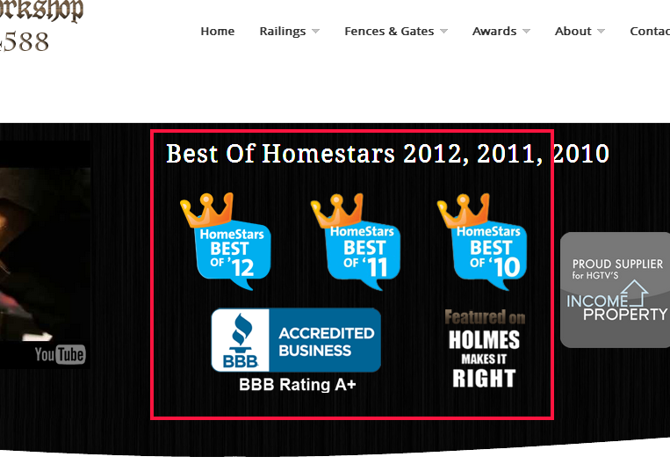

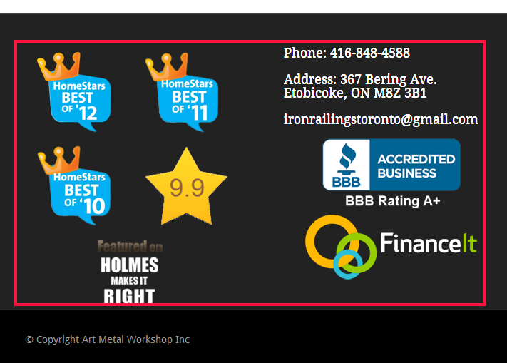

**Page Titles and Meta Descriptions**

* Page titles are duplicate on all of the pages
* Meta descriptions are missing
* Please copy them from the site

*Essential for SEO*

**Keep The Top Menu Fixed**

* Please keep the top menu fixed when scrolling down as in the original template: <http://www.kriesi.at/themes/enfold/>

**Capitalize "miscellaneous" in the in the menu**

* In the menu, please capitalize “miscellaneous”

**Add Margin Space on the Bottom, on All pages**

Please add more space between the content on all of the pages, as it seems there is very little space there.

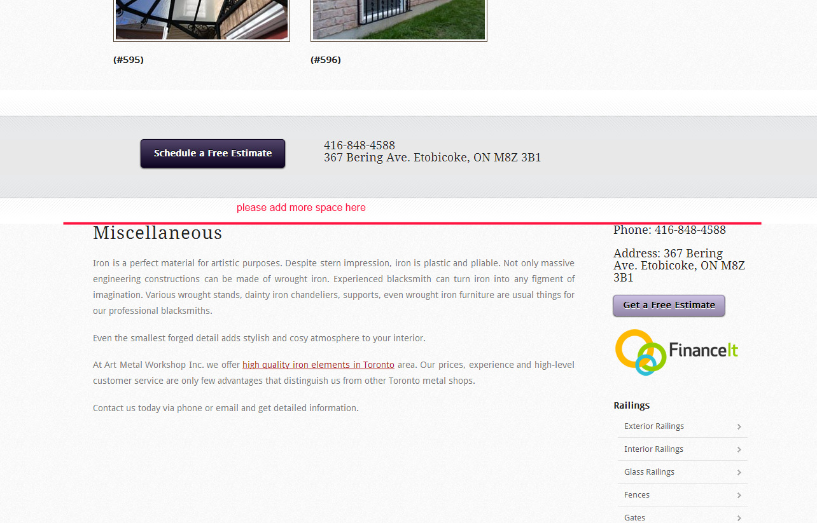

**Link to More Reviews on the Portfolio Page**

On this page, please fix the link <http://artmetaltoronto.pairserver.com/portfolio/>

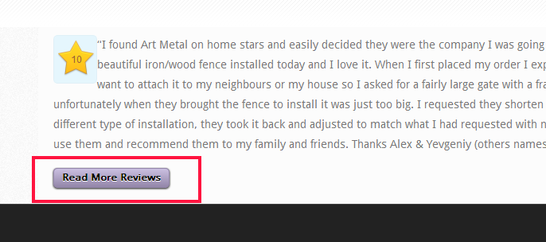

**Remove Navigation on the right side of the Financing Page**

Please remove the menu on the right side: <http://artmetaltoronto.pairserver.com/financing/>

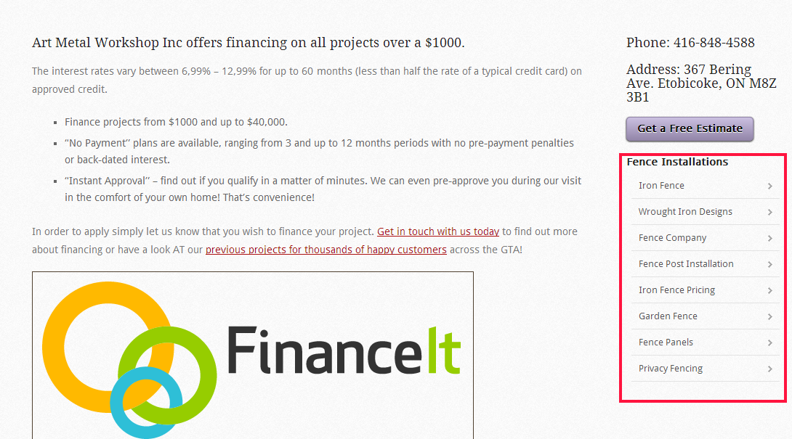

Can you please add the following menu links instead?

* About <http://artmetaltoronto.pairserver.com/about-us/>
* Financing <http://artmetaltoronto.pairserver.com/financing/>
* Awards <http://artmetaltoronto.pairserver.com/awards/>
* Mike Holmes <http://artmetaltoronto.pairserver.com/mike-holmes-show/>
* Income Property <http://artmetaltoronto.pairserver.com/income-property/>

**Extra White Space**

There seems to be extra white space on this page: <http://artmetaltoronto.pairserver.com/garden-gates/>

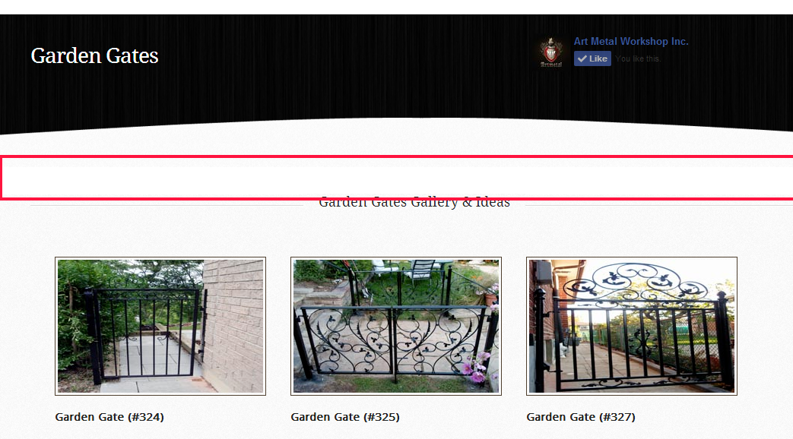

**Problems with the Header**

There seem to be problems with the header on the pages listed below:

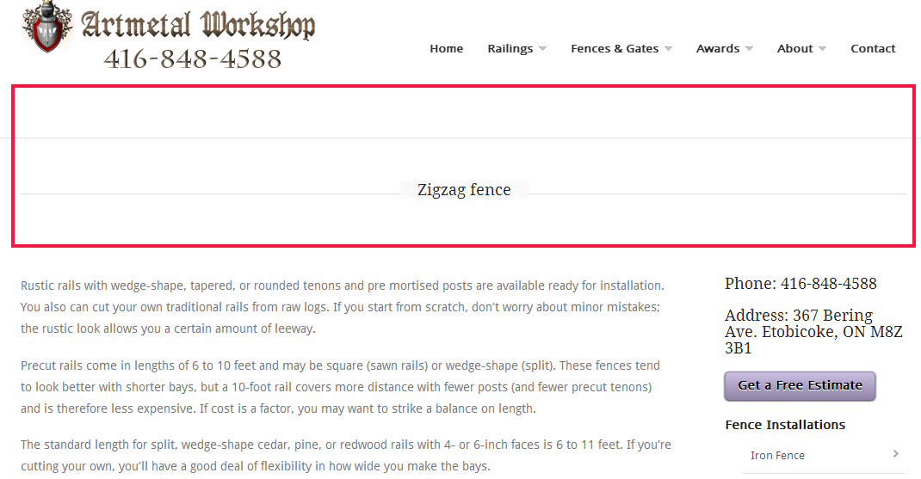

http://artmetaltoronto.pairserver.com/zigzag-fence/

http://artmetaltoronto.pairserver.com/horizontal-rail-fence/

http://artmetaltoronto.pairserver.com/ornamental-metal-fence/

http://artmetaltoronto.pairserver.com/security-fences/

http://artmetaltoronto.pairserver.com/synthetic-vinyl-and-metal-fencing/

http://artmetaltoronto.pairserver.com/variations-on-fence-style/

http://artmetaltoronto.pairserver.com/fence-preparations/

http://artmetaltoronto.pairserver.com/preparing-the-terrain-for-fences/

http://artmetaltoronto.pairserver.com/front-yard-and-back-yard-fences/

http://artmetaltoronto.pairserver.com/building-a-braced-frame-gate/

http://artmetaltoronto.pairserver.com/building-curved-fence-sections/

http://artmetaltoronto.pairserver.com/building-a-flat-rail-frame/

http://artmetaltoronto.pairserver.com/building-an-edge-rail-fence-frame/

http://artmetaltoronto.pairserver.com/curved-fence-line/

http://artmetaltoronto.pairserver.com/basic-fence-building/

http://artmetaltoronto.pairserver.com/installing-surface-mounted-in-fill/

http://artmetaltoronto.pairserver.com/footings-for-fences-and-overheads/

http://artmetaltoronto.pairserver.com/fasteners-and-hardware-for-fences/

http://artmetaltoronto.pairserver.com/fencing-materials/

**Delete the Scholarship**

Can you please delete page <http://artmetaltoronto.pairserver.com/scholarship/> and delete it from the menu

**Fix Some of the Homestars Popups**

Can you please limit the homestars popup size, to the same size as on the original art metal website.

Check the video here: <http://screencast.com/t/IAbmUjJq5ekY>

**Also some of the popups do not load the right pages:**

<http://artmetaltoronto.pairserver.com/>

* **Tamara in Toronto** – doesn’t load the correct page
* **Norma and Steve**– doesn’t load the correct page

<http://artmetaltoronto.pairserver.com/exterior_railings2>

Second testimonial doesn’t load the right page

<http://artmetaltoronto.pairserver.com/awards/#prettyPhoto>

the first testimonial doesn’t load the right page

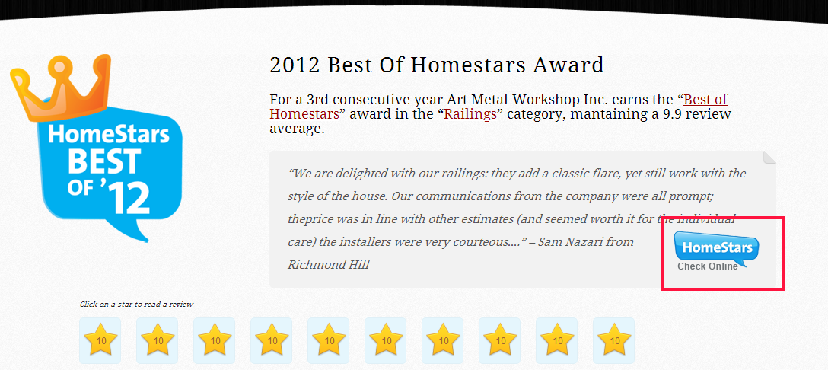

**Fix the Image**

The image on this page: <http://artmetaltoronto.pairserver.com/stair-railings/> seems to be slightly higher that needed.

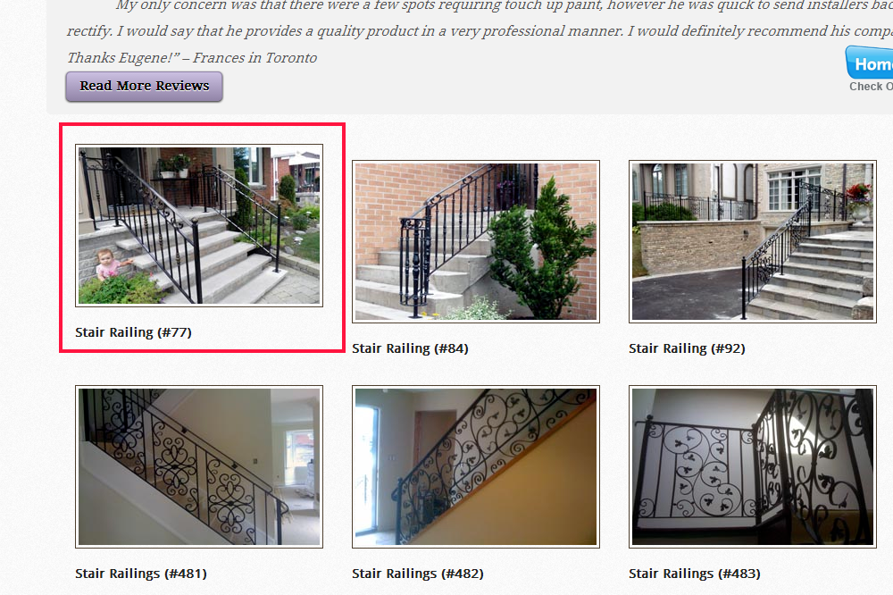

**Fix the gallery layout on the mobile version**

The description is in the video: <http://screencast.com/t/06XrOInJW>