Standard Operating Procedure (SOP)
Process Title: Daily Chatbot Operations Check | Department: AI Operations
SOP ID: AIO01 | Last Reviewed: 05/14/2026
Effective Date: 05/14/2026 | Version: 1
Purpose
Daily review of A.C.E. chatbot operations to identify knowledge gaps and operational issues before they affect more users. Approximately 10 minutes, every workday morning.

Procedure
Open the Analyze Tab
In CustomGPT.ai, open the A.C.E. agent. Click Analyze in the left sidebar. The view defaults to Overview.
Triage Missing Content  Read each new entry since yesterday. For each, tag:  • Fix it — in-scope, KB entry needed (use AIO05).  • Send elsewhere — belongs to another department.  • Skip — noise, test, or abuse. | 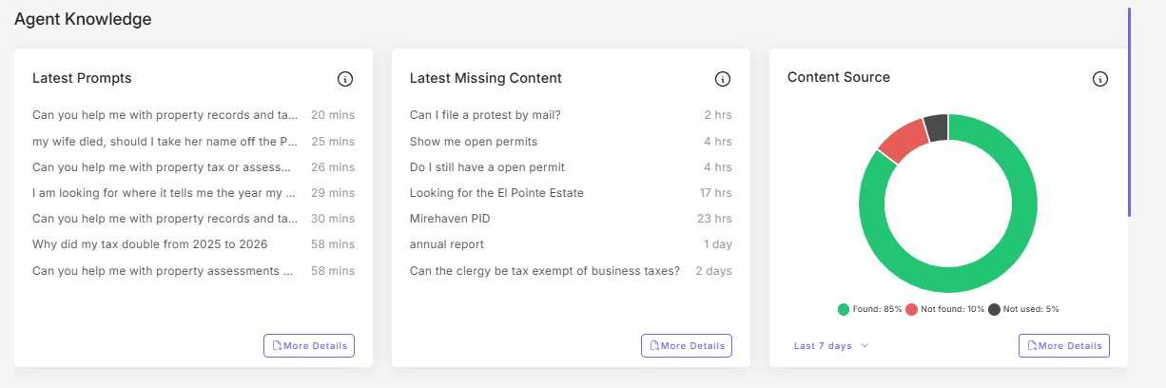
Check the Content Source Ratio
Donut chart on same screen. Not found should be under 15%. If over, note for follow-up.
Skim Top 5 Latest Prompts
Note anything sensitive, hostile, PII-containing, or politically charged. Escalate per AIO06 if warranted.
Review Risk Monitoring  Click Customer Intelligence tab. Today’s Incidents bar should be in line with the 7-day pattern. If elevated, investigate same day per AIO06. | 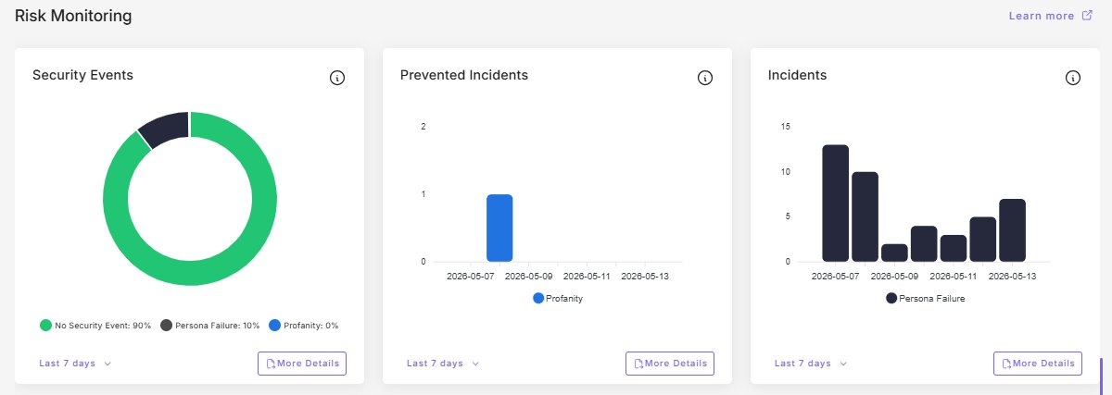
Check Main Dashboard
Return to Dashboard. Note any tile with a red border (typically Words Processed near plan cap).
End of Day
Fix or schedule “Fix it” items. Confirm any required notifications were sent.

Notify Assessor and Deputy Same-Day If
• A prompt contains PII that A.C.E. produced or exposed.
• A prompt contains threats against staff or office.
• Persona Failure incidents are clearly elevated above 7-day pattern.
• Agent is unreachable from the public site.
• Words Processed at plan cap and service is degraded.

