Standard Operating Procedure (SOP)
Process Title: Weekly Chatbot Conversation Review | Department: AI Operations
SOP ID: AIO02 | Last Reviewed: 05/15/2026
Effective Date: 05/15/2026 | Version: 2
Purpose
Weekly review of A.C.E. conversations to detect quality problems, confirm bilingual function, and maintain a conversation backup. Approximately 30 minutes, Monday morning.

Procedure
Open the Ask Tab  In CustomGPT.ai, open the A.C.E. agent. Click Ask in the sidebar. The conversation list shows newest first. | 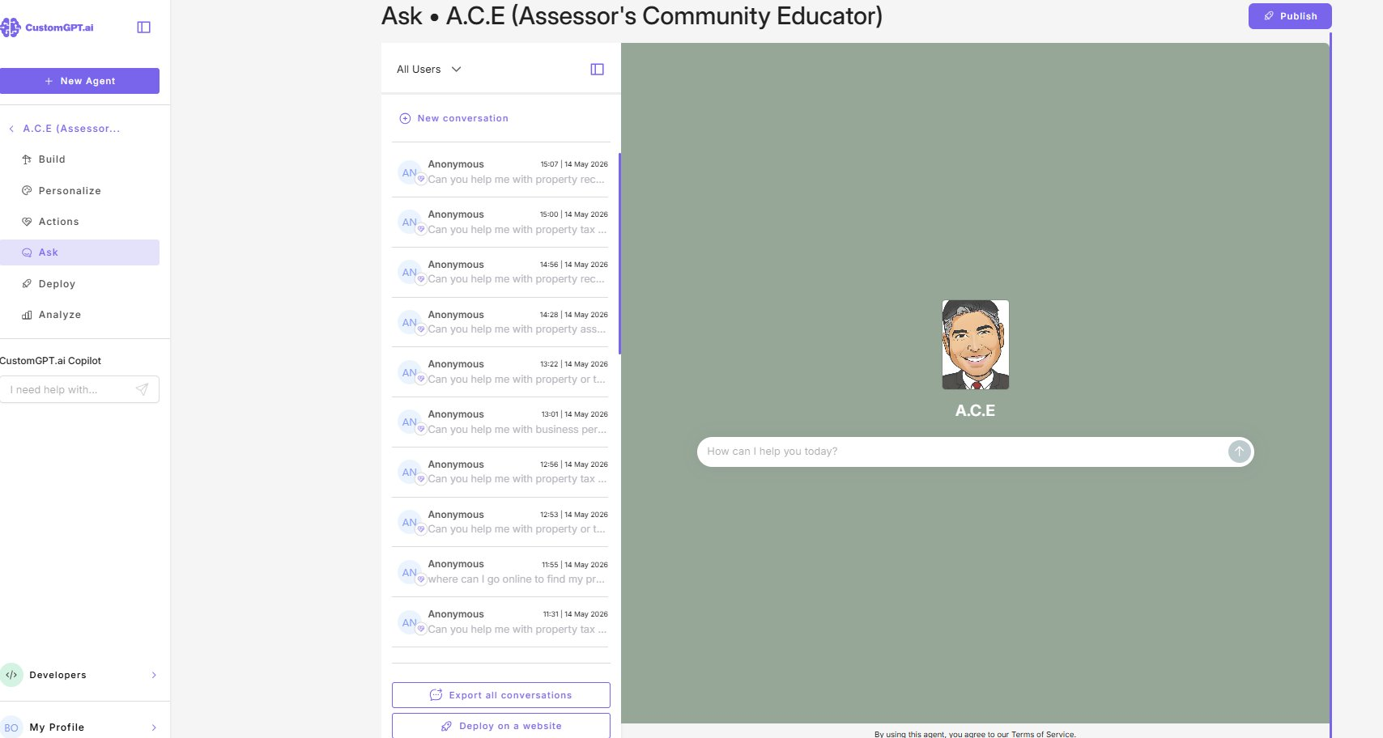
Sample 20 Conversations
Pick 20 conversations from the past 7 days. Skip near-duplicates. Aim for variety.
Tag Each Conversation
• Good — answered correctly.
• Wrong — factually wrong, misleading, or off-policy.
• Empty — declined or returned no useful answer.
Process Wrong Entries
Record question, A.C.E.’s answer, correct answer, and which AIO03 sub-procedure applies (Persona or KB File). Schedule the fix this week.
Process Empty Entries
Check whether the topic is already in Missing Content (Analyze tab). If not, add it.
Run the Spanish Canary
In a New conversation, type one Spanish-language question (example: “¿Cuál es el límite de ingresos para el congelamiento de valor para el año fiscal 2026?”).
Confirm both:
• A.C.E. detects Spanish and responds in Spanish (or offers to continue in Spanish).
• The factual answer is correct ($44,200 for Low-Income Value Freeze TY 2026).
If either fails, this is a persona regression — escalate per AIO05 Type A and fix per AIO03 → Persona Change.
Count Spanish Conversations  On the Customer Intelligence tab, note Spanish % and Spanish count. Record for AIO04 monthly report.  Small sample sizes make weekly percentages volatile. Trend over 4 weeks matters; single-week swings often do not. | 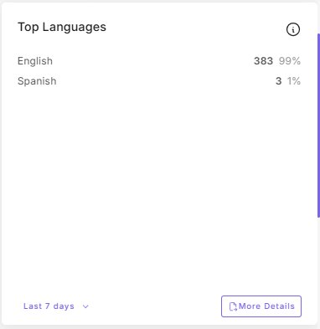
Export Conversations  Click Export all conversations at the bottom. Save to the backup folder with today’s date. | 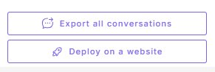

Notify Assessor and Deputy Same-Day If
• Wrong rate exceeds 10% of the sample (2 or more in 20).
• Any conversation contains PII that A.C.E. produced or revealed.
• Spanish canary fails.
• A topic appears repeatedly that A.C.E. consistently mishandles.
• Spanish-language conversations below 3% for 4 consecutive weekly checks.

