Standard Operating Procedure (SOP)
Process Title: Monthly Chatbot Metrics Report | Department: AI Operations
SOP ID: AIO04 | Last Reviewed: 05/15/2026
Effective Date: 05/15/2026 | Version: 2
Purpose
Monthly compilation of A.C.E. metrics for executive reporting and governance documentation. Approximately 30 minutes, first business day of each month, reporting on prior month.

Procedure
Collect Overview Metrics  In CustomGPT.ai, open the A.C.E. agent. Click Analyze → Overview. Record:  • Total queries (last 30 days).  • Total conversations.  • Queries per conversation.  • Found and Not found rates (%). | 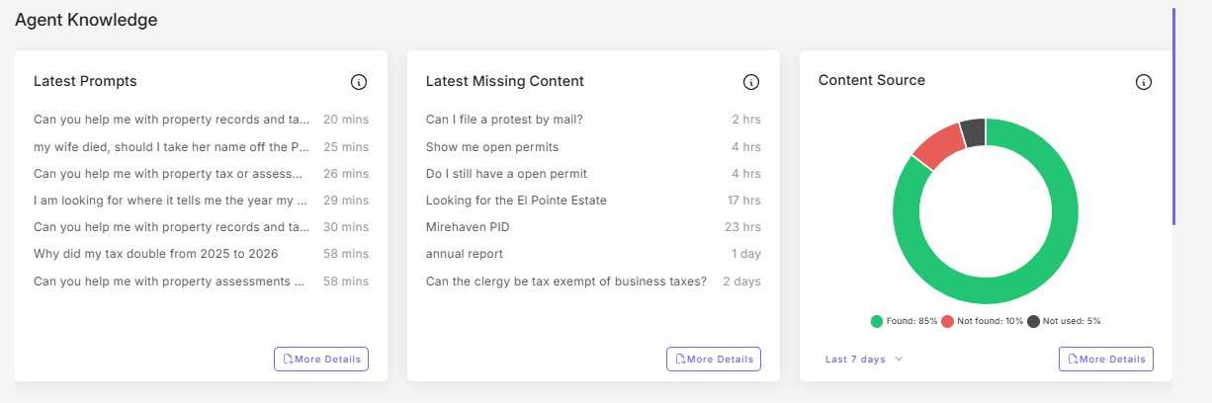
Collect Customer Intelligence Metrics  Click Customer Intelligence tab. Record:  • Persona Failure % (Risk Monitoring).  • Spanish % and Spanish count (Top Languages).  • Top intent category and its %.  • Any non-English language with > 1% share. | 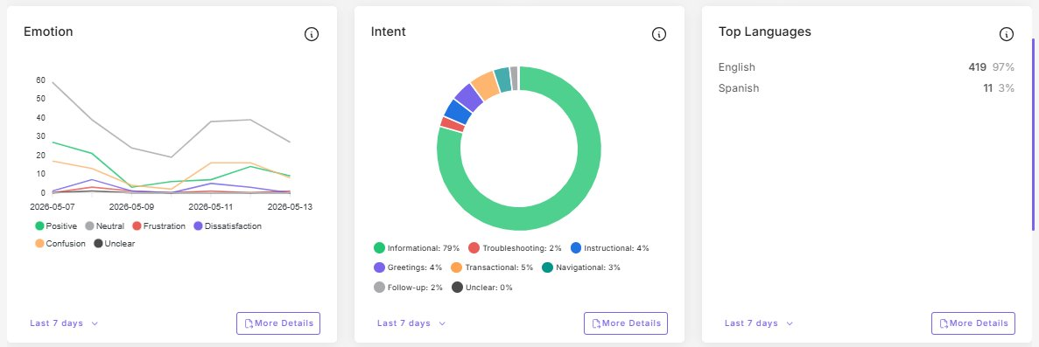
Collect Dashboard Metrics  Click back to Dashboard. Record:  • Query credits used this billing cycle.  • Words processed (note if at plan cap).  • Documents added and documents read (note ratio).  • Top three countries by conversation count. | 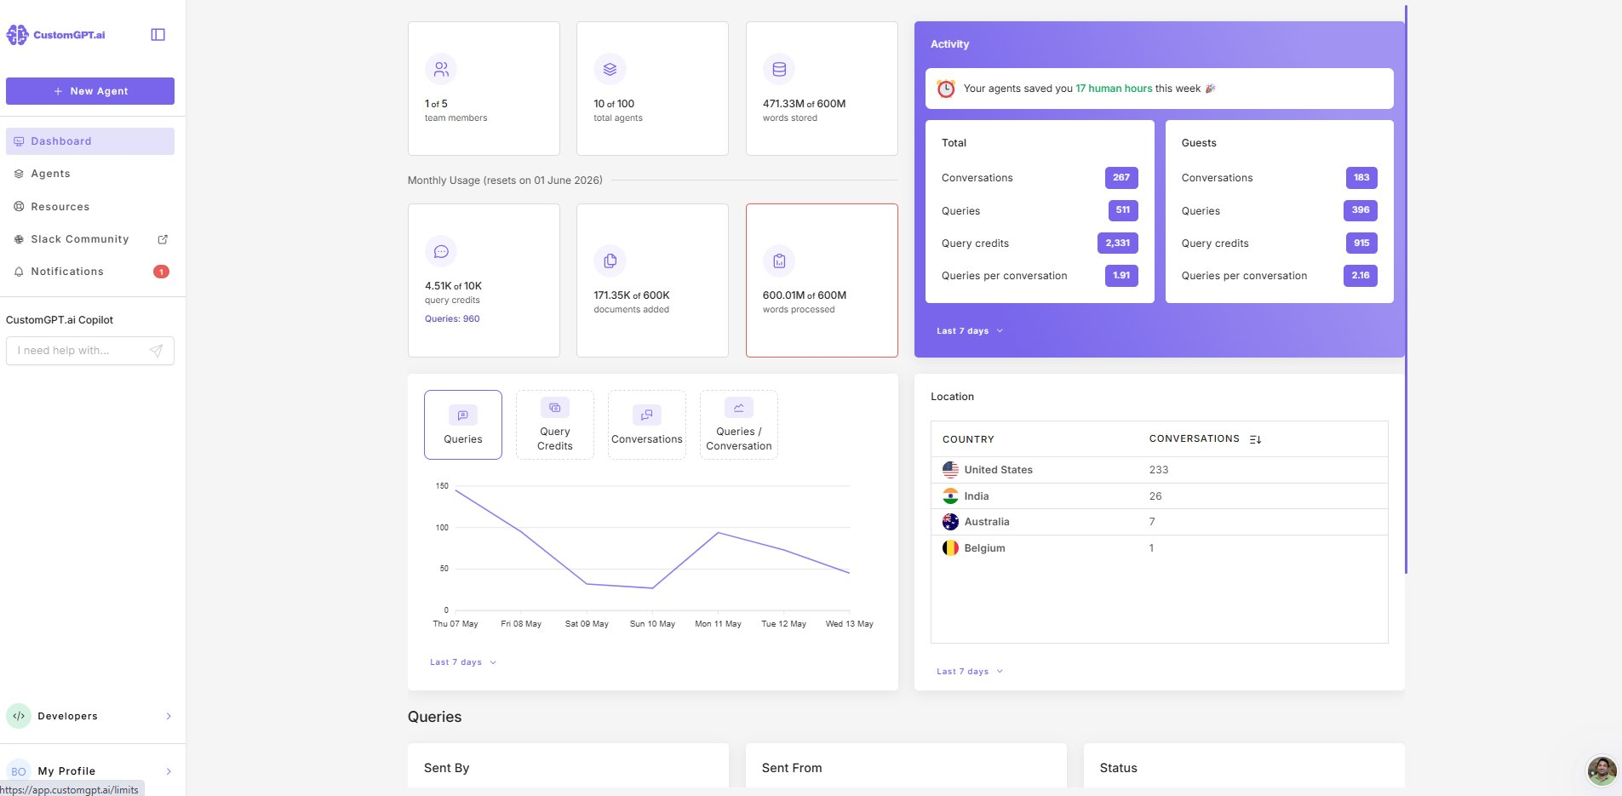
Update the Metrics Tracker
Add a new row dated for the reporting month. Compare against prior month, not prior day. Mark any threshold crossings.
Email Summary
One paragraph to Assessor and Deputy: totals, within/outside expected ranges, any month-over-month threshold breaches with proposed action, link to tracker.

Flag Thresholds
Thresholds apply to the monthly figure only. Daily and weekly snapshots may cross these because of small-sample volatility — that is expected and not a flag.
• Not found > 15% — KB coverage gap.
• Persona Failure > 15% — persona may be drifting.
• Spanish < 3% — bilingual service underutilized. Trend over 2+ months is the signal.
• Success rate < 97% — platform or integration concern.
• Words Processed at plan cap — consider plan adjustment if persistent.
• Single non-US country > 15% of conversations — possible bot traffic or unexpected exposure.

