Process Title: RingCentral Admin Portal Reference | Department: Customer Service
SOP ID: CS02 | Last Reviewed: 05/05/2026
Effective Date: 05/05/2026 | Version: 1

Purpose
This reference document describes how to access the RingCentral Admin Portal, navigate to call queues, and read the queue panel structure. It is cited as a prerequisite by CS03 through CS08 and should not be treated as a stand-alone task SOP.
Scope
Applies to all staff authorized to access the RingCentral Admin Portal: queue administrators, Customer Service Manager(s), Deputy Assessor(s), and IT staff supporting RingCentral configuration.
Definitions
Admin Portal – The web interface at https://service.ringcentral.com used for company-wide RingCentral configuration.
Call Queue – A group of users (members) configured to answer inbound calls routed to a single extension.
DID (Direct Inward Dial) – A direct phone number assigned to an individual user or extension.
Queue Panel – The right-hand configuration area that opens when a queue is selected from the Call Queues list.
Queue Inventory Overview
Primary citizen-facing queues at the Bernalillo County Assessor's Office:
- Assessor's Office (Ext 160001) — Switchboard / first-touch queue. Internally referred to as Q1.
- Assessor Customer Service (Ext 160002) — Overflow / 1st Floor queue. Internally referred to as Q2.
- Assessor Spanish Speakers (Ext 160011) — Spanish-language calls.
- Veteran & Value Freeze Specialty queue for veteran exemption and valuation freeze inquiries.
Additional division-specific queues exist (Business & Personal Property, GIS, LEAP Division, Commercial / Non-Residential, Manufactured Homes, Residential variants, etc.). The current full roster is at Phone System → Groups → Call Queues.
Queue Panel Section Map
Each queue exposes six expandable sections. The SOP that covers each section is shown in parentheses:
- Call Queue Details — identity, status, managers, PIN, SMS recipients (CS07)
- Direct Numbers — assigned phone numbers (CS07)
- Greeting & Hold Music — audio, blocked calls (CS06)
- Call Handling & Members — routing, members, wait settings, custom rules. Tabs: Work hours (CS03 + CS04), Wait settings (CS04), Display settings (CS04), After hours (CS04), Custom rules (CS05)
- Pickup Settings & Members — pickup permissions (CS07)
- Voicemail & Notifications — queue voicemail (CS07)
Related Documents
RingCentral Admin Portal: https://service.ringcentral.com
RingCentral Custom Answering Rules — official setup guide: https://support.ringcentral.com/content/dam/support/us/en/pdf/get-started/v2/RCA_Setting_Up_Custom_Answering_Rules_For_Your_Extension.pdf
RingCentral Call Queue Call Handling — developer documentation: https://developers.ringcentral.com/guide/voice/call-routing/manual/callqueue-answering-rules
CS03 — Queue Member Management
CS04 — Queue Routing and Wait Settings
CS05 — Holiday and Custom Rules
CS06 — Queue Greeting, Hold Music, and Blocked Calls
CS07 — Queue Identity and Administration
CS08 — Custom Inbound Routing Rules on User DIDs
Queue Change Log — RingCentral configuration history (maintained in shared drive)

Accessing the Admin Portal
Navigate to the Admin Portal URL
Open a web browser and go to https://service.ringcentral.com.
Alternatively, search the web for "RingCentral Admin" and select the result for service.ringcentral.com.
Bookmark this URL for repeat access.
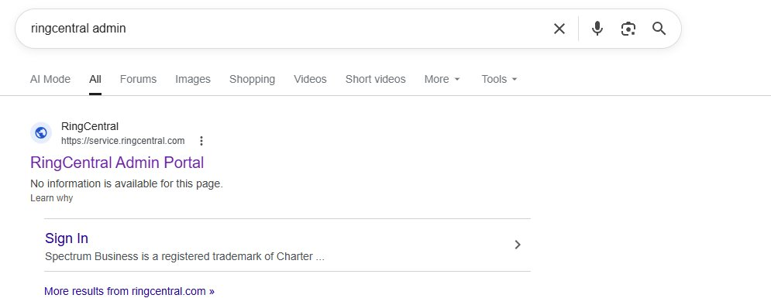
Enter your email address
On the Sign In screen, enter your Bernalillo County email address (firstinitial+lastname@bernco.gov).
Click Next.
Do not use Google, Apple, or Single Sign-On options unless directed by IT.
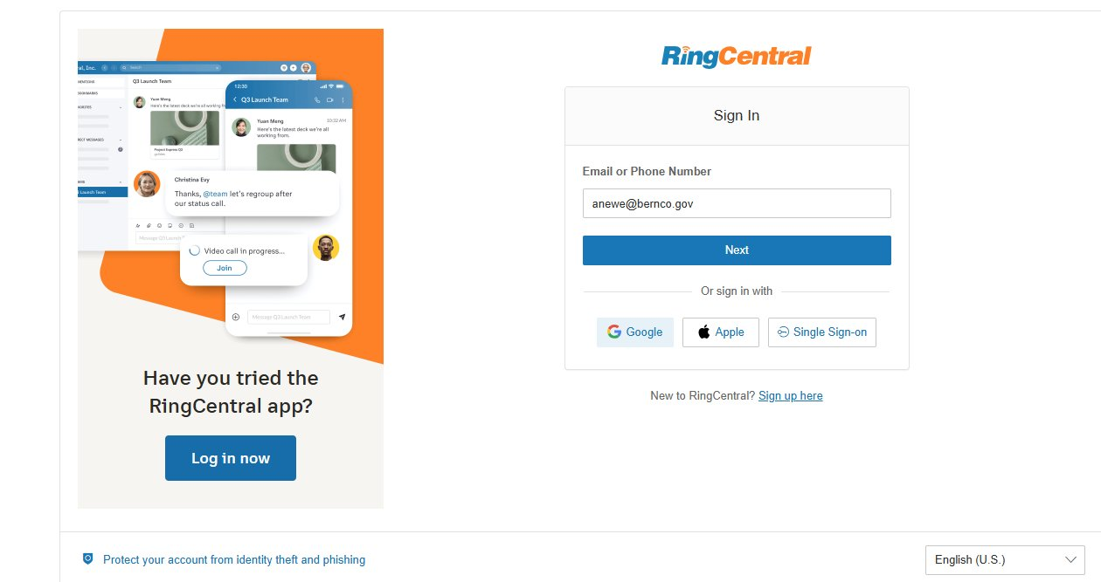
Enter your password
Enter your RingCentral password.
Click Sign In.
If you have forgotten your password, click Forgot Password to receive a reset link to your county email.
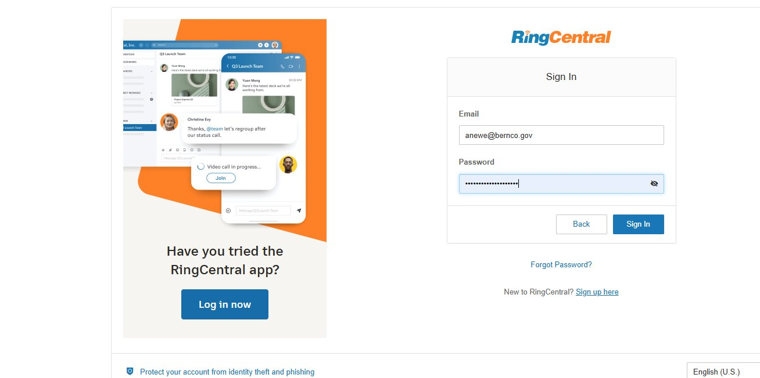
Confirm Admin Portal access
After sign-in you should land on the Admin Portal home page. Verify the upper-right dropdown reads Admin Portal.
Confirm the company name reads Bernalillo County and the address reads 415 Silver Ave SW.
Top navigation: Home, Users, Phone System, Analytics & Logs, Account, More.
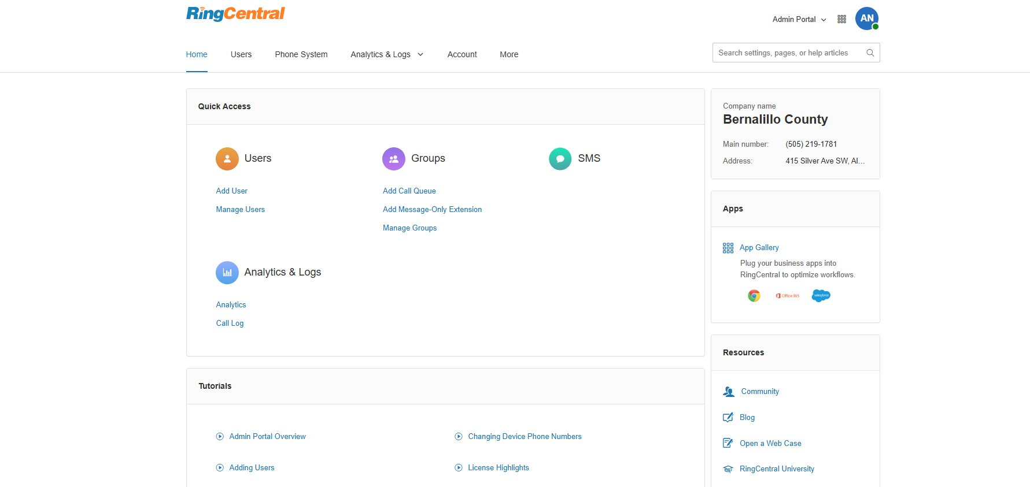

Navigating to a Call Queue
Open the Call Queues list
From the top navigation: Phone System → Groups → Call Queues.
(Alternative: Home page Quick Access → Manage Groups → Call Queues in the left rail.)
The list displays each queue with: Status, Name, Site, assigned Direct Numbers, Extension, Voicemail count (Msg.), Members Availability (online / total), Actions.
Use Search to filter by name or extension (e.g., 160001 for the Assessor's Office switchboard).
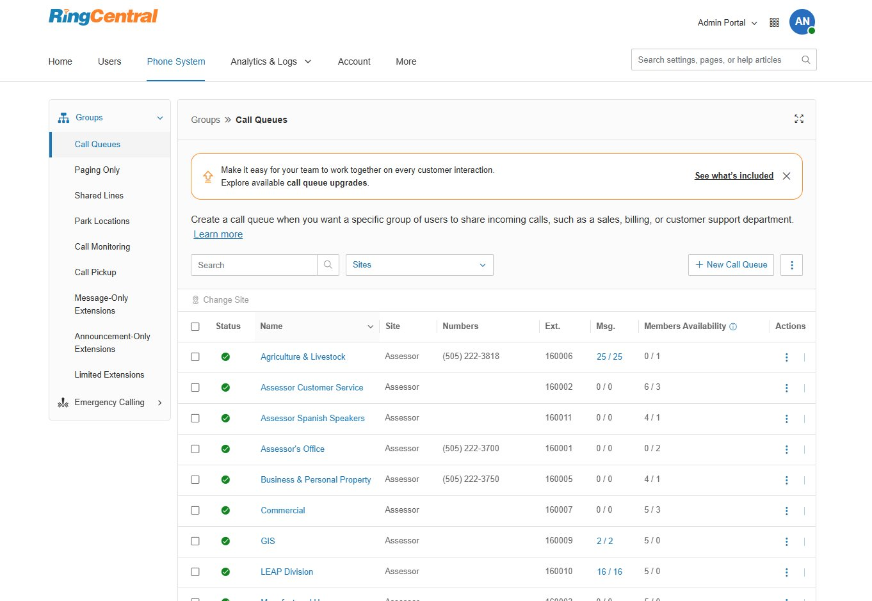
Open a queue
Click the queue name to open its configuration panel on the right.
The panel header shows the queue name and extension (e.g., Assessor's Office (Ext. 160001)).
Six expandable sections are listed. Click any section to expand or collapse it.
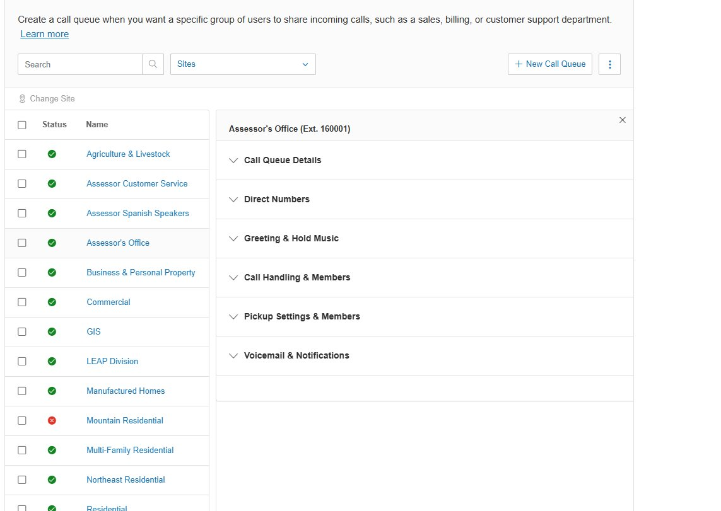

General Change Control Principles
Each task SOP (CS03 through CS08) defines its own authorization tier and procedure-specific verification steps. Common principles that apply across all RingCentral queue changes:
- Snapshot the current state before any change — screenshot or note the values you intend to modify.
- Save in the portal AND verify with a test call or call-log review afterward.
- Log every change in the RingCentral Change Log: date/time, queue, setting, prior value, new value, authorizer, applier, reason, verification result.
- For changes that affect answer rates or routing distribution, monitor the Call Records dashboard for at least one full business day after the change.

