Process Title: Queue Greeting, Hold Music, and Blocked Calls | Department: Customer Service
SOP ID: CS06 | Last Reviewed: 05/05/2026
Effective Date: 05/05/2026 | Version: 1

Purpose
This SOP outlines the standardized process for configuring a queue's welcome greeting, wait messages, hold music, and call blocking rules. These settings shape the caller's audio experience and filter unwanted inbound traffic.
Scope
Applies to settings under the Greeting & Hold Music section of a queue. The section has three tabs: Work hours, After hours, and Blocked calls.
Authorization
Greeting and hold music changes: Deputy Assessor overseeing Customer Service. Blocked-call rule additions: Customer Service Manager (per-number blocks for known nuisance callers); Deputy Assessor for area-code blocks or whitelisting changes that affect routing categories.
Definitions
Welcome greeting – Message played when a caller is added to the queue.
Wait announcement – Message played periodically while the caller waits.
Waiting in queue music – Music played to the caller before any agent answers.
Hold music – Music played when an agent has answered and then placed the caller on hold.
Trusted numbers – Whitelist that bypasses all blocking rules.
Prerequisites
This SOP assumes the operator is signed in to the RingCentral Admin Portal and can navigate to a specific call queue. For sign-in and navigation instructions, see CS02 (RingCentral Admin Portal Reference).
The operator must have appropriate manager access to the queue being modified — see Authorization below.
Related Documents
RingCentral Admin Portal: https://service.ringcentral.com
RingCentral Custom Answering Rules — official setup guide: https://support.ringcentral.com/content/dam/support/us/en/pdf/get-started/v2/RCA_Setting_Up_Custom_Answering_Rules_For_Your_Extension.pdf
RingCentral Call Queue Call Handling — developer documentation: https://developers.ringcentral.com/guide/voice/call-routing/manual/callqueue-answering-rules
CS02 — RingCentral Admin Portal Reference
Queue Change Log — RingCentral configuration history (maintained in shared drive)

Work Hours Tab
Reference: Welcome greeting and wait messages (top of tab)
Settings:
- Welcome greeting — Call queue greeting Enable checkbox; greeting type (Default or Custom); audio player; Edit link
- Wait announcement — message played periodically while caller waits
- Position in queue — premium feature (announces caller's position)
Wait messages play in order: Wait announcement, Position in queue, Estimated wait time, Callback request.
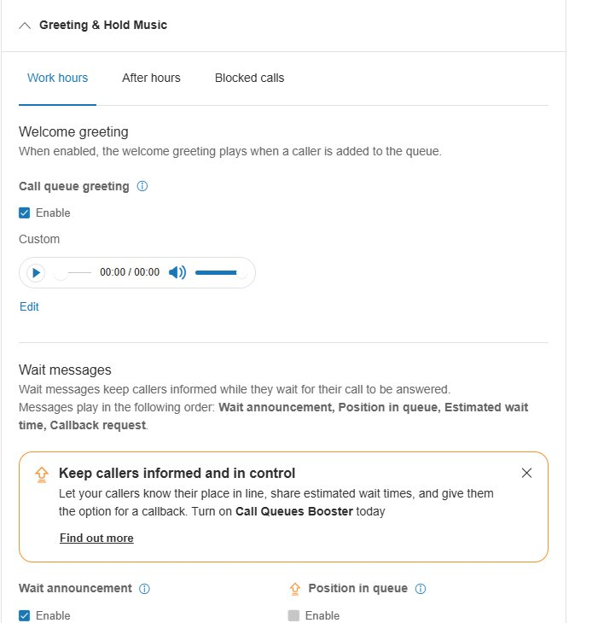
Reference: Timing and music settings (bottom of tab)
Settings:
- Estimated wait time — premium feature
- Callback request — premium feature
- Callers will hear wait messages — When they are added to queue and/or While waiting in queue (with Repeat interval, e.g., Every 15 seconds)
- Waiting in queue music — Enable, music selection (e.g., Acoustic), audio player, Edit
- Hold music — Enable, music selection, audio player, Edit
Note: Waiting in queue music plays before the call is answered; Hold music plays after, when the agent presses hold.
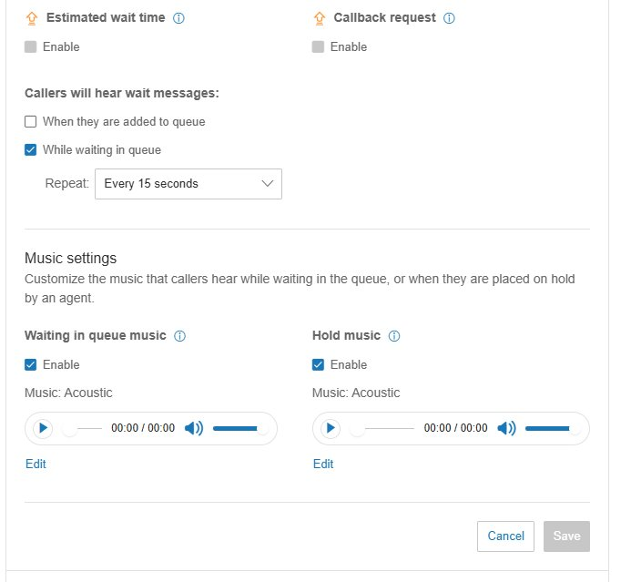
Update the welcome greeting
Click Edit under the Welcome greeting audio player.
Choose to upload a pre-recorded file, record from a phone, or record from a computer microphone.
After saving, play back the greeting to confirm it sounds correct.
Greetings should match the queue's purpose (Spanish-queue greeting in Spanish; switchboard greeting that sets caller expectations).
Configure wait message timing
Choose When they are added to queue (single message on entry), While waiting in queue (periodic, with Repeat interval), or both.
Typical: While waiting in queue with Repeat: Every 15 seconds.
Update music selections
For each music selection (Waiting in queue music, Hold music), click Edit to change.
Choose between RingCentral's bundled tracks (e.g., Acoustic) or upload custom audio.
Click Save.

After Hours Tab
Configures the greeting and wait messages played to callers outside business hours. Typically a brief message stating hours of operation and directing callers to alternative resources (A.C.E. chatbot, website).
Update procedure mirrors Work hours tab: click Edit on the relevant audio element, upload or record, save.

Blocked Calls Tab
The Blocked calls tab handles inbound call filtering. It manages five distinct categories on a single tab.
Reference: Block options (top of tab)
Sections at the top:
- Block option — top-level dropdown (Specific calls and faxes, etc.)
- Only block these numbers or area codes — entry fields plus Add button
- Callers will hear — pre-recorded blocked-call message; audio player and Edit
- Robocalls — informational; handled per account-wide settings
- Trusted numbers — whitelist that bypasses blocking
- Block calls with no caller ID — Block option dropdown
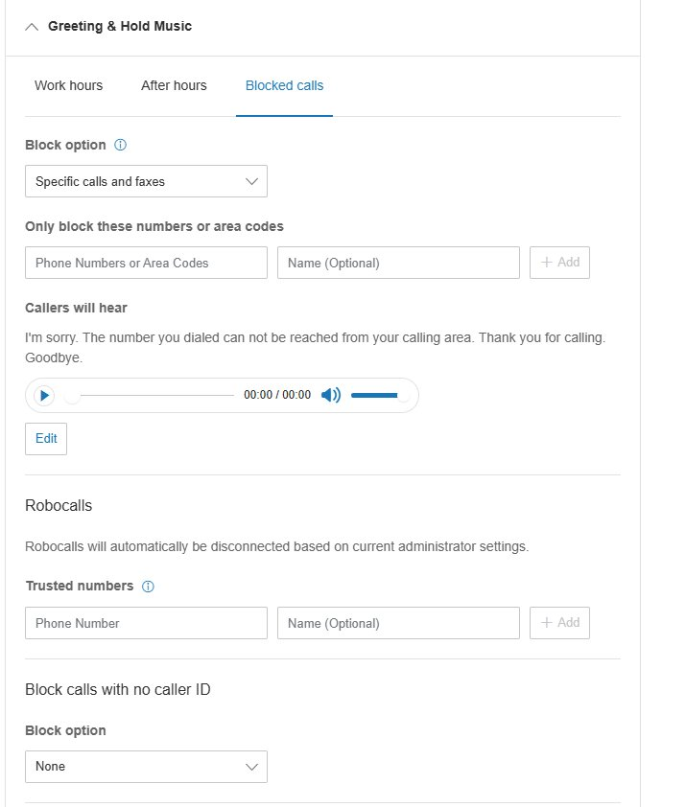
Reference: Block options (bottom of tab)
Sections at the bottom:
- Block calls with no caller ID — continued from above
- Block calls from pay phones — Enable checkbox; pre-recorded payphone-block message; audio player and Edit
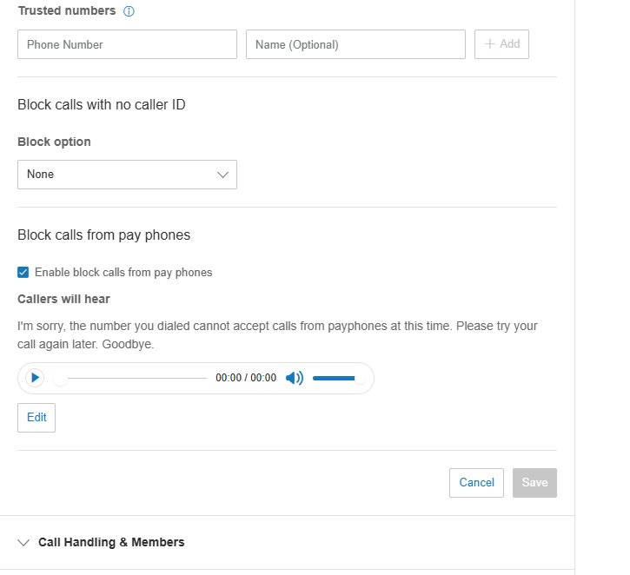
Block a specific number or area code
In Only block these numbers or area codes, enter the full phone number (10 digits) or area code (3 digits).
Optionally enter a Name for documentation.
Click + Add. Click Save.
Add a trusted number (whitelist)
In Trusted numbers, enter the full phone number and optional Name.
Click + Add. Calls from this number bypass all blocking rules.
Use for important callers (county officials, vendors, partners) whose calls must always reach the queue.
Block calls with no caller ID
Set the Block option dropdown to the desired blocking level.
Anonymous calls are common sources of unwanted traffic. Blocking them reduces noise but also blocks legitimate callers with privacy settings — weigh against expected caller demographics.
Block calls from pay phones
Check Enable block calls from pay phones.
Customize the message via Edit if a specific announcement is required.
Verify and save
Click Save.
Test by calling from a non-blocked number to confirm normal traffic still flows. If a number is added to blocking by mistake, callers from that number will hear the blocked-call message rather than reaching staff.

Change Control
All changes covered by this SOP must be authorized, snapshotted, applied, verified, and logged.
Authorization
Welcome greeting, wait messages, and music changes: Deputy Assessor overseeing Customer Service.
Per-number blocked entries (known nuisance callers): Customer Service Manager.
Area-code blocks, no-caller-ID blocking, pay-phone blocking, or whitelist additions affecting routing categories: Deputy Assessor.
Pre-change snapshot
Before making the change, screenshot the relevant settings panel or note the current values in writing. This is the rollback reference if the change must be reversed.
Make the change
Apply the change using the procedure in this SOP. Click Save and verify the new values are reflected.
Post-change verification
Place a test call when possible, or review the first live calls after the change in the call log to confirm expected behavior.
Log the change
Add an entry to the RingCentral Change Log: date and time, queue name and ID, setting changed, prior value, new value, who authorized, who applied, business reason, verification result.

