Process Title: Queue Identity and Administration | Department: Customer Service
SOP ID: CS07 | Last Reviewed: 05/05/2026
Effective Date: 05/05/2026 | Version: 1

Purpose
This SOP outlines the standardized process for managing a queue's identity (name, extension, status, managers, PIN, SMS routing), direct phone numbers, pickup permissions, and voicemail. These settings change rarely and most require Deputy Assessor or Assessor authorization.
Scope
Applies to four queue panel sections: Call Queue Details, Direct Numbers, Pickup Settings & Members, and Voicemail & Notifications.
Authorization
Enabling or disabling a queue, changing manager assignments, or changing direct number assignments: Deputy Assessor or Assessor approval. Changing the Group Name, Call Queue PIN, or SMS recipients: Customer Service Manager with Deputy Assessor confirmation. Voicemail recipient changes: Customer Service Manager.
Definitions
Group Name – The queue's display name in the Call Queues list and in member-side displays.
Call Queue PIN – PIN used for management actions outside the admin portal (e.g., recording a queue greeting from a phone).
SMS Recipients – User(s) who receive texts sent to the queue's number.
Direct Number – A phone number assigned directly to the queue. Callers dial this to reach the queue without going through the company auto-receptionist.
Prerequisites
This SOP assumes the operator is signed in to the RingCentral Admin Portal and can navigate to a specific call queue. For sign-in and navigation instructions, see CS02 (RingCentral Admin Portal Reference).
The operator must have appropriate manager access to the queue being modified — see Authorization below.
Related Documents
RingCentral Admin Portal: https://service.ringcentral.com
RingCentral Custom Answering Rules — official setup guide: https://support.ringcentral.com/content/dam/support/us/en/pdf/get-started/v2/RCA_Setting_Up_Custom_Answering_Rules_For_Your_Extension.pdf
RingCentral Call Queue Call Handling — developer documentation: https://developers.ringcentral.com/guide/voice/call-routing/manual/callqueue-answering-rules
CS02 — RingCentral Admin Portal Reference
CS03 — Queue Member Management
CS04 — Queue Routing and Wait Settings
Queue Change Log — RingCentral configuration history (maintained in shared drive)

Call Queue Details Section
Holds the queue's identity and administration settings. Two sub-tabs: General and Settings.

General Tab
Reference: General sub-tab fields
Fields on the General sub-tab:
- Short Extension Number — abbreviated dialable extension (e.g., 2)
- Full Extension Number — read-only full extension (e.g., 160002)
- Group Name — display name (e.g., Assessor Customer Service)
- Company Name — optional outbound caller ID override
- Managers — counts of Full Access and Member Management users; Edit button
- Call Queue PIN — Change Call Queue PIN button
- Record Group Name — label used in call recordings
- Contact Phone — optional public-facing contact
- Status — Enabled / Disabled toggle
- SMS Recipients — text message recipients
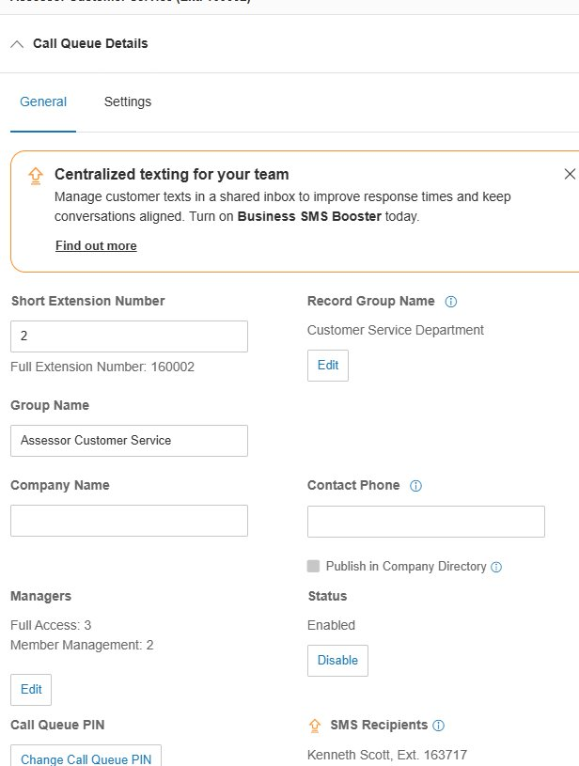
Enable or Disable a queue
To take a queue out of service without deleting it, click Disable next to Status. The queue displays a red X on the Call Queues list and stops accepting calls.
To restore a disabled queue, click Enable. Calls resume routing immediately.
Disabling preserves configuration and member roster — preferred over deletion when there's any chance the queue will be needed again.
Change Group Name
Edit the Group Name field. The change does not affect routing — the extension is unchanged.
Use clear, public-friendly names (e.g., "Assessor Customer Service" rather than "Q2").
Edit Managers
Click Edit next to Managers.
- Full Access — can change all queue settings, member roster, and routing
- Member Management — can add/remove members but cannot change routing or wait settings
Assign Member Management to supervisors who need roster control without ability to alter routing.
Change Call Queue PIN
Click Change Call Queue PIN to update.
Document the PIN in a secure location accessible only to authorized administrators.
Configure SMS Recipients
Configure the user(s) who receive texts sent to the queue's number.
Verify at least one recipient is active and currently employed before relying on SMS routing.

Settings Tab
Holds advanced queue-level settings (number formatting, regional preferences). Modify only when explicitly required by a configuration change request. Contact the RingCentral administrator group before changing fields you do not recognize.

Direct Numbers Section
Lists the phone numbers assigned directly to this queue.
Reference: Direct Numbers table
The table shows each assigned number:
- Number — phone number in (xxx) xxx-xxxx format (e.g., (505) 222-3700 for Assessor's Office)
- Number Type — Call Queue, Auto-Receptionist, etc.
- Name — optional label
A queue can have one or more direct numbers, or none.
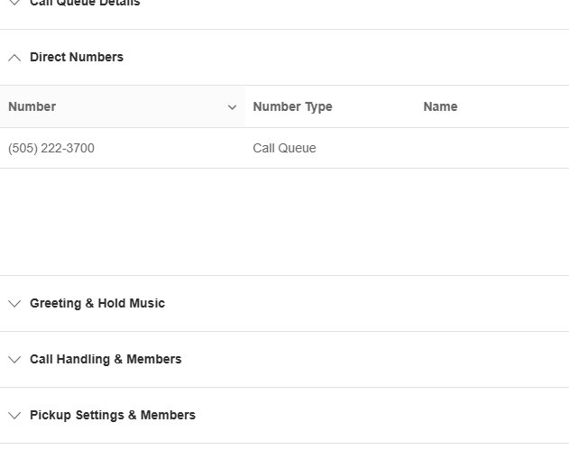
Add or remove direct numbers
Direct number assignment is typically performed at the account-wide phone number inventory (Account → Phone Numbers), not from this section.
Changes to the public-facing number a queue rings on are structural and require Deputy Assessor or Assessor approval.
Verify assigned numbers here when investigating a routing issue — if a number is reassigned to a different queue or extension, callers dialing the old number reach the new destination.

Pickup Settings & Members Section
Configures call pickup permissions — which other users can pick up a ringing call from this queue using the call pickup feature. Useful when members sit in proximity and want to grab each other's incoming calls.
Modify only when explicitly required by a workflow change. The default configuration matches RingCentral's account-wide pickup behavior.

Voicemail & Notifications Section
Configures the queue's voicemail greeting and who is notified when voicemails arrive. Voicemails left at this queue's mailbox are tracked in the Msg. column on the Call Queues list.
Common settings:
- Voicemail greeting (default or custom recording)
- Email notifications to specified recipients when a voicemail is received
- Voicemail-to-text transcription (account-dependent)
Verify at least one active recipient is listed for voicemail email notifications. Without a recipient, voicemails accumulate without alerting any staff member.

Change Control
All changes covered by this SOP must be authorized, snapshotted, applied, verified, and logged.
Authorization
Enabling or disabling a queue: Deputy Assessor or Assessor.
Changing manager assignments or direct number assignments: Deputy Assessor or Assessor.
Changing Group Name, Call Queue PIN, or SMS recipients: Customer Service Manager with Deputy Assessor confirmation.
Voicemail recipient changes: Customer Service Manager.
Pre-change snapshot
Before making the change, screenshot the relevant settings panel or note the current values in writing. This is the rollback reference if the change must be reversed.
Make the change
Apply the change using the procedure in this SOP. Click Save and verify the new values are reflected.
Post-change verification
Place a test call when possible, or review the first live calls after the change in the call log to confirm expected behavior.
Log the change
Add an entry to the RingCentral Change Log: date and time, queue name and ID, setting changed, prior value, new value, who authorized, who applied, business reason, verification result.

