Samenvatting Relational Databases & Datawarehousing

Gilles De Praeter

Contents

1. SQL Reviewed 3

2. SQL Advanced 7

3. Window Functions 7

4. Database Programming 7

5. Indexes and performance 7

6. Basics of Transaction Management 7

7. Datawarehousing & Business Intelligence 7

# SQL Reviewed

* SQL definition:
  + Relational data language for relational database systems.
  + Nonprocedural language
* Data Definition Language (DDL)
  + creation of a database, defining database objects (tables, stored procedures, views,…)
  + CREATE, ALTER, DROP
* Data Manipulation Language (DML)
  + Querying and manipulating data in a database
  + SELECT, INSERT, UPDATE, DELETE
* Data Control Language (DCL)
  + Data security and authorisation
  + GRANT, REVOKE, DENY

* + SELECT clause specifies the columns to show in the ouput.
    - DISTINCT filters out duplicate lines.
    - The AS keyword allows you to give a column a new title
    - Functies:
      * String functions: left, right, len, ltrim, rtrim, substring, replace, ...

* + - * DateTime functions: DateAdd, DateDiff, DatePart, Day, Month, Year
        + GETDATE(): returns current date and time in DATETIME format specified by MS-SQL Server.

* + - * Arithmetic functions: round, floor, ceiling, cos, sin, ...

* + - * Aggregate functions: AVG, SUM, ...
      * ISNULL: replaces NULL values with specified value
      * Explicit conversions
        + CAST (<value expression> AS <data type>)
        + CONVERT (<data type, <expression> [, <style>])



* + - * + FORMAT

* + - Transact-SQL dialect:
      * STDEV: standard deviation of column values
      * VAR: variance of column values
      * TOP:

* + FROM clause: table name
  + WHERE clause: filter condition on individual lines in the output
    - Numeric values: ... WHERE categoryID = 1
    - Alphanumeric values: ... WHERE productName = 'Chai'
    - Dates: ... WHERE orderDate = '4/15/2018' (15th april 2018)
    - Wildcard symbols:
      * % -> arbitrary sequence of 0, 1 or more characters
      * _ -> 1 character
      * [ ] -> 1 character in a specified range
      * [^] -> every character not in the specified range

* + - Logical operators:
      * OR, AND, NOT (ascending priority)
    - Values in an interval:
      * BETWEEN, NOT BETWEEN
    - List of values:
      * IN, NOT IN
    - Test for unknow (or empty) values:
      * IS NULL, IS NOT NULL
  + GROUP BY: grouping of data
    - Statistical functions:
      * Since a statistical function returns only 1 result, either all expressions in the SELECT clause have to contain a statistical function, or none!
      * SUM(expression): sum
      * AVG(expression): average
      * MIN(expression): minimum
      * MAX(expression): maximum
      * COUNT(*|[DISTINCT] column name): count
        + COUNT(*) – counts the number of rows in a SELECT
        + COUNT (column name) – counts the number of not empty fields in a column
        + COUNT(DISTINCT column name) -count the number of different NOT NULL values in a column
  + HAVING clause: filter condition on groups
  + ORDER BY clause: sorting
    - Sorting according to one or more sorting criteria
    - Each sorting criterion can be specified by either a column name, an expression or a sequence number that corresponds to the order of columns in the SELECT clause (starting from 1)
    - Sorting criteria are evaluated left to right
    - Default sort occurs in ascending order (ASC: default), if descending order is required specify DESC after the criterion
* Case expression:

* JOIN:
  + Specifies which tables must be joined and how
  + Produces 1 result set, joining the rows of both tables
  + Inner join:
    - Joins rows from one table with rows from another table based on common criteria in the corresponding tables.

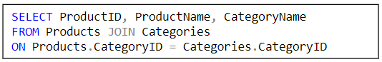

* + Outer join:
    - Returns all records from 1 table, even if there is no corresponding record in the other table
    - LEFT OUTER JOIN
      * Returns all rows of the first table in the FROM clause(SQL-92)

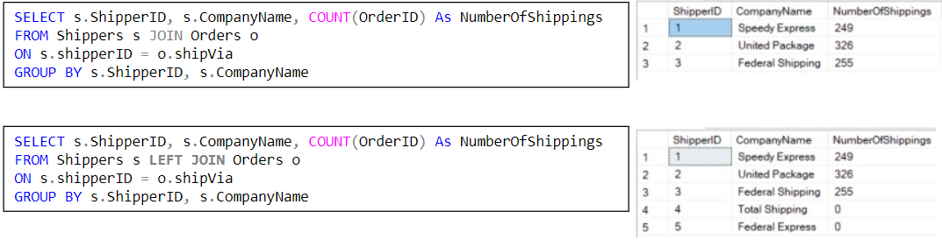

* + - RIGHT OUTER JOIN
      * Returns all rows of the second table in the FROM clause(SQL-92)
    - FULL OUTER JOIN
      * Returns all rows of the first and the second table in the FROM clause(SQL-92) even if there is no corresponding record in the other table
  + Cross join:
    - In a cross join the number of rows in the result set equals the number of rows in the first table multiplied by the number of rows in the second table
    - Application: Generate all combinations
    - Example: Make a schedule in which each employee should contact each customer

* UNION:
  + A UNION combines the result of 2 or more queries
  + Basic form:

* + Rules
    - Both SELECTs must contain an equal number of columns
    - Corresponding columns from both SELECTs should have compatible data types
    - The columns names or aliases from the first SELECT or shown
    - The result set does not contain duplicates. To keep duplicates, use UNION ALL
    - At the end an ORDER BY can be added. Column names or expressions can't be used in the ORDER BY if they differ between the two SELECTs. In this case use column numbers for sorting.
* EXCEPT:
  + The EXCEPT operator subtracts a result set from another result set.

# Indexes and performance

* A
  + a

# Basics of Transaction Management

* A
  + a

# Datawarehousing & Business Intelligence

* A
  + a