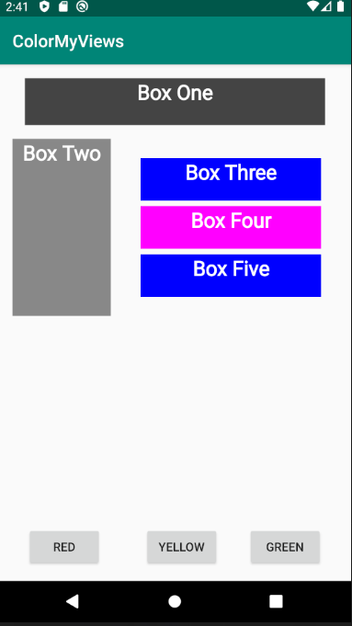

By default, all the boxes’ color are set to white. When the user clicks on a box it changes color. Each box is set to turn into a specific color.

When user clicks on the Red button, Box 3 turns Red.

When user clicks on the Yellow button, Box 4 turns Yellow.

When user clicks on the Yellow button, Box 5 turns Green.