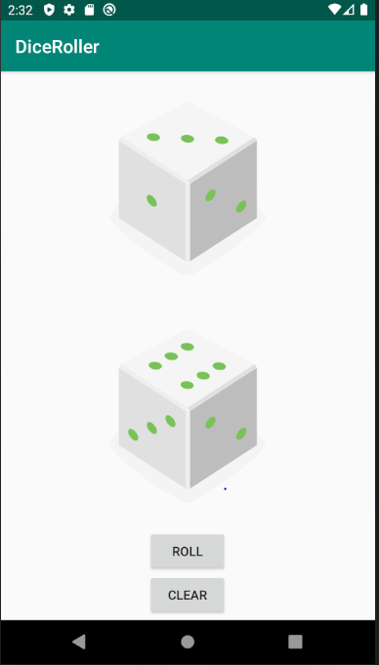

Roll Button: When a user clicks on the roll button, both the dice randomly roll between the numbers one to six

Clear: When a user clicks on the clear button, the dice disappears.

