ever

**MINUTES**

**Meeting Minutes Template**

**School PTA Minutes**

May 14, 2011

The meeting was called to order by Terry Adams at 7:00 p.m.

**In attendance**

[Attendees List]

**Approval of Minutes**

The minutes were read from the [month] meeting and approved.

**Board**

The Board, new principal, and guests were introduced in this meeting. Kim Abercrombie was nominated as the new Secretary. A motion to elect John was made by Michael Wang and seconded by David Jaffe. John Abercrombie was confirmed as the new Secretary.

**Advisory Committee**

There are a number of parent openings on the Advisory Committee. These openings were listed in the most recent newsletter. Three parents showed an interest in serving on the committee. Mark Bell will follow up with those parents and do some supplementary recruiting to fill these openings.

**Budget**

The budget for the current school year was distributed by Richard Miller, PTA Treasurer, and reviewed by the board and PTA members at the last meeting. In tonight’s meeting, Steve Watson made a motion to approve the budget which was seconded by Harry Anderson. All presents voted in favor of approving the budget as presented.

**Principal’s Report**

Principal Samuel Pattison presented his report.

**New Business**

* Recap of Back to School night – May 9
* Parent Education Programs – Counselors
* Teacher Grants Application Process – [School Name]

**Committee Reports**

* Membership
* Volunteers
* Newsletter
* Computer Support

**Announcements**

**Next Meeting**

October 14, 2011, at 7:00 p.m., school cafeteria

Motion to adjourn was made at 9:00 p.m. and was passed unanimously.

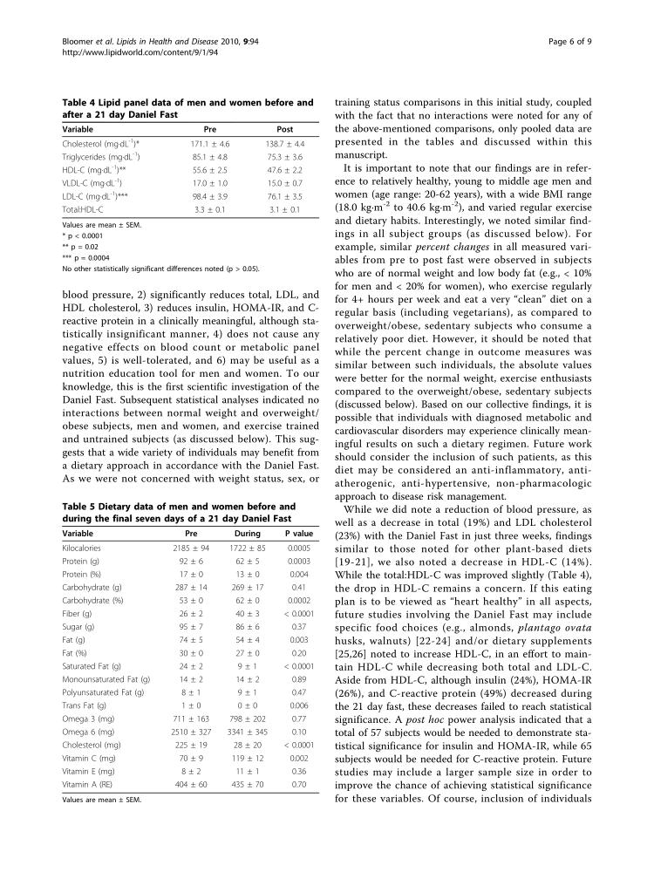

Simple uniform table

|  |  |
| --- | --- |
| Header Col 1 | Header Col 2 |
| Lorem ipsum | [A link example](https://tabul.com/) |

Nested Table

|  |  |  |
| --- | --- | --- |
| a | >b< | c |
| d | |  |  | | --- | --- | | e | f | | g&t | h | | i |
| j | k | l |

Table with merged cells

|  |  |  |
| --- | --- | --- |
| a | b | |
| c | d |
| e | |

**Budget**

The budget for the current school year was distributed by Richard Miller, PTA Treasurer, and reviewed by the board and PTA members at the last meeting. In tonight’s meeting, Steve Watson made a motion to approve the budget which was seconded by Harry Anderson. All presents voted in favor of approving the budget as presented.

**Principal’s Report**

Principal Samuel Pattison presented his report.

**New Business**

* Recap of Back to School night – May 9
* Parent Education Programs – Counselors
* Teacher Grants Application Process – [School Name]

**Committee Reports**

* Membership
* Volunteers
* Newsletter
* Computer Support