**PF2233 - IT Application Project Proposal (IT204F) Group 5**

**Members: Jasper, Justin, Jia Yang and Andy**

**Beauty industry**

In some cases, there isn’t enough information used, or the product details are structured unappealing in the distributors’ listings. This leads to inconsistent messaging which can confuse online shoppers, dilute their experience with the brand, and impact the brand’s reputation. There’s also the high possibility that shoppers will doubt the genuineness of the products these distribution partners are selling. With skincare, haircare, and cosmetics, consumers are looking for safe, reliable products. If product listings online don’t convey this, then brands are losing sales to competition with better-looking and more interactive displays and details.

**Problem Statement**

In the beauty industry, sellers tend to use perfect models to make products appealing to sell them and cause customers to spend a lot of time trying them on. This may cause confusion to customers and damage brand reputation. Therefore, by coding a software that is able to show how the product actually looks like, the software will allow customers to see what they are buying and receiving.

**What we are making**

We are going to be coding an interactive, personalised virtual makeup software where the customer would be able to change their character to look like them for example, their skin colour, the shape of their eyebrow, eyes, mouth and even hair. Now that their character looks like them, they will be able to apply different makeup like eyeliner, mascara, eyebrows, blush, lipstick, eyeshadow all with different varieties. These makeups are makeups that are being sold by the company allowing them to confidently order it online or walk into a stall to purchase it without trying it on.

With a virtual makeup software, it will allow their friends to share the products each of them own without needing each of them to purchase one that they might regret later. This allows people to save their money, time and effort. With the different types of hair, lipstick, eyebrow colour and many more, it can help customers find out the makeup that best fits them.

In addition, it also allows companies to gain a competitive edge over their competitors as it is able to reach customers that are busy with their life and just want to walk into a store and purchase their makeup or even delivery online. This way, companies using this software are able to build trust with customers.

Our 4 business needs are

1. **It is time consuming to try on beauty products in physical stores.**
2. **Virtual makeup eliminates the element of surprise and the possibility of customer dissatisfaction once the product is delivered.**
3. **Helping customers to find the beauty product that looks best on them without them spending so much.**
4. **Allow customers to try out new products without fear.**

**Business needs: It is time consuming to try on beauty products in physical stores.**

When one wants to try on beauty products, they would have to travel to the nearest makeup store. The main one in SIngapore is Sephora, and they only have 11 outlets. This means that it is not convenient for most Singaporeans. They would have to spend an average time of 20-30 minutes to travel there. Not only that, they would have to look for make up there to find the one they are interested in and spend another 30 minutes or more to apply the makeup. If the customer is unhappy with the product on their face, she or he would have to remove it and try on another makeup which wastes another 5 minutes of the customer's time. If one is unlucky and the store is packed, he or she would have to queue up to try the makeup, this may discourage them to try on the makeup and just purchase the makeup without trying. When tried at home, the makeup is not to their liking as it does not suit their face causing the customer to be unhappy with the store’s products which is something all businesses want to avoid.

Our digital innovation: Virtual makeup software

However, with our virtual makeup software, customers can try on makeup at any time and anywhere. This will save the customer time and hassle as they do not need to spend 30 minutes or more to apply the makeup, now they can just spend 3 minutes to fully try on makeup. 10 times less than the normal way. With one click the makeup applied can be changed to another colour or design. The customer would not have to remove the make up and try it again. This will also prevent wastage of makeup which is valuable.

The customer will not have to worry about queues or if the product is available as they can just purchase it online. This software that we are building will definitely save people time from going all the way down to the store to try on the beauty products. This software will also save the workers time from helping the customer to apply makeup, the worker can now help out on other aspects of the store or the store can hire lesser workers and lower the price of their products. Making customers happy as they can now save both time and money at once.

**Business needs: Virtual makeup eliminates the element of surprise and the possibility of customer dissatisfaction once the product is delivered.**

When some people see a commercial on television, they will want the product very quickly but they might not want to go out to make-up stores and try the make-up. This may be because they are lazy, they are not well enough to physically go to the store or they don’t know how to go to the store. If they can’t go to the store, they will not be able to try the make-up themselves unless their neighbour has the make-up that they want. This will cause them to give up on buying the product.

Then they will want to buy the product online but they might also give up on buying the product because they don’t know how they will look with the make-up, such as the shade of red of the lipstick.

**Digital innovation:**

With the help of a digital software like a game, customers will be able to try on the product that they want in the comfort of their own home. This way, they will not have to go out to the physical store to try the make-up. They can just try the make-up at home. The game could have a virtual version of the make-up and copy the exact look, colour and effect of the make-up. This way, people will know how their face will look after they use the make-up. The app will also have other types of make-up like lipstick and lipstick remover. Then they can safely decide which make-up they want.

**Business needs: Helping customers to find the beauty product that looks best on them without them spending so much.**

When one sees an influencer wear a certain beauty product and see that it looks good on them, there is a high chance that there may be an influence. Being influenced can make people buy that certain beauty product. However, a beauty product can improve the looks of one because of the different features of one's face. Hence, some beauty products that may look good on influencers may not look good on them. Having to buy the product and not satisfying the needs of the buyer, would result in them trying on more different products which can lead them to spend more. With upcoming inflation and increased cost of living, many would have to keep a certain budget for beauty products as money has to be used for other necessities. If there were a situation where one buys many products and ultimately did not satisfy the customer, they would lose their customers' loyalty. It is important for business to satisfy the needs of customer. This is because the business would be able to retain customers while attracting new customers, allowing the business to generate more revenue and also bloom.

**Digital innovation:**

With the help of the digital software, customers would be able to try on different beauty products. The customer would be able to change their character to look like them for example, their skin colour, the shape of their eyebrow, eyes, mouth, and even hair. Having the character that looks like them, they will be able to apply different makeup like eyeliner, mascara, enhanced eyebrows, foundation, concealer, contouring gel, blush, powder, lip-liner, lipstick all with different varieties. This would allow them to reduce the cost for trying the products.

With this feature, customers would be able to spend their money wisely. Also, this can reduce the expenses of the beauty business as they can reduce their expenses on samples. Ultimately, this feature can meet the customers needs and save more of their money. Customers will be able to save travelling cost to the beauty outlet, which allows them to spend more money on necessities.

**Business needs: Allow customers to try out new products without fear.**

As customers are buying beauty products, they might want to try out new products to see if it fits them better, or if it is more affordable. But they might pull back due to a few reasons such as allergy, or product might not fit product description and/or image. Samples in store may fit customers but could be pressuring them to purchase it and customers may find it to be not as appealing as they thought afterwards. This may cause customers to turn away from trying new products and businesses might lose potential customers.

Digital innovation: Therefore, by using technology, this will allow customers to consider before purchasing and not regret later. This also allows customers to explore more possibilities that may not be available in certain stores. It will also allow customers to visit stores whenever it’s convenient for them and allow them to look at products they normally wouldn’t try due to lack of samples. Customers won’t need to worry about too much for allergy as the product is tested virtually and be more open to testing new products and buying them.

**Method**

**The business needs that have to be solved**

1. **It is time consuming to try on beauty products in physical stores.**
2. **Virtual makeup eliminates the element of surprise and the possibility of customer dissatisfaction once the product is delivered.**
3. **Helping customers to find the beauty product that looks best on them without them spending so much.**
4. **Allow customers to try out new products without fear**

Our method is to create a digital model that allows individuals to modify it. This way individuals will be able to make the model to try and make them look as realistic as possible. The face feature that individuals can change is the size of eye, face, type of hair and even more. Then, they will be able to try on different type of makeup such as mascara, eyeliner, blush and more. This comes with a different variety of colours. Having this digital model, individuals will be able to save time, travelling, waiting for workers to help apply makeup and potential long queues when purchasing goods. Moreover, having this digital model that looks as realistic as the actual product, customers do not have to worry that the product that seems amazing on the website turns out as not they wanted. It allows the customers to know which makeup they prefer and overall allowing customer satisfaction. This would eliminate the element of surprise and the possibility of customer dissatisfaction once the product is delivered. Furthermore, the digital model is online thus, customers do not need to spend so much money to see which suits them more. Since it is online, customers will be able to try on the different makeup based on their preference. At the same time, customers will be able to see the total cost of the makeups used on their screen. This can help them see how much they will be spending and reduce the amount of makeup products based on their budget. Travelling cost can also be reduced as it is online and it can be done anytime,anywhere. Lastly, it is online, thus, customers can also try on the new products that they haven used without fear. This is because they do not have to waste time removing applying the makeup if it looks horrible on them. Some may fear that the makeup artist would judge them. Thus, having it to have a digital model, it allows customers to try out new products without fear.

**Result**



This is the start page of the product. Where it directs the user to the tutorials page.

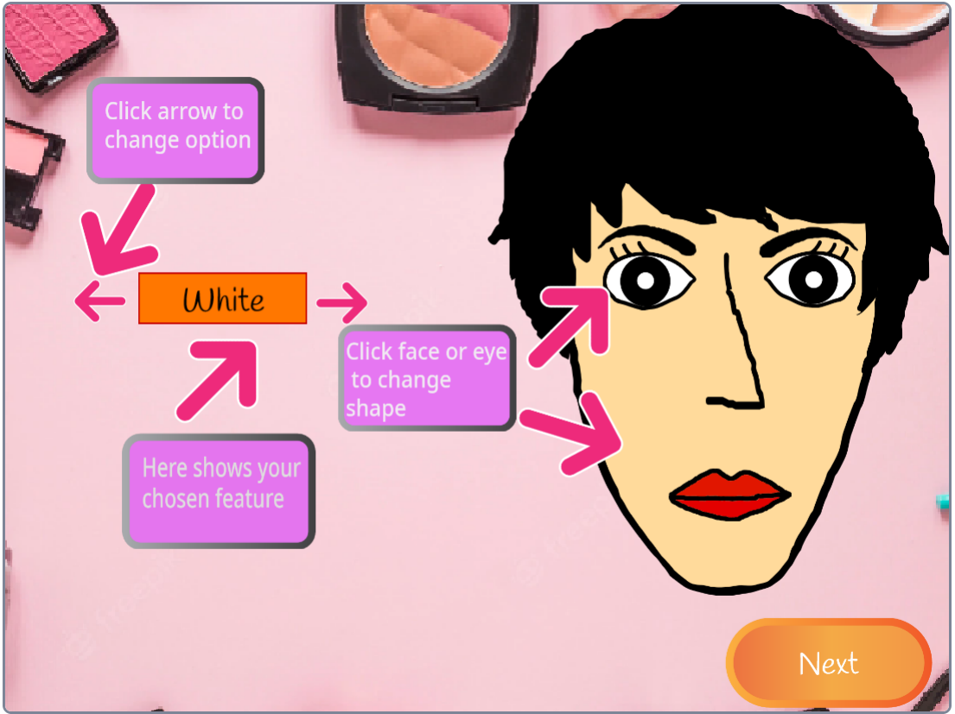

This is the tutorials page, where it explains how to customise the character and how to apply the makeup. This then leads the user to the character page.

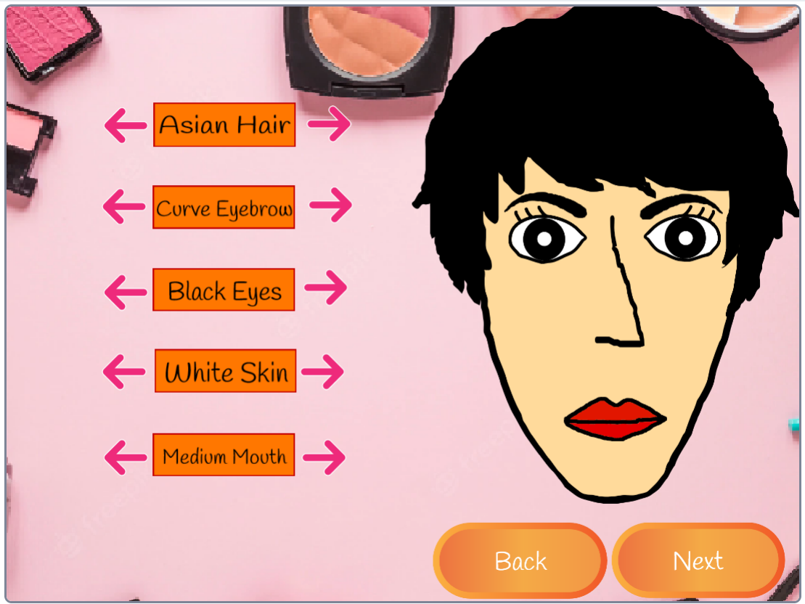

This is the characters page, where users are able to customise the character by clicking on the arrows, which will change the looks of the face on the right. Users are also able to click on the face to change the characteristics of them, such as small eyes and different face size. By clicking on the back button, will allow the user to go back to the tutorials page, while clicking on the next button, it will bring users to the makeup page.

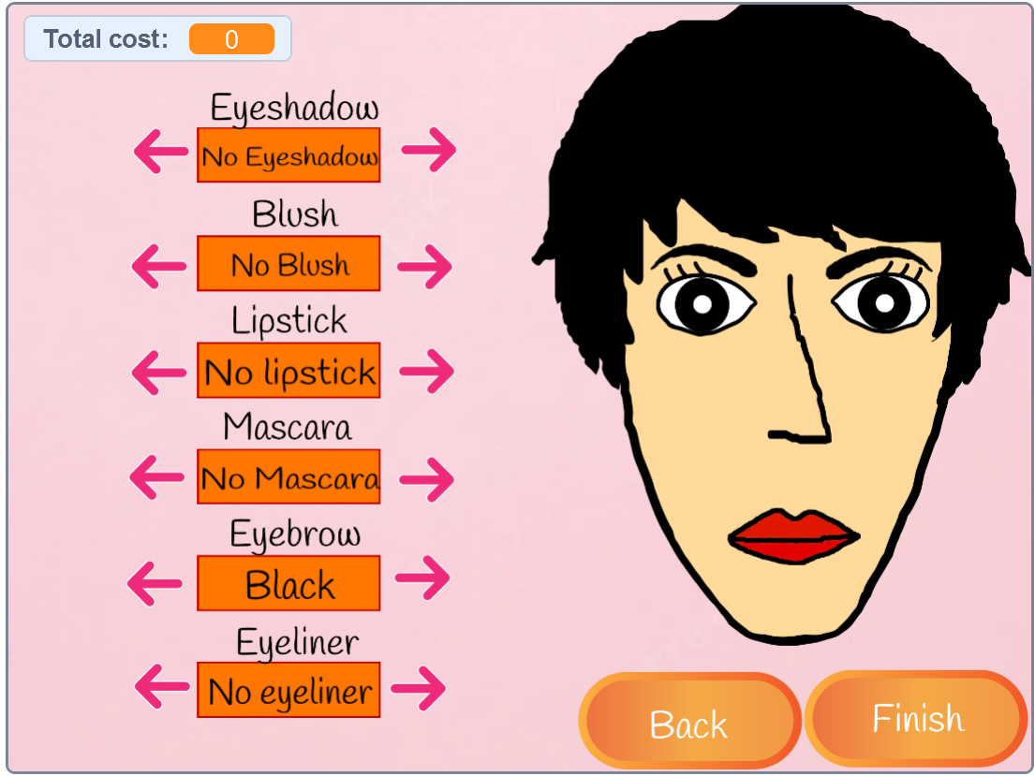

This is the makeup page, where users are able to put on makeup on a virtual face. They are able to choose the colour of eyeshadow, blush, lipstick, eyebrow and/or eyeliner, as well as decide if they prefer to have mascara. As users are browsing through the makeup, it also calculates and displays the total cost at the top left, which will inform users on how much it will cost them if they buy the makeup. There is also a back button which will allow them to go back to the characters page, they also have a finish button to bring them to the final product page.

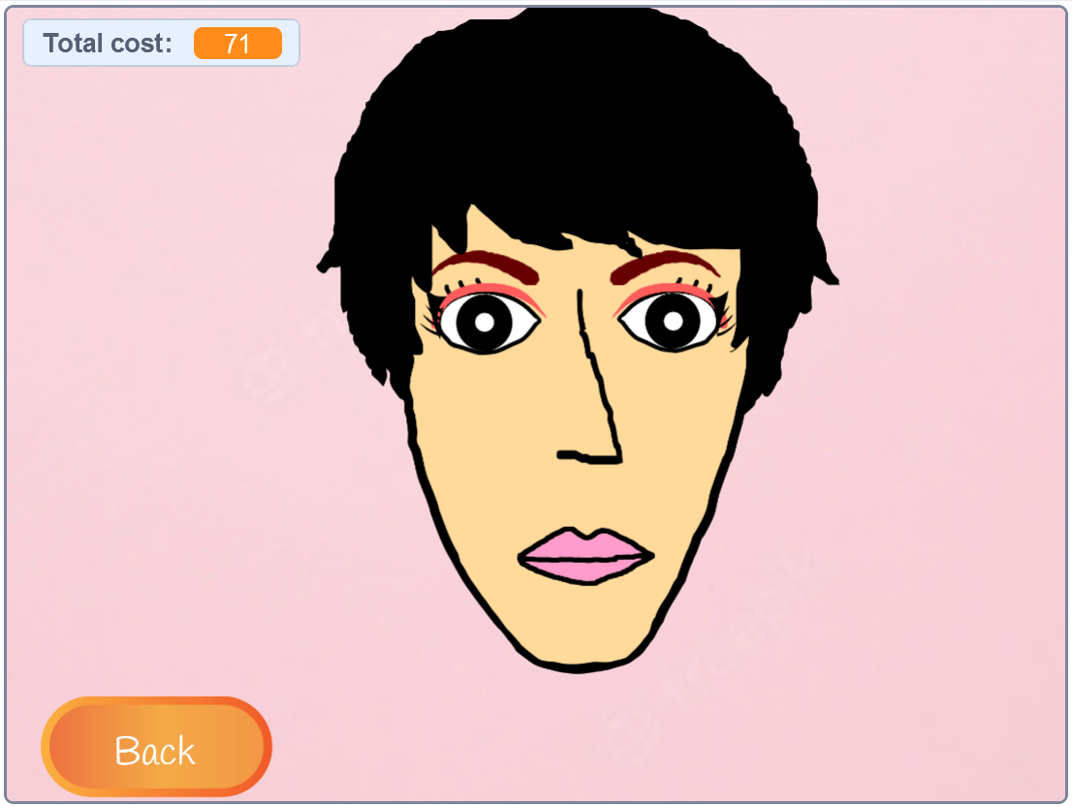

This is the final product page, where it shows the users how much the selected makeup would cost, as well as show how it will look on the consumer. This allows them to effectively test out new products without being allergic and overspending. Users can also press the back button to switch to a different outfit if they prefer to.

**Github:** https://github.com/TheCyberNerdy/AJCosmetics

**Discussion - How can we improve on AJ Cosmetics**

AJ Cosmetics make up software has many improvements to make, with the short time given to us and limited resources we tried to develop the software to the best of our abilities. After a thoughtful discussion as a team we have concluded that there are 4 main features we developers can add to the software. Virtual try-on with camera, Recommendation, Social media sharing option and Feedback gathering.

Firstly, Virtual try-on is a technology that allows users to try on different makeup products in real-time using their smartphone camera. With this the app can better increase customer engagement and encourage product purchases.

Secondly, Recommendation based on a user's preferences and behaviours.How personalised recommendation works is the app can record the products that are popular with customers and recommend it to other customers.This will increase the customer satisfaction because the customer will likely be more happy about the make up product.

Thirdly, Integrating social media sharing options can help increase the visibility of the app.

This feature can encourage users to share their looks and experiences with friends and followers, which can drive new users to the app. Social media sharing options can also help increase user engagement and create a community around the app.

Lastly, Encouraging users to provide feedback and regularly gather and analyse data to help identify areas for improvement. Data analysis from the feedback received can help us make informed decisions about the app's future direction and features.

**References**

We referred to other make up games to find inspiration, but made sure not to directly copy it.

1. Conclusion