Elite Cricket Insights

Sports Analytics and Team Management

Tuesday, 30 April 2024

Class of 2025

By: Roger Christy

Elite Cricket Insights: Revolutionizing Cricket Through Data

Business Overview:

Elite Cricket Insights is a pioneering sports analytics firm specializing in cricket. We leverage state-of-the-art data analytics to assist cricket franchises globally in crafting the most effective team line-ups. Our goal is to maximize team performance and provide a strategic edge in competitive matches.

Mission:

To empower cricket team managers, coaches, and analysts with actionable insights derived from advanced data analysis and predictive models, aiding them in making strategic decisions to enhance team outcomes.

Services Offered:

***Player Performance Analytics:*** Analyse extensive historical and current season data to offer detailed insights into players' batting averages, strike rates, bowling figures, and fielding statistics.

***Talent Scouting and Recruitment:*** Provide comprehensive scouting reports that enable franchises to identify and recruit top talent from both domestic and international circuits effectively.

***Predictive Match Modelling:*** Develop predictive models that forecast match outcomes and player performances, integrating variables such as opponent data, weather conditions, and pitch characteristics.

Table of Contents

1. Background: Advancing Cricket through Analytic 3

1.1 Introduction to the Field ………………………………………………………………………………………4

1.2 Problem Statement ……………………………………………………………………………………………...4

1.3 Opportunity Identification ………………………………………………………………………………..….4

1.4 Project Necessity ………………………………………………………………………………………………….4

1.5 Conclusion of the Background Statement …………………………………………………………….4

2. Objectives and Goals of the Project 4

2.1 Primary Objective 4

2.2 Specific Goals 4

2.3 Expected Outcomes ………………………………………………………………………………………………….5

2.4 Conclusion ………………………………………………………………………………………………………………..6

3. Data Extraction/Collection/Scraping 6

3.1. Overview of Data Sourcing 6

3.2 Methodology for Data Collection 6

3.3 Conclusion 7

4. Data Exploration 7

5. Data Visualization 7

5.1 Identifying Elite Openers: Key Parameters and Analysis……………………………………………………….7

5.2 Defining Anchors: Criteria for Middle-Order Mastery…………………………………………………………..8

5.3 Selecting Finishers: The Key to Closing Innings…………………………………………………………………….9

5.4 Selecting All Rounders: Balancing Batting and Bowling………………………………………………………10

5.5 Choosing Specialist Fast Bowlers: Criteria for Pace and Precision……………………………………….11

6. Insights and Findings 13

7. Bibliography/References/Works Cited…………………………………………………………………………………… 15

Background: Advancing Cricket through Analytics

* 1. Introduction to the Field.

In the evolving landscape of sports, the application of data analytics has become a cornerstone for strategic decision-making. Particularly in cricket, a sport rich in data and variables, analytics offers significant opportunities to enhance team performance. As teams seek competitive advantages, the reliance on sophisticated analytical approaches has intensified, transitioning from simple statistical analysis to complex predictive modelling.

* 1. Problem Statement.

Traditional cricket analytics have primarily focused on rudimentary metrics such as batting averages and bowling economies. These conventional methods, while useful, fail to capture the nuances that can influence match outcomes and player performances under varying conditions. Additionally, strategic planning based on these metrics often overlooks critical external factors like pitch conditions and weather, which can dramatically affect game dynamics.

* 1. Opportunity Identification.

Elite Cricket Insights recognizes the untapped potential of advanced data analytics in transforming cricket management and strategy. By leveraging detailed player performance data and incorporating external variables into predictive models, there exists a profound opportunity to not only enhance talent scouting and recruitment but also to refine match strategy and preparation. Predictive analytics can enable teams to anticipate player performance trends and match outcomes more accurately, providing a substantial strategic edge in competitive cricket.

* 1. Project Necessity.

The mission of Elite Cricket Insights aligns seamlessly with the need for advanced analytics in cricket. By providing actionable insights through sophisticated data analysis and predictive models, Elite Cricket Insights aims to empower cricket managers, coaches, and analysts with the tools necessary for making informed strategic decisions. This project is not only critical in filling the existing gap in advanced cricket analytics but also pivotal in enhancing the overall approach to team management and strategic game planning in the cricket industry.

* 1. Conclusion of the Background Statement

The necessity for advanced analytical solutions in cricket is clear. Elite Cricket Insights stands at the forefront of this transformation, ready to harness the power of data to revolutionize cricket strategy and performance. This project is poised to contribute significantly to the field of cricket analytics, providing teams with the insights needed to achieve unparalleled success.

# Objectives and Goals of the Project

* 1. Primary Objective.

The primary objective of this project is to utilize advanced data analytics to identify and recommend the best 11 players for the franchises. This recommendation aims to optimize team performance in competitive matches by focusing on statistical performance data.

* 1. Specific Goals.

### Player Performance Analysis:

- Analyse comprehensive historical and current season data to offer detailed insights into players' batting averages, strike rates, bowling figures, and fielding statistics.

- Evaluate players based on consistent performance metrics, focusing on quantitative data such as runs scored, wickets taken, and fielding successes.

### Strategic Team Composition:

- Provide data-driven recommendations on team composition that balances batting and bowling strengths to maximize overall team effectiveness.

- Offer insights into player combinations that are most likely to succeed together, based on past performance synergies.

### Actionable Insights for Team Management:

- Deliver actionable insights and data-driven recommendations for selecting the ideal team line-up.

- Assist team managers and coaches in making informed decisions about player selection and match strategy.

### Continuous Improvement and Updates:

- Continually update the player performance database to reflect the most recent data, ensuring that the predictive models and recommendations remain accurate and relevant.

- Provide ongoing support and updates to cricket teams as more data becomes available and as player forms evolve.

* 1. Expected Outcomes.

- Delivery of detailed reports to client teams that outline the top 11 players best suited for their specific competitive needs, supported by rigorous data analysis.

- Enhanced team performance through strategic player selection based on robust statistical insights.

- Reinforcement of Elite Cricket Insights’ position as a leader in cricket analytics by delivering precise and actionable player assessments.

* 1. Conclusion

This project is designed to transform traditional cricket team selection by integrating sophisticated data analytics into the decision-making process. By achieving these objectives, Elite Cricket Insights will enable cricket franchises to strategically enhance their line-up, significantly boosting their competitive performance on the field.

# Data Extraction/Collection/Scraping

* 1. Overview of Data Sourcing.

Our project relies on data sourced from ESPN Cricinfo, one of the most authoritative and comprehensive databases for cricket statistics. This website offers extensive historical and real-time data on players and matches across all major cricket formats, making it an ideal source for our analysis needs.

* 1. Methodology for Data Collection.

Data for our project was efficiently sourced using Bright Data’s web scraping tools, which allowed us to extract detailed player performance and match statistics from ESPN Cricinfo. Custom scripts targeted the necessary pages and compiled the data into JSON files for initial organization. For seamless analysis and compatibility with our tools, we converted this data into CSV format, optimizing it for the rigorous analysis required to identify the world's best 11 cricket players.

3.3 Data Extracted

Through our web scraping efforts, we obtained several critical datasets from ESPN Cricinfo. This includes player data featuring detailed profiles that encompass career statistics, recent performances, and defined roles within their teams. We also collected match data, which provides insights into match outcomes, scores, and contextual details such as the venue, date, and teams involved. Additionally, we gathered performance statistics for individual matches, which include batting metrics like runs scored, strike rate, and innings batted, as well as bowling metrics such as overs bowled, wickets taken, and economy rate. These datasets collectively offer a comprehensive view of player capabilities and match dynamics, essential for our analysis.

* 1. Definition and Scope of Data

The data we have collected includes quantifiable metrics that reflect player performance and match dynamics, carefully structured into various categories to meet our project requirements. The scope of our data encompasses of international cricket matches, ensuring a comprehensive analysis of players across varied conditions and against different levels of competition. This extensive coverage is crucial for understanding the full spectrum of player abilities and the diverse environments in which they perform.

* 1. Criteria for Data Selection

We selected data based on relevance to player selection and match strategy, ensuring alignment with our project goals. Coverage was comprehensive, including a wide array of performance indicators for a complete picture of player skills and game dynamics. We sourced our data from ESPN Cricinfo, guaranteeing accuracy and reliability. Timeliness was also crucial; we used the most recent data to reflect the latest in cricket trends, supporting our in-depth analysis and strategic planning.

* 1. Conclusion.

My project relies on meticulously gathered data to select the best global cricket talent. Using this data, we analyse trends, forecast outcomes, and strategize team compositions. Our analytical process, rooted in data from ESPN Cricinfo, is key to forming world-class teams and providing our clients with a competitive edge.

# Data Exploration.

In the data transformation phase, I designated the 'scorecard' field as a unique 'matchID' to link our datasets, supplemented by a dictionary correlating team names to these IDs for efficient analysis. I then processed a JSON file to populate a Pandas Data Frame, enhancing it with calculated columns like 'out/not_out' and purging unnecessary ones to refine our dataset. A rigorous clean-up of non-standard characters ensured data integrity. These steps culminated in a structured dataset, laying a solid foundation for the rigorous selection of top.

# Data Visualization.

For a comprehensive and interactive view of our analytical findings, please access the full Power BI report online. Due to the limitations of static documents, the dynamic features and interactive elements of the Power BI report cannot be fully captured here. To explore the interactive visualizations and in-depth data analysis, visit the following link: [Power BI Online Report](https://app.powerbi.com/groups/me/reports/8a6e74bf-4cfe-4e0e-a32c-2b09e9568fdf/ReportSection3a8cb23b814911c94608?experience=power-bi) This will provide you with the most engaging experience of our data-driven insights into cricket team compositions.

**5.1 Identifying Elite Openers: Key Parameters and Analysis.**

The "Cricket Best 11_Power Hitters" visualization in our Power BI dashboard presents an analysis of potential openers based on a set of defined performance metrics. We prioritize a batting average above 30 and a strike rate over 140, ensuring the players' ability to score consistently and quickly. Other factors include a minimum of three innings batted, over 50% of runs from boundaries, and a batting position in the top three. This data-driven approach enables us to recommend openers who are not just aggressive scorers but also offer a strategic edge right from the start of the match.

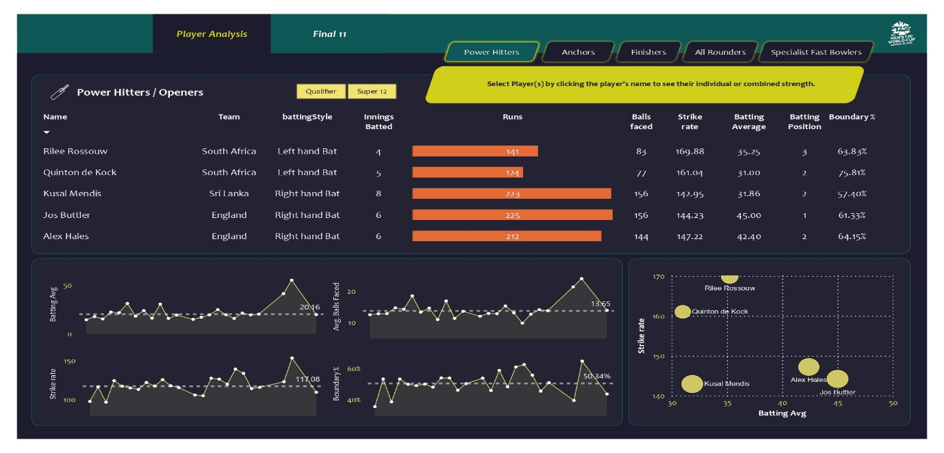

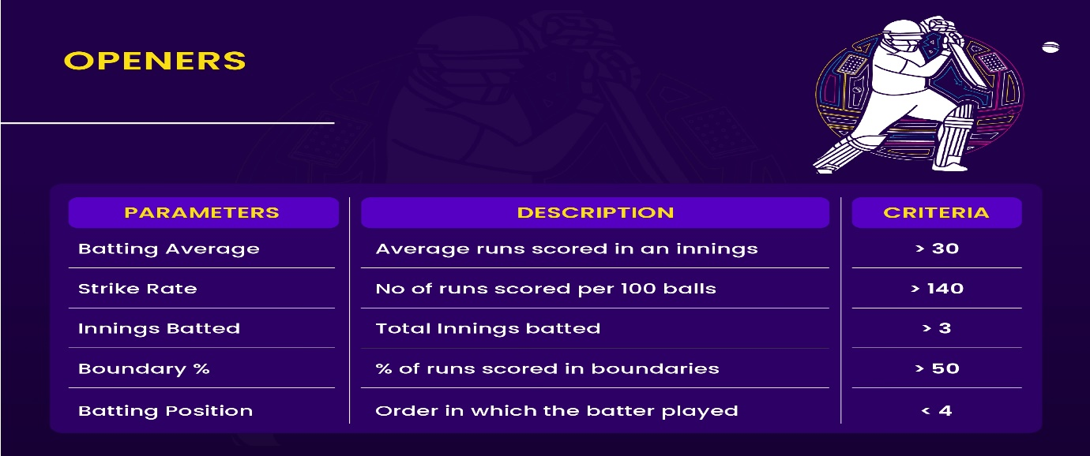

*Findings:* In our Power BI analysis of Power Hitters/Openers, key findings show Rilee Rossouw and Quinton de Kock leading with impressive strike rates and high boundary percentages. Jos Buttler stands out with the highest batting average. The selection criteria included a minimum batting average of 30, strike rate over 140, and considerable boundary scoring, which highlighted these players' abilities to provide explosive starts.

**5.2 Defining Anchors: Criteria for Middle-Order Mastery**

The "Cricket Best 11_Anchors" visualization from our Power BI dashboard examines the core players in the middle order. We focus on a batting average of over 40 and a strike rate exceeding 125 to select players capable of building the innings and accelerating the run rate when needed. Other critical factors include players having batted in more than three innings, faced over 20 balls on average, and typically occupying a batting position above the second spot. This analytical approach identifies middle-order batsmen who not only stabilize the innings but also effectively manage the pace, contributing to the team's solid foundation and strategic depth.

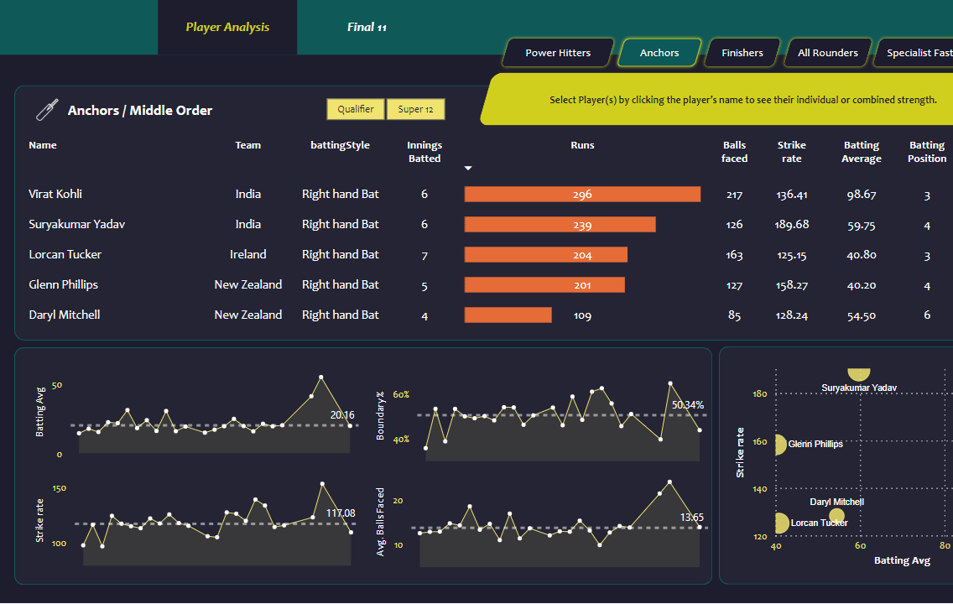

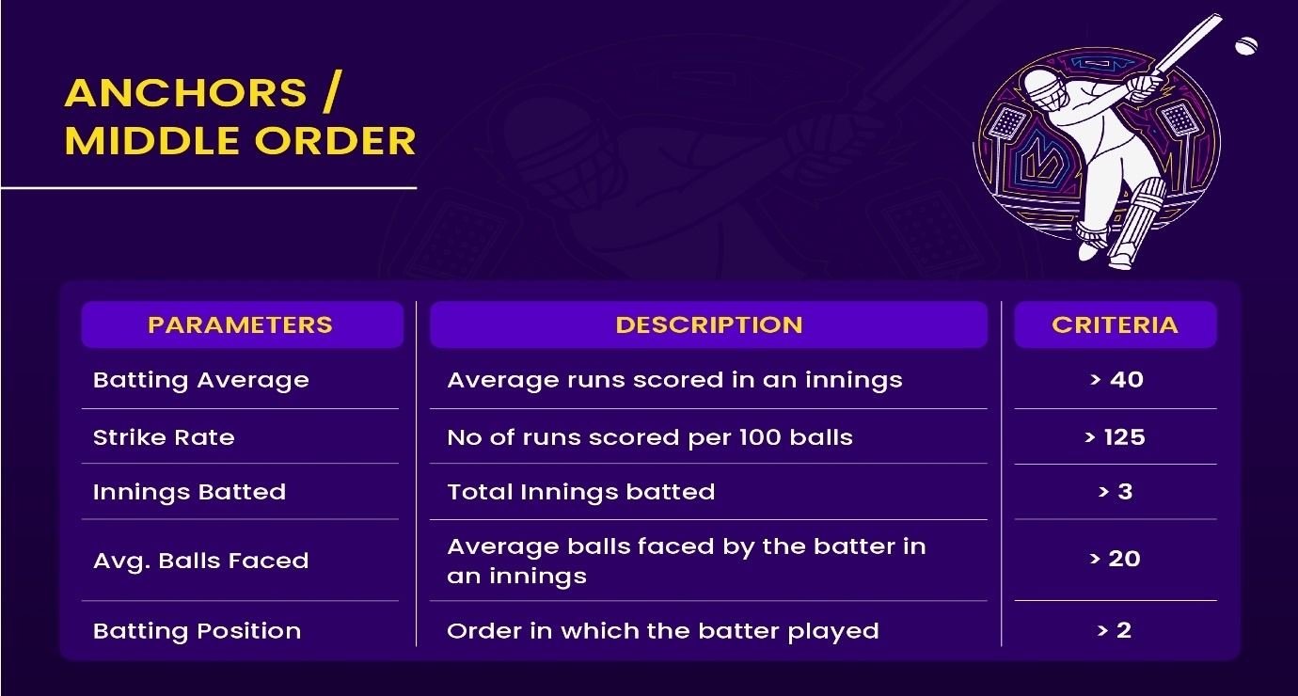

*Findings:* Our Power BI analysis identifies key Middle Order Anchors, focusing on players with a batting average exceeding 40 and a strike rate over 125, reflecting their crucial role in building innings. Notable performances include Virat Kohli's high average of 98.67 and Suryakumar Yadav's exceptional strike rate of 189.68. These criteria, along with the ability to consistently face a significant number of deliveries, highlight players capable of stabilizing and propelling the team's innings in middle overs.

**5.3 Selecting Finishers: The Key to Closing Innings.**

The "Cricket Best 11_Finishers" Power BI visualization offers insights into players who excel in concluding innings. For finishers or lower order anchors, we target a batting average greater than 25 and a strike rate above 130, ensuring they can maintain momentum and capitalize in the closing stages of the innings. Additional criteria include having faced more than 12 balls on average, signifying their ability to handle pressure situations and deliver when it counts. With these metrics, we pinpoint players like Curtis Campher and Glenn Maxwell, whose abilities to finish games make them invaluable assets to their teams. This methodology aids in identifying finishers who can not only sustain but elevate the team's performance towards the end of an innings.

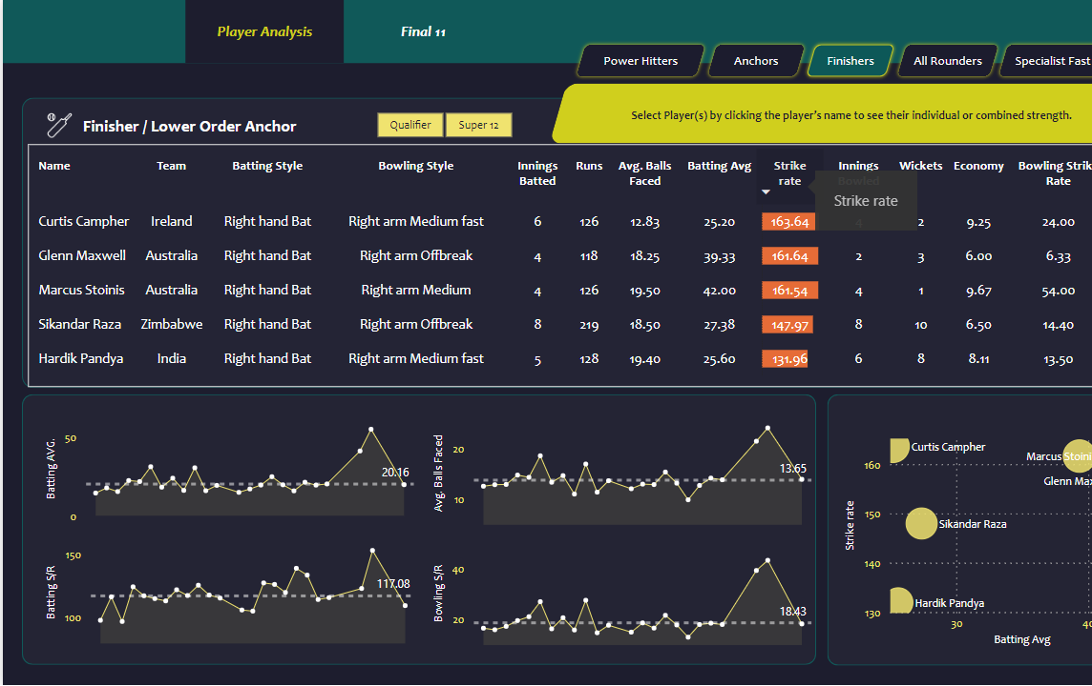

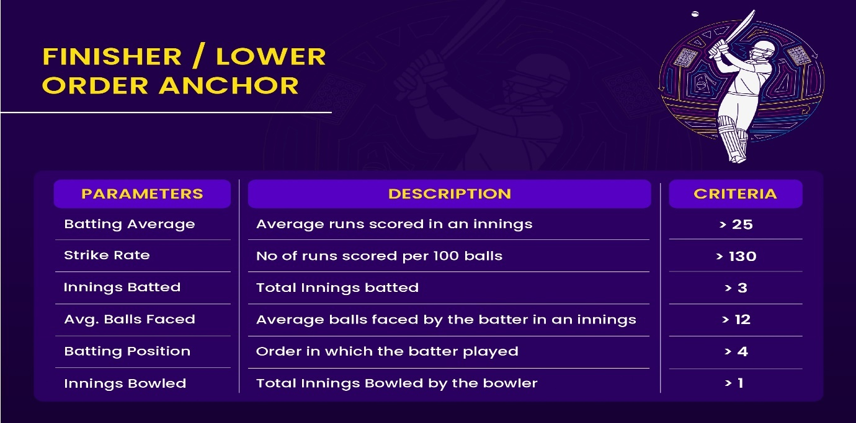*Findings:* The Power BI visualization for Finishers/Lower Order Anchors highlights the performance of key players who excel in the closing stages of the game. Notably, Curtis Campher and Glenn Maxwell exhibit high strike rates of 163.64 and 161.64, respectively, indicating their ability to score rapidly. Sikandar Raza and Hardik Pandya are also featured for their balanced contributions in batting and bowling, making them vital in finishing innings strongly. The selection was based on criteria of a batting average above 25, a strike rate over 130, and the ability to face a substantial number of deliveries, ensuring these players can sustain and accelerate the innings towards its conclusion.

**5.4 Selecting All Rounders: Balancing Batting and Bowling**

The "Cricket Best 11_All Rounders" visualization in our Power BI dashboard offers an evaluation of all-rounders based on crucial performance metrics. We look for players with a batting average above 25 and a strike rate over 130, indicating their capability to contribute significantly in the lower middle order. The ability to bat in more than three innings, coupled with proficient bowling reflected in economical rates and low bowling strike rates, allows us to identify versatile all-rounders like Rashid Khan and Sikandar Raza. These players are selected for their dual impact with both bat and ball, providing flexibility and depth to the team composition.

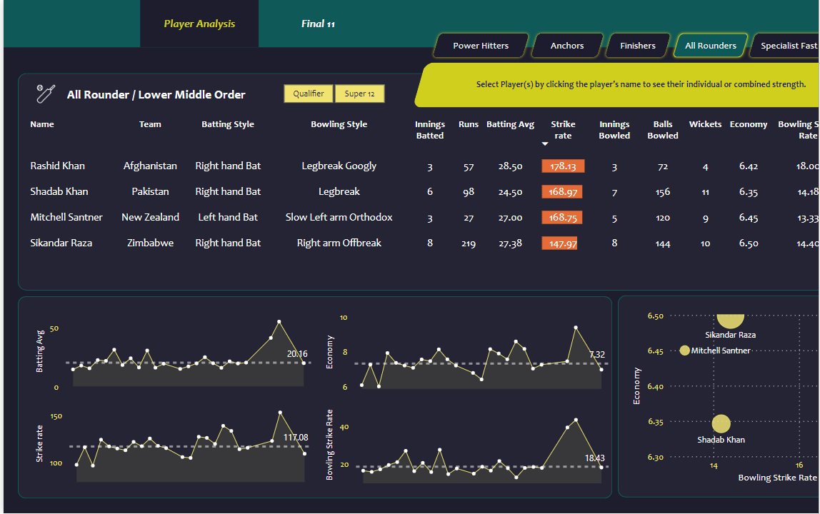

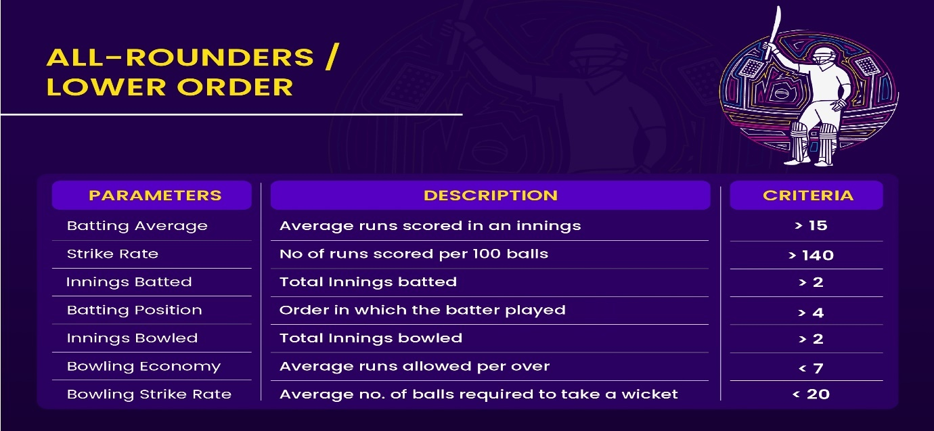*Findings:* Our analysis on All-Rounders/Lower Order players highlights their dual role, reflected in a batting average criterion of over 15 and a strike rate of more than 140. Players like Rashid Khan and Sikandar Raza meet these parameters with impressive batting and bowling statistics, indicating their ability to impact the game both with the bat and the ball. This underlines the value of versatile players in creating a balanced team dynamic.

**5.5 Choosing Specialist Fast Bowlers: Criteria for Pace and Precision**

Our "Cricket Best 11_Specialist Fast Bowlers" visualization delineates the selection framework for pace bowlers who excel in the crucial tail-end phase. We prioritize those with more than four innings bowled, an economy rate lower than 7 runs per over, and a bowling average under 20, ensuring their capability to restrict runs and take wickets efficiently. Additionally, a strike rate below 16 and a dot ball percentage over 40% highlight bowlers like Sam Curran and Anrich Nortje, who excel in delivering tight overs and applying pressure. These criteria are instrumental in identifying fast bowlers who can swiftly change the course of a match in the team's favour.

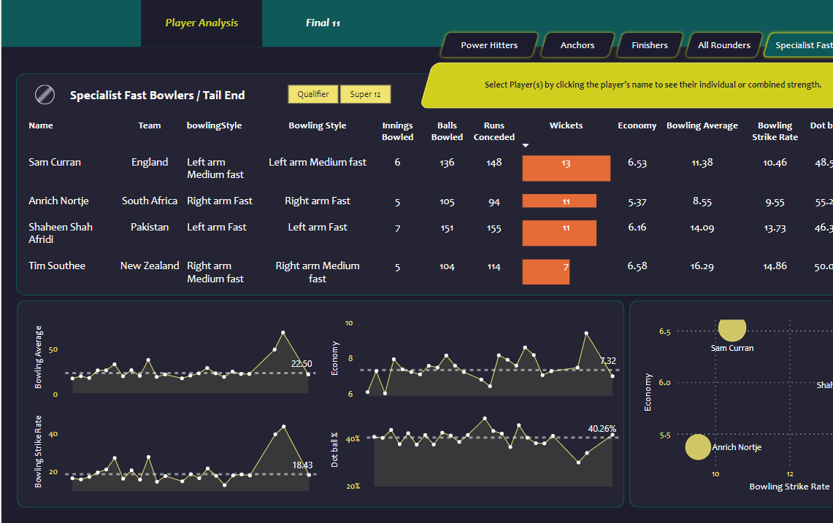

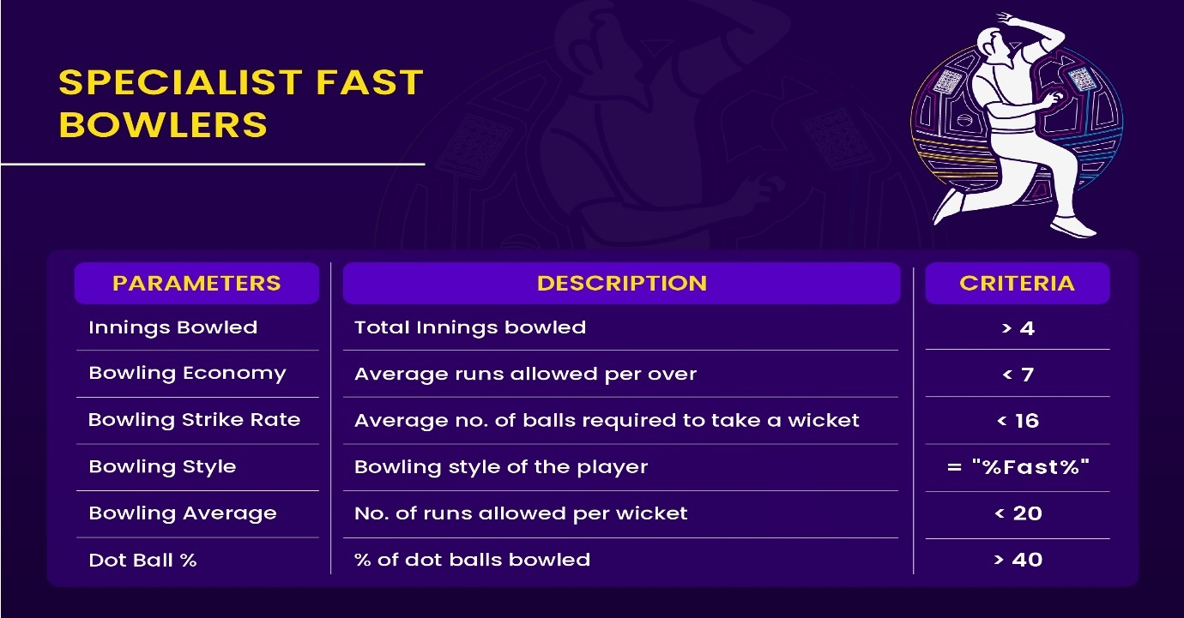

*Findings*: Our Power BI analysis of Specialist Fast Bowlers reveals that bowlers like Sam Curran and Anrich Nortje are excelling with low economy rates and high wicket-taking capabilities. With an innings requirement of over 4, an economy under 7, and a dot ball percentage above 40, these players have demonstrated efficiency and control, essential for tail-end bowling performance.

# Insights and Findings.

Our analytical model has successfully identified a diverse set of players who excel across various roles, from explosive openers to dependable finishers, and versatile all-rounders to specialist bowlers. The team includes:

- Openers: Jos Buttler and Rilee Rossouw, bringing exceptional strike rates and batting averages.

- Middle Order Stability: Virat Kohli and Suryakumar Yadav, providing high batting averages and the capability to anchor the innings.

- All-round Capabilities: Players like Marcus Stoinis and Sikandar Raza offer balance between batting aggression and bowling proficiency.

- Bowling Precision: Shaheen Shah Afridi and Anrich Nortje, offering low economy rates and high strike rates.

Overall, the team exhibits a strong batting average of 39.60 and a strike rate of 154.54, with a balanced bowling strike rate and economy indicating a well-rounded team performance.

Conclusions/ Recommendations:

Based on our comprehensive data-driven approach, we recommend:

- Balanced Team Composition: Ensure a blend of aggression and stability in the batting line-up, supplemented by reliable all-rounders and bowlers who can maintain pressure.

- Tactical Flexibility: The selected players should be utilized in a manner that leverages their strengths according to match conditions and opponent strategies.

- Dynamic Game Plan: Maintain a fluid batting order and flexible bowling changes to capitalize on the diverse skill set of the team.

- Continuous Data Review: As form and conditions change, regularly revisit the data to tweak the team composition and strategy as needed for sustained success.

The Dream Squad: Assembling Cricket’s Finest for Franchise Victory.

With rigorous analysis and data-driven selection, we have curated not just a team, but a powerhouse of cricketing excellence. The final roster of Jos Buttler, Rilee Rossouw, Virat Kohli, Suryakumar Yadav, Glenn Phillips, Marcus Stoinis, Sikandar Raza, Shadab Khan, Sam Curran, Shaheen Shah Afridi, and Anrich Nortje represents the pinnacle of global T20 talent. This elite ensemble, armed with their distinct skills and synergistic potential, stands poised to dominate the field and propel the franchise to unprecedented heights of success.

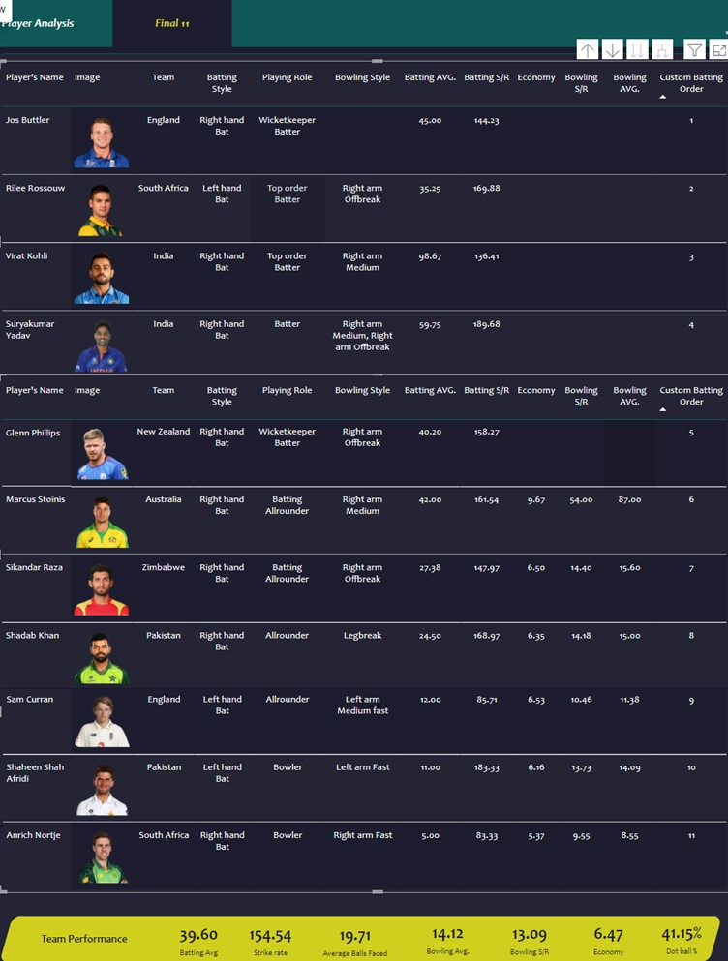

# Bibliography/References/Works Cited

Data on player performances and match summaries for the ICC Men's T20 World Cup 2022-23 was obtained from ESPN Cricinfo. This information was accessed through web scraping the specific webpage on ESPN Cricinfo. The data was retrieved on [insert date], from the following URL: [ICC Men's T20 World Cup 2022-23 Team Match Results]

<https://www.espncricinfo.com/records/tournament/team-match-results/icc-men-s-t20-world-cup-2022-23-14450>