Methods and Results (generated sections)

Methods
We analysed a simulated consumer decision-making dataset of 300 participants, each randomly assigned to one of 5 message-framing conditions (a plain control plus scarcity, sustainability, social-proof, and combined frames). After viewing the framed product, participants reported multi-item measures of price sensitivity, sustainability concern, brand trust, and perceived value, followed by their purchase intention and a hypothetical buy decision.
Multi-item scales were averaged into composite scores after reverse-scoring the relevant brand-trust item, and a value of $−99$ was treated as missing. Data were cleaned with scripted, version-controlled steps; the full codebook and cleaning code live in the project repository. All models were estimated in R with ordinary least squares (lm). Every figure and table in this paper is generated directly from the analysis code, so the reported numbers cannot drift from the analysis.

Results

Main effect
Relative to the control frame, the combined frame raised purchase intention by 0.58 points on the seven-point scale ($p=0.008$). Figure 1 shows the full pattern across conditions.
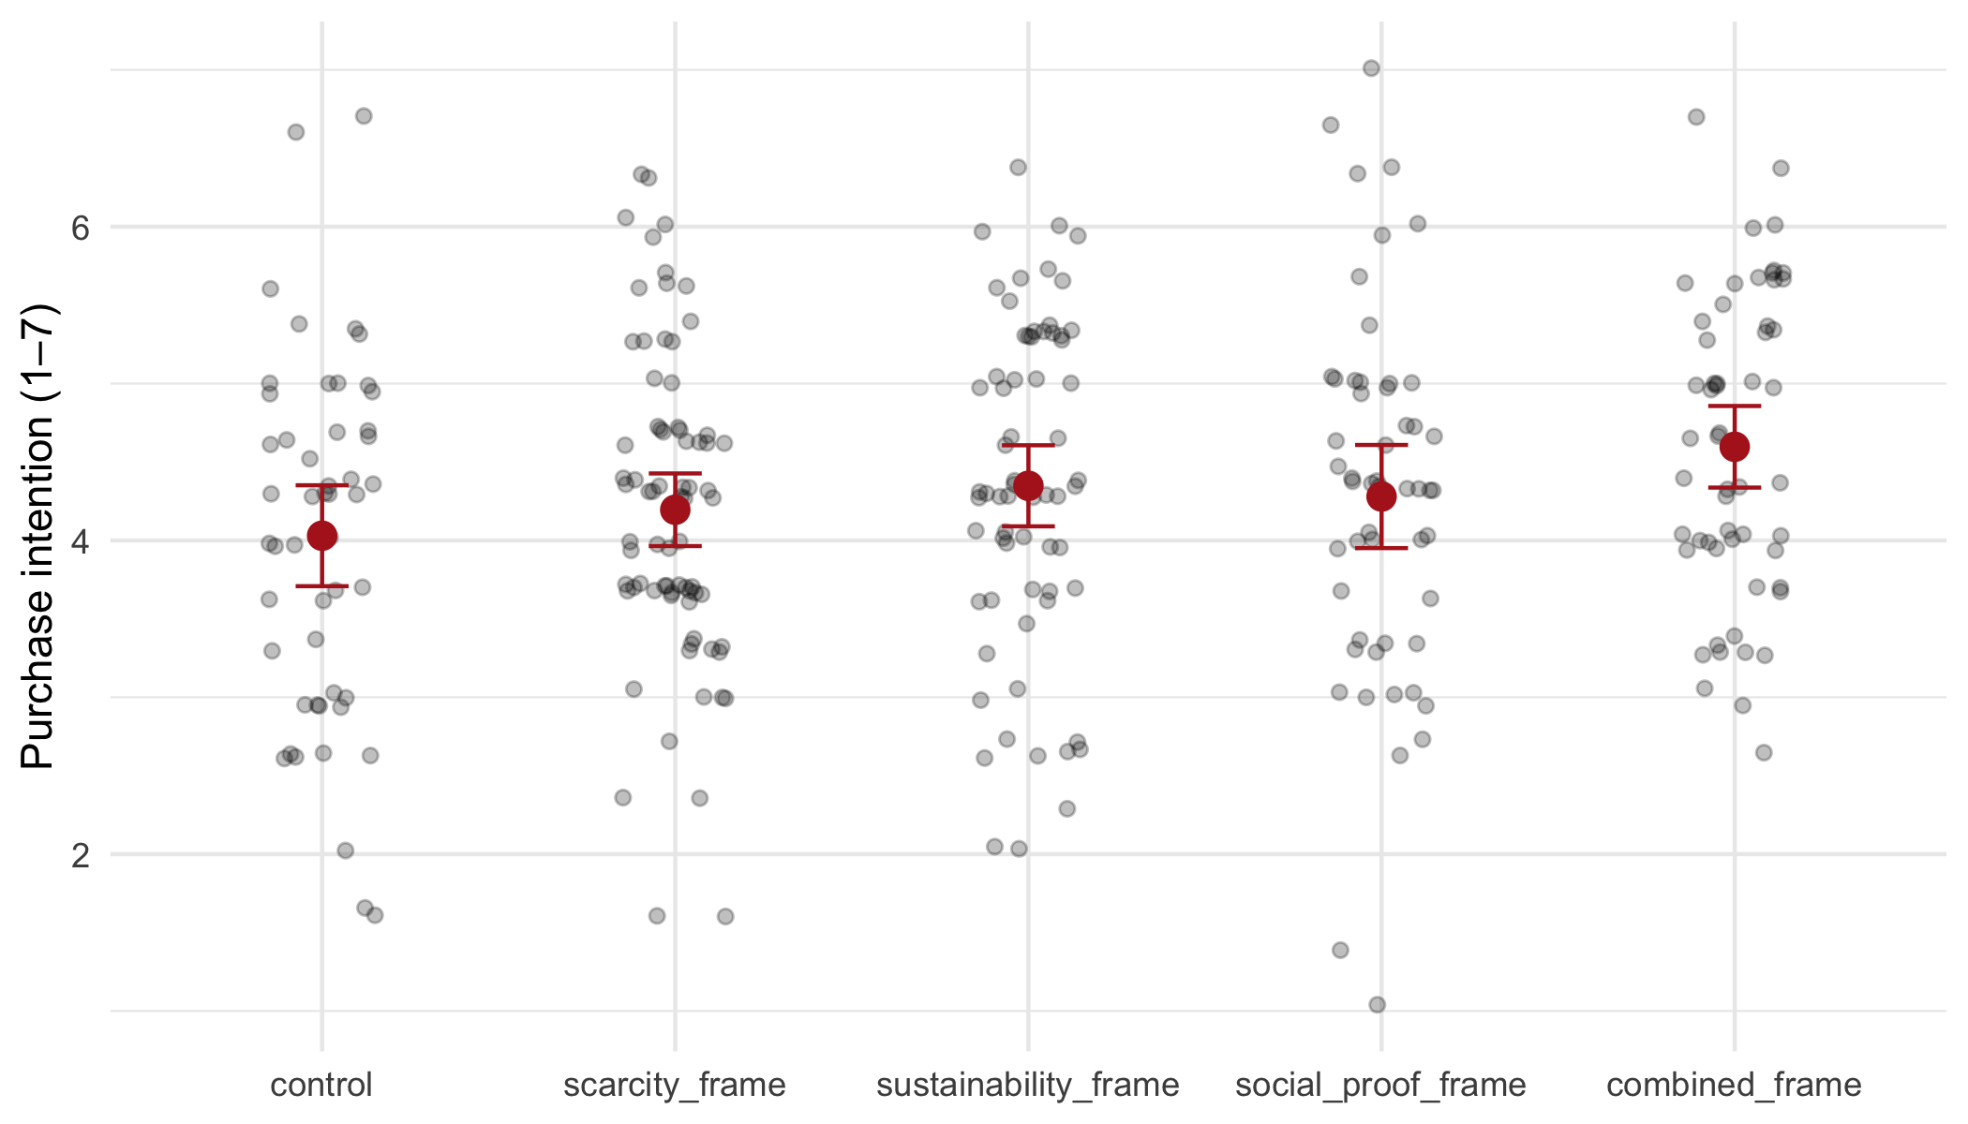
Figure 1: Purchase intention by condition. Red points are condition means with 95% confidence intervals.

Mediation through perceived value
The frames also shifted perceived value upward, and perceived value strongly predicted purchase intention (Figure 2); adding it to the outcome model attenuated the condition coefficients, the signature of an indirect path.
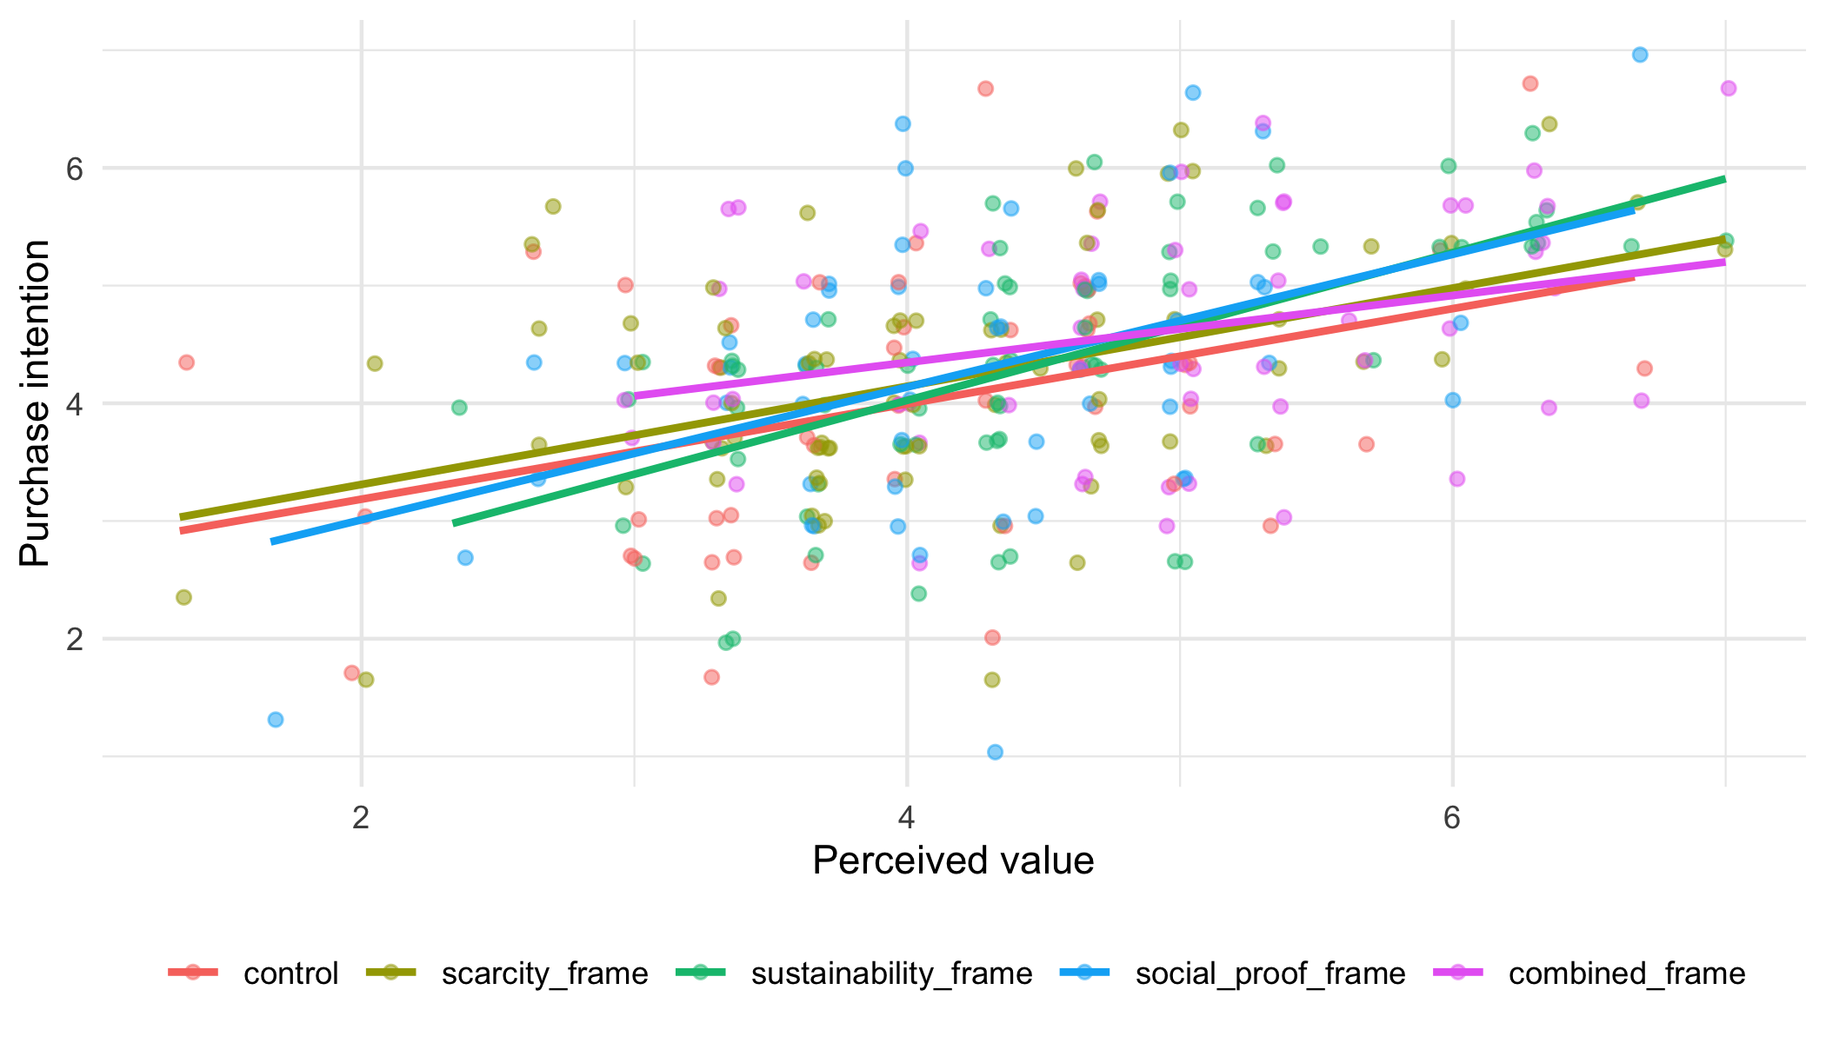
Figure 2: Perceived value predicts purchase intention; the frames shift perceived value upward, producing an indirect path.

Moderation by price sensitivity
The combined-frame boost was attenuated among the most price-sensitive respondents (Figure 3).
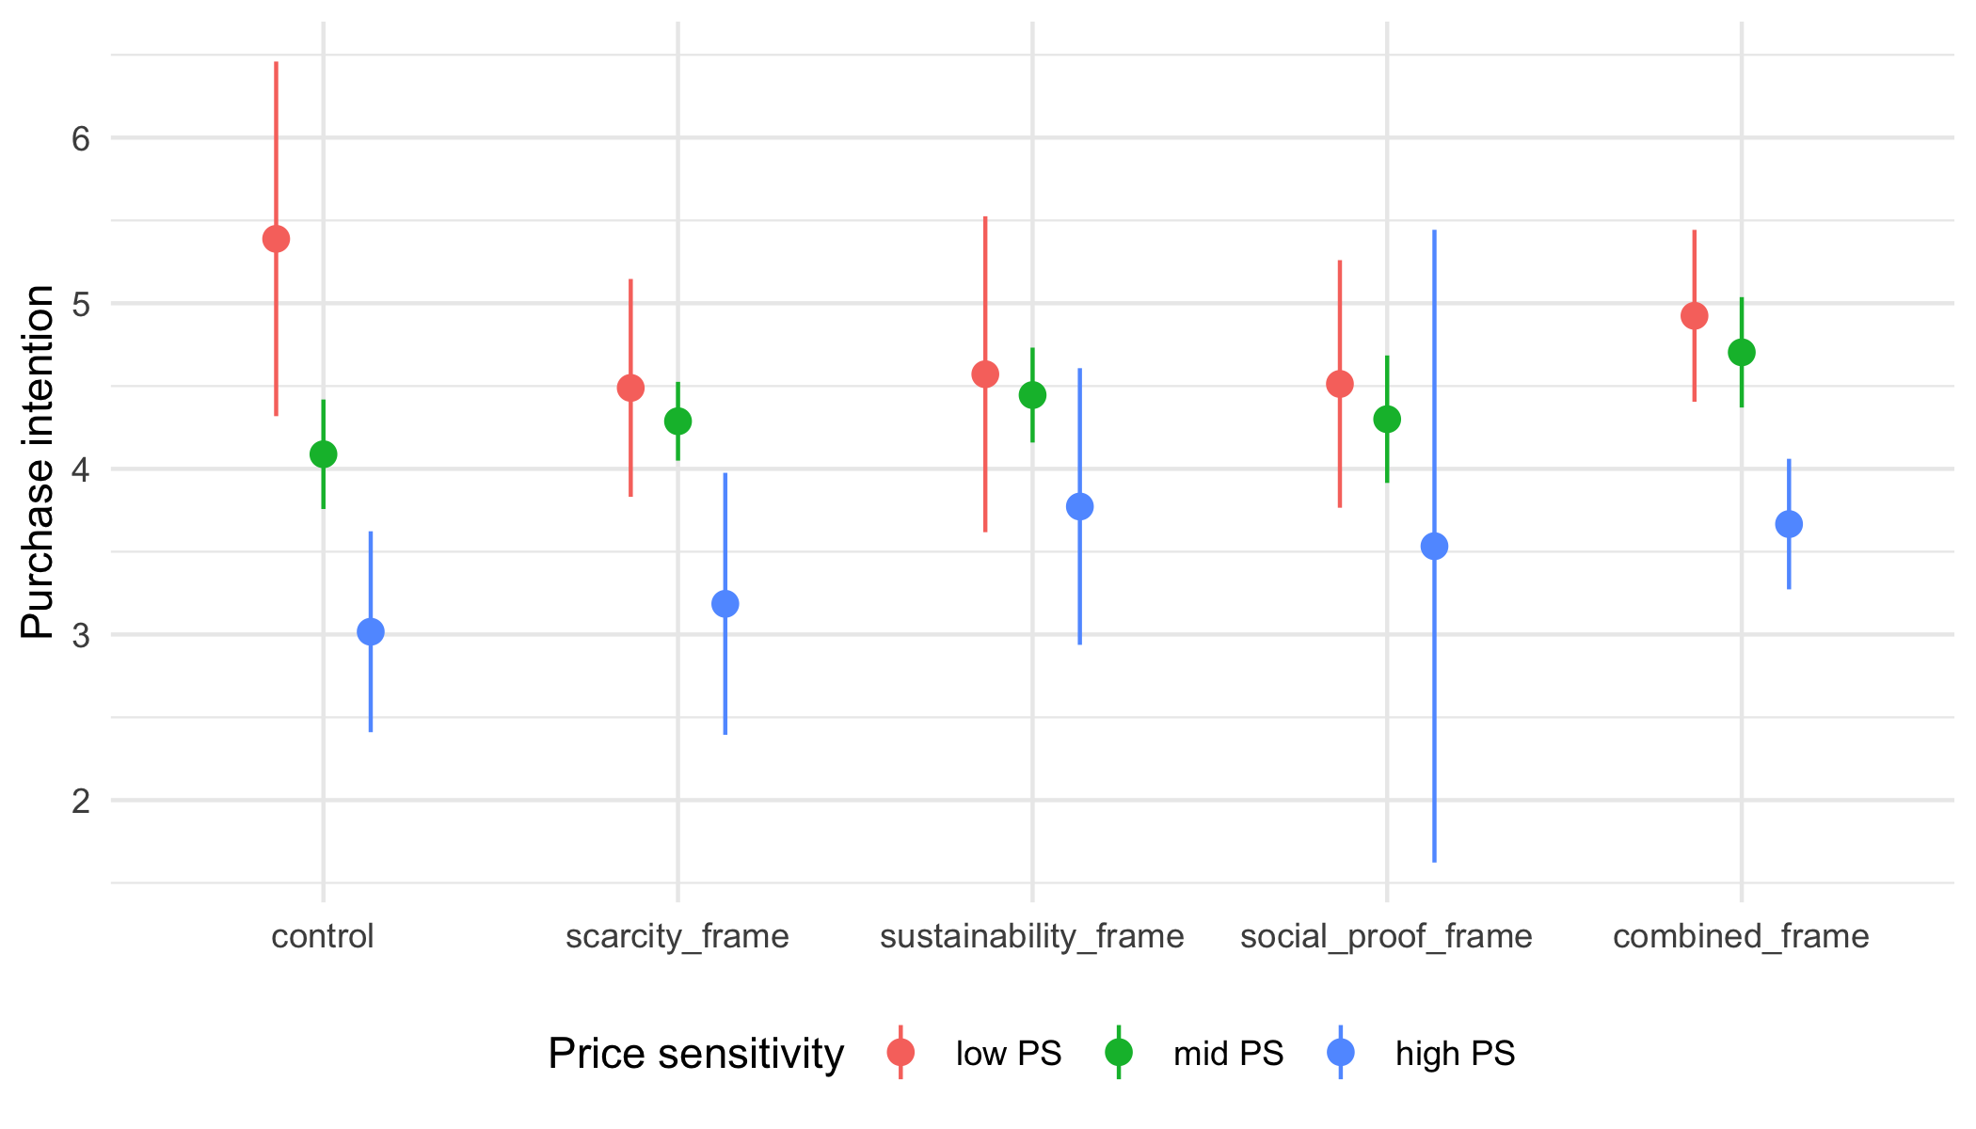
Figure 3: Condition $×$ price sensitivity: the combined-frame boost shrinks for high-price-sensitive respondents.

Model estimates
Table 1 collects the coefficients behind the figures above. It is generated by reports/manuscript/methods_and_results.qmd straight from the fitted models, so the paper’s numbers track the analysis exactly.
Table 1: Model estimates with 95% confidence intervals.
Model | Term | Estimate | SE | CI low | CI high | p
total | (Intercept) | 4.08 | 0.25 | 3.59 | 4.58 | 0.000
total | conditionscarcity_frame | 0.14 | 0.20 | -0.26 | 0.54 | 0.494
total | conditionsustainability_frame | 0.31 | 0.21 | -0.09 | 0.72 | 0.133
total | conditionsocial_proof_frame | 0.24 | 0.22 | -0.19 | 0.67 | 0.271
total | conditioncombined_frame | 0.58 | 0.22 | 0.15 | 1.01 | 0.008
total | age | 0.00 | 0.01 | -0.01 | 0.01 | 0.858
total | genderman | -0.03 | 0.14 | -0.30 | 0.24 | 0.816
total | gendernon_binary | -0.46 | 0.34 | -1.14 | 0.21 | 0.175
total | genderprefer_not_to_say | 0.12 | 0.30 | -0.46 | 0.71 | 0.676
total | income_group.L | -0.18 | 0.13 | -0.43 | 0.08 | 0.177
total | income_group.Q | 0.02 | 0.10 | -0.18 | 0.23 | 0.841
mediator | (Intercept) | 4.06 | 0.24 | 3.58 | 4.55 | 0.000
mediator | conditionscarcity_frame | 0.04 | 0.20 | -0.34 | 0.43 | 0.820
mediator | conditionsustainability_frame | 0.48 | 0.20 | 0.09 | 0.87 | 0.016
mediator | conditionsocial_proof_frame | 0.20 | 0.21 | -0.22 | 0.61 | 0.351
mediator | conditioncombined_frame | 0.85 | 0.21 | 0.44 | 1.26 | 0.000
mediator | age | 0.00 | 0.01 | -0.01 | 0.01 | 0.877
mediator | genderman | -0.11 | 0.13 | -0.37 | 0.15 | 0.413
mediator | gendernon_binary | -0.07 | 0.33 | -0.72 | 0.58 | 0.832
mediator | genderprefer_not_to_say | 0.43 | 0.29 | -0.13 | 1.00 | 0.132
mediator | income_group.L | -0.10 | 0.12 | -0.35 | 0.15 | 0.424
mediator | income_group.Q | 0.04 | 0.10 | -0.15 | 0.24 | 0.665
outcome_w_m | (Intercept) | 2.23 | 0.32 | 1.60 | 2.87 | 0.000
outcome_w_m | conditionscarcity_frame | 0.12 | 0.18 | -0.24 | 0.48 | 0.516
outcome_w_m | conditionsustainability_frame | 0.09 | 0.19 | -0.28 | 0.46 | 0.630
outcome_w_m | conditionsocial_proof_frame | 0.15 | 0.20 | -0.24 | 0.54 | 0.443
outcome_w_m | conditioncombined_frame | 0.19 | 0.20 | -0.20 | 0.59 | 0.334
outcome_w_m | perceived_value | 0.46 | 0.06 | 0.35 | 0.57 | 0.000
outcome_w_m | age | 0.00 | 0.01 | -0.01 | 0.01 | 0.784
outcome_w_m | genderman | 0.02 | 0.12 | -0.22 | 0.26 | 0.888
outcome_w_m | gendernon_binary | -0.43 | 0.31 | -1.04 | 0.17 | 0.160
outcome_w_m | genderprefer_not_to_say | -0.07 | 0.27 | -0.60 | 0.46 | 0.786
outcome_w_m | income_group.L | -0.13 | 0.12 | -0.36 | 0.10 | 0.267
outcome_w_m | income_group.Q | 0.00 | 0.09 | -0.18 | 0.19 | 0.990
moderation | (Intercept) | 4.15 | 0.24 | 3.67 | 4.63 | 0.000
moderation | conditionscarcity_frame | 0.09 | 0.20 | -0.30 | 0.48 | 0.649
moderation | conditionsustainability_frame | 0.27 | 0.20 | -0.12 | 0.66 | 0.177
moderation | conditionsocial_proof_frame | 0.09 | 0.21 | -0.33 | 0.51 | 0.667
moderation | conditioncombined_frame | 0.48 | 0.21 | 0.06 | 0.89 | 0.025
moderation | price_sensitivity_c | -0.49 | 0.12 | -0.72 | -0.25 | 0.000
moderation | age | 0.00 | 0.01 | -0.01 | 0.01 | 0.947
moderation | genderman | -0.07 | 0.13 | -0.33 | 0.19 | 0.603
moderation | gendernon_binary | -0.32 | 0.33 | -0.97 | 0.33 | 0.329
moderation | genderprefer_not_to_say | 0.15 | 0.29 | -0.41 | 0.72 | 0.590
moderation | income_group.L | -0.21 | 0.13 | -0.45 | 0.04 | 0.102
moderation | income_group.Q | 0.03 | 0.10 | -0.16 | 0.23 | 0.743
moderation | conditionscarcity_frame:price_sensitivity_c | 0.29 | 0.15 | -0.01 | 0.60 | 0.060
moderation | conditionsustainability_frame:price_sensitivity_c | 0.28 | 0.16 | -0.05 | 0.60 | 0.095
moderation | conditionsocial_proof_frame:price_sensitivity_c | 0.24 | 0.16 | -0.08 | 0.57 | 0.142
moderation | conditioncombined_frame:price_sensitivity_c | 0.35 | 0.17 | 0.02 | 0.69 | 0.039

