Hourly employees: How to get paid

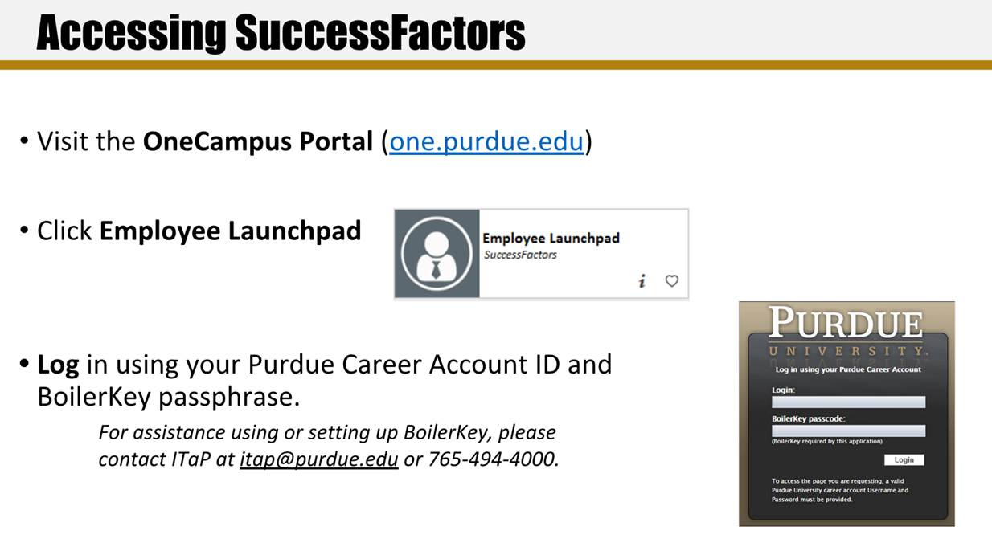

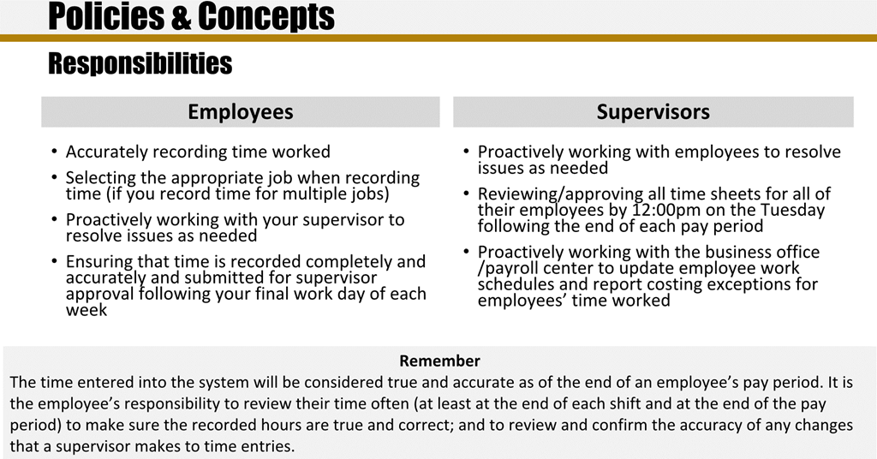

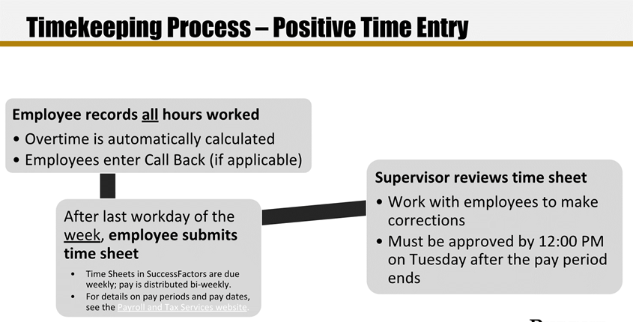

If you have multiple positions for which you record time, use the Change Selected Employment icon in the upper right corner of the screen to select the position for which you would like to record time.

* Scroll down the **My Info** section
  + In the case of similarly named positions, click **My Profile** and consult the *Employment Information* tab to verify that the correct position is selected. Click the Home icon at the top of the screen to return to the SuccessFactors home page. Don’t forget to re-select the appropriate position.
* Click the **Time Sheet** tile

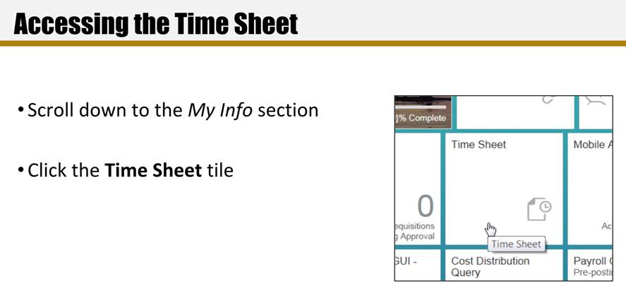

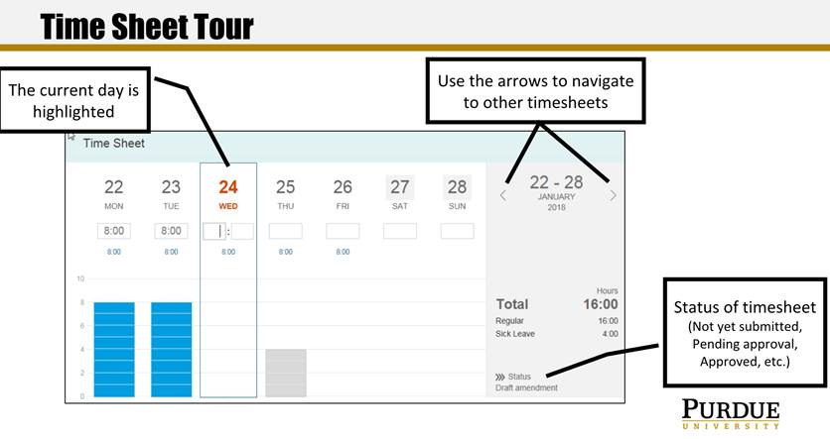

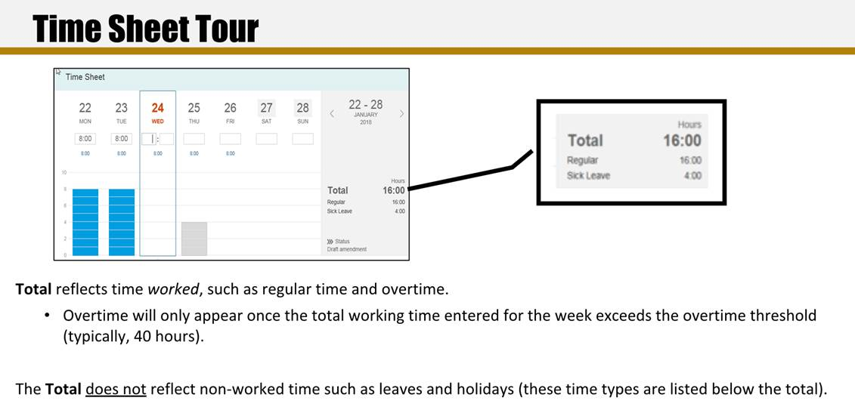

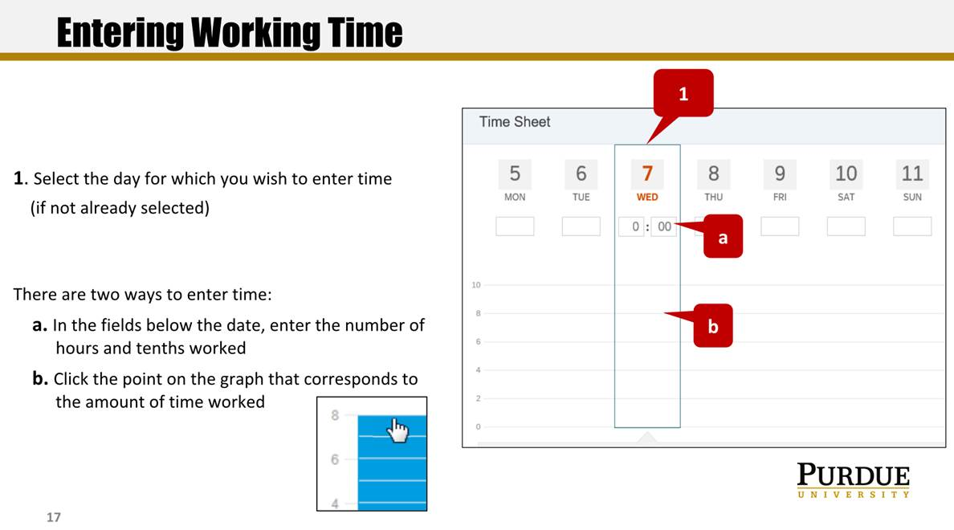

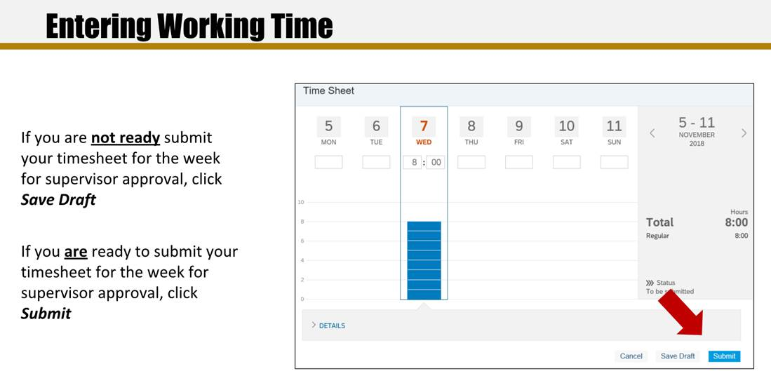

When you enter your time each day, hit "save". Wait to hit "submit" until the end of the week.

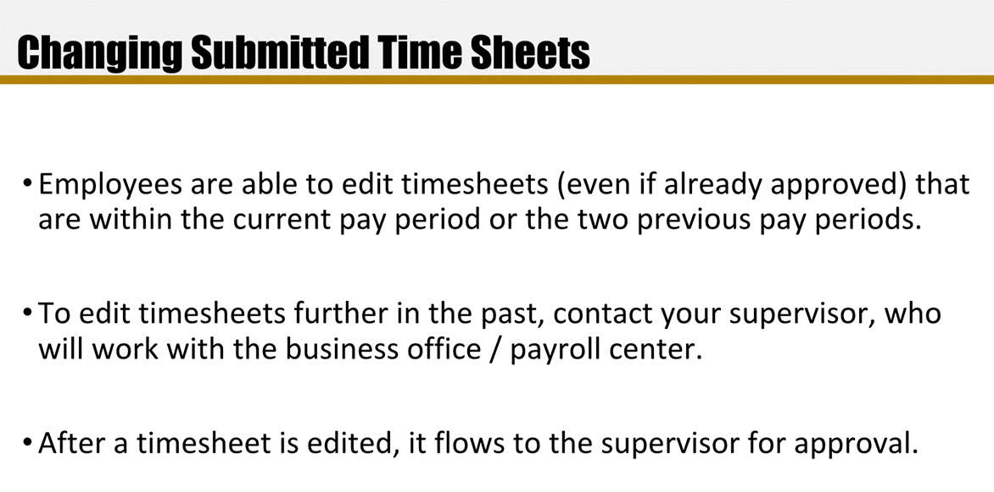

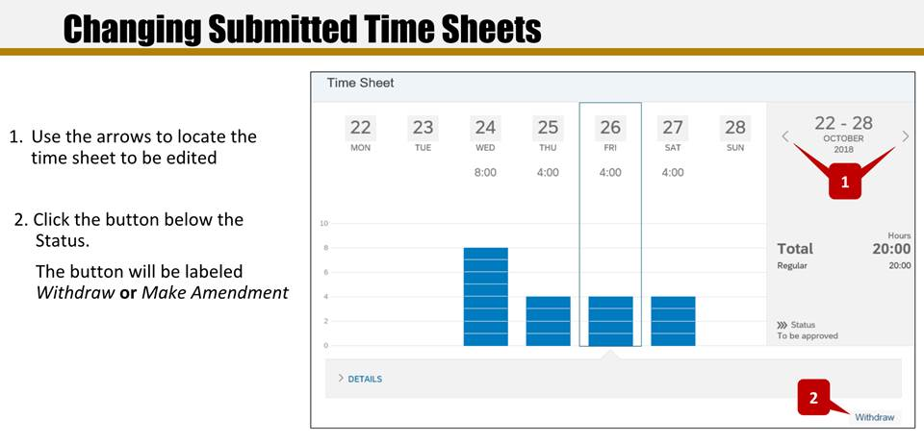

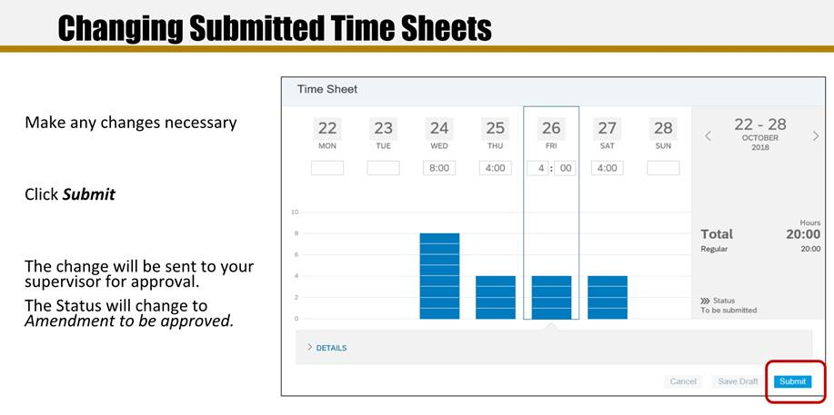

Data Mine staff will approve all the Success Factors time sheets for the previous week on Monday mornings.