Slot 14 exit slip Name ____________ ID ______  An element is in period 3, group 14. On the grid, mark its box with an X and shade its whole block. Then write its valence configuration and how many valence electrons it has.  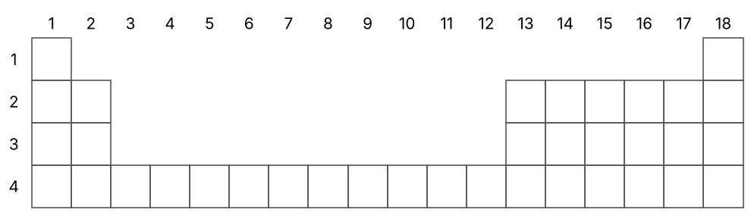  Valence configuration: ______________________  Valence electrons: ______ | Slot 14 exit slip Name ____________ ID ______  An element is in period 3, group 14. On the grid, mark its box with an X and shade its whole block. Then write its valence configuration and how many valence electrons it has.  Valence configuration: ______________________  Valence electrons: ______
Slot 14 exit slip Name ____________ ID ______  An element is in period 3, group 14. On the grid, mark its box with an X and shade its whole block. Then write its valence configuration and how many valence electrons it has.  Valence configuration: ______________________  Valence electrons: ______ | Slot 14 exit slip Name ____________ ID ______  An element is in period 3, group 14. On the grid, mark its box with an X and shade its whole block. Then write its valence configuration and how many valence electrons it has.  Valence configuration: ______________________  Valence electrons: ______
Slot 14 exit slip Name ____________ ID ______  An element is in period 3, group 14. On the grid, mark its box with an X and shade its whole block. Then write its valence configuration and how many valence electrons it has.  Valence configuration: ______________________  Valence electrons: ______ | Slot 14 exit slip Name ____________ ID ______  An element is in period 3, group 14. On the grid, mark its box with an X and shade its whole block. Then write its valence configuration and how many valence electrons it has.  Valence configuration: ______________________  Valence electrons: ______

