Domain Analysis Document

The aim of the project is to create a computer game where the user attempts to defend their base from enemies trying to reach it by placing down towers to take them down. We want the main theme of the game to be from The Smurfs universe, which we will use to design the enemies and towers.

# Characteristics

* The game will be round based.
* The player must initiate the next round.
* The player may place down towers to eliminate their enemies, in exchange for currency.
  + The player may also upgrade these, in exchange for currency.
* The player gains currency by eliminating enemies.
* The enemies will move from one side of the map to the other.
  + If they are successful, the player loses lives depending on the toughness of the enemy.
* The round ends when all enemies have been eliminated.
* If the player loses all their lives, the game will end.
* If the player survives a certain number of rounds, they win.

# UI sketches

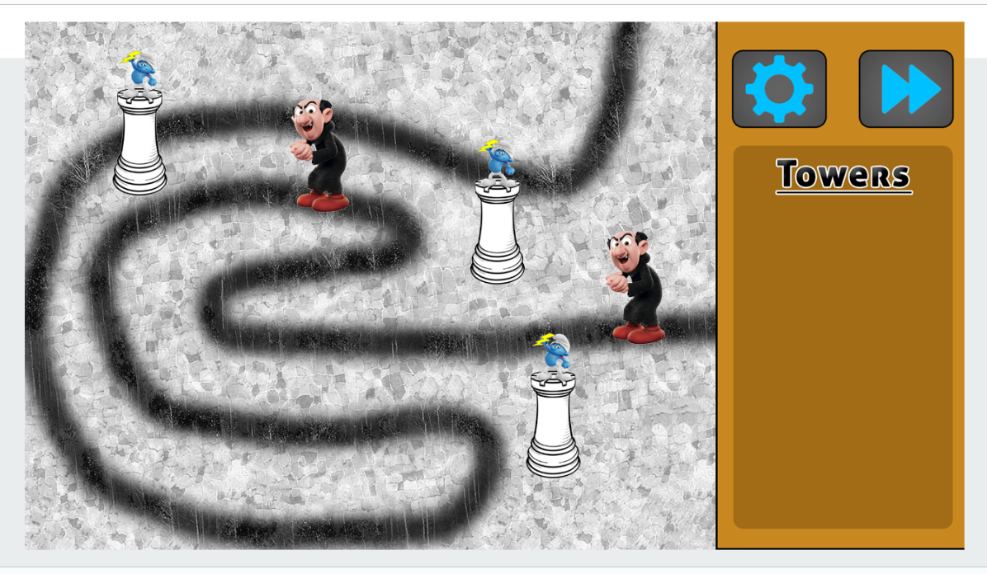

UI sketch made in Photoshop. Here the enemies are seen while walking on the path, starting from the top end.

# Domain Model

The domain model for the game

# Epics

As a: user

I want to: play Smurf Tower Defense.

So that: I can kill time.

Acceptance:

* User can play the game according to basic Tower Defense principles.

As a: user

I want to: place down Towers.

So that: I can eliminate my enemies and get more money.

Acceptance:

* User can place down Towers in exchange for currency.
* User can use the Towers to kill enemies.
* User can receive currency for killing enemies.

As a: user

I want to: start the next round.

So that: enemies start spawning and I can try to win.

Acceptance:

* User can start the next round by pressing a button.
* Enemies spawn during a round.
* User loses health if unsuccessful in defending their base.

# User stories

As a: player

I want to: have different variations of enemies.

So that: it adds more variation to the game.

Acceptance:

* Enemies have different types with different health stats.
* Enemies have different colors and/or design attributes.

As a: player

I want to: be able to upgrade my towers.

So that: I can defeat my enemies easier.

Acceptance:

* Towers can be upgraded.

As a: player

I want to: have a visually dynamic game map.

So that: I can understand the game flow and enemy pathways.

Acceptance:

* Maps have clear pathways that show where the enemies come from and where they go to.
* Towers show where they can be placed.