**Results for Telco Dataset**

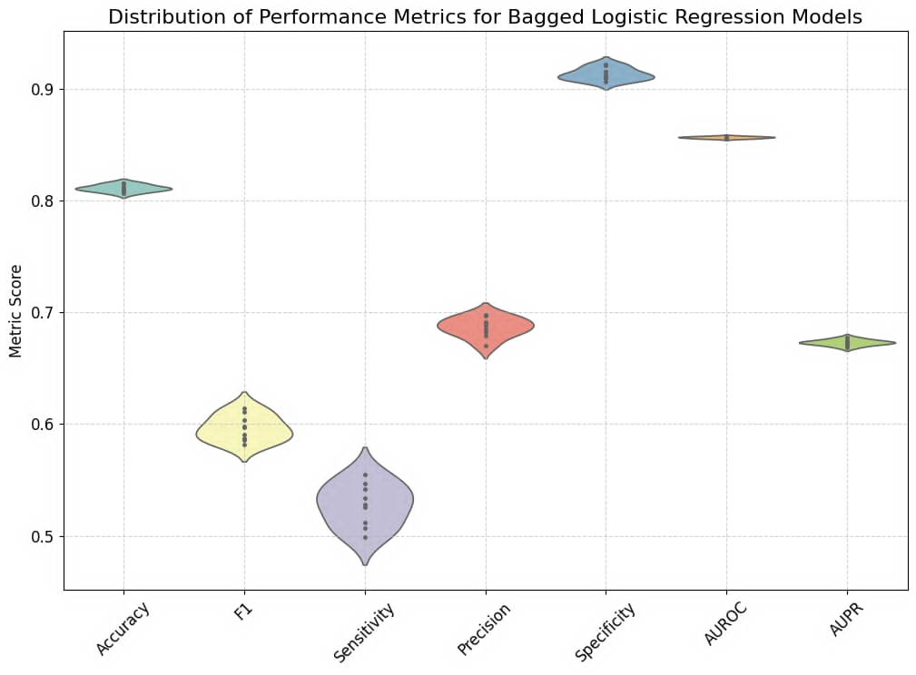

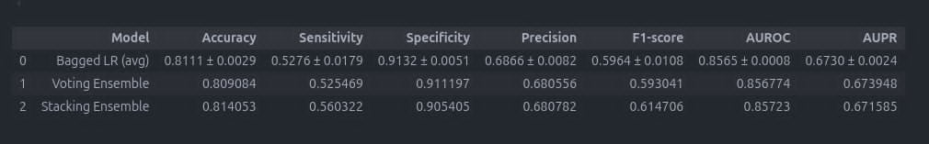

**Results for Adult Dataset**

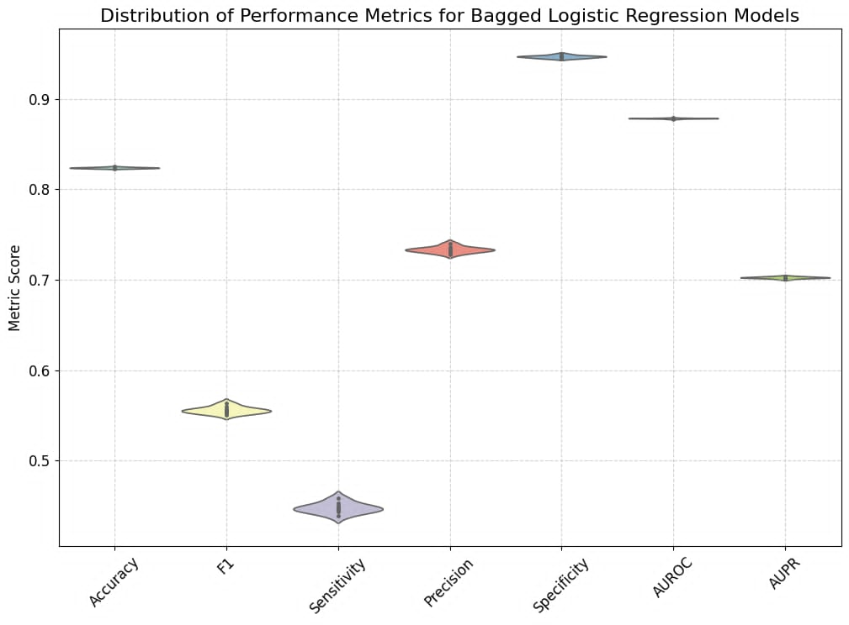

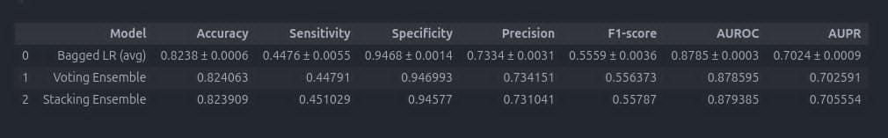

**Results for for Credit Dataset**

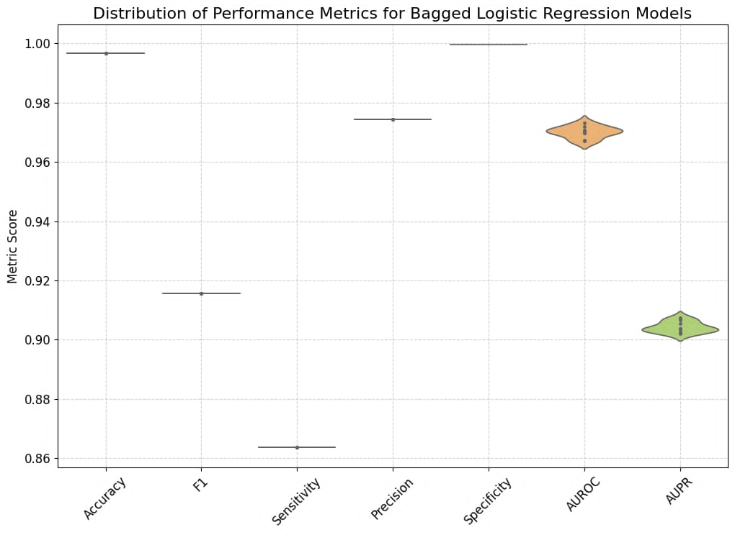

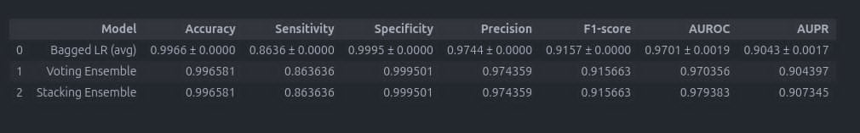

Observations:

* First dataset predicted true negatives better. But the precision was moderate and sensitivity was low
* Second dataset had low sensitivity score. That means it did not predict true positives good. F1-score was low as well
* The model overfits. The data was biased as there were about 20k negative examples and only around 500 positive examples