Derick Dao – 1772 6966

COMPUTER GRAPHICS 200

Assignment 2

Contents

Introduction 2

Description 2

Main Algorithms 2

Modelling Objects 2

Animations 3

Rendering 3

Personal Creations 4

Design Ideas 4

Tools and References 5

Conclusion 5

# Introduction

The assignment specifications indicated to create objects in a scene using the theme of “Under the Sea”. This report is made to illustrate the description of my assignment, the main algorithms used in coding my scene, the modelling that is done for the scene, the simple and composite objects that were created for the scene and the design ideas behind my scene.

# Description

For my scene to incorporate the theme of “Under the Sea”, I thought of a pitch black deep down in the sea with objects that would have been evident to be seen thrown to the pits of the sea. The cube is a toy that a kid might have forgotten at a beach and was washed away by waves and ended up being in the bottom of the sea. The green and red coloured flat fish is a species of fish that has never been discovered. The pyramid is a chipped off piece of a rock that was established in the sea. The sphere is a red pearl that was released from a clam that isn’t evident in the scene. The black background is the pitch black parts of the sea where nothing is evident with only two specs of light. One coming from above down and from far forward pointing to the camera. I created transparency with the pearl to make it image a somewhat a real concept of a pearl. I have implemented a display menu that is evident on the bottom left of the screen with the various commands to alter the scene such as rotate, zoom, animate and change the speeds of the animations.

# Main Algorithms

The main algorithms I have used for this assignment includes global variables that are used to alter the scaling and rotational values of objects for my animation, keyboard functions and creating the objects by drawing from vertex to vertex to create the attributes in my scene.

## Modelling Objects

Drawing a cube was created by drawing lines from one vertex to another (shown below):

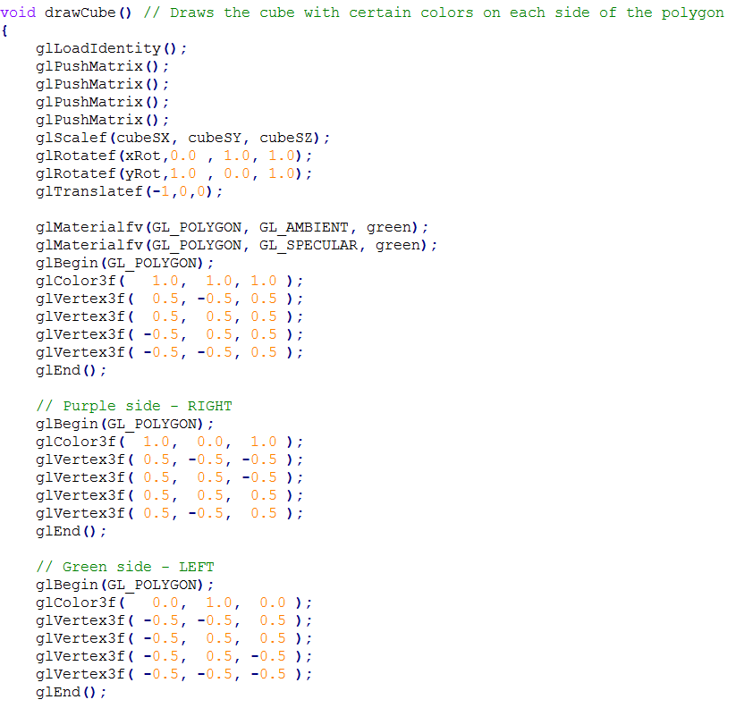

The scaling factor for my cube is used to resize my object using the global variables cubeSC, cubeSY and cubeSZ as factors to scale.

xRot and yRot are used to rotate the cube whenever it is needed.

Drawing from vertex to vertex allowed my program to create lines to form my object (the cube).

## Animations

For animations, I have animated the fish to swim from the right side of the screen to the left while wagging its tail slowly.

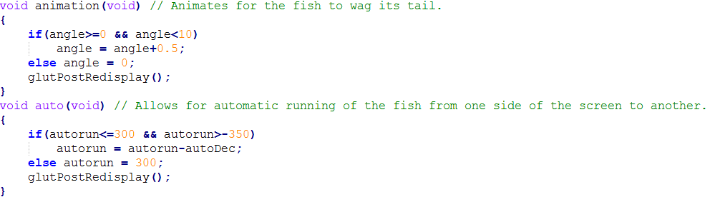

The angle specifies the angle at which the tail will wag at and allow for the program to reset the angle counter after it exceeds a 10 degree rotation. The function auto(void) allows for the fish to transition from the right of the screen to the left of the screen so that it appears to be “swimming”. autoDec is a global variable which indicates the speed at which the fish is swimming and autorun being the variable that dictates the positioning of the fish’s starting point and after reaching -350, it will reset to its original position.

## Rendering

My lighting function doLights() allow for a foggy but unnoticeable effect which allows for my sphere to be transparent. It creates two light sources; a diffuse light source and a normal light source. 

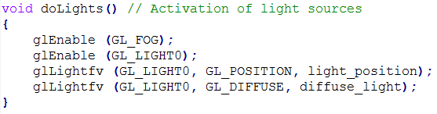

For rendering, my objects are created in a window with the title CG – Under The Sea of size 1000 x 700.

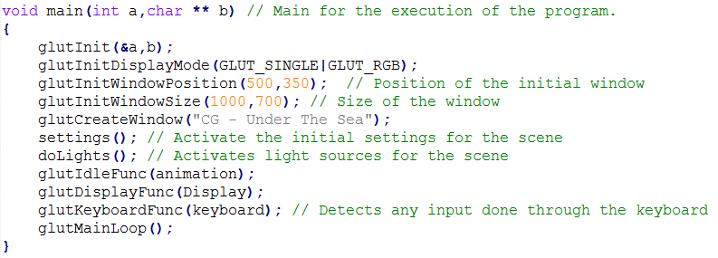

## Personal Creations

An indication of my own work is the cube that was created, the sphere and the pyramid. In particular, the fish when I created it, I used a reference which told me how to create a 2D fish to make it a flat fish that fits the story of my assignment. This reference also helped with creating the animation of the fish wagging its tail and going from one side of the screen to the next. Although, I changed up the decrementing or incrementing factor of the animation to fit the assignment specifications for slowing and increasing the movement of the fish by pressing specific buttons.

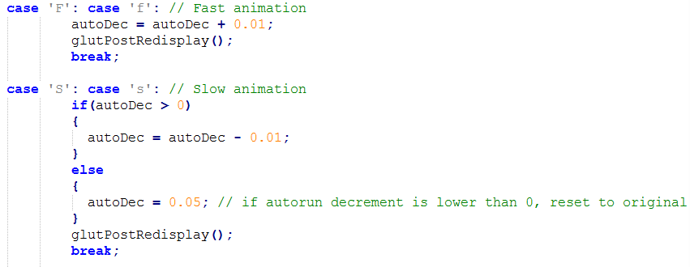

# Design Ideas

The design ideas I had in mind when creating this scene initially started with a few big boulders with fish swimming around them and aquatic plants to accompany the scene. I changed up my idea to a very more simplistic idea of being in the darkest parts of the ocean with two light sources to show the evident objects in that area. I found that this idea was more optimal for me due to the amount of time I had available to complete this assignment while keeping into consideration other units and their own assessments.

Having to adjust my scene to a more simplistic scene allowed me to explore basic ways to create something simple yet complex. Complex meaning the characteristics of the object is more advance while the object itself is simple (i.e. transparency). Having the story of being in the deepest part of the sea reminded me of a scene I was watching from a show that showed the bottom of the sea with various objects that weren’t even related to the sea. The show explained the background story to these objects and it made sense why they were in the sea in the first place. I used this idea to formulate the scene with having objects (such as the box) evident in the sea where a box wouldn’t usually be placed in the sea environment.

# Tools and References

Boualy. (2012) Drawing Fish in OpenGL – GitHub. Accessed 19 October 2016.

<https://gist.github.com/Boualy/5014506>

* This link helped me with drawing the fish and animating the fish to wag its tail and move from the right of the screen to the left.
* This link really helped me with the information needed to create a fish and allowed me to adjust accordingly to fulfil with the keyboard instructions the specifications of the assignment specified.

Avereue Gredere. (2015). Nagi no Asukara Episode 18 English Dubbed – YouTube. Accessed 16 October 2016. <https://www.youtube.com/watch?v=xZmPeqULvcQ>

* This YouTube video of an episode from an anime called Nagi no Asukara allowed me to be able to adjust from having a complicated scene into a simplistic scene. At around 15:00 is a graveyard full of totems and things you would normally not find at the bottom of the sea. This had given me the insight to create a pitch black place in the sea with objects you would not normally see in the sea.

ZbuffeR and Silver. (2004). Drawing a cube. Accessed 19 October 2016. <https://www.opengl.org/discussion_boards/showthread.php/137599-Drawing-a-cube>

* This link allowed me to have access to information about drawing a cube from a vertex to another which gave me insight, not on only how to draw the cube but also how to draw a pyramid using coordinates for X, Y and the Z-axis planes.

# Conclusion

In concluding this report, this assignment has been a very adventurous journey starting from a blank screen to implementing some objects to fill a scene, learning about light sources, how shading works, how different lightings create different surface finishings, how objects look from a certain point of view and how objects look when altered to a different angle from where you are looking at.

I have thoroughly enjoyed this assignment given the amount of time I allocated for this assignment but I would love to have continued on this assignment a little more. I am semi-disappointed with my scene because it did not end up being the scene I wanted it initially to be, but due to time constraints, I had to improvise and allow for the scene to be completed to its minimal sufficient form to complete the assignment.

Overall, the assignment gave a very broad topic to work with which made the assignment a lot more flexible. The flexibility given allowed me to adjust accordingly to complete the assignment. The time spent on this assignment was fun and very educational.