Travis Moore

GAT-110 F13

Week 5—Digital Game Analysis: Warhammer 40,000: Space Marine

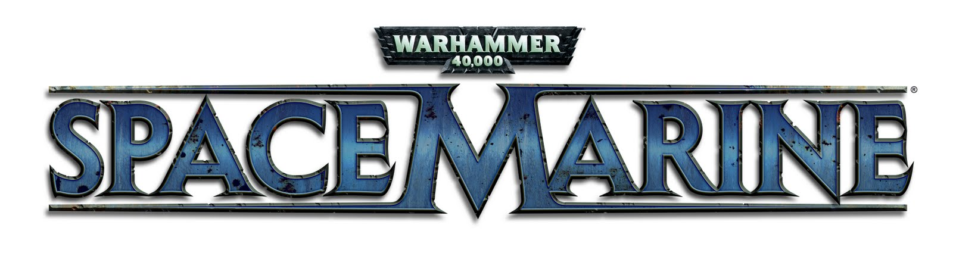

I grew up playing the tabletop strategy game *Warhammer 40,000* and immediately fell in love with the game. *Warhammer 40,000* had everything I could have asked for in a game: customizable armies, in-depth strategy, a grim art style, and many different ways to play the game. The only downside to *Warhammer 40,000* is that it requires buying, building, and painting ridiculously expensive miniatures that I could not afford then and even now. Thankfully, there have been video games that are nowhere near as heavy as an investment as playing the tabletop version of *Warhammer 40,000*. However, none of these games fully capture the experience as well as I have always hoped that they would. That is, until I played *Warhammer 40,000: Space Marine*.

Eschewing the command of entire armies, *Warhammer 40,000: Space Marine* puts the player in control of a single Space Marine, a super-human solider, who must defend humanity against an onslaught of enemy Orks. While this premise might not seem entirely different than other “save the world” type games, what makes *Warhammer 40,000: Space Marine* successful is its near-perfect execution of creating the look and feel of being a lone Space Marine in the *Warhammer 40,000* universe.

*Warhammer 40,000: Space Marine* does an amazing job of very nailing the gravitas of the Space Marine. A Space Marine is supposed to be super-human in strength, ability to fight using melee and ranged weapons, and equipped with heavy power armor that absorbs tons of damage. *Warhammer 40,000: Space Marine* accomplishes this by establishing exactly how this should look and feel. Moving in the game you can visually experience the weight of the armor when moving through gunfire, the strength behind a sword blow, and the ease of firing heavy weapons. All this might make it sound like the game is easy if the Space Marine is so powerful, but this is wonderfully balanced by the sheer amount of Orks the player must face at any one time. While a Space Marine is certainly quite a capable hero, the overwhelming amount of enemies makes even getting from one area to the next quite difficult.

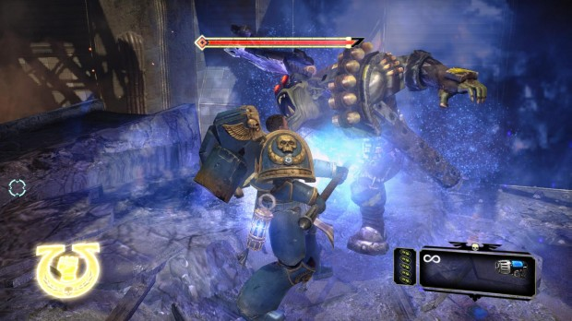

*A player performing an execution on an Ork in order to refill their health meter is an example of how the game encourages melee fighting over always using ranged weapons.*

From the art style of the game, to the care put into making the game controls of the Space Marine feel like an actual Space Marine, *Warhammer 40,000: Space Marine* just manages to feel right. It is wonderfully to finally see a *Warhammer 40,000* game where the game developers took the time to fully explore the universe that their game encompasses, instead of simply plopping in *Warhammer 40,000* characters into a game that already has been made before.