Travis Moore

GAT-110 F13

Design Journal #6—Digital Game Analysis: FEZ



Sometime during the rise of competitive multiplayer games I stopped playing single player games. I grew up on the popular 2-Dimensional platformer games that you could only play by yourself, like Mario and Sonic, but at one point they just started to feel stale. Perhaps I got used to type of challenges that they provided or bored of the art style commonly featured in these types of games. Either way, I gave up playing games that did not involve competing with or against other people. This was the case for quite some time until I played FEZ.

FEZ is a game that is both lauded and loathed by many players and critics, alike. Being an Indie game, the game does not have the big budget look, but the retro style of the game is carefully detailed and charming. The big sell to FEZ, and the game’s big hook, is the ability to rotate the camera to give you a new perspective of the world. Arguments against FEZ include that it gives you unlimited respawns, does not pressure you with a game timer to complete levels, and does not have enemies. The challenge of collecting gold cubes by walking, jumping, and rotating the camera is simply not enough to make the game great to some players. I would agree with these players if this was the case, but these players have only scratched the surface of what FEZ has to offer.

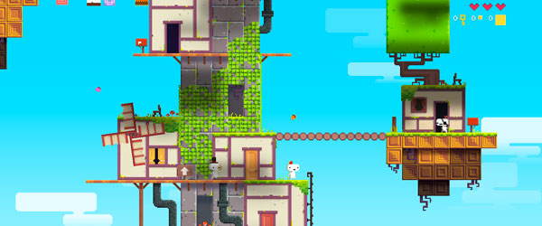

*This image showcases the amazing care and detail that went into the 2D retro pixel art style of FEZ.*

FEZ is a game that can be played easily, but features many advanced puzzles tucked away that must be actively searched for in order to solve them. For this reason, it is easy to see how FEZ might not appear to be difficult, because many puzzles are not forced down the throat of the player. In a way, FEZ forces the player to slow down and really observe the world in order to find everything. FEZ is a good lesson for any game developer in how to integrate puzzles into their world without making them overtly obvious. In an era of dumbing down games so they can appeal to everyone, FEZ takes the risk in making a seemingly simple game extremely difficult to thoroughly complete.

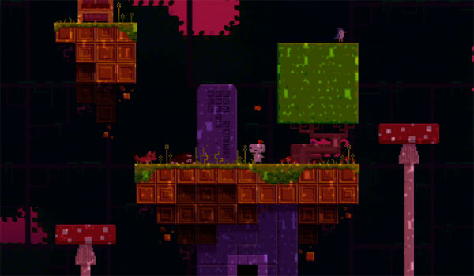

*While some challenges in FEZ are easy, the game is not afraid to give the player extremely difficult puzzles such as this one featuring cryptography.*