Travis Moore

GAT 110 — Fall 2013

Instructor: Rich Rowan

Assignment: Paper #1 — Race Games

|  |  |  |
| --- | --- | --- |
| Dice Outcome | Rules for the Dice Outcome | Probability |
| 1 flat side up | Move pawn 1 space forward | 25% |
| 2 flat side up | Move pawn 2 spaces forward | 37.5% |
| 3 flat side up | Move pawn 3 spaces forward. | 25% |
| 4 flat side up | Move pawn 4 spaces backwards. | 06.25% |
| 4 flat side down | Move pawn 6 spaces forward. | 06.25% |

*Figure 2-3 Senet—Dice Values, Rules, and Probability*

|  |  |  |  |
| --- | --- | --- | --- |
| Test | Players | Game Length | Player Comments |
| 1 | Travis, Preston, Auston, Shae | 1.25 hours | “The addition of in-home kidnapping makes for a crazy, hilarious, and morally twisted version of Sorry!. This makes the game the ultimate game of vengeance. Be careful, the rule could potentially leave the game without an end in sight.” - Preston |
| 2 | Travis, Brittney, Michael, Maddy | 1.5 hours | “Made me laugh. Really enjoyed the mod. Made it really interesting, but also annoying. One downfall is that it increased the time it takes to play the game and have a winner. But on the other hand; it allowed people to come from behind to win.” -Brittney |

Figure 5-1 **Sorry! “Home Invasion” Mod—Test, Players, Game Length, and Player Comments**

|  |  |
| --- | --- |
| Token | Description |
| Per Player: | 4 |
| Colors: | Red, Blue, Green, Yellow |
| Ownership: | Each player only controls their color group of tokens |
| Design Purpose: | Player representatives |

Figure 1-2 **Sorry!—Player Token Attributes**

|  |  |
| --- | --- |
| Token | Description |
| Per Player: | 5 |
| Colors: | Black, White |
| Ownership: | Each player only controls their color group of tokens |
| Design Purpose: | Player representatives |

*Figure 2-2 Senet—Player Token Attributes*

|  |  |
| --- | --- |
| Token | Description |
| Per Player: | 1 |
| Available Racers: | Mario, Luigi, Princess Peach, Yoshi, Bowser, Goomba, Koopa, and Pokey  (racers do not perform different from one another) |
| Ownership: | Each player only controls their selected token |
| Design Purpose: | Player representatives that can collect gold, collect items, use items, use a boost, move forward, backwards, and jump. |

*Figure 3-2 Super Mario Kart Racing Tournament—Player Token Attributes*

|  |  |
| --- | --- |
| Game Board | Description |
| Size: | Square, 15 spaces x 15 spaces. |
| Movement Direction: | Clockwise (unless otherwise directed by a card). |
| Safe Zone, Start, Home | 1 for each color (red, green, blue, and yellow) located in the corners of the game board, 4 in total. |
| Slides | 2 for each color (red, green, blue, and yellow). Slides are grouped by color, 1 group of 2 slides per side of the board. Slides allow a pawn that lands on the beginning of a slide to move forward to the end of the slide (unless the pawn is the same color as the slide). |
|  |  |

Figure 1-1 **Sorry!—Game Board Attributes**

|  |  |  |
| --- | --- | --- |
| mario-diagram.jpg | | 1—Item Slots  2—Boost Indicator  3—Current Place  4—Current Gold  5—Opposing Player  6—Power-Up (Red Mushroom)  7—Obstacles  8—Player  9—Power-Up Block |
| Size: | Each level is roughly a minute long to complete (assuming little to no obstacle collisions). | |
| Movement Direction: | Start from the left of the level and proceed to the finish at the right of the level. | |
| Levels Menu: | There are 8 standard levels and 1 locked level. | |

*Figure 3-1 Super Mario Kart Racing Tournament—Level attributes*

|  |  |  |
| --- | --- | --- |
| Value | Rules for the Card | Probability* |
| 1 | Move pawn from Start or move a pawn 1 space forward. | 11.11% |
| 2 | Move pawn from Start or move pawn 2 spaces forward. Drawing a 2 entitles the player to draw again at the end of his or her turn. If you cannot use 2, you can still draw again. | 08.89% |
| 3 | Move pawn 3 spaces forward. | 08.89% |
| 4 | Move pawn 4 spaces backwards. | 08.89% |
| 5 | Move pawn 5 spaces forward. | 08.89% |
| 7 | Move one pawn 7 spaces forward or split the 7 spaces between two pawns (such as four spaces for one pawn and three for another). This makes it possible for two pawns to enter Home on the same turn, for example. The 7 cannot be split into a 6 and 1 or a 5 and 2 for the purposes of moving out of Start. The entire seven spaces must be used one way or the other or the turn is lost. | 08.89% |
| 8 | Move pawn 8 spaces forward. | 08.89% |
| 10 | Move pawn 10 spaces forward or 1 space backward. If a player cannot go forward the full ten spaces, then one pawn **must** go backward one space. | 08.89% |
| 11 | Move pawn 11 spaces forward or switch places with one opposing pawn. A player that cannot move 11 spaces is not forced to switch and instead can forfeit the turn. | 08.89% |
| 12 | Move pawn 12 spaces forward. | 08.89% |
| Sorry! card | Move any one pawn from Start to a square occupied by any opponent, sending that pawn back to its own Start. If there are no pawns on the player's Start, or no opponent's pawns on any squares, the turn is lost. | 08.89% |
| *Probability assumes a full deck of 45 cards that has had no cards drawn from it yet. The probability of the next card drawn after a card has been pulled is dependent on the previously drawn card and the new number of cards left in the deck. | | |

Figure 1-2 **Sorry!—Card Values, Rules, and Probability**

|  |  |  |
| --- | --- | --- |
| Power-Up | Descriptions | Probability |
| Coin | Gives the player 1 gold coin. | 16.67% |
| Green Mushroom | Gives the player 25 gold coins. | 16.67% |
| Red Mushroom | Gives the player a temporary speed boost. | 16.67% |
| Star | Gives the player temporary invulnerability. Any other racer that the player runs into while invulnerable is stunned for a short time. | 16.67% |
| Feather | Gives the player temporary ability to fly. | 16.67% |
| Flower | Gives the player 1 projectile that shoots from the front of the player and will pass through objects until it hits another racer. A racer hit by this projectile will be stunned for a short time. | 16.67% |

*Figure 3-1 Super Mario Kart Racing Tournament—Power Ups, Descriptions, and Probability*

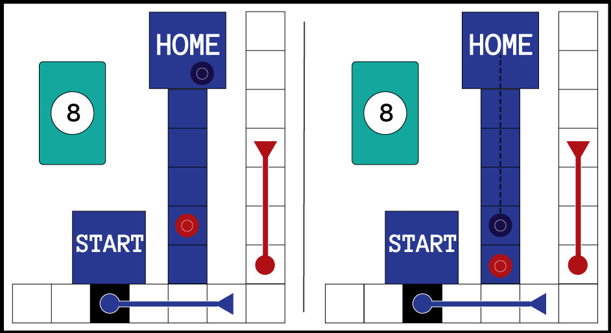

*Figure 4-1: Sorry! “Home Invasion” scenario where the red player draws an 8 and steals a blue pawn from its home. The blue player will need to retry to get the stolen pawn back into home.*

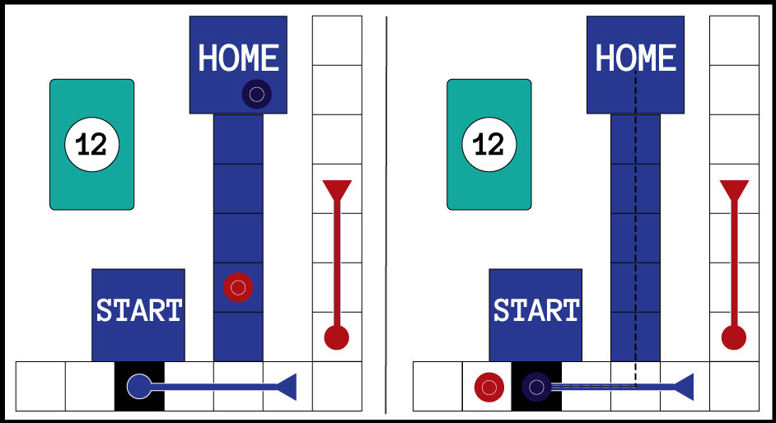

*Figure 4-2: Sorry! “Home Invasion” scenario where the red player draws a 12, steals a blue pawn far enough outside of its home that the blue pawn will have to travel around the board again to get back to home.*