**Travis Moore**

**GAT 110—Fall 2013**

**Instructor: Rich Rowan**

**Assignment: Paper #2—Card Games**

**Game Analysis**

*Conquian* is a turn-based card game that is played by two players that utilizes forty cards out of a standard deck of playing cards. The objective of *Conquian* is to be the first player to form melds, such as four of a kind, of up to eleven cards and have no cards remaining in your hand (see figure 1-1). Similar to the card game *Rummy*, *Conquian* differs in that there are very specific rules for how cards are picked up on a player’s turn that basically disallow collecting cards in order to form melds (see table 1-2). Instead, if a player can be used to create a meld for the player, they must take the card and use it right away. This particular rule dictates the actions of a player in a huge way.

*Conquian* is a card game, so the probabilities of drawing any particular card change every turn based upon the cards already dealt and in the players’ hands. If this were not the case, every card is unique in suit and number, so there is an equal 2.5% chance of drawing any particular card. All this makes the game a challenge to keep track of what the chances are of any one card still left in the deck. There is some strategy in *Conquian*, such as the “Refusal”, which forces a player to pick up a card and add it to an existing displayed meld. Mostly a player relies heavily on having the right cards dealt to them at the start of the game and luck of the draw to get cards needed to create melds and win.

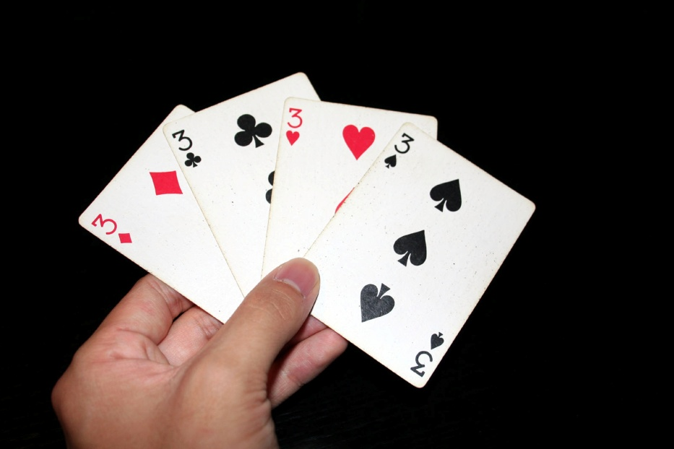

*Figure 1-1 Conquian can be played with a normal deck of cards,   
in this example the player has a meld of 3’s*

*Table 1-2 Conquian—Attributes and Description*

|  |  |
| --- | --- |
| Attributes | Description |
| Components | A deck of 40 cards which rank:  A 2 3 4 5 6 7 J Q K  A normal deck of cards may be used as long as the 8, 9, and 10 cards are removed. There is a 2.5% chance of drawing any one card from the deck (assuming no other cards have been drawn). |
| Players | *Conquian* is played by 2 players but can be played with more. |
| Goal | To win a hand of *Conquian*, a player must meld eleven cards and by their last play, must use the drawn card on their meld. |
| Setup & Deal | Each player is dealt nine cards , one card is turned face-up to start the discard pile, and the remaining cards are stacked face-down on the table to be used as the draw pile. |
| Play | On a player’s turn they must take and use the face-up card on the discard pile if they can create a meld with it. If the player is unable to do so, then the next player has the option of using the card. If all players are unable to use the card, then a new card is turned face-up on top of the discard pile and the previous card is no longer able to be used in the game. |
| Melding & Refusal | Melding can be accomplished by pairing 3 – 4 cards of the same kind or by a straight flush sequence of 3 – 10 cards of the same suit (A 2 3 4 5 6 7 J Q K would be a valid sequence of 10 cards).  If a player refuses a face-up card in the discard pile which can be legally added to an existing meld, then the opposing player can force the player to take and use the card in the meld. |
| Scoring | Points still in the losing player’s hand are awarded to the winner with the face card values for cards 2 – 7, 10 points each for Jacks, Queens, and Kings, and 15 points for Aces. |

*Mille Bornes* is a turn-based and team-based auto race card game that is playable by two teams of two players each (see figure 2-1). The objective of the game is to go a total distance of 1000 miles before the opposing team does. The game is played with a specialized deck made up of four types of cards for a total of 106 cards (see table 2-2). The four different types of cards can be used to help your team gain distance, repair a hazard, prevent or block a hazard, and also inflict a hazard upon the opposing team. The variety of types of cards and team-based nature of *Mille Bornes* allows for the game to be played out in many different ways.

As a card game with a variety of cards, the probability of drawing any one card in *Mille Bornes* is different with every card already drawn, and as such it is difficult to keep track of what the probabilities of drawing any one card can be (see figure 2-3). While a challenge, it is a good idea to keep track of what cards have been played and which are left in the deck. There are unique rules for each card that allow for different types of strategies to be used during play. A player can attack an opponent, counter an opponent, repair their team’s car, prevent hazards to their team’s car, or go specified distances if their current situation allows it.

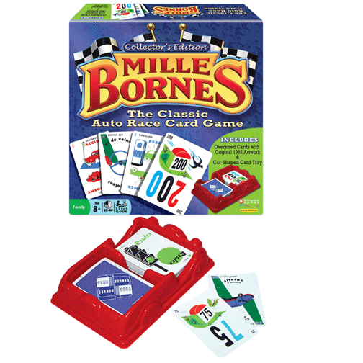

*Figure 2-1 Mille Bornes Auto Race Card Game*

*Table 2-2 Mille Bornes—Attributes and Description*

|  |  |
| --- | --- |
| Attributes | Description |
| Components | A special deck that consists of 106 cards. |
| Players | 2 teams of 2 players each for a total of 4 players. |
| Goal | Be the first team to reach 1000 miles in a hand in order to earn enough points to win the game (typically 5000 points). |
| Setup & Deal | 6 cards are dealt to each player and the remaining cards are stacked face-down to create the draw pile. A discard pile is created when a player is unable to play a card. Each team sets up a tableau; an example can be seen in the image below, to organize cards being played.  http://upload.wikimedia.org/wikipedia/commons/thumb/1/11/MB-tableau1.svg/250px-MB-tableau1.svg.png |
| Play | On a player’s turn they must draw a card and then play a card if they are able to do so. If the player is unable to play a card then one card from their hand must be placed into the discard pile. |
| Coup-fourré | A player may counter an opposing player’s placement of a Hazard card if they use the corresponding Safeties card during the opposing player’s turn. This effectively blocks the Hazard card and the player may draw another card from the deck to ensure that they have 6 cards in their hand. |
| Scoring | When a hand ends, the game is scored by both teams using the following scale:  **Distance**: 1 point per distance traveled.  **Safeties**: 100 points per safety played.  **All Safeties Played**: 700 points (on top of Safeties points).  **Coup-fourré**: 300 points each (on top of Safeties points).  **Trip Completed**: 400 points for the winner.  **Delayed Action**: 300 points for completing the trip after the draw pile is exhausted.  **Safe trip**: 300 points for winning using no 200 mile cards.  **Shutout**: 500 points for winning without the opposing team playing any distance cards. |

*Table 2-3 Mille Bornes—Card Types, Descriptions, and Ratios*

|  |  |  |
| --- | --- | --- |
| Card Types | Descriptions | Ratios |
| Hazards Cards | Hazards cards are used to stop the opposing team from gaining distance. There are 18 Hazard cards in total, made up of 5 different kinds of Hazards cards which can only be fixed with the corresponding Remedies card:  **Accident Cards (Qty 3)**  **Out of Gas (Qty 3)**  **Flat Tire (Qty 3)**  **Speed Limit (Qty 4)**  **Stop (Qty 5)** | **106** cards in total **18** Hazards cards.  **16.98%** of the cards are Hazards cards.  **2.83%** of the cards are Accident, Out of Gas, and Flat Tire cards.  **3.77%** of the cards are Speed Limit cards.  **4.71%** of the cards are Stop cards. |
| Remedies Cards | Remedies cards are used to fix the specific Hazard card that has afflicted your team. There are 38 Remedies cards in total, made up of 5 different kinds of Remedies cards which can only be used to fix the corresponding Hazards card:  **Repairs (Qty 6)**  **Gasoline (Qty 6)**  **Spare Tire (Qty 6)**  **End of Limit (Qty 6)**  **Roll (Qty 14)** | **106** cards in total **38** Remedies cards  **35.85%** of the cards are Remedies cards.  **5.66%** of the cards are Repairs, Gasoline, Spare Tire, and End of Limit cards.  **13.20%** of the cards are Roll cards. |
| Safeties Cards | Safeties cards are used to fix and also prevent Hazards cards of the corresponding type. There are 4 different Safeties cards in total:  **Driving Ace (Qty 1)**  **Extra Tank (Qty 1)**  **Puncture Proof (Qty 1)**  **Right of Way (Qty 1)** | **106** cards in total **4** Safeties cards  **3.77%** of the cards are Safeties cards.  **~1%** of the cards are Driving Ace, Extra Tank, Puncture Proof, and Right of Way cards. |
| Distance Cards | Distance cards are used to gain mileage in the game. Mileage cards can only be used if your team has no Hazards unfixed and have a ‘Go’ card in play.  **25 Mile (Qty 10)**  **50 Mile (Qty 10)**  **75 Mile (Qty 10)**  **100 Mile (Qty 12)**  **200 Mile (Qty 4)** | **106** cards in total **46** Distance cards  **43.40%** of the cards are Distance cards.  **9.43%** of the cards are 25 Mile, 50 Mile, and 75 Mile cards.  **11.32%** of the cards are 100 Mile cards.  **3.77%** of the cards are 200 Mile cards. |

*Marvel Super Hero Squad Online Card Game* is a digital card collecting and playing game that is playable by one player against a computer opponent. The goal of the game is to discard all of your opponent’s cards that they have in their deck and hand. The game consists of digital cards that can be accessed, bought, and sold by going to the game’s website (see figure 3-1). Leveraging the fact that this card game is a digital game, *Marvel Super Hero Squad Online Card Game* is played like a super hero battle with attack and block animations that play depending on the 40 cards per player deck that is used during the game (see table 3-2).

*Marvel Super Hero Squad Online Card Game* has a variety of cards that have unique attributes and rules depending on the card (see figure 3-3). On top of this, the game encourages building a customized deck, so the probabilities of drawing any one card are entirely based upon the current build of the deck. The game employs a coin-flip randomizer, which increments on heads, providing some pacing to the game by delaying powerful cards from being used right away. The variety of cards provides a multitude of strategies to win. In general, the cards exist to attack your opponent, block attacks from your opponent, and employ special rules that will help you win the game. All of these actions are successful or not depending on the “factor” of the card and the current power level of the game.

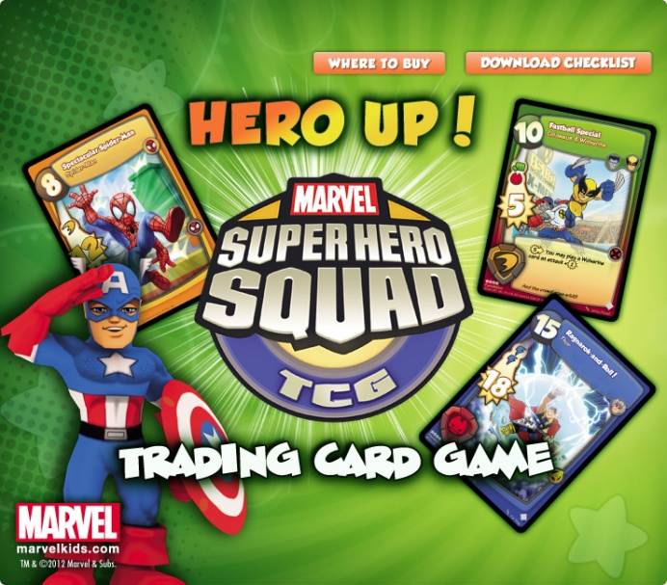

*Figure 3-1 Marvel Super Hero Squad Online Card Game*

*Table 3-2 Marvel Super Hero Squad Online Card Game —Attributes and Description*

|  |  |
| --- | --- |
| Attributes | Description |
| Components | A deck of 40 cards per player which can consist of any legal cards decided by the player. Due to this, the composition of a deck can vary greatly. |
| Players | *Marvel Super Hero Squad Online Card Game* is played between 2 players. |
| Goal | Be the last player to have cards remaining in either your hand, deck, or both when you opponent runs out of all cards. |
| Setup & Deal | A coin is flipped to determine who goes first. Each player deals 4 cards from their own deck and then creates the draw pile by stacking the remaining cards face-down. A discard pile is created as cards are “knocked” out of play or used. A “Keeper” pile is created upon successfully attacking an opponent with a card with the “Keeper” special rules. |
| Play | At the start of a turn a coin is flipped. If the coin is heads the game’s power goes up by 1. A player then draws one card from their deck and chooses either to attack or pass their turn. |
| Attack | A player may attack if the card they choose to play is equal or less than the game’s current power level. If the attack is not blocked then the card does damage based on the attack value of the card. If the card has a special ability, the special ability is then followed. After this, or if the attack is blocked, the card is discarded in the player’s discard pile face-up. |
| Block | A player may block an attack by matching its color with the block color. |
| Damage | Damage is dealt out to a player based on the attack value of the card that is used. Cards are removed from a player’s deck until either a card matches the block type needed or the max attack value is reached. |
| Special Ability | Special ability instructions vary from card to card and some may only apply if a minimum damage was done with the attacking card. |
|  |  |

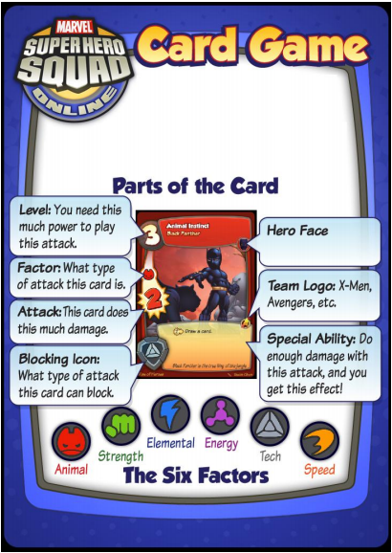

*Figure 3-3 Super Hero Squad Online Card Game—Card Explanation*

*Conquian, Mille Bornes,* and *Marvel Super Hero Squad Online* share some commonalities, despite feeling like entirely different games (see table 4-1). All three of the games are turn-based games where the goal is to be the first player to accomplish an objective using primarily cards as the main component and randomizer for the game, with the only exception being the addition of a coin flip used in *Marvel Super Hero Squad Online Card Game*. All three card games use some form of strategy that works against the opponent, but they all do so in different ways. *Mille Bornes* and *Marvel Super Hero Squad Online Card Game* are very similar in that they both use custom cards that either harm an opponent or help the player in some way. Both games achieve this mechanic in different ways, such as the attacking and blocking in *Marvel Super Hero Squad Online Card Game* while *Mille Bornes* uses hazards and remedies to accomplish this.

*Table 4-1 Game Analysis Comparison*

|  |  |  |  |
| --- | --- | --- | --- |
|  | *Conquian* | *Mille Bornes* | *Marvel Super Hero Squad Online Card Game* |
| Share the same Deck | Yes | Yes | No |
| Traditional Card Setup (Draw/Discard) | Yes | No. There are additional Card placements. | No. There are additional Card placements. |
| Simple Cards/ Complex Cards | Simple cards with no additional rules attached to each card. | Complex cards that have different rules depending on the type of card it is. | Complex cards that have different rules depending on the type of card it is. |
| Solo /  Team-Based | Solo | Team-Based | Solo |
| Turn Based | Yes | Yes | Yes |
| Card Collecting | No | Yes | Yes |
| Strategy Mechanisms | Refusal and Melding | Hazards, Remedies, Safeties, Distance, and Coup-fourré. | Level, Factor, Attack, Blocking, and Special Abilities |
| Win Condition | Form 11 cards worth of melds and have no cards left in hand before your opponent. | Reach 1000 miles before your opponent. | Discard all cards from the opponent’s deck and hand while still having cards remaining in either your hand, deck, or both. |
| Randomizers | Cards left in deck | Cards left in deck | Cards left in deck and coin flip |

**Dynamics Analysis**

*Conquian* is a challenging game that often feels frustrating and slower than it actually is. In order to win a hand the player must rely greatly on being dealt a good hand. This can cause frustration because the player cannot remedy a bad hand by collecting cards in order to correct what they currently have. Instead a player must wait in the hopes that the right cards will appear from the deck or from their opponent. While the game can go by quickly, the lack of options available to a player during a turn can make the game feel slow. This is especially true if the player has been unable to take a card for several turns because the cards do not help the player form a meld. While it is nice to win a game, winning more often than not felt like it came from luck more than strategy.

*Mille Bornes* is meant to be an auto racing card game and it often felt like the best and worst parts of an actual car race. The game felt like it went at a moderate pace, which is probably because there are a lot of decisions any player can make in their turn, and there are three players that must play before play starts from the first player again. However, playing with more players made the game fun because of the camaraderie between teams and the satisfaction of winning a hand through teamwork. The variety of cards helped the game feel like the player was more in control of the outcome, despite the probabilities of drawing any one card. The game did feel significantly longer to play, especially when a team had a car stuck and waiting on the right remedy or a ‘Go’ card to get moving again. These situations made the game feel extremely frustrating at times.

*Marvel Super Hero Squad Online Card Game* is a complex game that can be very difficult to play if your deck is not very good. The pace of the game often felt slower than it should have because of the animation sequences between cards being played. The variety of cards did help the player feel in control of the action, but not having the right cards could make the game feel like it was stalling when there were never the right cards to play to attack or block an opponent. Playing against a computer opponent often made the game feel like a lot of luck was needed in order to draw the right cards against whatever random cards the computer opponent had.

Even though *Conquian, Mille Bornes,* and *Marvel Super Hero Squad Online Card Game* are all card games, they all felt different to play. What the games did share in common were the stall moments where no cards could be played during a player’s turn. These moments made all three of the card games frustrating and were a big problem every time it happened. The depth of strategy in *Mille Bornes* and *Marvel Super Hero Squad Online Card Game* helped the game feel more in control of the player, as opposed to *Conquian* which always felt like luck was needed in order to win. The lack of variety in cards hurt *Conquian* and made the game feel far less satisfying when compared to *Mille Bornes* and *Marvel Super Hero Squad Online Card Game.*

*Table 5-1 Dynamics Analysis Comparison*

|  |  |  |  |
| --- | --- | --- | --- |
|  | *Conquian* | *Mille Bornes* | *Marvel Super Hero Squad Online Card Game* |
| Tempo | Since the game did not have much to it a hand could go by quick, but it might seem to be slow if there was never a card you could use for meld. | The game involved more people so the game felt slower between turns. The game also featured huge stall moments that could make the game take even longer. | The animations between turns were fun, but soon became repetitive and make the game slower between turns. There were not a lot of stall moments. |
| Rhythm | There were not a lot of decisions a player could make, so the rhythm felt flat and not interesting. | A variety of card types made the game interesting and varied in the actions that were taken per game. | The complexity of the card types meant every turn could be played in any number of ways making it fun to decide how to play. |
| Composition | Slightly satisfying, though winning felt mostly based on luck of the draw. | Satisfying due to team camaraderie and variety of strategies to win. | Playing against a computer made luck seem important because the game feel stacked in the AI’s favor. |

**Modification**

I decided to modify *Mille* *Bornes* in an attempt to help negate the frustrating stall moments by making the game quicker and hopefully more satisfying to play. In particular, my modification is an attempt to rid the game of painfully long situations where one team is stuck for multiple turns in a stall moment waiting for the “Roll” card to be drawn from the deck to help their team get going again. It was especially absurd to be waiting for a “Roll” card after waiting for a long time for the correct remedy card to fix the car. After thinking through several solutions to this problem I decided to simply remove all “Stop” and “Roll” cards from the game and call my modification to *Mille Bornes* “No Stop, Just Roll”.

The “No Stop, Just Roll” modification allows teams to simply place down distance cards without the need of first playing down a “Roll” card. If a team has a hazard inflicted upon their car, they must play the corresponding remedy to remove the hazard. However, because there are no long “Roll” cards in the deck, the team can start playing distance cards right away. Also, because remedying the car requires no “Roll” to start moving again and there are no “Stop” cards. Since these situations now cancel each other out, there should be no need for “Roll” or “Stop” cards at all. This should also have a side-effect of making the “Right of Way” card significantly less powerful as it only applies to “Speed Limit” cards. This modification seemed like a good way to keep the game moving and correct extremely long stall periods.

**Testing Report**

Upon conceiving of “No Stop, Just Roll” I wanted to make *Milles Borne* more enjoyable by reducing stall times in the game by not needing a “Roll” card to go after remedying a team’s car. Upon the first test I was concerned that my modification would not be successful because the first hazard played caused the afflicted team to wait quite a few turns before they finally got the right remedy. Due to this, I feared that because my modification did not affect waiting for the right remedy card it would fail in significantly reducing stall moments. Thankfully, further into the testing this fear would be proved to be completely wrong.

While the “No Stop, Just Roll” modification did not affect waiting for the right remedy, it still managed to make a large impact on overall waiting times between waiting to move and being able to again. In fact, all “No Stop, Just Roll” modified games were completed quickly, with the fastest test clocking in at around 12 minutes. Players commented on this by saying things such as, “time of gameplay was significantly shorter, engagement was slightly increased. Overall, taking out the ‘Roll’ and ‘Stop’ cards was effectively in making the game play more smoothly”, and, “I liked the lack of ‘Roll’ and ‘Stop’ cards. It significantly improved the pace of the game” (see table 6-1). The resulting comments made by nearly all test players seem to reflect that *Milles Bornes* played smoother and more enjoyably with the “No Stop, Just Roll” modification.

Unexpectedly, the “No Stop, Just Roll” modification did work a little too well at eliminating the effectiveness of hazard cards. In particular, by removing the “Stop” card, there were only thirteen of the original eighteen hazards to be played. This meant fewer chances to stop an opposing team as well as the reduced wait times between being stopped and being able to go again. This was noted by a few players who said, “not getting stuck as often resulted in less gameplay time which somehow changed the dynamics noticeably” (see table 6-1). This is not to say that some tests did not experience long stalls, as test four had a team stalled for quite awhile. However, this allowed the other team to win even quicker than perhaps possible before. The side effect of reducing the effectiveness of the “Right of Way” card was seen as a good change to the card, with many players explaining that they thought the card was too powerful in the original version of the game anyway.

Overall, the effectiveness of the “No Stop, Just Roll” modification to correct the frustration felt during long stalls of *Mille Bourne* worked and was found to be fun by the players. By removing the “Stop” hazard and reducing the requirements of going the mechanics of movement were majorly altered to make the game very smooth to play. One of the most flattering comments that spoke to this said, “The game was perfect. Do not change a thing. It’s fast, engaging and easy to play! A large improvement over the original” (see table 6-1). However, the modification largely affected the dynamics of the game by really shortening the time needed to play a hand and was noticeable to the players. This is because the game negatively affected the effectiveness of the hazard mechanics by making it easier for a team to remedy and get going again.

*Table 6-1 Mille Bornes “No Stop, Just Roll” Mod—Test, Players, Time, and Player Comments*

|  |  |  |  |
| --- | --- | --- | --- |
| Test | Players | Time | Player Comments |
| 1 | Preston, Rebecca, Shae, Travis | 15 minutes | “Game was closer because no team was stuck without a ‘Roll’ card. Far less frustrating, but with less variability which is good and bad.” —Rebecca Lepore  “The game was perfect. Do not change a thing. It’s fast, engaging and easy to play! A large improvement over the original.” —Preston Lowery |
| 2 | Brittany, CJ,  Michael, Travis, | 14 minutes | “Time of gameplay was significantly shorter, engagement was slightly increased. Overall, taking out the ‘Roll’ and ‘Stop’ cards was effectively in making the game play more smoothly. However, not getting stuck as often resulted in less gameplay time which somehow changed the dynamics noticeably.” —CJ Payne |
| 3 | Auston , Brittany, Garrett, Travis | 15 minutes | “Really enjoyed it! It shortened the gameplay by quite a bit. It did make the game lose it’s ‘stall’ ability without the ‘Roll’ and ‘Stop’ cards. This made it easier to repair things and keep going with a reduced ‘stall’.” —Brittany Keller  “I liked the lack of ‘Roll’ and ‘Stop’ cards. It significantly improved the pace of the game.” —Garrett Huxtable |
| 4 | Aubrey, Ian, Michael, Maddie | 12 minutes | “Game movement was increased dramatically making the game shorter and reducing fatigue. Did not make a huge change beyond waiting times.” —Michael Van Zant  “This game was very entertaining and fun to play. The other team had issues getting repairs, so my team won quickly.” —Maddie Santino |

**Further Modifications**

While my “No Stop, Just Go” modification to *Mille Bornes* was successful in reducing the stall times and the accompanying frustration that comes with the stall, it was not perfect. I am happy that the modification made the game play smoother and much quicker than before, but the downsides of the modification take away from an important part of the game, the effectiveness of the hazard cards. I had not anticipated that the modification would affect the effectiveness of hazards so greatly, which are important in allowing teams to catch up when they are far behind or simply gain some ground against the opposing team.

Without completely getting rid of the core change to “No Stop, Just Go” modification of removing the “Roll” and “Stop” cards from *Mille Bornes,* there are still a few ways that might fix the modification to make it work better. It is possible that adding more types of hazard cards could restore the balance of no longer having the “Stop” cards in the game. New hazards like “nails in the road” or “oil slick” could potentially be fun new hazards to play. This solution could help offset the lack of “Stop” cards, but does nothing to increase the stall factor of any one hazard. Another solution could be to simply increase the effectiveness of the hazards already in the game. One such idea could be to implement a turn penalty to a hazard. Perhaps each hazard could inflict a certain number of “skipped turns” to a team who receives a hazard card. This could make the hazard effective in making the opposing team wait before they can attempt to fix the hazard. This would also not keep the game from stalling too long if the team has the right remedy card for the hazard and must simply wait before they can use it. This change to the “No Stop, Just Go” modification might be a fair way of making sure hazard cards are still useful in their intended function.