Travis Moore

GAT120—F13

Paper #5—Portal: How to Teach the Player

With every new player to a game, there is a crucial moment right from the start that the game must do correctly: teach the player how to play the game. This is an important part of retaining a player’s attention in order that they do not get frustrated early and quit the game before they have even really started to play the game. For this reason, teaching the player how to play the game is something a game designer cannot ignore if they want their game to appeal to the masses. This is especially true if the game has difficult concepts for the player to learn, such as solving puzzles using portals in Valve’s critically acclaimed game, *Portal*. By properly using several different teaching methods, the designers for *Portal* are able to successfully train a player how to play game.

Perhaps the most overt method of teaching, *Portal* does not shy from simply telling the player how to play the game. Right from the start of the game, *Portal* visually shows the player the controls on the screen using text (see Figure 1). While not subtle, this is important information that must be made as crystal clear as possible so visually showing this to the player ensures that they can begin to play the game. *Portal* also communicates concepts to the player visually, such as having the player see their own character go through a portal to understand how portals operate (see Figure 2). By showing the action to the player they are able to learn how going in one portal leads to exiting out the other portal. Aside from showing, *Portal* also is not afraid to audibly explain to the player how to accomplish tasks. For example, in test chamber 10 GlaDOS explains to the player, “[Momentum, a function of mass and velocity, is conserved between portals. In layman's terms: Speedy-thing goes in, speedy-thing comes out.”](http://i1.theportalwiki.net/img/b/b1/GLaDOS_06_part1_success_2-1.wav) This kind of reinforcement helps the learning process of the player as they proceed in the game.

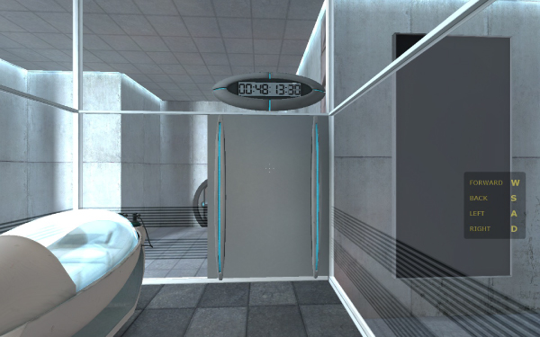

*Figure 1—an example of visually showing the player the controls on the screen.*

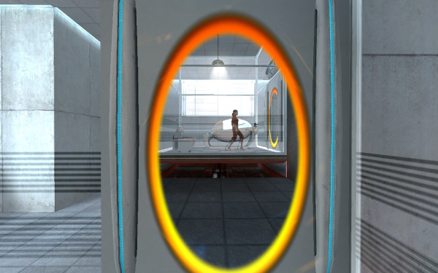

*Figure 2—an example of how a player sees themselves entering through a portal to appear on the other side.*

Taking full advantage of *Portal* mostly taking place in test chambers, *Portal* also utilizes signage to help a player learn how to play the game. At the entrance to every test chamber there are large signs that help a player understand what kind of obstacles they will be up against (see Figure 3). Along with this, *Portal* test chambers make prominent use of floor and wall signage that explain every significant element of a test chamber (see Figure 4). There are even signs explaining concepts, such as flinging through portals, step-by-step to the player (see Figure 5). This excessive signage not only fits the obsessive testing environment well, but also establishes a pattern to the player that they are able to learn quickly.

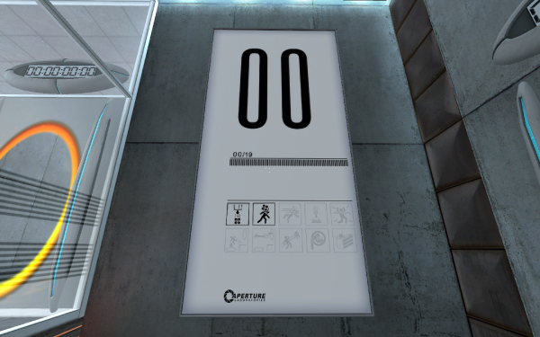

*Figure 3—an example test chamber sign that shows companion cubes will be featured in this test chamber 00.*

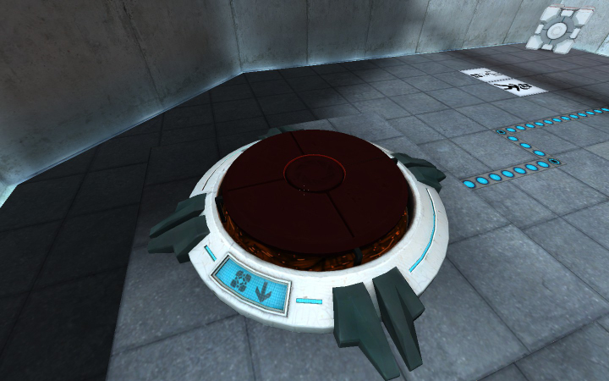

*Figure 4—an example of signage where a Fifteen Hundred Megawatt Aperture Science Heavy Duty Super-Colliding Super Button shows that a Weighted Storage Cube must be placed upon it.*

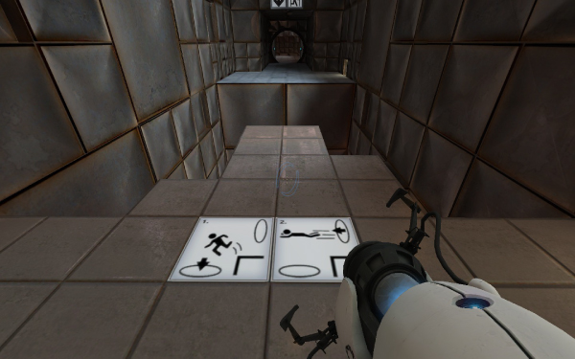

*Figure 5—an example of signage that explains the concept of flinging through a portal.*

While so far the methods of teaching a player in *Portal* have not been subtle, the use of design consistently throughout *Portal* is perhaps something that is not noticeable until one looks for it. *Portal* is an amazing example of how you can teach a player to associate shapes and colors in a game. Shapes in *Portal* are used in a consistent manor so as to help the player quickly recognize objects and their purpose. The iconic oval shape of the portal is unique to portals and portals only, helping the player see them when they are placed in the environment (see Figure 6). Buttons are always circular and require something to push them, usually a cube; which exists only to be placed on buttons and not for any other use (see Figure 7). Trailing power lines are also consistently colored so the player knows if they need to solve a puzzle or have already solved it (see Figure 8). Consistency helps a player understand how to play a game, and *Portal* is exceptional at establishing consistent shapes and colors early in *Portal*.

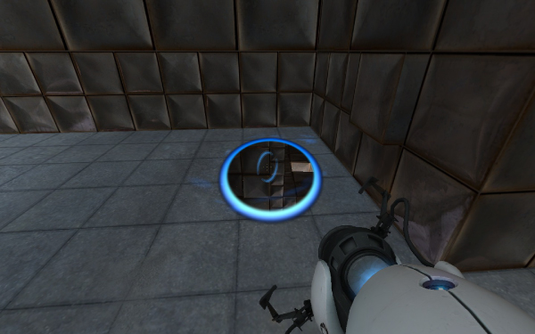

*Figure 6—an example of how the oval shape of a portal stands out in such a geometric environment.*

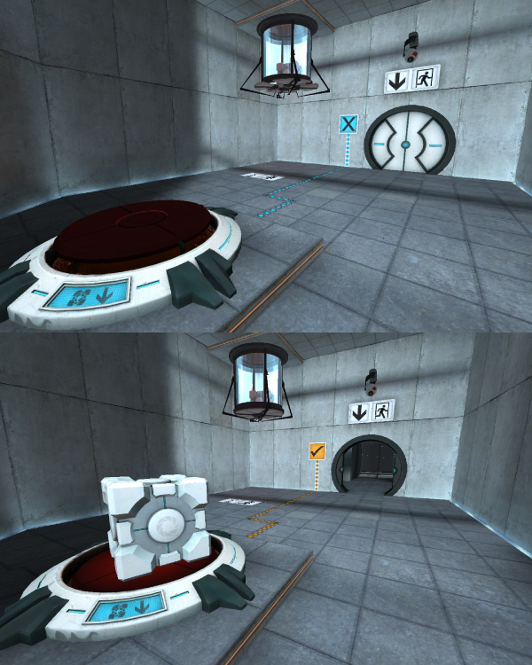

*Figure 7—an example of the shape of button and cubes and how they relate to their function in solving puzzles.*

*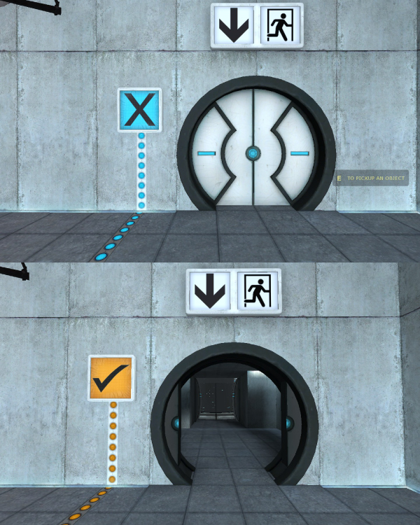Figure 8—an example of how the colors blue and orange are used to indicate a puzzle being solved.*

Even the environment is a teaching tool for players in *Portal*. By extending a platform over a pit so that it looks like a diving board encourages the player to place a portal into it and jump through it (see Figure 9). Jumping into a pit might seem counter-intuitive to an experienced gamer, but the diving board shape invites the player to jump into the pit like jumping into a pit of water. Test chambers also extend panels from the wall to help teach the player to use great heights to help solve puzzles (see Figure 10). A common motif in *Portal*, this teaches the player to place portals in high places to help learn the flinging concept in a way where maybe the player would not have looked up to place a portal before.

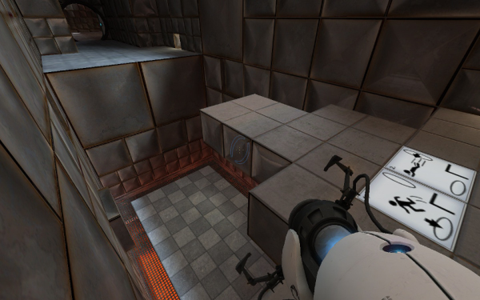

*Figure 9—an example of the diving board-like platform with an accompanying sign help teach flinging by jumping through portals places into a pit.*

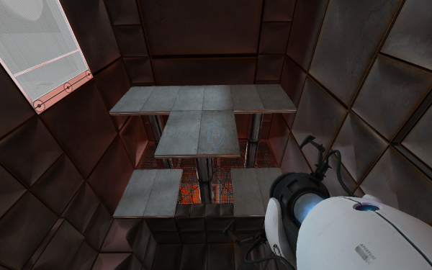

*Figure 10—an example of panels pushing out from the wall to invite the player to place a portal up high.*

Make no mistake, while *Portal* is a challenging game, it would be needlessly difficult if the game did not handle teaching the player properly. There is so much teaching happening in *Portal*, whether it is or is not subtle, that the player cannot help but learn how to master playing the game. *Portal* proves that even difficult concepts can be taught if a game designer knows how to teach them in a game the right way.