Travis Moore

GAM205—Fall 2014

Milestone 2

Testing Report

Table of Contents

**Testing Report 3 – 6**

Concept Art Testing 3 – 4

Intentions 3

Testers 3 – 4

Results 4

Character Controls Testing 5 – 6

Intentions 5

Testers 5

Results 5 – 6

Concept Art Testing

Intentions

As the art lead it is up to me to determine an art style for our game that we can us to help our game look like it is fun and fits our theme well. I am found of a simple, geometric look, so my concept art involves using this low-poly, geometric style. Because our game takes place during the day when things are safer and also during the night when things are much stranger and scarier I thought I’d test the looks of enemies to see if this change is distinct enough. Also, we’ve recently decided to really play up the time period of the 1950’s post WW2 idea, so the night version of enemies should have a slightly WW2/American feel to them.

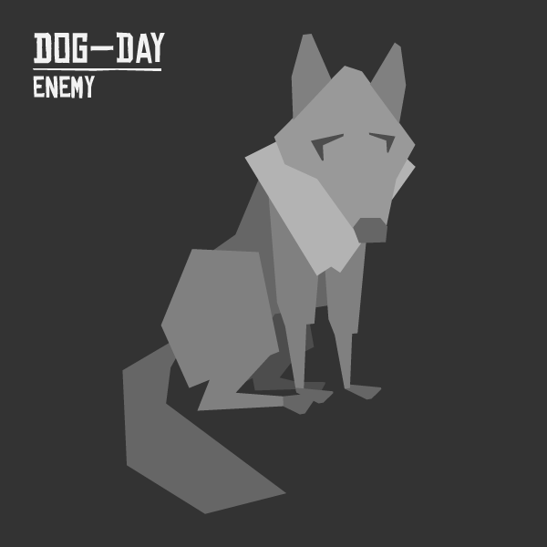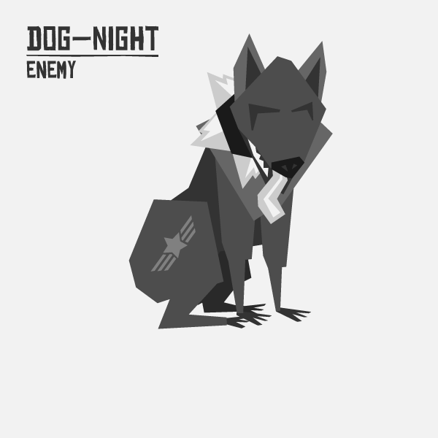

Testers

Classmates from the Digipen, non-Digipen friends, as well as fellow teammates participated as testers, giving me their opinions on how the concept art looked and if it matched what we are looking to convey with it.

**Name:**

* Jason Guelber t
* Berne Capone
* Eric Gleiser
* Garret Huxtable
* Auston Lindsey
* Shaheene Moore
* Chris Sherwood
* Faith Legat
* Christopher Christensen
* Alina Tkatz
* Robyn Wakimoto
* Martha Stensland
* Maddie Santino

Results

I’ve come to rely on this group of people because they all give great responses and do not all agree with me or each other. I reserve the right to make my own decision, but the thoughts and opinions of the testing surely will be on my mind in future versions of developing the game’s art style. To prevent color choices being an issue, I decided to show an enemy dog in both its day and night forms in black and white to make sure people would focus on the form of the enemy.

Everybody seems to love the daytime version of the dog. Testers see the dog as initially non-threatening and many of the testers think the geometric style of the dog is fun and looks really good. The night version of the dog has mostly good feedback but there is some confusion about it, as well. Testers see the night version of the dog as definitely more threatening, especially in comparison to the day version of the dog. The spike collar is the biggest reason why people see the dog as more threatening, followed by the darker value of the dog itself.

The biggest point of ambiguity comes from whether or not the dog is seen as WW2-ish or not. The stars and bars definitely come off as American to most of the testers, but the leap to an automatic military feel is not as overtly there. It has been suggested that the dog wear an American style WW2 helmet and I might just implement this idea. This way the stars and bars shaved into the fur is not so random in feel and it would be right in place on a helmet. The lack of a tail is an issue to some testers, but I feel like having no tail better distinguishes the dog from its day version.

Character Controls Testing

Intentions

As we keeping adding functionality to our main character, Setsuko, it is important that the character feels right to our players. As such, we have tested our character’s controls amongst ourselves and a few Digipen students at school. In particular we want to make sure that the movement of Setsuko feels right as far as speed and turning goes, the deployment of pushing with the umbrella is strong enough, targeting feels right and is not confusing, and that controlling the tongue with the second analog stick is not difficult and feels natural.

Testers

Classmates from the Digipen, as well as fellow teammates participated as testers, giving us their opinion on how the character feels with the way the controls currently work.

**Name:**

* Jason Guelber t
* Berne Capone
* Eric Gleiser
* Garret Huxtable
* Auston Lindsey
* Shaheene Moore

Results

There are some problems that we are aware of prior to testing the character controls. For one thing, we do not have a tutorial level to learn the controls, so the testers have to just try things out without any real instruction. This causes problems with the people who are not on our team trying out the character for the first time. This is something we will definitely need to do in the near future so that we can get better results with testers. Secondly, our character still has functionality missing, so this test will only be accurate for the abilities we currently have in place.

Movement with Setsuko is described as being good. She feels fluid and while she looks very mechanical, her speed and turning feels pretty natural. Her push ability has been described as fun and easy to do, but testers think there should probably be a limit to how many times you can push things per button press. As it stands if you press the button the umbrella pushes things, so mashing the button causes a lot of pushes to happen nearly at once. I will more than likely be working with Eric on implementing a cooldown UI timer for the umbrella before the next milestone to correct this.

Lastly, the targeting is not as obvious as it could be. I think we need to do something better graphically to represent targeting because while there is a cone that appears above the target it does not really call out a lot of attention to itself. We should probably zoom in the camera a bit and rotate the graphical element around the target so that is extremely clear that we are targeting something. As it is right now it is way too passive, despite being functional. We did run into one bug where a target that dies while being targeted causes the targeting to break if it is reused. This is something Eric will correct.

Of the most concern from the play testing the ability to move the tongue is not all there yet. It does not feel very natural and definitely needs work. Aside from Eric, everyone has a hard time trying to get the tongue to do what we want it to do. This might be okay if we convince the player that the umbrella has a “mind of its own”, but if we want full player control of this then we need to spend some time fine-tuning this.