Travis Moore

GAT 211A—Fall 2014

Instructor: Jeremy Holcomb

Lab Report 10

Team Fortress 2   
CTF Playtest #3

Table of Contents

**Lab Report 3 – 10**

Team Fortress 2 CTF (version 03)

Written Rules 3 – 6

Intentions 7

Playtesters 7

Playtesting 8 – 9

Other Student Games 9 – 10

Project 4 Idea 10

Team Fortress 2 CTF (version 03)

Written Rules

Components

* 12 class tokens (6 Blu and 6 Red)
* 1 D4 die
* **1 D8 die**
* 1 map
* 2 class stat/rule sheets
* **12 weapon cards (6 Blu and 6 Red)**

Players

2 players

Objective

The objective of the game is to ~~eliminate all nine classes of your opponent~~ **capture the flag and bring it back to your spawn room before your opponent does.**

Setup

Players roll a die to determine who will go first in the game. The highest die roll lets this player go first, while the losing player gets to choose which color team they’d like to be. Players place all 6 of their class tokens in their color spawn room without revealing the class side of their class tokens to their opponent. The player who won the die roll moves first.

Rules

Players can move and ~~take one action~~ **attack** with each of their class tokens per turn **(the scout is an exception to this rule and has an extra move that can be made after moving and attacking normally)**. An ~~action~~ **attack** can be either moving or shooting. Each class follows their own stat/rule sheet to determine moving, health, and shooting. Do not reveal which the class side of your token unless there is clear line of sight between your token and an enemy token. Movement is orthogonal on the grid and firing at an enemy is based upon line of sight of an enemy (from the center of your grid square, to the center of the target grid square). Classes do not respawn after dying.

Class/Weapon Rules

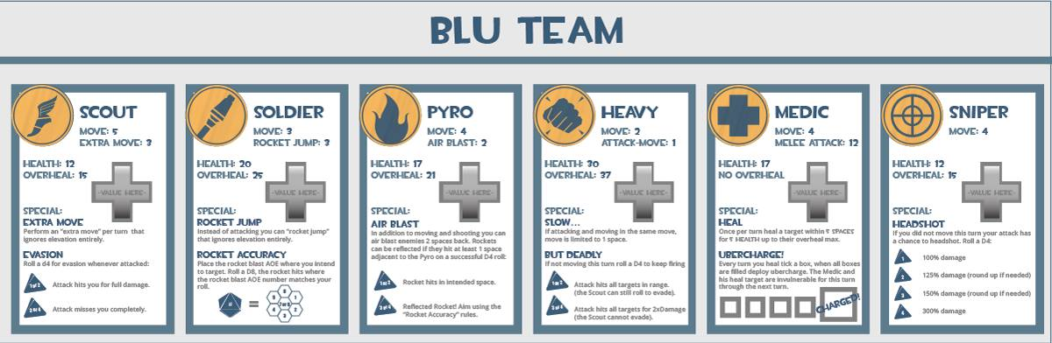

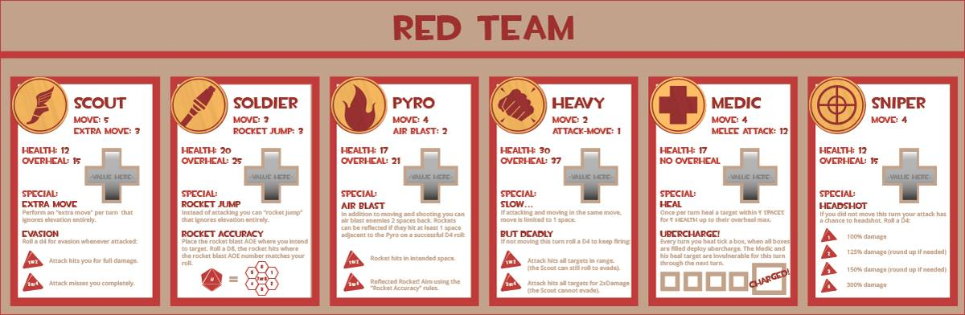

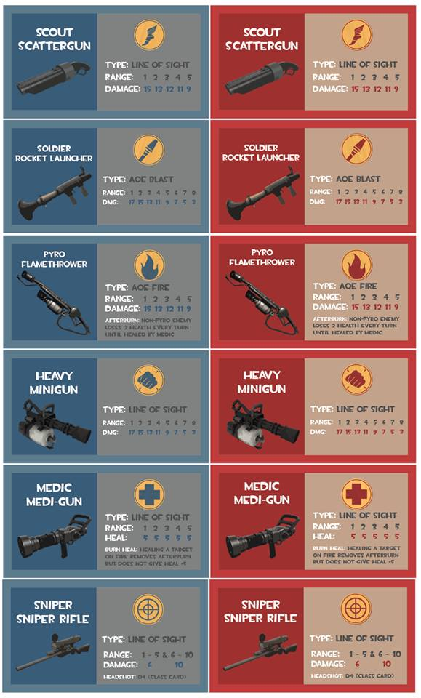

Victory

The player who has managed to eliminate their opponent’s 6 classes or **capture the flag and bring it back to your spawn room before your opponent does** wins!

Intentions

My last few playtests have been relatively well-received so I felt that at this point I can probably start to polish things a bit. The biggest changes in this version of the game is that I have added actual team class cards to help players keep track of what their classes can do, how much health they have, and so forth. I have also split up their weapons into separate cards for the possibility of adding a different load-out to the classes if in the final game I decide to let my players respawn.

The class tweaks to the game have been to up damage overall for most classes, further emphasizing the need to get up close and in harm’s way in order to maximize the damage done. The Scout received some big changes in the form of a better evasion, from 33% to 50%, and the addition of an extra move which should let him survive a little easier and make hit-and-runs possible. Other than this, the Pyro has an air blast ability and the Medic now has an Ubercharge. These extras add complexity, but hopefully the added complexity will not outweigh the added *Team Fortress 2* experiences that they are.

The last couple of changes involve me still trying to find a good way to move all the pieces. I will be playtesting a turn style that has each player moving one piece at a time, moving a different piece each turn until all pieces have been moved once before allowing pieces to be moved for a second time. My hope is that this allows for a good play experience and one that does not just have the players waiting to make a first move. Moving all pieces at once worked well in previous tests, but I just want to see if this would be better or not. I have also added a capture the flag objective to the game and put more of an emphasis on hidden information with my game pieces.

Playtesters

Classmates from the GAT211 participated as first-time players for the version of my Team Fortress 2 board game that I brought to lab.

**Name: Email:**

* Jason Guelbert j.guelbert@digipen.edu
* Berne Capone [charlesberne.capone@digipen.edu](mailto:charlesberne.capone@digipen.edu)

Playtesting

Yet again Jason Guelbert and Berne Capone will be playtesting my game, with Berne playing as the Blu team and Jason playing as the Red team. I did not bring written rules to class in order to see how well the class cards and weapon cards speak for themselves. Both Jason and Berne like the look of the cards and even the idea of writing health on the cards using a dry erase marker (provided by the teacher’s assistant, Chris Beagle). Jason did bring up a good point about how players are meant to erase their markings. I will have to include a cloth, paper towels, or some sort of eraser if I want this to work out well in a future version of the game.

The game started out quickly, with both Jason and Berne trying similar strategies in the previous playtesting sessions. This might be an indicator that I need to playtest outside of Jason and Berne. While their insight has always been helpful, I should probably get some new opinions. Right away it is apparent that the every other turn system is not working out well. Both Jason and Berne ask to drop the every other turn system in order to play the game the way it was played in all the playtests before: each player moves all class tokens all at once per turn. I agree, as there is no point in continuing to play this way when it is this unanimous that the turn system is awful.

Shortly thereafter it is revealed that the hidden information part of the class tokens are not very fun either. Because each token has distinct movement, it is obvious what class token is moved at the time, but annoying to have to try and remember when this game is not meant to be focusing on memorizing who is who. The game proceeded using the hidden information feature but it is clear that it will need to be dropped in order to make the game work out better.

Despite these setbacks, the game proceeded well and the changes to the Scout are appreciated by both Jason and Berne. In particular it needs to be made clearer that the extra move is made after the regular move and attacking, but other than that the added mobility seems to suit the Scout well. The Ubercharge of the medic never came into play, which is something I’ll have to check out in another playtest. The Sniper changes were confusing at first because of the need to calculate 125% and 150% when a D4 roll of 2 or 3 happened, so I think I’ll just give straight numbers for the next playtest.

Overall, while the game did not have as much time as the other playtests it worked out well in getting rid of a few glaring problems and pointing out areas where I need to be clearer. The next version of the game will take care of these problems, refine a hex map suitable for my game, and have additional weapon load-outs.

Other Student Games

Before playtesting my game I was a playtester for both Jason and Berne’s game board versions of *Team Fortress 2*. The first game I played was Jason’s game as the Blu team against Berne’s Red team. As a whole Jason’s game works well. With the exception of minor tweaks to the Sniper and maybe the scout, the game’s different classes feel about right. The Sniper’s range is pitiful, and he’s basically good for one shot because in the next turn any class, including the Heavy, can get in range and kill him easily with his 3 health. The Scout is an interesting class which has undergone some changes since the last time I played Jason’s game. The Scout is still paper thin, but he has a 33% chance at dodging, of which I was able to accomplish one time out of the 3 lives I had for my Scouts. It did not help much because he died soon after. Jason’s map works well for his pieces in terms of size and the range of most of the classes. It was fun to play and pretty quick to get up and start going at it.

Berne’s game could use a little bit of work. Berne is attempting to use a staggered class turn system that I think just needs to die already. Considering in the playtest of my game the staggered turn system was thrown out the door after only two turns, you’d think Berne would catch on to this. I have to give him some credit for doing all the classes, but the Heavy is really slow, and in the small time we had to play the Spy on both teams did not get in range to do anything. Berne also needs to make a bigger map because his pieces do not fit well on it. Other than this, the damage the classes do feel right, and the ranges are generally okay. The Demoman has some crazy physics involved with his grenades, which is odd, but not entirely out of character. Overall, it was an okay experience, but did not feel like *Team Fortress 2* so much.

Project 4 Idea

For project 4 I am considering doing a game similar to my GAT210 game *Subterfuge* or possibly a new idea in conjunction with Jason Guelbert based on our Project 2 Maps brainstorming session for a game called *Scavenge*. The *Subterfuge* idea would expand upon my previous game fixing the problems with the event cards and refining the gameplay, game components, and just making the game as polished as possible. The *Scavenge* game idea would be pitched to Professor Holcomb as a cooperatively made board game between Jason and I where we make a 1 versus 1 game where the goal is to strip as much from an abandoned starship as possible, which mechanically removes playable space from the board game. The game would be wacky and kind of a race against time before the ship falls apart entirely.