Travis Moore

GAT 211A—Fall 2014

Instructor: Jeremy Holcomb

Lab Report 4

Linear Maps I

Table of Contents

**Lab Report 3 – 10**

1D Map—Pile of Peoples 3 – 4

1D Map 3

1D Map Content Explanation 4

2D Grid Map—Pile of Peoples 5 – 6

2D Grid Map 5

2D Grid Map Content Explanation 6

2D Region Map—Pile of Peoples 7 – 8

2D Region Map 7

2D Region Map Content Explanation 8

2D Freeform Map—Pile of Peoples 9 – 10

2D Freeform Map 9

2D Freeform Map Content Explanation 10

1D Map—Pile of Peoples

1D Map

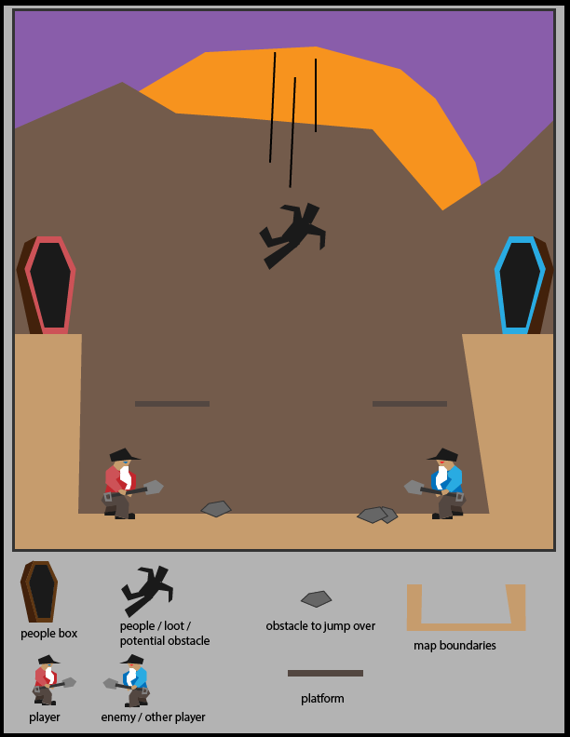

1D Map Content Explanation

Pile of Peoples in its 1D map form is meant to be a video game similar to a standard platformer that could work well as a console game using a gamepad or a mobile game using touch controls. The map boundaries keep the player within the pit in which they start the game in and the camera does not move at all, limiting all movement to the initial camera view of the map. The objective of the game is to fling the falling people with your shovel into your color people box to earn points.

**Player** Red player is controllable by the player.



**Enemies**Blue player competes as an enemy ai or person controlled player.

**Loot** People act as loot by being lung into a people box, this earns the player or enemy ai points.



**Obstacles**People act as an obstacle if they are not flung within an "x" amount of time, they will pile up and will add to the ground. If too many people pile up, the game is over.

**Obstacles**Rocks can act as obstacles, requiring players to jump over them.



2D Grid Map—Pile of Peoples

2D Grid Map

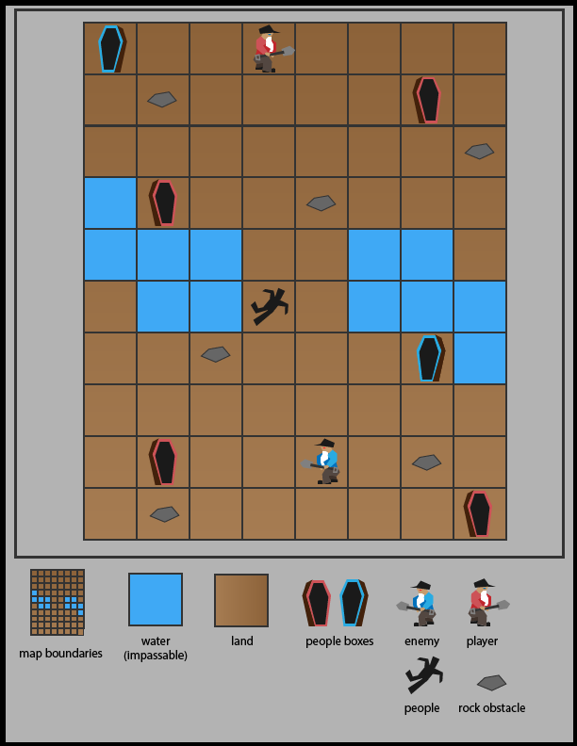

2D Grid Map Content Explanation

Pile of Peoples in its 2D grid map form is meant to be a board game. The map is a traditional checkerboard-like map with limits to how many spaces a player can move. The objective of the game is to collect randomly positioned people with your shovel and place the people in the people box to score points.

**Player** Red player is controllable by the player.

**Enemies**Blue player competes as the opposing or enemy player.

**Loot **People act as loot by being lung into a people box, this earns the player or enemy points. Some peoples are worth more than others (they could be wearing jewels).

**Obstacles**People also act as an obstacle if they are not flung within an "x" amount of time, they will pile up and the area will be impassible.

**Obstacles**Rocks can act as obstacles, requiring players to spend a turn to shovel them to move them away.

2D Region Map—Pile of Peoples

2D Region Map

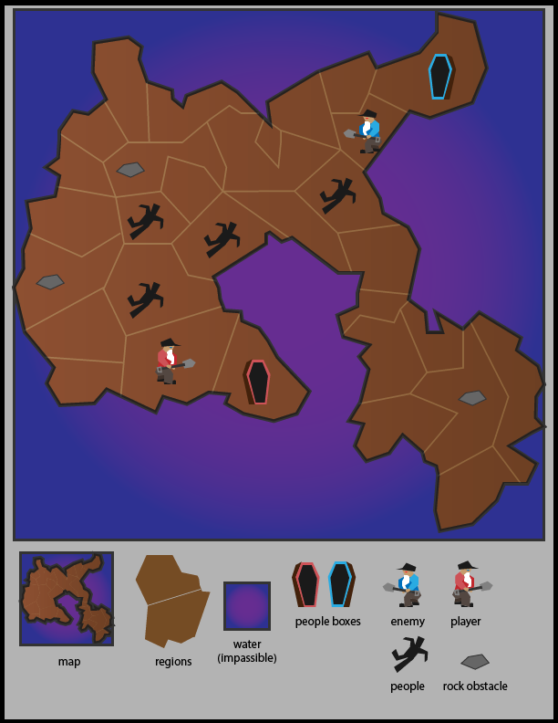

2D Region Map Content Explanation

Pile of Peoples in its 2D region map form is also meant to be a board game. The map is similar to risk in that players move from region to region and water is impassible. The goal of the game is to pile up multiple people by using your player to travel from the people box to a region. Collecting rocks and delivering it to the people box increases the amount of people you can place in a region.

**Player** Red player is controllable by the player.

**Enemies**Blue player competes as the opposing or enemy player.

**Obstacles**People are used to attack other regions and are a sort of obstacle that the players must overcome.

**Loot**Collecting rocks increases the amount of people you can pick up from the people boxes.

2D Freeform Map—Pile of Peoples

2D Freeform Map

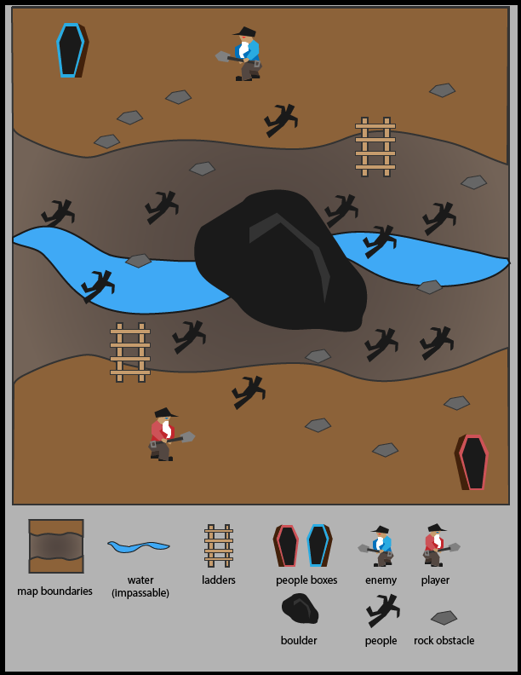

2D Freeform Map Content Explanation

Pile of Peoples in its 2D freeform map version is similar to a tabletop game like Warhammer. The game pits two players trying to collect people in their people boxes. The map has multiple depths with ladders that can be used to go between depth layers.

**Player** Red player is controllable by the player.

**Enemies**Blue player competes as the opposing or enemy player.

**Loot**People are collected to score points. They can be flung an "x" amount of distance to hit the other player or to throw the people up to a different depth level.

**Loot**Rocks can be thrown at other players to make them drop their current loot and to stun them for a turn. If the player is on a ladder when hit by a rock, they will fall down.