Travis Moore

GAT 211A—Fall 2014

Instructor: Jeremy Holcomb

Lab Report 5

Ranged Combat

Table of Contents

**Lab Report 3 – 10**

1D Map—Pile of Corpses 3 – 5

1D Map 3

Design Notes 4

Target Audience 5

Intensity Curve Sample 5

2D Grid Map—Pile of Corpses 6 – 8

2D Grid Map 6

Design Notes 7

Target Audience 7

Intensity Curve Sample 8

2D Region Map—Pile of Corpses 9 – 11

2D Region Map 9

Design Notes 10

Target Audience 10

Intensity Curve Sample 11

2D Freeform Map—Pile of Corpses 12 – 14

2D Freeform Map 12

Design Notes 13

Target Audience 13

Intensity Curve Sample 14

1D Map—Pile of Corpses

1D Map

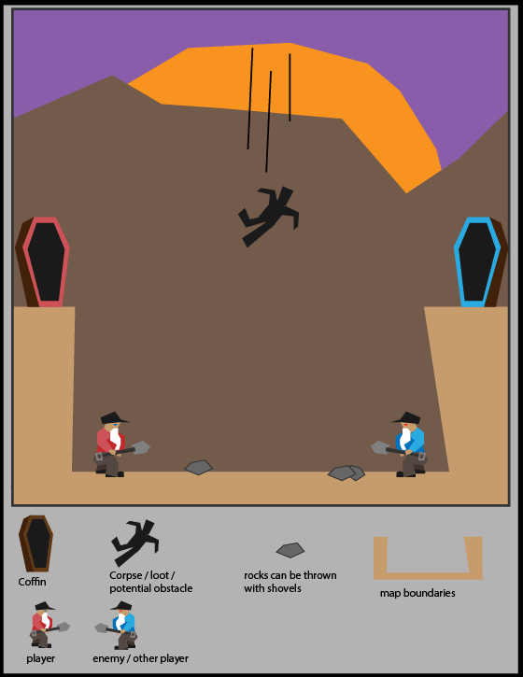

Design Notes

Pile of Corpses in its 1D map form is meant to be a video game similar to a standard platformer that could work well as a console game using a gamepad or a mobile game using touch controls. The map boundaries keep the player within the pit in which they start the game in and the camera does not move at all, limiting all movement to the initial camera view of the map. The objective of the game is to fling the falling people with your shovel into your color people box to earn points.

The ranged combat in this game comes from the ability to fling people and rocks at the other player. Hitting a player with a rock or person will stun them, making it easier for you to fling another person into your people box.

**Player** Red player is controllable by the player.



**Enemies**Blue player competes as an enemy ai or person controlled player.

**Loot** People act as loot by being lung into a people box, this earns the player or enemy ai points.



**Obstacles**People act as an obstacle if they are not flung within an "x" amount of time, they will pile up and will add to the ground. If too many people pile up, the game is over.

**Items**Rocks can act as obstacles and ranged combat objects requiring players to jump over them or use them to hit the other player.



Target Audience

The target audience for this game would be something along the lines of the "Plants vs. Zombies" audience of casual gamers with a sense of morbid humor. I imagine that this game would work well as an arcade game or even a mobile game. It is mostly meant to be a "get in, get out" kind of game that people can just play for a bit against friends.

Intensity Curve

I imagine the intensity curve for a sample portion of this game would look something like the following:

I imagine this game starting off with a slow pace of people falling to the ground but quickly picking up pace as the game goes on. Fighting over people, whether through hitting the other player with a shovel or flinging rocks, should be exciting for both players. Scoring should feel good, but with the amount of people falling starting to add up, the intensity of the level should start to reach a fever pitch as there is less arena space to play in. The end of the game should be a huge pressure release, allowing the intensity of the game to melt away.

2D Grid Map—Pile of Corpses

2D Grid Map

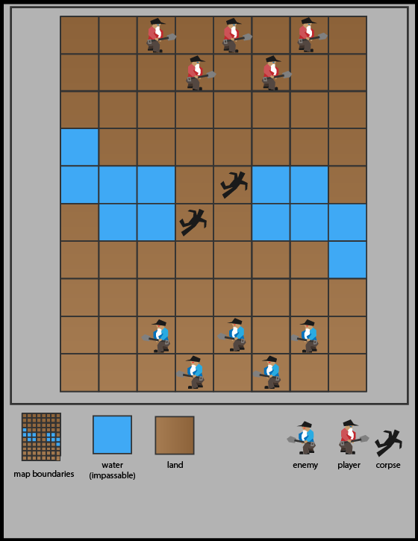

Design Notes

Pile of Corpses in its 2D grid map form is meant to be a board game. The map is a traditional checkerboard-like map with limits to how many spaces a player can move. The objective of the game is to eliminate the opposing player's units by using your shovel as a melee weapon or as a corpse slap-shot ranged weapon.

While the battlefield starts out with only 2 corpses on the field, with the elimination of enemy units, more corpses are created and can be used to wipe out the enemy. Corpses are dual purpose as obstacles and as ranged ammunition. Corpses can be flung in a straight line an "x" number of spaces, depending on a die roll. Think of the corpses like a hockey puck being slapped down the ice.

**Player** Red players are controllable by the player.

**Enemies**Blue players are controlled by the opposing player.

**Obstacles/Ammunition**Corpses act as an obstacle that must be slap-shotted across the field to take out other units. Dead units become corpses, quickly adding up the many ways a player can lose pieces.

Target Audience

The target audience for this game would be similar to those who like one versus one board games like Stratego or Chess. While not as complex as either of those games, this game is meant to be for those who like competitive games with just a dash of luck thrown into the game by the means of a dice roll to determine how far bodies can be slap-shot across the map.

Intensity Curve

I imagine the intensity curve for a sample portion of this game would look something like the following:

I imagine that the game starts out as a fight for the middle, where the first player gets the biggest advantage of shooting a corpse across the map. From there, there are probably a few melee contests, but the bulk of the fun comes from when there are so many options for shooting corpses across the map. Quickly the map is dangerous because corpses are piling up and can be thrown about the map non-stop. The last player standing is probably relieved when all the madness is over.

2D Region Map—Pile of Corpses

2D Region Map

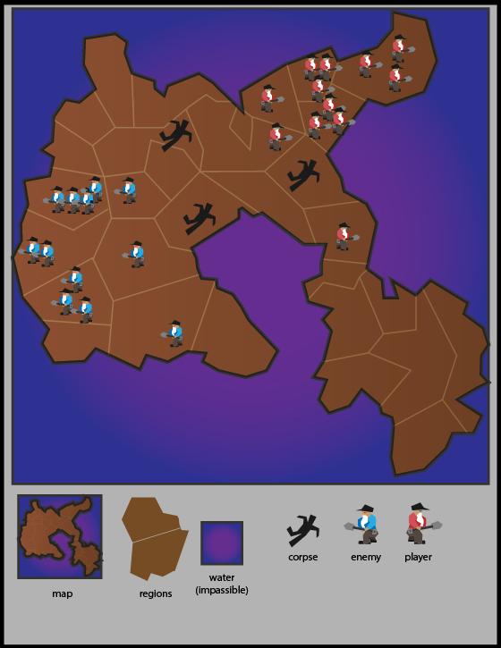

Design Notes

Pile of Corpses in its region map form is a lot like risk but with a twist that involves ranged combat. Like regular risk, you can invade regions with your units, but you can also launch units from your spaces several spaces away depending on how many units are in that region. For example, if you have a region with 5 units on that space you can launch one of those units up to 5 units away. Of course, things do not always go to plan, so a roll would have to be made see if that unit landed safely or if they went splat on the ground. Areas with splat corpses must be evacuated because they can cause diseases, but they will eventually return to normal in a few turns.

**Player** Red players are controllable by the player.

**Enemies**Blue players are controlled by the opposing player.

**Obstacles **Corpses act as an obstacle when a failed launch occurs. If units persist in any area with a corpse, they must roll to see if they become infected. On a fail roll, that player will die on the next turn, turning into a corpse. Corpses expire after 2 turns of play.

Target Audience

The target audience for this game would be similar to those who like one versus one board games like Stratego or Chess, or even the original game of Risk. The added ranged mechanic adds a layer of depth to the existing game of Risk and creates space for the game to include area denial. I see this game going over well for the strategy minded and would think that they would be the prime target audience for this kind of game.

Intensity Curve

I imagine the intensity curve for a sample portion of this game would look something like the following:

Being a lot like risk, I see this version of Pile of Corpses being slow to start, as units are not plentiful in the beginning of the game. Expansion takes some time, but starts to speed up when players have units that they can expend by gathering them in mass and launching them across several regions. Launching should be a highlight of the game, and create interesting areas where players will have to deal with area denial or suffer potentially losing units.

Like all games, the game will probably reach a point where there is an obvious winner and soon-to-be loser, so I think the expansion and shrinking of territory will bring the game down.

2D Freeform Map—Pile of Corpses

2D Freeform Map

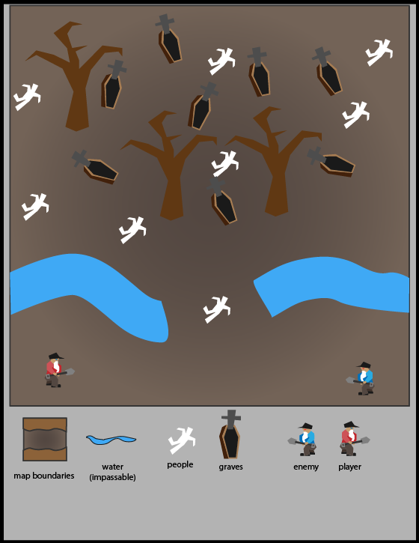

Design Notes

Pile of Corpses in its freeform map variation is a lot like tabletop games like Warhammer. The objective of this game is to put all the corpses in the graves, with each corpse you put in earning you a point and turning that corpse your team color (red or blue). Once all corpses are in graves, the game is over. Corpses can be thrown as a ranged combat mechanic to stun the opposing player and gain an advantage of having an extra turn while they are stunned.

**Player** Red players are controllable by the player.

**Enemies**Blue players are controlled by the opposing player.

**Loot/Ammunition **Corpses are both loot and ammunition in this game as you need to place them in graves to turn them your color, but when you dislodge a corpse you can fling it in the line of sight of another player and potentially stun them.

Target Audience

Another strategy game, I see this game going over well with most strategy enthusiasts. That being said, this game could potentially appeal to those who want a quick laugh with a game that has combat involving a rather morbid theme. The game is not meant to be complicated, so it could well suited for a casual crowd, given they have the humor for the theme of the game.

Intensity Curve

I imagine the intensity curve for a sample portion of this game would look something like the following:

I think this version of Pile of Corpses would have quite a buildup of intensity as more and more corpses get planted into graves. Racing to the graveyard will determine who has the advantage of reaching the first corpse accessible on the map. This can either be used to combat the opposing player or score. While melee combat happens it can be exciting, but not as exciting as dislodging a corpse that scored for the other player and stunning him with it. As more corpses fill the graves it will turn into a game of chicken, where one player will probably be flinging corpses in desperation of trying not to lose. This will probably be the most intense part of the game. When all the corpses are in graves this will be the release for all the tension that has been built up.