Travis Moore

GAT 211A—Fall 2014

Instructor: Jeremy Holcomb

Lab Report 7

Team Fortress 2 Notes

Table of Contents

**Lab Report 4 – 23**

Game Notes 4 –5

Class Roles 4

Pickups 4 – 5

Why Is TF2 Successful? 5

Scout 6 – 7

Role 6

Special Abilities 6

Weapons 6 – 7

Soldier 8 – 9

Role 8

Special Abilities 8

Weapons 8 – 9

Pyro 10 – 11

Role 10

Special Abilities 10

Weapons 10 – 11

Demoman 12 – 13

Role 12

Special Abilities 12

Weapons 12 – 13

Heavy 14 –15

Role 14

Special Abilities 14

Weapons 14 – 15

Engineer 16 – 17

Role 16

Special Abilities 16

Weapons 16 – 17

Sniper 18 – 19

Role 18

Special Abilities 18

Weapons 18 – 19

Medic 20 – 21

Role 20

Special Abilities 20

Weapons 20 – 21

Spy 22 – 23

Role 22

Special Abilities 22

Weapons 22 – 23

Game Notes

Class Roles

There are nine classes that exist in TF2: the Scout, Soldier, Pyro, Demoman, Heavy, Engineer, Medic, Sniper, and Spy. Each of these nine classes is unique, but they can be grouped together into the following categories: Offensive, Defensive and Supportive.

Offensive

The Offensive classes are the Scout, Soldier, and Pyro. These classes focus on mobility and offer the highest speed/health ratio of all the classes when all classes are equipped with their standard weapons.

Defensive

The Defensive classes are the Demoman, Heavy, and Engineer. These classes focus on inhibiting enemy access, holding enemies back from capturing the intelligence or control points, and have the most firepower of all the classes.

Supportive

The Supportive classes are the Medic, Sniper, and Spy. These classes cannot easily hold a fight by themselves, but they have special abilities that help their team as a whole. The Supportive classes help bolster the offensive and defensive capabilities helping to give them the edge in a game.

Pickups

Pickups are spawned in various locations across most maps and call be picked up by simply walking over the item. There are 3 categories of pickups: Health, Ammo, and Metal.

Health pickups all have a 10 second respawn time and refill a portion, or all, of a player's health depending on the pickup size. Small health kits heal for a fifth of a user's health, medium health kits heal for half a player's health, and large pickups heal for all of a player's health.

Ammo crates all have a 10 second respawn time and can double as metal for the Engineer class, as well. The small ammo crate replenishes a fifth of a player's ammo and 40 metal for the Engineer, the medium ammo crate replenishes half of a player's ammo and 100 metal for the Engineer, and the large ammo crate replenishes all of a player's ammo and 200 metal for the Engineer. Debris, including dropped weapons, can also be picked up for ammo and metal.

Why is TF2 Successful?

I believe that TF2 is successful because it took the popular FPS genre and did everything right with it, starting with taking out the idea that all FPS games must be as realistic as possible. TF2 looks cartoony, with its retro style similar to that of Pixar's *The Incredibles*. Right away you can tell by the look of this game that it is not going to be a serious shooter, but that being said it does everything right for this type of game.

Suddenly making instant health pickups on the ground make sense in this zany world. The lack of a reason for why you need to capture points or steal intelligence is okay, it's simply a red versus blue without the need for huge reason behind why this is all happening. Shooting at each other in a cartoon and not dying instantly makes sense because this is not real life. Exploding people becomes a gib-fest and is funny and not gruesome. Marry all this lack of realism with great controls and a great rock-paper-scissor mechanic, and it's easy to see why this game hit the nail right on the head.

Scout

Role

The Scout is the fastest class in the game and is the ideal class for aggressive fighting and flanking, due to his high mobility. The Scout is also a great class for quick hit-and-run tactics and for completing capture objectives quickly. The Scout has 125 health and 133% of the base speed set for the game.

Special Abilities

The Scout is the only class that can double jump (once on the ground and once while in the air) and has the capability to capture control points and push carts at the rate of 2 players.

Weapons

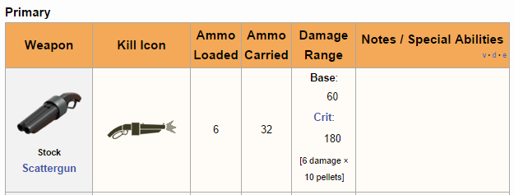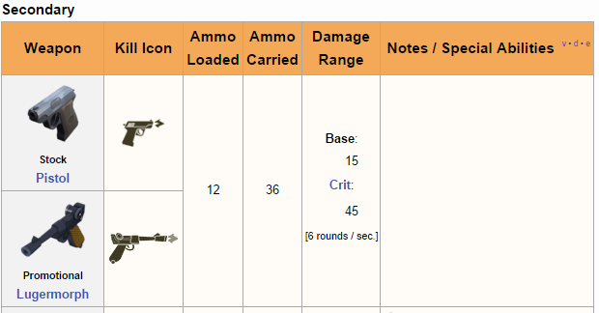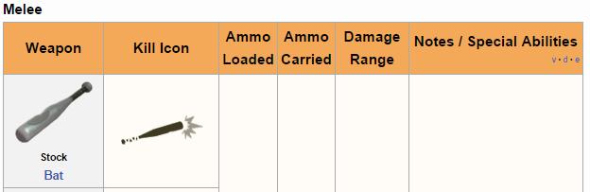

Soldier

Role

The Soldier is considered to be the most versatile class, with great offensive and defensive capabilities. The soldier has 200 health and 80% of the base move speed set by the game.

Special Abilities

The soldier can use rocket jumping at the cost of some health to fly through the air and high areas or clear areas of the map quickly.

Weapons

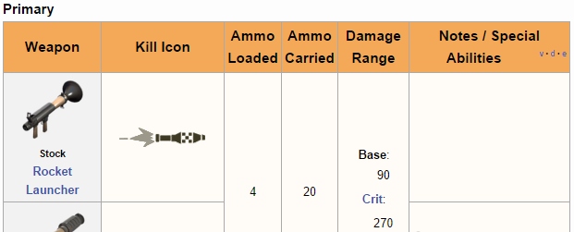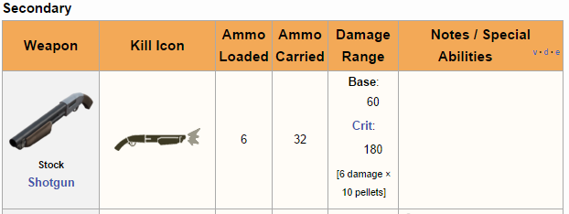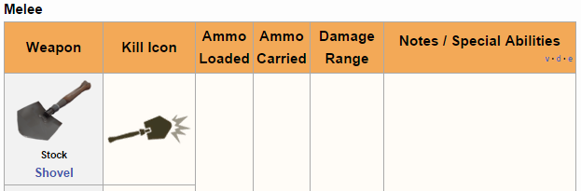

Pyro

Role

The Pyro specializes in fighting enemies up close with the use of a flame thrower. Enemies can be set on fire and suffer damage over time from burning. The Pyro starts with 175 health and has 100% of the base speed set for the game.

Special Abilities

The Pyro wears an asbestos-lined suit that protects from the burning over time effect from other enemy Pyros.

Weapons

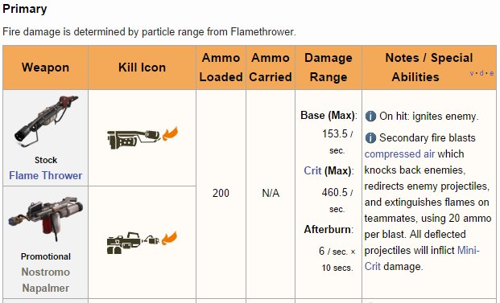



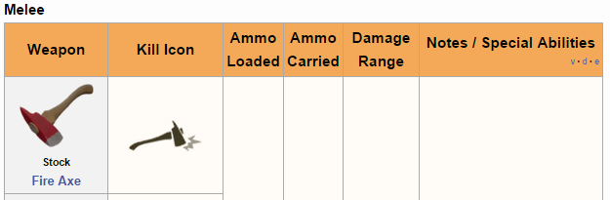

Demoman

Role

The Demoman uses area of effect explosives to deal indirect and midrange splash damage. The Demoman starts with 175 health and has 93% of the base speed set for the game.

Special Abilities

The Demoman can use his stickybombs to jump in a way that is very similar to the way a soldier can rocket jump.

Weapons

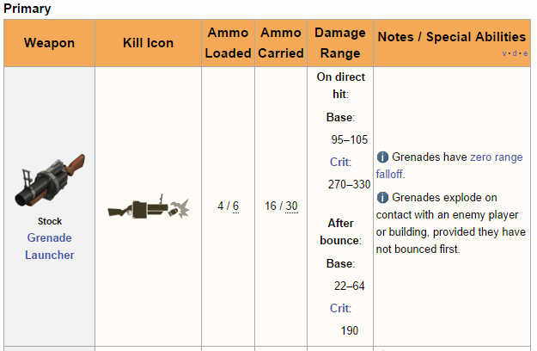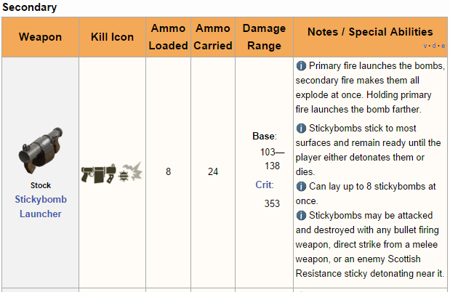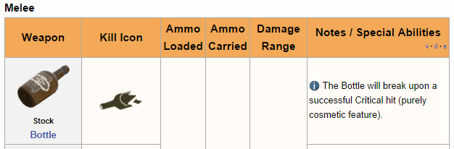

Heavy

Role

The Heavy uses a minigun to inflict devastating firepower in the form of a high rate of fire at short to medium range. The Heavy starts with 300 health and has 77% of the base speed set for the game.

Special Abilities

The ability to hold and actually fire a minigun is impressive on its own, but it comes at a cost of slower than normal move speed when revving or firing the minigun.

Weapons

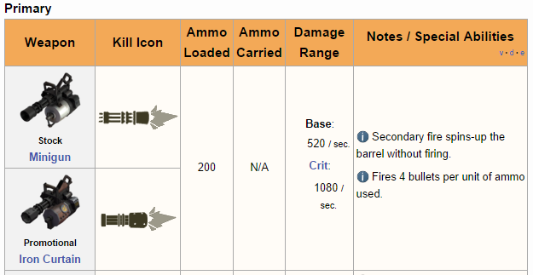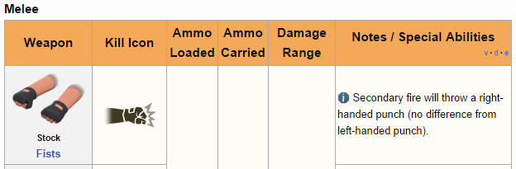

Engineer

Role

The Engineer specializes in building mechanical contraptions for his team and is the only class that uses metal in the game. The Engineer starts with 125 health and has 100% of the base speed set for the game.

Special Abilities

The Engineer can build and upgrade a sentry gun for area denial, a dispenser that heals and generates ammo and metal, and also teleporters to help himself and the team move from one location to another on the map.

Weapons

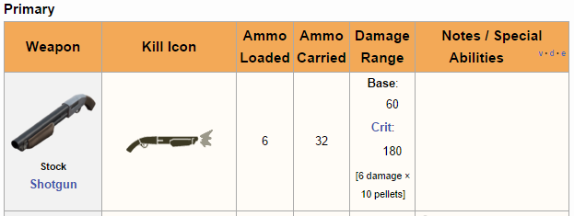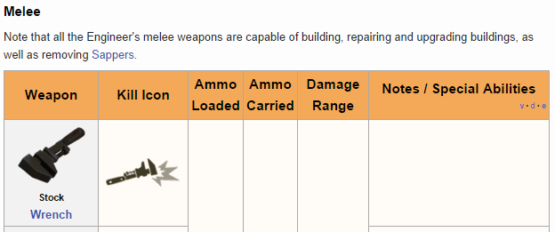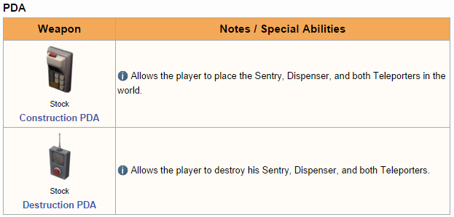

Medic

Role

The Medic is the primary healing class of the team who can heal members of his team using the Medi Gun and also inflict damage with weapons. The Medic starts with 175 health and has 107% of the base speed set for the game.

Special Abilities

The Medi Gun allows for healing teammates to build an UberCharge which will grant the medic and his heal target temporary invulnerability. The medic also heals himself slowly over time.

Weapons

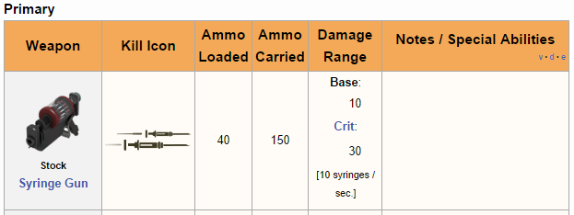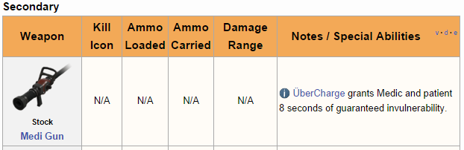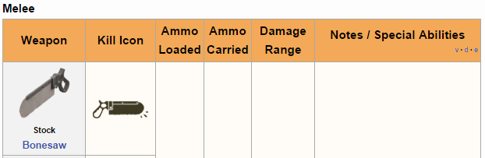

Sniper

Role

The Sniper is a long distance high priority target eliminator who uses his Sniper Rifle with deadly precision. The Medic starts with 125 health and has 100% of the base speed set for the game.

Special Abilities

Other than the fact that the sniper owns a sniper rifle, he does not really have any other special abilities.

Weapons

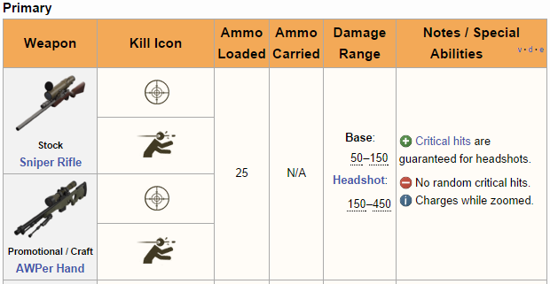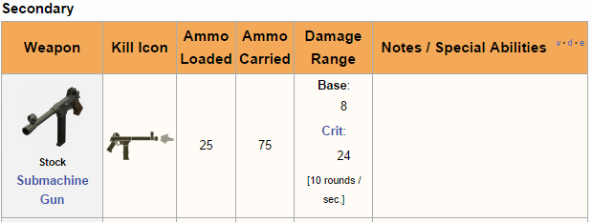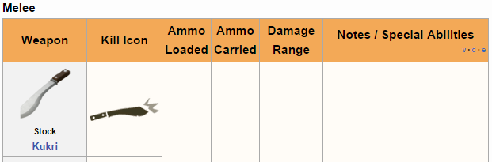

Spy

Role

The Spy is the ideal class for taking out high priority targets and dealing with engineer buildings. The Spy starts with 125 health and has 100% of the base speed set for the game.

Special Abilities

The Spy has the ability to go invisible for a brief period of time, disguise as any class, sap enemy structures, and can also instantly kill enemies with a successful stab to the back with his knife.

Weapons

