Travis Moore

GAT 211A—Fall 2014

Instructor: Jeremy Holcomb

Project 2

Map #10—2-D Freeform  
Nom Nom Racers

Table of Contents

Map #10—1-D Freeform: Nom Nom Racers! 3 – 7

Map 3

Design Concept 4

Map Legend Breakdown 4 – 5

MDE 5 – 6

Mechanics 5

Dynamics 5

Experience 6

Intensity Curve 6 – 8

Overview 6

Point-Analysis 7 – 8

Map

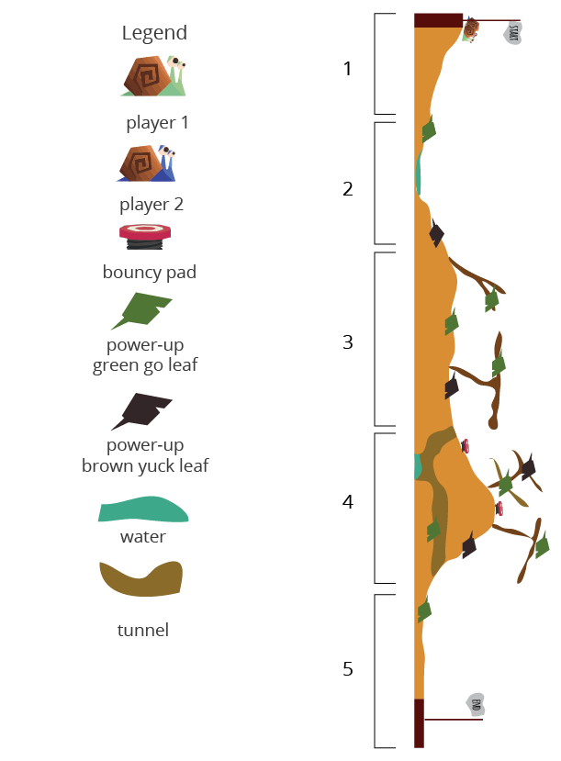

Design Concept

The last map in my ten maps is a 2-dimensional freeform game that is meant to be a played as an arcade racing game called "Nom Nom Racers". The game is meant to be a single player or multiplayer competitive experience that features snails that race slowly but eat everything in their path along the way.

The objective of the game is to be the first snail to cross the finish line by picking the best possible path to reach your goal. In order to do this snails can crawl slowly, jump, use bouncy pads to jump higher, and lastly eat green go leaves in order to move even faster for a short period of time. Snails can also draft behind one another for a slight speed boost.

I believe the audience for this game is probably children and teens who want a cute and fun racing game that involves little snails. Since there is nothing disturbing about this game I think it is mostly meant for children, but perhaps adults will find this kind of game fun, as well.

Map Legend Breakdown



The player 1 and player 2 characters are green and blue snails. These snails are identical in movement and jumping stats and both will eat anything good or bad that is in their path.



The bouncy pad is used to let snails reach greater than normal heights when a snail jumps directly on the bouncy pad. Failing to jump onto the bouncy pad will not activate a high bounce for a snail.

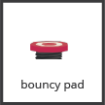

The leaf power ups are used to affect speed in the game. The green go leaf temporarily increases the speed of the snail that eats it first. The brow yuck leaf will slow the snail that eats it first. Once a leaf has been run over by one snail it disappears.

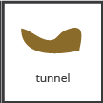

The terrain in the game also affects the way a snail moves in the game. Tunnels are cool and damp making it easier for a snail to move just a little bit faster. Large pools of water will also affect the movement of a snail, but in a negative way, making the snail move slower through it.

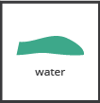

MDE

Mechanics

* Player Movement Speed
* Player Jump Speed / Height
* Player Drifting Mechanic
* Map Layout
* Power Up Placement
* Terrain Features (water and tunnels)
* Green Leaf Speed Increase
* Yuck Leaf Speed Decrease
* Tunnel Speed Increase
* Water Speed Decrease
* Power Up Disappearance
* Bound Pad Locations
* Bouncy Pad Jump Height Increase

Dynamics

The dynamics of "Nom Nom Racers" involve managing your position on the track as well as taking advantage of power ups and terrain features throughout the level. As a racing game the idea of the game is to travel as quickly as you can, but you need to make sure to avoid obstacles and bad power ups while maximizing the good power ups you can take before your opponent does. Drifting can also allow a snail to come from behind and take the lead at just the right moment in the game.

Experience

The primary aesthetics in "Nom Nom Racers" are both the competition and challenge aesthetics. The point of the game is to challenge yourself to see how quickly you can make it through a level by taking the best path possible. However, you are not racing against yourself and your opponent has the same goal. Out maneuvering your opponent is a big part of the game, as well as forcing them to take the bad power-ups whenever you can.

Intensity Curve

Overview

I have not playtested "Nom Nom Racers" with actual playtesters. I imagine the intensity curve for a typical game of "Nom Nom Racers" would look something like the following:

Point-Analysis

* Start of Game (Intensity = 2)

The start of the game gives the player a "3, 2, 1" countdown which hopefully can build some anticipation before the game starts, helping to amp the player up for the action ahead. We don't expect a lot of intensity here, but it is better than giving the player a cold start.

* Introducing Power-Ups and Water (Intensity = 4)

At the beginning of the game the player has a bit of time to get used to the controls and they can begin to contest the other player at this point. The introduction of how eating the green go leaf is introduced and the water and yuck leaf slows both players down, as well.

* First Multiple Path (Intensity = 5)

The first time the players can choose their own path provides one player with an advantage of green go leaves, leaving the other player to rely on drifting or suffer the consequences of a yuck leaf.

* 3 Paths (Intensity = 7)

At this point there are multiple ways to go, some worse and some much better than others. Tunnels are introduced, but this tunnel does have a downside if the player cannot jump all the way across. The upper route on top of the sticks is also an option, but the player can miss a jump and fall back down on a yuck leaf.

* Home Stretch (Intensity = 5)

With only one green go leaf left the winner should be clear depending on who reaches the yuck leaf first.

* End of Game (Intensity = 2)

The end of the game should see both players coming down of the high of a close game and leave the players coming back for some more.