Travis Moore

GAT 211A—Fall 2014

Instructor: Jeremy Holcomb

Project 2

Map #1—1-Dimensional  
Pile of Corpses

Table of Contents

Map #1—1-Dimensional: Pile of Corpses 3 – 9

Map 3

Design Concept 4

Map Legend Breakdown 4 – 5

MDE 6 – 7

Mechanics 6

Dynamics 6

Experience 6 – 7

Intensity Curve 7 – 9

Overview 7

Point-Analysis 8 – 9

Map

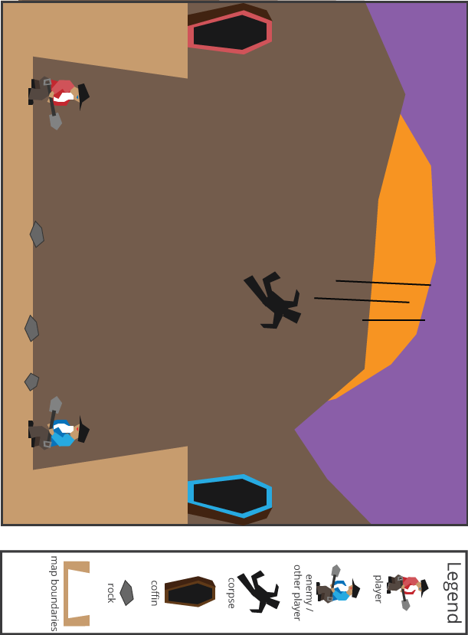

Design Concept

The first of my ten maps is a 1-dimensional map that is meant to exist as the main arena for a video game called "Pile of Corpses". The game is meant to be a competitive arcade-like experience played by two people. In the background there is a huge battle taking place and as the war rages on corpses fall from the sky down into the pit of two grave keepers.

The objective of both the players is to score the most points by using their shovels to fling corpses into their coffins while collecting treasures that some corpses carry with them. Combat involves players using their shovel to either fling rocks or the corpses themselves at the other player, stunning the player hit for a few seconds. As the game goes on more and more corpses fall at a faster rate, becoming one with the terrain if they are not picked up within a few seconds. The game is over when the pit is completely full and no longer playable.

The intended audiences for this game are teens and adults who want to play a frantic, fast-paced arcade game against one another. I see this game working well as either a PC or console experience, with the possibility of a one player mobile version using touch screen finger flinging on modern cell phones.

Map Legend Breakdown

The 1-player position is the red grave keeper. Both grave keepers are old, bearded men with slow movement and low jumping ability. The shovel is used to approach a corpse or rock and with a press and hold of a button charge up their shovel fling to launch a corpse over their shoulder in an arc that is determined by the length of time spent charging up their fling.



The 2-player position is the blue grave keeper. The blue grave keeper is identical to the red grave keeper in every mechanical way. The blue keeper can be played by a computer AI if there is only one player, but is intended to be played by another human player.

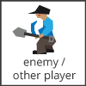

Corpses are meant to act as both loot and obstacles in the game. Corpses fall from the sky and are available to be flung within the first few seconds of landing on the ground. When flung into a coffin they score points for the players. However, if the corpse stays on the ground for too long it adds to the terrain of the pit, making the corpse become an obstacle.

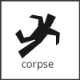

Corpses with treasures are exactly like regular corpses but with additional value in the form of treasure. The point of these corpses is to add to the variety of game and give the players something worth extra points to fight over throughout the course of a game.



Coffins are stationary objects in the game that the players have to try and successfully fling their corpses into. Because players cannot carry corpses, the coffins act like the basket in basketball, adding to the challenge of the game.

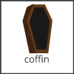

Rocks exist in the game as ammunition and obstacles. Rocks can be flung from one player to hit the other player, stunning them for a few seconds and making them drop a corpse. Enough rocks piled up in an area can make it difficult for a player to maneuver as grave keepers are slow and not very good at jumping.

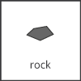

MDE

Mechanics

* Grave Keeper Movement Speed
* Grave Keeper Jump Height
* Grave Keeper Flinging Charge Time
* Grave Keeper Flinging Angle
* Rocks / Rock Size
* Corpses
* Treasure / Treasure Value
* Coffin Placement / Size
* Stunning / Stun Time
* Rate at which Corpses Fall
* Speed of Falling Corpses
* Corpse Decay into Terrain
* Corpse Decay Time
* Arena Size

Dynamics

The dynamics of "Pile of Corpses" include corpse management. Combating the opposing player with a corpse or rock versus scoring points with a corpse is a dynamic decision that a player must make. Corpse management also plays into how the terrain of the arena will grow over time, so terrain management becomes a dynamic as well. As the pace of corpses fall quicker as the game goes on player awareness and positioning will become more critical as being stunned from a falling corpse is something a player must watch out for. The entire game as a whole is a game where the tension slowly builds up to an impossible to keep up with pace and adjusting your game play means deciding when to help yourself or hinder the other player.

Experience

"Pile of Corpses" provides the players a sense of challenge where they must overcome the obstacles of corpses falling from the sky and score points with them. Compounded with the challenge of pace of the game is also the addition of competition. As the player is not alone in this game, competing against another player or an enemy AI also adds a competition experience to the game. Although not as heavily placed into the game as challenge and competition, it is my hope that there is a sense of accomplishment in the game in mastering the easy to learn, but intentionally difficult controls involved with flinging. Flinging involves the player learning just how long to press the button and getting just the right angle when they fling, so mastery of these controls will take some time and patience for the player.

Intensity Curve

Overview

I have not playtested this "Pile of Corpses" with actual playtesters; however, I imagine the intensity curve for a typical game of "Pile of Corpses" would look something like the following:

Point-Analysis

* Start of Game (Intensity = 2)

The start of the game begins with both players on opposite sides of the map. A countdown of "3, 2, 1, GO!" followed by a slowly falling corpse should add a bit of beginning anticipation to the game, but nothing too intense yet. Hopefully this little build up will make it so that players will have some intensity build up before the game actually begins.

* Corpses Start Falling Slowly (Intensity = 3)

As corpses start to fall slowly down upon the arena the game should start to pick up in intensity a bit. Since there are not many corpses yet, players will probably have time to decide on whether or not they want to fight with corpses to steal a point from the other player. Throughout the game the rate at which the corpses fall will start to increase slowly, but it is not yet overwhelming.

* The Fight Over the First Corpse (Intensity = 5)

The pace of the game is not overwhelming yet, so players will probably choose to engage the other player over scoring a point with a corpse. The movement speed and jumping of the grave keepers will require the players to really commit to a fight as it will take time to recover from whatever positioning they have during the fight. This is the first real big competitive part of the game.

* Flinging Corpses/Rocks at Each Other (Intensity = 8)

Flinging corpses and rocks at each other is a commitment of resources with a risk of giving the player ammunition with rocks and potentially points with a corpse that is now closer to the enemy player. However, hitting the other player will stun them allowing you to make up the time spent in combat with relative safety of scoring points by yourself. This part of the game should be fun and intense as there are bodies and rocks flying around in addition to corpses raining from the sky.

* Corpses Start to Pile Up/More Terrain (Intensity = 5)

At this point in the game corpses should start to fall from the sky much quicker than before, giving the players plenty of corpses to pick up, but too many for both of the players to handle. Terrain should start to pile up at random points in the map because the players did not get to them in time. This will probably not be too much of a concern yet for players because they will be busy fighting each other and trying to score points.

* Corpses Falling Too Fast (Intensity = 9)

I liken this part of the game to that of Tetris when the blocks are piling up too fast and there is not a lot of space left to place things. This part of the game should see players frantically avoiding corpses falling from the sky and focusing on trying to get as many last minute points as possible before the arena fills up all the way. Combat is still possible at this point, but with all the corpses falling from the sky it may be too difficult to successfully pull off.

* End of Game (Intensity = 3)

A pressure release for all the tension that has been building up to a boil, the end of the game should highlight the winner of the game and their score and provide relevant stats like "number of times stunned", "points", and so forth. The intensity of the game should leave the players feeling slightly worked up from when they started playing the game in the first place.