Travis Moore

GAT 211A—Fall 2014

Instructor: Jeremy Holcomb

Project 2

Map #2—1-Dimensional  
Fire Run

Table of Contents

Map #2—1-Dimensional: Fire Run 3 – 11

Map 3 – 4

Design Concept 4

Map Legend Breakdown 5 – 7

MDE 7 – 8

Mechanics 7 – 8

Dynamics 8

Experience 8

Intensity Curve 9 – 11

Overview 9

Point-Analysis 9 – 11

Map

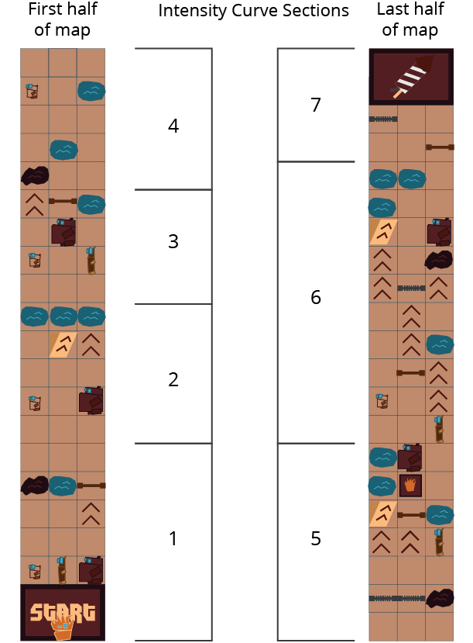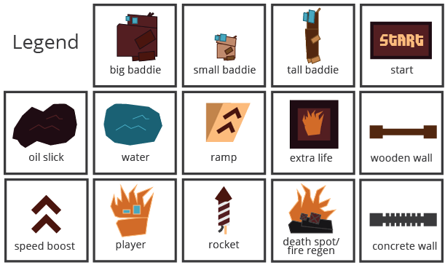

Design Concept

The second of my ten maps is also a 1-dimensional map that is meant to exist as a sample level for the game "Fire Run". The game is meant to be a single player video game done in a style similar to "Temple Run". The game is set in a fictional world where you play as a lonely flame trying to make his way back to the bonfire. Each level you must attach to a host and make it to the end of the level where a rocket is lit and you fly towards the next level in the game.

The level starts with you choosing a host right away and then it's a non-stop forward dash to get to the rocket before your host dies or you run into an obstacle and crash. Each host has its pros and cons and you must monitor their health and your burn level wisely in order to reach the end of the level. As you progress you can maneuver left and right between 3 lanes to help dodge obstacles and run over enemies and items. A level ends if you reach the rocket alive or if you crash and no longer have any extra lives.

The intended audiences for this game are teens and adults who want to play a quick and casual game with a little bit of quick puzzle solving and situations where you have to figure out how to solve obstacle puzzles.

Map Legend Breakdown

The player in this game is a little flame who must make use of hosts by using himself to light them on fire. The player has a fire intensity and health meter to keep track of which controls how quickly a host can move and how long it will last before you must move on to a new host.



The small baddie is an enemy that the player can attach to in order to stay alive and keep moving forward. The small baddie does not have a lot of health, but does move fast and has the advantage of being small and quick to maneuver. The small baddie will spit small, fast moving water pellets at the player when the player is not attached to it.

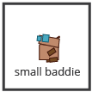

The tall baddie is an enemy that the player can attach to in order to stay alive and keep moving forward. The tall baddie moves at a medium speed, has a standard amount of health, and has the advantage of being able to jump over small puddles. The tall baddie will shoot a long stream of water at the player when the player is not attached to it.

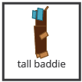

The big baddie is an enemy that the player can attach to in order to stay alive and keep moving forward. The big baddie moves at a slow speed, but has a ton of health and has the advantage of being able to smash through wooden walls. The big baddie will shoot a big gush of water that will take up 2 complete lanes when fired.

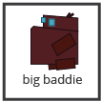

Each level begins with a start platform that spans the three lanes. From here you can choose which baddie you want to start the level with. If a player dies and has more than one life they will respawn at the start with 3 new baddies to try the level again with.

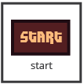

Speed boosts exist on the ground and on ramps and activate when you run a baddie over them. Speed boosts will make your baddie run faster for a few seconds before they return to their normal speed after the speed boost expires.



Ramps exist on the ground and are usually combined with speed boosts. Ramps will help your baddie clear a large distance while in the air, with the potential that you will pass over an obstacle or gap in the map. Ramps only come in one size and are usually worth taking.



Water is an obstacle that has the potential to harm the fire intensity of the player. Water can be a ground obstacle as well as pellets, streams, and gushes that are spat at the player by enemies. When the fire intensity of the player goes down, the speed at which the baddie runs is lowered making it easier to be shot at from other baddies.

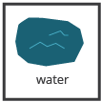

Oil slicks increase the intensity of the player's fire intensity meter. When a player's fire intensity is increased their host baddie runs faster but also loses health quicker.

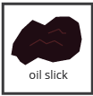

Death spots are dropped right before where a player has died. They act as a power up in that will increase the fire intensity of the player and help them get past an area that was trouble for the player before. They exist to help a player not be frustrated in dying and provide help for the player's next attempt.

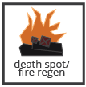

Extra lives are a power up that adds to the lives counter for a player. Extra lives are usually placed on paths that are more difficult than a normal path and are a reward to a player that enjoys a challenge.



Concrete walls exist as an obstacle that a player cannot overcome. Concrete walls cannot be broken or jumped over so the player must avoid running into them at all costs.

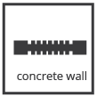

Wooden walls are an obstacle that a player usually must avoid, but they are more forgiving than concrete walls. Big baddies can crash through wooden walls and only take a little bit of health damage. Other baddies cannot crash through wooden walls without dying, but on the player's next attempt the wooden wall will no longer be there.

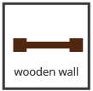

MDE

Mechanics

* Player
* Big Baddie
* Tall Baddie
* Small Baddie
* Fire Intensity Meter
* Health Meter
* Big/Tall/Small Baddie Health Meter Size
* Big/Tall/Small Baddie Move Speed
* Big Baddie Wood Wall Crash
* Tall Baddie Jump
* Small Baddie Quick Maneuver
* Water / Puddle / Pellets / Stream / Gush Size
* Speed Boost
* Speed Boost Duration
* Ramp Jump Distance
* Extra Lives
* Death Spot
* Map Layout
* Wooden Walls
* Concrete Walls
* Oil Slicks / Fire Increase
* All Meters Rate of Decay

Dynamics

The dynamics of "Fire Run" involve the pacing of the game. The game is as much about avoiding enemy shooting and obstacles as it is about maintaining a good balance of health meters and fire intensity. Avoiding enemies shooting at you and water puddles means taking the right lanes at the right time. As a whole taking the most optimal path available is a key strategy in the game.

However, the rate at which you move forward and your overall health requires you to run into enemies to gain a new host. The game has a strategy element where players must judge which host to take at any one point in time. This makes the player have to balance health meter decisions like taking a big guy for his durability over his speed or taking the small guy because the path ahead requires good mobility.

While taking care of a health meter you also need to care for your fire intensity. This makes the game a balancing act where you must navigate a map while maintaining your meters as optimally as possible. The tempo of the game is mostly in the hands of the player, depending on which path they take and how quickly they make their hosts run by choosing a host and controlling the fire intensity.

Experience

"Fire Run" is mostly a game that focuses on the challenge aesthetic. The joy of this experience is feeling smart about how quickly you were able to blow through a challenge with the difficulty of avoiding obstacles and managing a health and fire intensity meter. The game does have a small bit of fantasy in believing that you are this little flame creature, but the bulk of the game does not rely heavily on this.

Intensity Curve

Overview

I have not playtested this "Fire Run" with actual playtesters; however, I imagine the intensity curve for a typical game of "Fire Run" would look something like the following:

Point-Analysis

* Start of Game (Intensity = 2)

The start of the game gives the player a "3, 2, 1" countdown which hopefully can build some anticipation before the game starts, helping to amp the player up for the action ahead. We don't expect a lot of intensity here, but it is better than giving the player a cold start.

* Section 1 (Intensity = 5)

This section has the player choosing which baddie to take as a host. This is the first time the player is seeing this, so it could be overwhelming. Whatever choice the player makes we place the first type of obstacle that the host can get through without having to change lanes. You can see the big baddie crush through a wall, a tall baddie jump a puddle of water, or simply see the small baddie race through an oil slick.

* Section 2 (Intensity = 3)

Section 2 starts to give the player a little bit more choice about taking a new host and tackling a puddle of water. No matter what a player should be able to take a few hits or go through a puddle and not be entirely out of the game, but it will be a lot harder for them if they do.

* Section 3 (Intensity = 6)

Section 3 does not give the player a lot of time to figure out what they want to do as everything is more crammed into a tighter space. The left is the easier path with no obstacle avoidance, while the middle and right lanes require the player to master how to crush walls and avoid puddles with a big baddie or choose a tall baddie to jump over water.

* Section 4 (Intensity = 4)

Section 4 is mostly meant as a brief rest before the game starts to get more intense. If a player decided to take the big baddie this section is much harder, but it will reward the player in the next section.

* Section 5 (Intensity = 7)

Section 5 starts to ramp up the difficulty by making a hard ramp jump, a wooden wall, and another puddle right after introducing the difficult concrete wall. A big baddie host will barely make it through here as they are not as good changing lanes fast, but if the player is successful they can knock down a wall and get an extra life here.

* Section 6 (Intensity = 9)

This part is the highlight of difficulty in the map. The big baddie will have a hard time with all the speed boosts, but will need them to make it through without dying from loss of health. The little guy will have an easier time, but will have to be on full speed with no damage taken to make it through on such little health. The tall baddie will have to use jumping to make it through, but has the option of going full left or full right.

* Section 7 (Intensity = 4)

Unless the big baddie has made it through, the player will have to lose a little health right before this section, but should have enough to make it through. This spot is kind of a cool down before the end of the map.

* End of Game (Intensity = 2)

Once the player reaches the rocket the level is over and they are treated to a nice cinematic of the rocket taking off. This is supposed to be rewarding and also a pressure release for the player.