Travis Moore

GAT 211A—Fall 2014

Instructor: Jeremy Holcomb

Project 2

Map #3—2-D Region  
Soldiers of Caliber

Table of Contents

Map #3—2-D Region: Soldiers of Caliber 3 – 9

Map 3

Design Concept 4

Map Legend Breakdown 4 – 5

MDE 6 – 7

Mechanics 6

Dynamics 6

Experience 6 – 7

Intensity Curve 7 – 9

Overview 7

Point-Analysis 8 – 9

Map

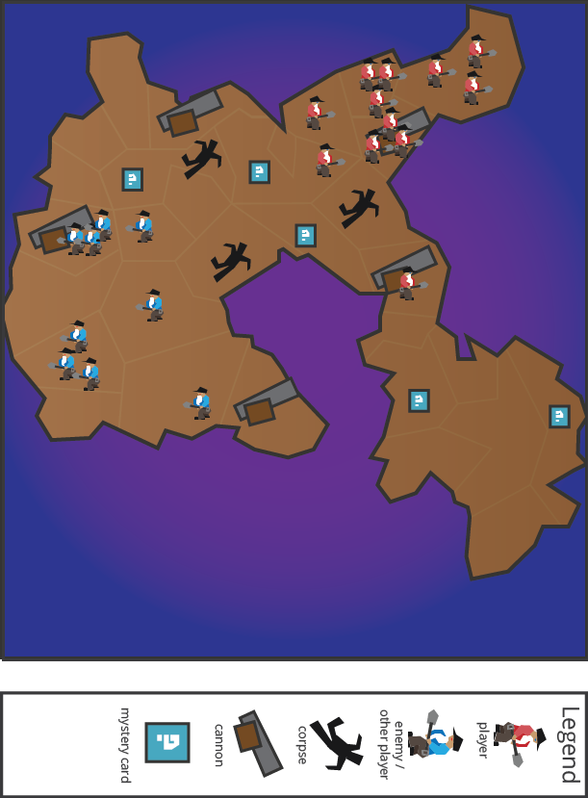

Design Concept

The third of my ten maps is a 2-dimensional region map that is meant to be a region-based board game of territory control called "Soldiers of Caliber". The game is meant to be a competitive game that pits one player's army over another player's where you can choose to invade each other's territories through marching over their borders or by launching soldiers through the use of the cannon.

The objective of the game is to own just over half of the regions on the board, at 16 territories. This is accomplished by having at least one soldier alive in each territory. The game is over when one player has accomplished this or if they manage to rid the opposing player of all of their soldiers. Players can invade territory by marching over regions or by using the cannon to launch soldiers from one territory to the other. Cannons can only launch a soldier the number of spaces equal to the soldiers in the territory of the cannon. However, cannon fire is risky and if a player fails a survival roll than a corpse is placed in this territory instead of a soldier. Corpses are wrought with diseases and can harm soldiers in the area.

The target audience for this game would be similar to those who like one versus one board games like Chess or even the original game of Risk. The added ranged mechanic adds a layer of depth to the existing game of Risk and creates space for the game to include area denial. I see this game going over well for the strategy minded and would think that they would be the prime target audience for this kind of game.

Map Legend Breakdown

The 1-player position is the red soldier. These soldiers in particular do not believe in fighting with guns. As such, they combat one another with shovels. Shovels are weapons of the brave and they make a handy tool to bury your opponent in the ground after you are through with them.



The 2-player position is the blue soldier. These soldiers in particular do not believe in fighting with guns. As such, they combat one another with shovels. Shovels are weapons of the brave and they make a handy tool to bury your opponent in the ground after you are through with them.

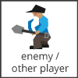

The cannon is used to launch soldiers or corpses across territories in the game. Cannons can only fire units the same number of spaces as there are soldiers in the territory with the cannon in it. Cannons are not entirely safe, so soldiers being fired from the cannon must roll to see if they survive the launch. If not, then the soldier becomes a corpse in the territory it intended to assault.

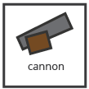

Corpses are the result of a soldier not surviving the aerial assault of being launched out of the cannon. Any soldiers in the territory that has a corpse in it must roll to see if they become infected. Infected soldiers will live for 1 turn and then die on the next turn, turning into a corpse. Corpses last for 2 rounds unless stored as ammunition for a cannon.

Mystery cards are used to add some variety to the game play, as well as some incentive to get out there and start capturing farther territories. Mystery cards give the player extra soldiers, the ability to save a failed cannon survival role, turn corpses into soldiers, and so on. They are always a good thing and should be highly contested throughout the game.



MDE

Mechanics

* Map Size / Number of Territories and Layout
* Mystery Cards / Placement and Availability
* Cannons / Placement and Availability
* Starting Location for Red and Blue
* The Amount of Soldiers Allowed
* Beginning Soldier Amount
* Dice Throws / Type of Dice Used
* Cannon Survival Roll
* Infected Roll
* Cannon Launching of Soldiers
* Types of Mystery Cards
* Corpse / Area Denial

Dynamics

The dynamics of "Soldiers of Caliber" include territory and resource management in the form of both soldiers you must manage and corpses. The game features lots of dice rolling to figure out who won battles, but in the end how you manage your soldiers and how you use or avoid corpses will determine how well you can play the game. Territory control involves understanding which regions are most important and resource manage includes when to expend soldiers for territory and just how many you can spend. Cannons are an important resource for breaking into hard to reach territories with your soldiers, but also can be used for area denial by loading in corpses instead. The game is definitely a strategy game and will have players determining just how they want to go about winning the game.

Experience

"Soldiers of Caliber" primarily plays with the aesthetic of competition. The main obstacle for winning is the other player playing the game, so you must be able to outwit your opponent to win the game. Both of the players start out with the same amount of soldiers, but the map is asymmetrical so players will have to figure out how to use the environment layout to their advantage. Aside from competition, accomplishment exists in the form of acquiring territories and mystery cards. Lastly, there is a little bit of fantasy involved in the game as the game is meant to give the players the feeling of commanding a quirky little army with no regard for their own personal safety as you fire them at will out of cannons.

Intensity Curve

Overview

I have not playtested this "Soldiers of Caliber" with actual playtesters; however, I imagine the intensity curve for a typical game of "Soldiers of Caliber" would look something like the following:

Point-Analysis

* Start of Game (Intensity = 1)

The game starts when both players agree to play the game and go through the motions of setting up the game. Intensity is at its lowest here and failure to communicate the rules fully can end up in the game not being played at all.

* Expanding to Uncontested Territories (Intensity = 3)

The game will start out at a slow pace, having both players expand their territory and start to gain more soldiers. At this point in the game there is strategic decisions involving where to go and just how much to expand.

* Getting to a Cannon (Intensity = 6)

Getting to a cannon should feel awesome. Cannons allow for rapid movement and a way to start the battle early or even deny the enemy player from making progress. The intensity of using a cannon should definitely feel great even if the soldier does not survive the flight.

* Getting a Mystery Card (Intensity = 5)

Mystery cards can give the players an advantage and should feel good when a player gets one. Once the players understand how important they can be battles can start to erupt from trying to get to a mystery card first. The intensity of the mystery card is going to be dependent upon how many cards there are, their locations, and just how effective the cards are for players.

* First Battle (Intensity = 7)

The first major battle should take place when both players have a good grip of where they are, how much they've got, and should feel like it is about time for a fight to break out. The intensity of the battle will depend on just how many soldiers are put into the fight, with lots of dice rolls and corpses coming out of this battle.

* Less Open Territory (Intensity = 5)

This part of the game starts having battles more and more frequently so the intensity will be less than in the first battle. The lessening of territory will make some battles more important than others, so the intensity will still be high, but not as much as a spike as the first time.

* Corpses Deny Territory (Intensity = 4)

With all the battles taking place and cannon fire going on, there are bound to be corpses on the battlefield making movement decisions have more weight to them than they previously had before. The intensity is not as high because the game is repetitive in some ways, but using corpses to deny territory can feel rewarding for forcing a player to make a move that they may not want to do.

* Invading with a Cannon (Intensity = 8)

Invading with a cannon should feel amazing. This is where I think the game feels very different. Unlike risk where the bulk of your force is on the perimeter, cannons will punish a player for spreading their forces too thin. Players can take out their opponent from the inside out by invading with cannons.

* One Player Pulls Ahead (Intensity = 4)

At one point in the game it is going to feel like one player is bound to win the game. My hope is that this part of the game goes quickly and smoothly so that the game does not feel like it is dragging on.

* End of Game (Intensity = 1)

The end of the game should be satisfying, but only really for one player. I imagine that the players will feel like they probably did before the game even started, but maybe slightly happier for having enjoyed playing a game together.