Travis Moore

GAT 211A—Fall 2014

Instructor: Jeremy Holcomb

Project 2

Map #4—2-D Region  
Subterfuge

Table of Contents

Map #4—2-D Region: Subterfuge 3 – 9

Map 3

Design Concept 4

Map Legend Breakdown 4 – 5

MDE 5 – 6

Mechanics 5

Dynamics 5 – 6

Experience 6

Intensity Curve 6 – 9

Overview 6 – 7

Point-Analysis 7 – 9

Map

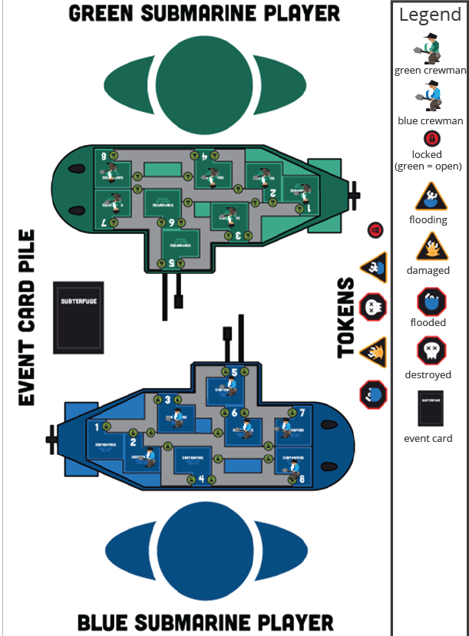

Design Concept

The forth of my ten maps is a 2-dimensional region map that is meant to be a region-based board game featuring not-so-serious nautical warfare called "Subterfuge". The game is meant to be a competitive game that pits one player's sub against another player's sub in a battle to see who can survive the longest against each other and a nasty giant squid that is attacking both subs.

The objective of the game is to eliminate all crewmen aboard the enemy sub while having at least one crewman still alive aboard your sub. The game is turn based and involves trying to keep your systems alive so that you can attack the enemy sub's systems and kill of his crewmen. There are event cards that are drawn every round with most of the even cards involving a giant squid attacking your sub.

The target audience for this game would be similar to those who like one versus one board games and want a game that definitely does not take combat so seriously. This game is meant for teens to adults who want silly combative fun with nautical puns.

Map Legend Breakdown

The 1-player position is the blue crewman. The blue crewman can move one region per turn and perform one action per turn. This allows them to combat other units or perform actions like firing a torpedo or using sonar.



The 2-player position is the green crewman. The green crewman can move one region per turn and perform one action per turn. This allows them to combat other units or perform actions like firing a torpedo or using sonar.

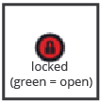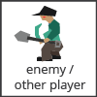

Lock token is used to lock (red) and unlock (green) hatches in the sub. This can be used to keep an enemy unit out or to stop an area from flooding outwards or inwards.

Flooding and Damaged tokens are yellow tokens, which mean that areas are in danger and can possibly start to flood or become destroyed.

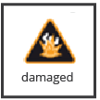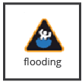

Flooding and Destroyed tokens are red tokens, which mean that areas are no longer accessible to crewmen and crewmen that are in these areas when these are placed are now dead.

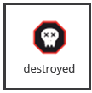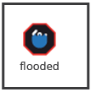

Event cards are used to provide a bit of variety to the game. Good things can happen, like gaining loot in the form of an extra crewman, but mostly bad things happen, like getting attacked by a giant squid.

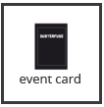

MDE

Mechanics

* Sub Layout (where rooms are located)
* Sub Systems (7 in total)
* Status Tokens (Good, Damaged, Flooding, Flooded, Destroyed)
* Door Locking / Unlocking
* Crewmen mechanics (1 more and 1 action a turn)
* Event Cards (Types of cards and Ratio)
* Torpedo Mechanics
* Dice Rolling
* Dice Types
* System Interaction
* Melee Combat
* Flooding Mechanics
* Hidden versus Known Knowledge (Sonar)

Dynamics

The dynamics of "Subterfuge" include resource management in the form of sub systems, crewmen, and damage control. The game is purposely made so that you do not have enough crewmen to man every system in your ship, so choosing which systems to use, which to repair, and which to just let go is a huge part of "Subterfuge". The game is as much a battle against your opponent as it is a race against time, as with every crewman you lose, more and more of your submarine will either start to flood and affect other systems. Balancing between controlling where your crewmen are, when to attack, and when to repair is needed in order to successfully win the game.

Experience

"Subterfuge" primarily plays with the aesthetic of competition. The main objective is to take out your opponent's crewmen. While the giant squid does a good load of the work for you, it is vital that you hit your opponent where it will hurt them the most. Challenge is another aesthetic that is huge in "Subterfuge". The game is constantly making you evaluate where you can best serve your sub and tough decisions on what to keep and who to save will be made throughout the course of the game. Lastly, the fantasy aesthetic runs deep in "Subterfuge". More often than not the game had both playtesters deeply engaged in nautical nonsense and scrambling to save their sub and crew as if they were the commander of their poor sub.

Intensity Curve

Overview

I have playtested "Subterfuge" with actual playtesters in a previous semester; however, no intensity curves were made at that time. I imagine the intensity curve for a typical game of "Subterfuge" would look something like the following:

Point-Analysis

* Start of Game (Intensity = 1)

The game starts when both players agree to play the game and go through the motions of setting up the game. Intensity is at its lowest here and failure to communicate the rules fully can end up in the game not being played at all.

* Drawing an Event Card (Intensity = 4)

Event cards can get crazy, but for the most part event cards involve getting some damage done right away. This can make drawing event cards right off the bat an intense way to start the game and in the continuing turns it can further add to intensity by being a big hindrance or a major relief.

* Performing Crew Actions (Intensity = 3)

Performing crew actions will be one of lowest points of the game (especially at the start of the game). However, as less crewmen exist, it will become increasingly important which crew actions will be made. However, this is the moment of the game where players take their time and come down off the intensity of the previous events of the game.

* Firing on an Opponent (Intensity = 6)

Firing on an opponent is an intense moment that can dramatically change how the opposing player will play out their next turn. As such, firing on an opponent is a highlight of the game, sometimes it does not even happen that much due to damage control that must be made.

* Subterfuge! (Intensity = 7)

Drawing a subterfuge card is meant to feel awesome. This allows for you to take away an enemy crewmen and replace him with your own crew. Now you can perform mayhem and chaos aboard the enemy sub and it is in the enemy's best interest to stop what they are doing and get your saboteur.

* Ending a Turn (Intensity = 3)

The end of a turn is a chance to take a breather, allowing a player to take a moment to rest. However, the results of their opponent's turn can be a tense moment, as well.

* Systems Start to Fail (Intensity = 6)

Eventually the game starts to get to a point where you have to let certain systems go and consolidate what you have left or focus resources on the problem and save that system. Either way it is an intense moment of the game where game changing moments are made.

* Controlling the Flooding (Intensity = 5)

Flooding is not fun for you, but fun for your opponent. Flooding is like temporarily losing control of an area so it must be taken care of otherwise sections of your sub will no longer be useful. This is not the most intense part of the game, but it is something that should always be on the back of the player's mind.

* Things are Looking Grim (Intensity = 9)

At last the game has reached a fever pitch where things may not look good for one or even both players. There are not many crewmen left, systems need repair, and maybe you cannot even fire on the enemy at this point. Whether through the luck of a good roll or the bad luck of a horrible event card, the game will soon be over.

* End of Game (Intensity = 2)

The end of the game should be a huge pressure release for the game. From most of the playtests, the end of the game was usually a big release of tension for the losing player.