Travis Moore

GAT 211A—Fall 2014

Instructor: Jeremy Holcomb

Project 2

Map #5—2-D Grid/Hex  
Castle Capture

Table of Contents

Map #5—2-D Grid/Hex: Castle Capture 3 – 9

Map 3

Design Concept 4

Map Legend Breakdown 4 – 5

MDE 5 – 6

Mechanics 5

Dynamics 5 – 6

Experience 6

Intensity Curve 6 – 9

Overview 6 – 7

Point-Analysis 7 – 9

Map

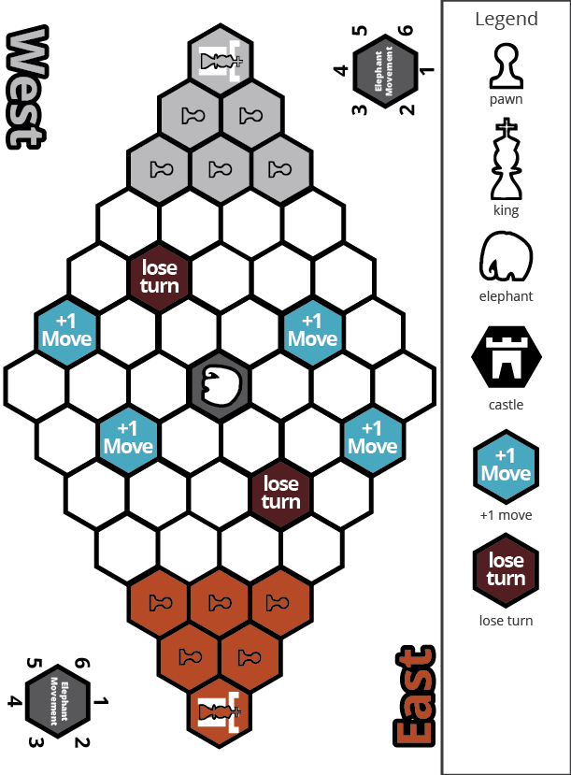

Design Concept

The fifth of my ten maps is a 2-dimensional hex map that is meant to be a board game featuring a semi-controllable piece that cannot be captures, the elephant. The game is meant to be a competitive game that pits one player's king and army against another player's king and army. The elephant is an agent of chaos that can be steered by either player, but never fully controlled.

The objective of the game is to eliminate the opposing player's king or capture their castle, whichever comes first. This is made possible by moving your army from your starting position on the board to the opposite end of the board where you can either capture the castle or eliminate the enemy's king along the way.

The target audience for this game would be similar to those who like one versus one board games and want a game with a random element of chaos by means of a rampaging elephant.

Map Legend Breakdown

The pawn is the most basic of unit available to the player. The pawn can move or attack in any one hex square adjacent to it. The pawn is also the only piece that can attempt to take control of an elephant by performing a control roll.

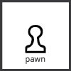

The king is the most valuable piece to the player. The king is the only piece that can capture an enemy castle. The king moves and attacks just like the pawn, but it can also jump over friendly pawns, gaining extra movement.

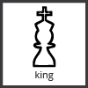

The elephant is the agent of chaos of the game. Once after both players have taken their turns the elephant rolls randomly to see which direction and how many spaces it will trample. Any pieces caught in its path are trampled. The elephant can be controlled by pawns, but a control roll must be made.



The castle space is the main objective of the game. Bronze must try to capture silver's castle and silver must try to capture bronze's castle. Only kings may capture the castle.



Any piece that moves on a lose turn space will lose its next turn and not be able to move at all. Move the piece on its side and after your next turn place the piece back upright to keep track of turns passed.



+ 1 move allows any piece that lands on it to move an additional space adjacent to this special space.



MDE

Mechanics

* Dice Throwing
* Types of Dice Used
* Control Roll
* +1 Movement Power Up
* Lose Turn Power Up
* Elephant Movement and Direction Mechanic
* Elephant Control Mechanic
* Pawn / King Movement
* Pawn Control Mechanic
* King Hop Mechanic
* King Capture Mechanic
* Turn Based Game
* Hex Layout
* Placement of Power Ups
* Placement of Elephant
* Starting Spaces
* Placement of Castles

Dynamics

The dynamics of "Castle Capture" include piece positioning and resource management in the form of how pawns are used and placed throughout the board. Due to the presence of an "agent of chaos" with how the elephant works, careful arrangement of pieces, especially the king, are needed in order to win this game.

However, the game does have a bit of risk and reward in trying to take control of the elephant to bowl over your enemy. This plan is not full-proof, however, and bad things can happen because of this. The addition of movement power-ups also help to shape the way pawns and kings are positioned in the game and can make the elephant stronger or weaker for a short time. The game is a strategy game and dynamics involving capturing enemy pieces and forcing your opponent into bad positioning are all possible dynamics of the game.

Experience

"Castle Capture" primarily plays with the aesthetic of competition. The main objective is to capture the enemy castle or take the enemy king. Because the board is a symmetrical layout and the army sizes are equal from the start the game is a battle of wits between two opponents. There is a random element in the elephant, but the game is mostly a strategy game. The fantasy element is not as strong in this game, despite the fact that you can believe that you are commanding an army and are playing as the king. The challenge aesthetic does exist depending on how deeply you want to get into trying to capture all of your opponent's pieces or try to make it across without losing any of your pieces to the enemy or the elephant.

Intensity Curve

Overview

I have playtested "Castle Capture" with actual playtesters in a previous semester; however, no intensity curves were made at that time. I imagine the intensity curve for a typical game of "Capture" would look something like the following:

Point-Analysis

* Start of Game (Intensity = 1)

The game starts when both players agree to play the game and go through the motions of setting up the game. Intensity is at its lowest here and failure to communicate the rules fully can end up in the game not being played at all.

* Leaving Your Castle (Intensity = 2)

The game starts off slowly with pawns and kings moving out of their castle zone and into the open board. At this point maximizing your possible movement gives us a tad bit more intensity than starting the game, but not much more.

* Rolling for the Elephant (Intensity = 4)

Rolling for the elephant does a lot for the game. While the elephant cannot possibly kill a unit on the first elephant turn, it will get close to one player and influence their behavior on the next turn. Sequential turns after the first one will be more intense than this one depending on where the elephant is.

* Losing a Piece to the Elephant (Intensity = 6)

Losing a piece to the wild elephant sucks, and is an intense moment because chances are the elephant is close to one of your other units, as well. It is at this point that a player can choose to either avoid the elephant or try to control it to send it at the other player.

* Using the Elephant to Attack the Enemy (Intensity = 9)

Successfully controlling the elephant can lead to you moving it further away or potentially bowling over several enemies as you send it charging forth. This is meant to be an extremely intense part of the game which can result in the elephant changing possession several times. It is also the most intense because this is the only way to lose more than one unit at a time using a single unit.

* Crossing the Middle (Intensity = 5)

Crossing the middle should happen roughly at the same time for both players and is usually when melee combat will start. As the widest part of the board it has the most space available to move and pieces can create discouraging barriers for the enemy.

* Melee Combat (Intensity = 7)

Melee combat is a first come first server, with the attacking player always winning the bout. Melee combat should feel awesome because you either forced your opponent into losing a piece or forced them into an awkward position on the board.

* Chasing Down the King (Intensity = 5)

After the middle is crossed the game usually becomes focused on trying to get the other player's king. Sometimes both players' kings are close enough to almost fight, but often each king went a different direction, resulting in a chase from other pawns.

* Break Away for the Castle (Intensity = 8)

Near the end of the game one player usually has better positioning than the other player and makes a break away for the enemy castle. At this point usually only the elephant can catch him now.

* End of Game (Intensity = 2)

The end of the game should feel good for both players as the game is generally pretty fair (except for the luck of the roll when it comes to the elephant). The game should leave both players feeling like the chase at the end was a tense moment that they are coming down from.