Travis Moore

GAT 211A—Fall 2014

Instructor: Jeremy Holcomb

Project 2

Map #6—2-D Grid/Hex  
Jellyfish: I Don't Think You're Ready For This Jelly

Table of Contents

Map #6—2-D Grid/Hex: Jellyfish: I Don't Think You're  
 Ready For This Jelly 3 – 9

Map 3

Design Concept 4

Map Legend Breakdown 4 – 5

MDE 6

Mechanics 6

Dynamics 6

Experience 6

Intensity Curve 7 – 9

Overview 7

Point-Analysis 8 – 9

Map

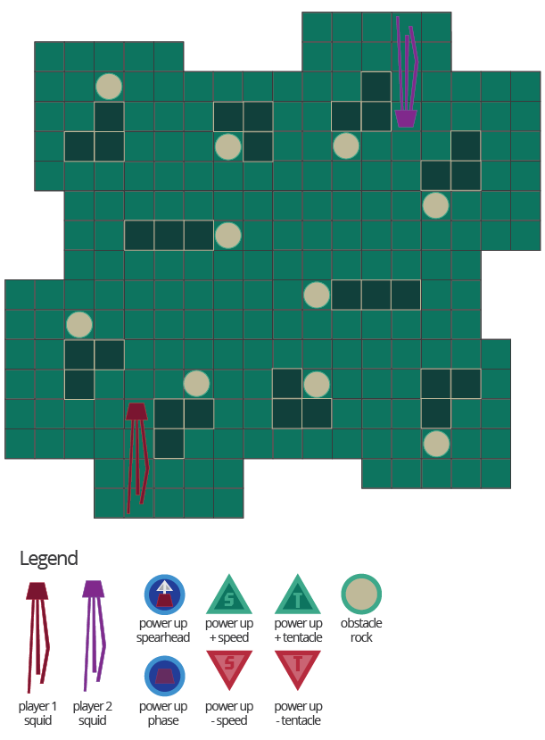

Design Concept

The sixth of my ten maps is a 2-dimensional grid map that is meant to be a played as an action arcade game called "Jellyfish: I Don't Think You're Ready For This Jelly". The game is meant to be a competitive game that pits one squid against another player's squid in a grid arena with movement comparable to the game of "Snake".

The objective of the game is to eliminate the opposing player's squid by making them run into your tentacles or into a wall or other obstacle. This will result in their squid losing one grid space worth of tentacles. When a player runs of out tentacles they are eliminated.

I believe the audience for this game could be potentially anyone, but probably mostly children because of all the bright colors. However, with adults being into children television programs and such, I am sure anyone could really get into this game if they wanted to. The competitive aspect of the game means that even hardcore gamers could like it for all I know.

Map Legend Breakdown

The player one and player two squids are identical in every way except for in color. Both squids start out with 3 grids worth of tentacle that can either increase with power ups or decrease with negative power ups or running into walls or the other player.

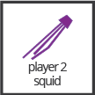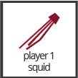

Obstacle rocks can be picked up with the last grid space of tentacles and released wherever a player sees fit. This allows the players to attempt to rearrange the layout of the map and create blocked off areas or potentially block the enemy squid's escape.



The Green Power Ups are used to denote positive power ups in the game. Specifically the "T" power up increases the length of your tentacles by 1 grid space and the "S" power up increases the move speed of your squid by 1 extra grid per second.

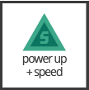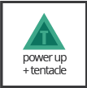

The Red Power Ups are used to denote negative power ups in the game. Specifically the "T" power up decreases the length of your tentacles by 1 grid space and can kill a player, while the "S" power up slows down your squid's move speed by 1 less grid per second.

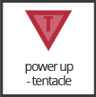

The Blue Power Ups are used to denote temporary power ups in the game. Specifically the "phase" power up allows the player to phase through all obstacles, including the enemy player, for 5 seconds. The "spearhead" power up allows the player to run into the enemy player one time and cut off a segment of tentacles, allowing for the enemy player to potentially lose a lot of tentacle length.

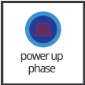

All power ups appear randomly on the map, but are more biased towards the outsides of the maps forcing players into a potentially compromising position.

MDE

Mechanics

* Jellyfish Movement Speed
* Jellyfish Tentacle Length
* Jellyfish Starting Position
* Grid Map Layout
* Movable Rocks
* Picking up Rocks
* Placing Rocks
* Green Power Up Permanence
* Red Power Up Permanence
* Green Power Up Types / Potency
* Red Power Up Types / Potency
* Blue Power Up Length
* Blue Power Up Types
* Phasing
* Colliding with Spearhead
* All Power Up Spawn Locations / Frequency

Dynamics

The dynamics of "Jellyfish: I Don't Think You're Ready For This Jelly" involve managing your position while keeping track of where your opponent is. Like the game "Snake" your body of tentacles can be used as a form of territory control and force your opponent into a compromising position on the map. Resource management also exists as players must be aware of the good and bad power ups because they can enable a player to take an advantage or inadvertently because they can cause players harm.

Experience

The primary aesthetic in "Jellyfish: I Don't Think You're Ready For This Jelly" is the competition aesthetic. Because the primary threat to your jellyfish is your opponent's jellyfish and how they choose to rearrange the environment, competition is always prevalent in the game. The challenge aesthetic can also be experienced in the game through the solving of environmental puzzles involving how the rocks are scattered throughout a level.

Intensity Curve

Overview

I have not playtested "Jellyfish: I Don't Think You're Ready For This Jelly" with actual playtesters. I imagine the intensity curve for a typical game of "Jellyfish: I Don't Think You're Ready For This Jelly" would look something like the following:

Point-Analysis

* Start of Game (Intensity = 1)

The start of the game gives the player a "3, 2, 1" countdown which hopefully can build some anticipation before the game starts, helping to amp the player up for the action ahead. We don't expect a lot of intensity here, but it is better than giving the player a cold start.

* Moving Rocks (Intensity = 4)

There are many rocks throughout the map and since rocks cannot be locked down I imagine that moving rocks around will be fun, but at the beginning of the game not much will be accomplished right away. Still, a plan can be set in motion which could lead up to an intense moment later in the game.

* "The Dance" (Intensity = 3)

I refer to "The Dance" as the part of the game where players are trying to push each other into a wall or an obstacle by maneuvering close to each other. Both players are dancing around each other trying to get the other to screw up while making sure not to get hit by the player's tentacles.

* Getting Power Ups (Intensity = 6)

Whether or a good or a bad power up, the intensity of getting a permanent change to your squid should feel intense. Fasting moving squids should be able to get in and out of bad situations, longer tentacles should help to trap the enemy, and the opposite power ups just plain suck. Power up frequency and placement should help create spikes in the game.

* Using a Blue Power Up (Intensity = 8)

Blue power ups are meant to be rare and can be held and triggered when a player wants to make a move. Whether it's escaping a trap with a phase power up or cutting multiple segments of tentacles off with the spearhead, using the blue power up is supposed to be awesome!

* Trying to Trap an Opponent with Rocks (Intensity = 4)

Using rocks when you cannot get a power up is definitely an option and because of how indirectly rocks work they should provide players a moment of a breather when they are not chasing down each other and instead are placing rocks on the map.

* Running Short on Tentacles (Intensity = 7)

After losing a few tentacles the pressure of losing should be intense for a player near death. Seeing the tentacles cut off should be intense and inspire the player to get revenge or flee quickly.

* Trapping an Opponent (Intensity = 9)

Trapping an opponent with rocks or with your body should make a player feel smart. They have managed to best their opponent or trick them into making a mistake. Whether it's a high or a low, this moment should feel very intense for both players.

* End of Game (Intensity = 2)

The end of the game should feel good for both players as the game is generally pretty fair from the start. The game should leave both players feeling like they want to keep playing and try to "out dance" the other into losing their positioning.