Travis Moore

GAT 211A—Fall 2014

Instructor: Jeremy Holcomb

Project 2

Map #7—2-D Freeform  
Thar's Grenades in the Volcano

Table of Contents

Map #7—2-D Freeform: Thar's Grenades in the Volcano 3 – 9

Map 3

Design Concept 4

Map Legend Breakdown 4 – 5

MDE 6 – 7

Mechanics 6

Dynamics 6

Experience 6 – 7

Intensity Curve 7 – 9

Overview 7

Point-Analysis 8 – 9

Map

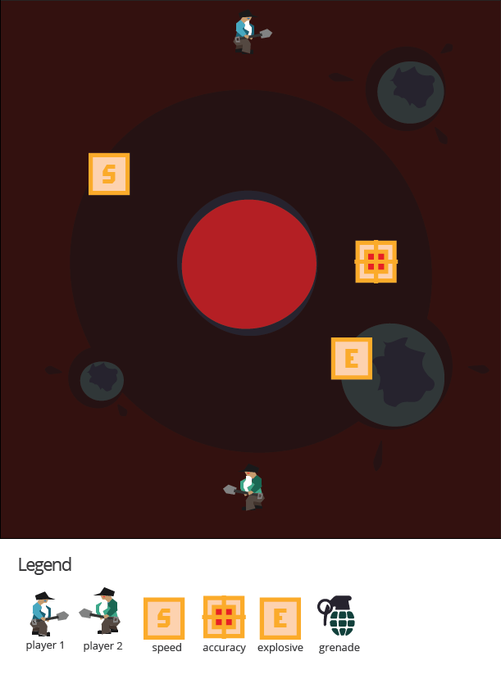

Design Concept

The seventh of my ten maps is a 2-dimensional freeform map that is meant to be a played as an action arcade game called "Thar's Grenades in the Volcano". The game is meant to be a competitive game that pits one player's miner against another player's miner in an explosive battle atop a volcano. As a freeform game the players can only move a couple of units in any direction, but can lob grenades in any direction by holding down the fire button and lobbing a grenade over their shoulder. The wind in the game adds to the variability of the grenade toss so that a player is not always accurate when they toss a grenade.

The objective of the game is to eliminate the opposing player's miner by digging up grenades and lobbing them at your opponent while making sure to collect as many power ups as possible. Watch out, because the volcano is still active and one errant grenade into the volcano's center and all kinds of explosions will happen. The game is over when one player explodes to either the other player's grenades or an explosion from the volcano.

I believe the audience for this game is probably teens and adults who just want to have a quick and silly action experience of lobbing grenades at each other on top of a volcano. There's a certain fantasy element to this game because of just how unreal the whole scenario sounds.

Map Legend Breakdown

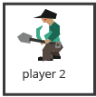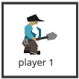

The player one and player two characters are exactly the same in every way but their colors. Because of this, both miners have an extreme hatred to one another. They will finally settle their feud by the only way they know how: dig up grenades buried on top of a volcano and battle to the death.

The accuracy power up reduces the effects of the wind by a little bit to make the player's initial grenade lob more accurate than it was before. This power up appears randomly on the ground every so often.



The explosive power up increases the size of the explosion radius from a lobbed grenade. This power up appears randomly on the ground every so often.



The speed power up increases the speed of the player who picks it up by a little bit. This power up, like all power ups, stack upon itself so that each time it is picked up it increases a little bit more. This power up appears randomly on the ground every so often.



The most commonly found power up, the grenade is found by digging in the ground. Charging up you lob increases the strength of the lob while the analog stick chooses which direction to throw the grenade in. Lobbing a grenade requires the player to stand still, so caution should be taken. Grenades are not very accurate and the wind will affect every lob a player makes.



MDE

Mechanics

* Player movement
* Player lobbing strength / charge time
* Player standing still to lob grenades
* Grenade availability upon digging
* Power up spawn locations
* Power up spawn frequency
* Speed increase percentage
* Explosive increase percentage
* Accuracy increase percentage
* Grenade initial explosion size
* The size of the volcano explosion
* Knockback on players
* Wind
* Move speed adjustment the closer you are to the volcano hole
* Blowing up power ups

Dynamics

The dynamics of "Thar's Grenades in the Volcano" involve managing your position while keeping track of where your opponent is. Timing is also crucial in this game because you do not want to get caught standing still, about to lob a grenade, when there is a grenade about to hit near your position. Managing your position also affects how easily you will be able to find and pick up power ups as they spawn into the environment. Maybe it is in the best interest of a player to deny a power up by blowing it up so that your opponent cannot get to it. Overall, "Thar's Grenades in the Volcano" is a fast paced game where the longer the players live the more power ups they will get making their explosions that much more powerful.

Experience

The primary aesthetic in "Thar's Grenades in the Volcano" is the competition aesthetic. Because the primary threat to your minor is the other player, the competitive element of the game is ever-present and your primary concern. Along with the competitive aesthetic of the game the way lobbing grenades works should provide something to the challenge aesthetic of the game. Being forced to stand still to lob a grenade should create for some interesting strategies and provide a challenge for both players. Finally, there is a hint of the fantasy aesthetic that can be found in the silliness of playing with grenades on a volcano's peak. It's a silly fantasy that players can indulge in without the real danger of fighting to the death in such a bizarre location.

Intensity Curve

Overview

I have not playtested "Thar's Grenades in the Volcano" with actual playtesters. I imagine the intensity curve for a typical game of "Thar's Grenades in the Volcano" would look something like the following:

Point-Analysis

* Start of Game (Intensity = 2)

The start of the game gives the player a "3, 2, 1" countdown which hopefully can build some anticipation before the game starts, helping to amp the player up for the action ahead. We don't expect a lot of intensity here, but it is better than giving the player a cold start.

* Moving Around the Volcano (Intensity = 3)

At the beginning of the game miners move slowly and take their time digging up the earth around the volcano. The players know that the environment is not stable so this should feel kind of intense because their miners are not very quick.

* Avoiding Small Volcano Bursts (Intensity = 5)

Small volcano bursts happen throughout the game and avoiding them can mean giving up a grenade or a power up just to survive. Avoiding these small blasts should get easier as more and more speed power ups are collected

* Digging for Grenades (Intensity = 3)

Digging for grenades can uncover power ups, but more often than not you get either nothing or a shiny, new grenade to lob. Grenades are very common so they are not that intense to find.

* Lobbing a Grenade (Intensity = 6)

Lobbing a grenade is a risk because your miner has to stand still to lob the grenade and the charging can take some time. Because of this, and the possibility of hitting your opponent, every lobbed grenade should feel awesome. The chance a grenade might also fall in the volcano is also a reason why the intensity is high.

* Finding New Spots to Dig (Intensity = 4)

Every spot dug up no longer provides anything of value, so miners must run around to new locations in order to dig up grenades. As the game continues this gets harder and harder as more bursts from the volcano start to happen and moving around can place you closer to the enemy.

* Dodging Big Volcano Blasts (Intensity = 8)

If a big volcano blast happens players should feel threatened and should stop digging to try and save their miner from the lava explosions. This is supposed to halt the combat of the game as players just try to stay alive.

* Exploding the Opponent (Intensity = 9)

Lobbing that grenade just right to take out your opponent should not feel easy until you've gotten quite a few power ups. For this reason, when you finally do land a grenade on your opponent it should feel very satisfying.

* End of Game (Intensity = 3)

The end of the game should feel good for both players as the game is generally pretty fair from the start. All the tension of the game is now passed and the chance to start a new should be available for both players. The game should leave both players feeling like they experienced a frantic battle in a very unlikely location.