Travis Moore

GAT 211A—Fall 2014

Instructor: Jeremy Holcomb

Project 2

Map #8—2-D Freeform  
Feed the Fatties

Table of Contents

Map #8—2-D Freeform: Feed the Fatties 3 – 9

Map 3

Design Concept 4

Map Legend Breakdown 4 – 5

MDE 6 – 7

Mechanics 6

Dynamics 6

Experience 6 – 7

Intensity Curve 7 – 9

Overview 7

Point-Analysis 8 – 9

Map

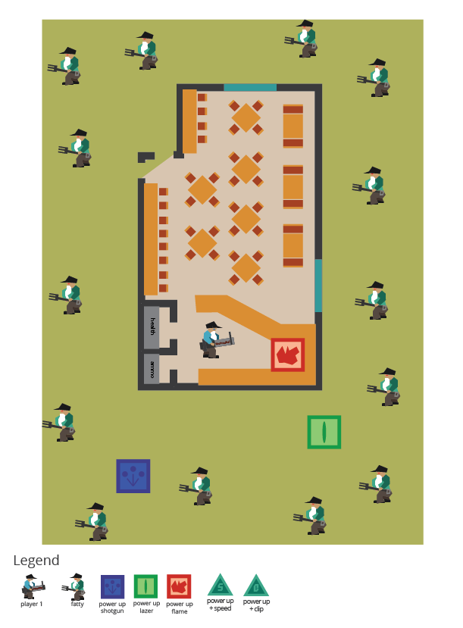

Design Concept

The seventh of my ten maps is a 2-dimensional freeform map that is meant to be a played as an action arcade game with a dash of tower defense thrown in called "Feed the Fatties". The game is meant to be a single player experience where the player must defend their deep fat fryers from the hordes of fatties that are descending upon your humble taco restaurant. Through the use of careful shooting, ammo conservation and liberal use of power ups the player must defend their restaurant at all costs using their taco-zuka.

The objective of the game is to survive wave after wave of fatties by shooting them with tacos from your taco-zuka. The game is over if a player touches a fatty or if a fatty falls into a deep fat fryer, burning themselves, and then suing your restaurant for all its worth.

I believe the audience for this game is probably teens and adults who have worked a customer service job, particularly one at a fast food restaurant. I see this game as a good way for them to get some pent up rage and anger out before they hurt someone in real life.

Map Legend Breakdown

The player 1 character has basic moving and shooting with his taco-zuka. The player is unable to jump over obstacles like tables and chairs and must go around them. The player can pick up and instantly use power ups to "feed" his customers either shotgun pellet tacos, lazer tacos from the future, or flame thrower tacos. The player can also pick up and move chairs and tables to create obstacles.

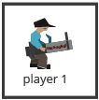

The fatty enemy carries a giant fork and will hurt the player if they touch them. The fatties rely on mass numbers and are slow moving, unable to climb tables and chairs, and are very, very hungry. Fatties will break down windows and obstacles that are in their way, but it will take some time before they can fully break down most obstacles.

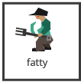

The green series of power ups are permanent pick-ups that increase the speed at which the player fires and how many tacos are in a clip for the player. These power-ups appears randomly on the ground every so often

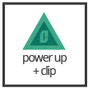

The weapon power ups temporarily give the player the shoot special types of tacos. The flame power up gives the player a wave of fiery tacos to lavish upon the fatties. The lazer power up allows for futuristic tacos to penetrate multiple fatties at a time. The shotgun power up gives the player a spread shot of tacos to take out multiple fatties at one time. These power-ups appears randomly on the ground every so often.



MDE

Mechanics

* Player movement
* Player shooting speed
* Player reload speed
* Player initial clip size
* Taco size
* Fatty movement speed
* Fatty pathing ability
* Fatty initial hit points
* Green power up percentage increase / frequency
* weapon power up effects / frequency
* Table / Chair / Window hit points
* Player ability to move obstacles
* Fatty ability to break obstacles
* Obstacles per map
* Fatties per map

Dynamics

The dynamics of "Feed the Fatties" involve managing your position while conserving your resources and using obstacles to defeat an enemy of overwhelming numbers. Managing your position means that players will have to quickly assess the map layout and figure out how best to use the chairs and tables without placing them in the way of the player's ability to shoot down fatties.

Conserving resources means knowing when to fire at an enemy and when to save your ammo for a more sure shot. The trick to creating this dynamic the right way will involve testing to see how fast a player should reload, how fast he should fire, and how much ammo a player should have before going to get more ammo.

Using obstacles gives the player the ability to strategically use his environment to reduce points of entry in the restaurant. While obstacles can hinder the player as well, if used properly players can create temporary barricades to keep fatties out.

Experience

The primary aesthetic in "Feed the Fatties" is the challenge aesthetic. The point of the game is to challenge yourself to see how long you will last against a horde of fatties. Managing the resources and navigating and creating obstacles plays right into the challenge aesthetic and should be enjoyable to those who like to create a plan and see how it unfolds. On top of the challenge aesthetic there is a bit of accomplishment and fantasy aesthetics as well. The accomplishment comes from saving ammo and collecting power ups, while the theme of the game should provide some fantasy for anyone who has ever had a food service or customer service type of job.

Intensity Curve

Overview

I have not playtested "Feed the Fatties" with actual playtesters. I imagine the intensity curve for a typical game of "Feed the Fatties" would look something like the following:

Point-Analysis

* Start of Game (Intensity = 2)

The start of the game gives the player a "3, 2, 1" countdown which hopefully can build some anticipation before the game starts, helping to amp the player up for the action ahead. We don't expect a lot of intensity here, but it is better than giving the player a cold start.

* Assessing the Environment (Intensity = 3)

At the beginning of the game the player has a bit of time to see what parts of their environment they can put to use, maybe the player is even tempted to go outside to get a big obstacle to place in front of a window or door.

* Rearranging Obstacles (Intensity = 4)

The player does not have much time to arrange obstacles and another countdown soon begins to let the player know that the fatties are going to start coming.

* The Fatties Start to Trickle In (Intensity = 3)

Fatties come from all directions. At this point the player can only make minor adjustments to the obstacles they've placed and might start to take shots at fatties at this time.

* Feeding a Fatty (Intensity = 6)

Because of the slow rate of fire and limited ammo, taking down a fatty is satisfying, but due to the sheer number of fatties the intensity is short lived and not as intense as it could be.

* Collecting Power-Ups (Intensity = 5)

Power-ups should help the player feel a bit more powerful in how quickly they can move and shoot. This should relieve some stress from having to perfectly time every fatty being shot at.

* More Fatties (Intensity = 7)

As more and more fatties come to the restaurant the obstacles are starting to break down and the player will either have to reconstruct obstacles if he has time or start kiting the fatties while trying to get weapon power-ups.

* Using a Weapon Power-Up (Intensity = 8)

Weapon power-ups should feel awesome for the player and help him take out waves of enemies. Weapon power-ups are rare, but extremely satisfying, especially in a crunch moment of the game.

* Overwhelming Number of Fatties (Intensity = 9)

Eventually paths available to the player will become limited and there will be just too many fatties for the player to take down. The game is at its most intense at this point as players desperately try to save their deep fat fryer.

* End of Game (Intensity = 3)

The end of the game should feel like a huge pressure release from all the build up during the ending stages of the game.