Travis Moore

GAT 211A—Fall 2014

Instructor: Jeremy Holcomb

Project 2

Map #9—2-D Freeform  
Snail

Table of Contents

Map #9—2-D Freeform: Snail 3 – 9

Map 3

Design Concept 4

Map Legend Breakdown 4 – 5

MDE 5 – 6

Mechanics 5 – 6

Dynamics 6

Experience 6

Intensity Curve 6 – 9

Overview 6 – 7

Point-Analysis 7 – 9

Map

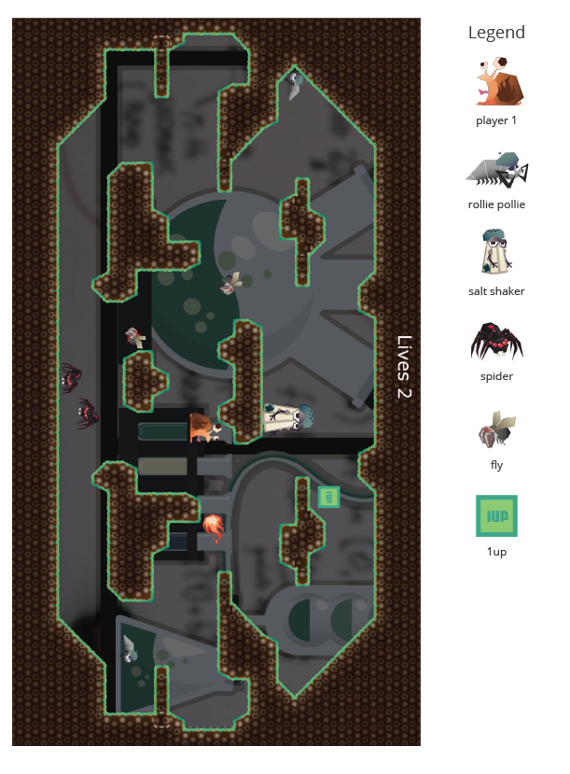

Design Concept

The ninth of my ten maps is a 2-dimensional freeform map that is meant to be a played as an action arcade game called "Snail". The game is meant to be a single player experience where the player is the ultimate genetically engineered weapon of war: a fire breathing snail! As a fire breathing snail you must survive waves of other genetically engineered bugs in a battle for ultimate supremacy and your life!

The objective of the game is to survive every level with its enemies and its bosses. Your main weapon against enemies is your wits and fire breath which has the unfortunate side effect of knocking you clear across the map every time you breathe out fire. The game ends when you defeat a level's enemies including the boss or if you run out of lives before clearing the level of its enemies. Either way, the mad scientist that has created all you killer bugs wins!

I believe the audience for this game is probably teens and adults who want a wacky and fun filled arena beat down game that is not realistic in the slightest way. The game should serve as a fun distraction from life and just a frantic bit of fun.

Map Legend Breakdown

The player 1 character is a fire breathing snail. Every time the snail breathes fire he flies backwards through the air. This incredible aerial feat makes up for the fact the snail is sticky and usually moves slowly on the ground. Since the snail is sticky he can cling to walls and ceilings, too.



The Salt Shaker is the main boss of the level. He takes quite a few hits of fire to take down and is the only enemy that shoots at you by throwing insta-kill salt pellets. When his health gets low he runs fast and drops salt out of his crack in the glass.

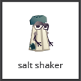

The Rollie Pollie is a simple enemy that paces back and forth, but he will roll at the player if he sees him. Rollie Pollie is weak and does not take a lot of fire hits before he is defeated.

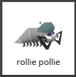

The spider enemy will crawl along the walls and ceilings in an attempt to ambush the player. Quite fast, the spider enemy is tougher than the snail and takes several fire hits before he is defeated.

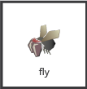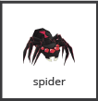

The fly enemy is rather weak and dumb enemy that just kind of flies around throughout the level. A first attempt at making a genetic weapon, this enemy is not the mad scientist's greatest achievement.



The 1-Up is the only power up in the game worth getting because it gives you an extra life. Seriously, what is better than that?

MDE

Mechanics

* Player Movement Speed
* Player Jump Speed / Height
* Player Fireball breath
* Player Fireball Knock Back
* Player Fireball Cooldown
* Player Ability to Stick to Walls
* Salt Shaker Move Speed
* Salt Shaker Health
* Salt Shaker Salt Throwing
* Salt Shaker Salt Drop while Fleeing.
* Player Health / Lives
* Rollie Pollie Health
* Rollie Move Speed
* Rollie Pollie Patrolling
* Rollie Pollie Rolling
* Spider Stick to Walls
* Spider Movement
* Spider Health
* Spider Speed
* Fly Flying
* Fly Speed
* Fly Health
* Map Layout
* 1 Up Frequency / Spawn Locations

Dynamics

The dynamics of "Snail" involve managing your position and accurately guessing how the enemies will engage you. Managing your position in "Snail" is difficult because the snail does not move fast unless you breathe fire, in which case the snail is knocked back in the opposite direction of the fire. Learning how the controls work and how to use the knock back to your advantage is key to surviving in "Snail". Aside from movement management, learning the way enemies will try to attack you is also a big part of the game.

Experience

The primary aesthetic in "Snail" is the challenge aesthetic. The point of the game is to challenge yourself to see how long you will last against a many different types of enemies and bosses. There is a little bit of accomplishment and fantasy aesthetics in play, but they pale in comparison to how much "Snail" really hits on the challenge aesthetic.

The accomplishment aesthetic can be seen in mastering the controls and beating the game with as many lives as possible. The fantasy aesthetic involves just how much the art style and feel of the game can make the player feel like they really are a high-flying, fire breathing snail. "Snail" is meant to be a game where a player can spend a long time learning how to manipulate the fire knockback to perform aerial feats to dodge past enemies and destroy them with fire.

Intensity Curve

Overview

I have not playtested "Snail" with actual playtesters. I imagine the intensity curve for a typical game of "Snail" would look something like the following:

Point-Analysis

* Start of Game (Intensity = 2)

The start of the game gives the player a "3, 2, 1" countdown which hopefully can build some anticipation before the game starts, helping to amp the player up for the action ahead. We don't expect a lot of intensity here, but it is better than giving the player a cold start.

* Assessing the Environment and Enemies (Intensity = 3)

At the beginning of the game the player has a bit of time to see the layout of the environment and get a good feeling for where safe areas are and which areas are move open to flying through the air.

* Breathing Fire / Flying Through the Air (Intensity = 5)

The first time a player breathes fire and flies through the air it should feel awesome and also kind of crazy. The player will have to learn to manage how the knockback works in the game.

* Taking Out an Enemy with Fire (Intensity = 7)

Burn! Taking out an enemy should feel great and I imagine a lot of this game would have to involve just how awesome burning an enemy should look through the animation.

* Dodging by Flying in the Air (Intensity = 5)

Almost equally as awesome as breathing fire is just how quickly the snail can avoid traps and enemies by dodging enemies with a well timed fire breath. Dodging should be difficult to pull off right, but rewarding for when it happens correctly.

* Collecting 1-Ups (Intensity = 4)

1 Ups are important to get if a player wants to have a few more chances at winning the game, but they can often get the player in trouble. It should be kind of hard to get them, but worth doing so if it is safe.

* Defeating All Normal Enemies (Intensity = 5)

As the player becomes more skilled at defeating normal enemies it should be less intense to take out small groups of enemies, but if there are quite a good number than the acrobatics needed to do so should feel kind of intense.

* Engaging the Boss (Intensity = 8)

The boss should feel different from normal enemies and take quite a lot of fire damage before he is defeated. This fight should be difficult and less predictable than normal enemy behavior. Perhaps bosses have a two stage attack depending on what health they have left.

* Defeating the Boss (Intensity = 9)

At long last! Defeating a boss should be incredibly rewarding and feel like the challenge was difficult and did not require luck.

* End of Game (Intensity = 3)

The end of the game should feel like a huge pressure release from all the build up during the ending stages of the game.