Travis Moore

GAT 211A—Fall 2014

Instructor: Jeremy Holcomb

Project 2

Map X—Type of Map  
Name Of Map

Table of Contents

MAP X—TYPE OF MAP: NAME OF MAP 3 – 5

Map x

Design Concept x

Map Legend Breakdown x – x

MDE x – x

Mechanics x

Dynamics x

Experience x

Intensity Curve x – x

Overview x

Point-Analysis x

Map

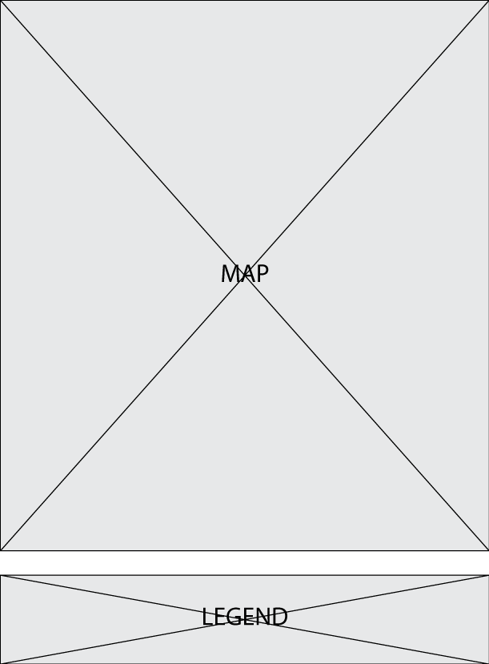

Design Concept

The first version of the game was informally tested between my wife and me prior to developing the second version of this game. The sheer amount of dice and the complexity of the maximum total value called for some changes to be made for this game before I formally playtested this game in lab.

my boxing theme.

The first version of the game was informally tested between my wife and me prior to developing the second version of this game. The sheer amount of dice and the complexity of the maximum total value called for some changes to be made for this game before I formally playtested this game in lab.

my boxing theme.

Map Legend Breakdown

The first version of the game was informally tested between my wife and me prior to developing the second version of this game. The sheer amount of dice and the complexity of the maximum total value called for some changes to be made for this game before I formally playtested this game in lab.

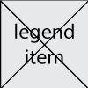

my boxing theme.

The first version of the game was informally tested between my wife and me prior to developing the second version of this game. The sheer amount of dice and the complexity of the maximum total value called for some changes to be made for this game before I formally playtested this game in lab.

my boxing theme.

The first version of the game was informally tested between my wife and me prior to developing the second version of this game. The sheer amount of dice and the complexity of the maximum total value called for some changes to be made for this game before I formally playtested this game in lab.

my boxing theme.

The first version of the game was informally tested between my wife and me prior to developing the second version of this game. The sheer amount of dice and the complexity of the maximum total value called for some changes to be made for this game before I formally playtested this game in lab.

my boxing theme.

The first version of the game was informally tested between my wife and me prior to developing the second version of this game. The sheer amount of dice and the complexity of the maximum total value called for some changes to be made for this game before I formally playtested this game in lab.

my boxing theme.

The first version of the game was informally tested between my wife and me prior to developing the second version of this game. The sheer amount of dice and the complexity of the maximum total value called for some changes to be made for this game before I formally playtested this game in lab.

my boxing theme.

The first version of the game was informally tested between my wife and me prior to developing the second version of this game. The sheer amount of dice and the complexity of the maximum total value called for some changes to be made for this game before I formally playtested this game in lab.

my boxing theme.

MDE

Mechanics

* mechanic
* mechanic
* mechanic
* mechanic
* mechanic
* mechanic
* mechanic
* mechanic
* mechanic

Dynamics

The first version of the game was informally tested between my wife and me prior to developing the second version of this game. The sheer amount of dice and the complexity of the maximum total value called for some changes to be made for this game before I formally playtested this game in lab.

my boxing theme.

Experience

The first version of the game was informally tested between my wife and me prior to developing the second version of this game. The sheer amount of dice and the complexity of the maximum total value called for some changes to be made for this game before I formally playtested this game in lab.

my boxing theme.

Intensity Curve

Overview

The first version of the game was informally tested between my wife and me prior to developing the second version of this game. The sheer amount of dice and the complexity of the maximum total value called for some changes to be made for this game before I formally playtested this game in lab.

my boxing theme.

Point-Analysis

* Point 1

The first version of the game was informally tested between my wife and me prior to developing the second version of this game. The sheer amount of dice and the complexity of the maximum total value called for some changes to be made for this game before I formally playtested this game in lab.

my boxing theme.

* Point 2

The first version of the game was informally tested between my wife and me prior to developing the second version of this game. The sheer amount of dice and the complexity of the maximum total value called for some changes to be made for this game before I formally playtested this game in lab.

my boxing theme.

* Point 3

The first version of the game was informally tested between my wife and me prior to developing the second version of this game. The sheer amount of dice and the complexity of the maximum total value called for some changes to be made for this game before I formally playtested this game in lab.

my boxing theme.

* Point 4

The first version of the game was informally tested between my wife and me prior to developing the second version of this game. The sheer amount of dice and the complexity of the maximum total value called for some changes to be made for this game before I formally playtested this game in lab.

my boxing theme.

* Point 5

The first version of the game was informally tested between my wife and me prior to developing the second version of this game. The sheer amount of dice and the complexity of the maximum total value called for some changes to be made for this game before I formally playtested this game in lab.

my boxing theme.

* Point 6

The first version of the game was informally tested between my wife and me prior to developing the second version of this game. The sheer amount of dice and the complexity of the maximum total value called for some changes to be made for this game before I formally playtested this game in lab.

my boxing theme.