Travis Moore

GAT 211A—Fall 2014

Instructor: Jeremy Holcomb

Project 3

Team Fortress 2Concept & Design

Table of Contents

Team Fortress 2 (version 01: Stripped to the Basics) 3 – 6

Design Goals 3

Written Rules 4 – 6

Team Fortress 2 (version 02: Refining Classes/Map?) 7 – 10

Design Goals 7 – 8

Written Rules 8 – 10

Team Fortress 2 (version 03: New Weapons/Objective/Map) 11 – 15

Design Goals 11

Written Rules 12 – 15

Team Fortress 2 (version 04: Final) 16

Design Goals 16

Team Fortress 2 (version 01: Stripped to the Basics)

Design Goals

Upon creating the first version of my Team Fortress 2 board game I knew right away that I would be unable to truly capture Team Fortress 2 in its entirety. There is so much complexity and so many weapons, class combinations, and little things that make up Team Fortress 2 as it currently is to date. If I stand any chance in trying to recreate Team Fortress 2 as a board game I knew I would have to think back to how the game was upon its initial release.

Team Fortress 2 as it was upon its release in 2007 is still quite a large game. I know I’ll have to strip back as much as possible to have a chance at creating this kind of experience. With this in mind my first version of the game will only feature 6 of the 9 classes. Of these 6 classes I’ll be focusing on distilling these classes to their base features to hopefully be able to capture the experience of playing that class in a board game form. Each class will only have a primary weapon, with the exception of the medic who will have the ability to melee as a mostly last resort.

Using stats obtained from the TF2 wiki and from experience playing the game, I am going into this first playtest hoping that my classes will hold up as feeling like the classes they are meant to be. This means I’ll be looking to see how they are used, how they move on the map, and just how effective all the classes played are relative to their video game classes. To help me get my playtesting results, I will be using the “highlander” rules of Team Fortress 2, where both players cannot play more than one of each type of class in the game and must pick new classes when one class dies.

While the map is important to discovering how these classes work, I know the map in its current state is nowhere near perfect and could use a lot more work. This being said, I made sure to include some open spaces, some close quarters, and a bit of walls to provide cover behind. My main inspiration for the map comes from my limited experience playing the *Warhammer 40,000* table-top game. The biggest difference is that I am using a grid to constrain player movement, but this might change in future versions of the game.

Written Rules

Components

* 12 class tokens (6 Blu and 6 Red)
* 1 D4 die
* 1 map
* 2 class stat/rule sheets

Players

2 players

Objective

The objective of the game is to eliminate all nine classes of your opponent.

Setup

Players roll a die to determine who will go first in the game. The highest die roll lets this player go first, while the losing player gets to choose which color team they’d like to be. Players choose any 3 of their 6 classes and place them in their color spawn room without revealing the class side of their class tokens to their opponent. The player who won the die roll moves first.

Rules

Players can move and take one action with one class token per turn. Each class follows their own stat/rule sheet to determine moving, health, and shooting. Movement is orthogonal on the grid and firing at an enemy is based upon line of sight of an enemy (from the center of your grid square, to the center of the target grid square).

Class Stats/Rules

Class: Scout  
Health: 12  
Move: 6  
Weapon Range: 1 – 5 Line of Sight  
Weapon Effectiveness:  
Range: 1 2 3 4 5  
Damage: 10dmg 8dmg 6dmg 4dmg 2dmg  
Special: Fast  
Sacrifice Shooting for 2 additional move (8 total)

Class: Soldier  
Health: 20  
Move: 3  
Weapon Range: 1 – 8 Line of Sight/AOE Blast/Accuracy Roll  
Weapon Effectiveness:  
Range: 1 2 3 4 5 6 7 8  
Damage: 12dmg 11dmg 10dmg 9dmg 8dmg 6dmg 4dmg 2dmg  
Special: Rocket Jump  
Shoot at feet and move 4 additional spaces at the cost of 5 health

Class: Pyro  
Health: 17  
Move: 4  
Weapon Range: 1 – 5  
Weapon Effectiveness: Line of Sight/AOE Flame  
Range: 1 2 3 4 5  
Damage: 12dmg 10dmg 8dmg 6dmg 4dmg  
Special: Sustained Fire   
Enemies that do not move completely out of AOE Flame continue to take full damage. Flames ignore cover.

Class: Heavy  
Health: 30  
Move: 2*  
Weapon Range: 1 – 8  
Weapon Effectiveness: Line of Sight/AOE Cone  
Range: 1 2 3 4 5 6 7 8  
Damage: 15dmg 13dmg 11dmg 9dmg 7dmg 5dmg 3dmg 1dmg  
Special: Slow Mover  
If moving and shooting in one turn then move is reduced to 1

Class: Medic  
Health: 17  
Move: 4  
Heal Range: 1 – 5  
Weapon Effectiveness: Melee Only  
Range: 1  
Damage: 12dmg  
Special: Heal  
Can heal 25% of in-range target’s health per turn (overheal also 25% with no degradation)

Class: Sniper  
Health: 12  
Move: 4  
Weapon Range: 1 – 10  
Weapon Effectiveness: Line of Sight/AOE Cone  
Range: 1 2 3 4 5 6 7 8 9 10  
Damage: 1dmg 2dmg 3dmg 4dmg 6dmg 8dmg 10dmg 10dmg 10dmg 10dmg   
Special: Headshot  
Roll a D4 with every shot if you roll a 4 then the damage is doubled

Victory

The player who has managed to eliminate their opponent’s 6 classes wins!

Team Fortress 2 (version 02: Refining Classes/Map)

Design Goals

The previous playtest for my game went really well for the most part so I felt comfortable in adding some additional complexity to my characters in the form of tweaking the way their special abilities work. I figured that if I really hone in on what makes each class unique through their special abilities then I will have a lot of success in capturing the real feel of a *Team Fortress 2*-like board game.

In addition to updating the special abilities of most of the classes, I also adjusted the damage values of most weapons in the game. For the most part I’ve made each class more dangerous the closer they get with their weapon. My intention in this is to give the players incentive to get close to each other instead of treating each class as a sniper-like class. The damage fall-off with increased range is now pretty steep on some classes, like the Heavy and the Soldier. This keeps them from being as effective as the Sniper, despite the range of their weapons allowing classes like the scout and pyro who are inherently short range classes, to not get destroyed right away. In this playtest I’ll be looking for if the classes feel even more unique than last time and hopefully not too difficult to understand with these additional rules. I will also be looking to see if the damage done in the game feels right for each class, or if they still need to be tweaked some more.

In addition to the class specific changes I’ve also added elevation to my map and I have changed the way the game starts out. Instead of playing with 3 classes and spawning in classes that have not been played yet when a class dies, I have both teams starting out with the six classes offered in the game with no respawning in a team death match scenario. Turns will be taking with a player moving and performing actions on all their pieces before their turn is over. It is my hope elevation will add a new layer to this game, favoring the soldier and scout. I am also interested in seeing if starting with all six classes changes the way in which players use their classes. For example, the medic should be considered valuable and not just charge straight into a fight if he cannot be respawned again. Lastly, I am still doubtful of how turns will work in the game, so I’ll be looking for if this all at once turn order works better than the previous playtest’s one-by-one approach.

Written Rules

Components

* 12 class tokens (6 Blu and 6 Red)
* 1 D4 die
* 1 map
* 2 class stat/rule sheets

Players

2 players

Objective

The objective of the game is to eliminate all nine classes of your opponent.

Setup

Players roll a die to determine who will go first in the game. The highest die roll lets this player go first, while the losing player gets to choose which color team they’d like to be. Players ~~choose any 3 of their~~ **place all 6 of their** **class tokens** in their color spawn room without revealing the class side of their class tokens to their opponent. The player who won the die roll moves first.

Rules

Players can move and take one action with each of their class tokens per turn. An action can be either moving or shooting. Each class follows their own stat/rule sheet to determine moving, health, and shooting. **Do not reveal which the class side of your token unless there is clear line of sight between your token and an enemy token.** Movement is orthogonal on the grid and firing at an enemy is based upon line of sight of an enemy (from the center of your grid square, to the center of the target grid square). **Classes do not respawn after dying.**

Class Stats/Rules

Class: Scout  
Health: 12  
Move: **5**  
Weapon Range: 1 – 5 Line of Sight  
Weapon Effectiveness:  
Range: 1 2 3 4 5  
Damage: **12 10 8 6 4**Special: Fast/**Evasion**  
If the Scout did not shoot last turn he can move 2 additional spaces (**7 total**). **The scout always evades on a roll of 4 at close range (sub 5 spaces) and 3/4 at long range (beyond 5 spaces). The scout can ignore elevation entirely.**

Class: Soldier  
Health: 20  
Move: 3  
Weapon Range: 1 – 8 Line of Sight/AOE Blast/Accuracy Roll  
Weapon Effectiveness:  
Range: 1 2 3 4 5 6 7 8  
Damage: **17 15 13 11 9 7 5 3**  
Special: Rocket Jump/**Rocket Variance**  
Shoot at feet and move 4 additional spaces at the cost of 5 health (ignores elevation). **Rockets have a d6 roll to determine rocket variance at distances beyond 5 spaces.**

Class: Pyro  
Health: 17  
Move: 4  
Weapon Range: 1 – 5  
Weapon Effectiveness: Line of Sight/AOE Flame  
Range: 1 2 3 4 5  
Damage: **15 14 13 12 11**  
Special: Sustained Fire  
Enemies that do not move completely out of AOE Flame continue to take full damage. Flames ignore cover.

Class: Heavy  
Health: 30  
Move: 2*  
Weapon Range: 1 – 8  
Weapon Effectiveness: Line of Sight/AOE Cone  
Range: 1 2 3 4 5 6 7 8  
Damage: **15 13 11 9 7 5 3 1**  
Special: Slow Mover/**Sustained Fire**  
If moving and shooting in one turn then move is reduced to 1. **If the heavy does not move he can hit 2 targets in line of sight or the same target twice.**

Class: Medic  
Health: 17  
Move: 4  
Heal Range: 1 – 5  
Weapon Effectiveness: Melee Only  
Range: 1  
Damage: 12dmg  
Special: Heal/**Overheal**  
The Medic can heal 25% of in-range target’s health per turn **(round up to a whole number)**. Overheal also 25% with no degradation **(round up to a whole number)**.

Class: Sniper  
Health: 12  
Move: 4  
Weapon Range: 1 – 10  
Weapon Effectiveness: Line of Sight/AOE Cone  
Range: 1 2 3 4 5 6 7 8 9 10  
Damage: **2 4 6 8 10 10 10 10 10 10**   
Special: Headshot  
Roll a D4 with every shot if you roll a 4 then the damage is doubled

Victory

The player who has managed to eliminate their opponent’s 6 classes wins!

Team Fortress 2 (version 03: New Weapons/Objective/Map)

Design Goals

My last few playtests have been relatively well-received so I felt that at this point I can probably start to polish things a bit. The biggest changes in this version of the game is that I have added actual team class cards to help players keep track of what their classes can do, how much health they have, and so forth. I have also split up their weapons into separate cards for the possibility of adding a different load-out to the classes if in the final game I decide to let my players respawn.

The class tweaks to the game have been to up damage overall for most classes, further emphasizing the need to get up close and in harm’s way in order to maximize the damage done. The Scout received some big changes in the form of a better evasion, from 33% to 50%, and the addition of an extra move which should let him survive a little easier and make hit-and-runs possible. Other than this, the Pyro has an air blast ability and the Medic now has an Ubercharge. These extras add complexity, but hopefully the added complexity will not outweigh the added *Team Fortress 2* experiences that they are.

The last couple of changes involve me still trying to find a good way to move all the pieces. I will be playtesting a turn style that has each player moving one piece at a time, moving a different piece each turn until all pieces have been moved once before allowing pieces to be moved for a second time. My hope is that this allows for a good play experience and one that does not just have the players waiting to make a first move. Moving all pieces at once worked well in previous tests, but I just want to see if this would be better or not. I have also added a capture the flag objective to the game and put more of an emphasis on hidden information with my game pieces.

Written Rules

Components

* 12 class tokens (6 Blu and 6 Red)
* 1 D4 die
* **1 D8 die**
* 1 map
* 2 class stat/rule sheets
* **12 weapon cards (6 Blu and 6 Red)**

Players

2 players

Objective

The objective of the game is to ~~eliminate all nine classes of your opponent~~ **capture the flag and bring it back to your spawn room before your opponent does.**

Setup

Players roll a die to determine who will go first in the game. The highest die roll lets this player go first, while the losing player gets to choose which color team they’d like to be. Players place all 6 of their class tokens in their color spawn room without revealing the class side of their class tokens to their opponent. The player who won the die roll moves first.

Rules

Players can move and ~~take one action~~ **attack** with each of their class tokens per turn **(the scout is an exception to this rule and has an extra move that can be made after moving and attacking normally)**. An ~~action~~ **attack** can be either moving or shooting. Each class follows their own stat/rule sheet to determine moving, health, and shooting. Do not reveal which the class side of your token unless there is clear line of sight between your token and an enemy token. Movement is orthogonal on the grid and firing at an enemy is based upon line of sight of an enemy (from the center of your grid square, to the center of the target grid square). Classes do not respawn after dying.

Class/Weapon Rules

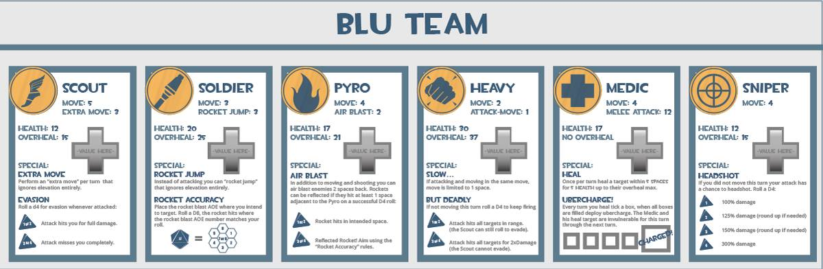

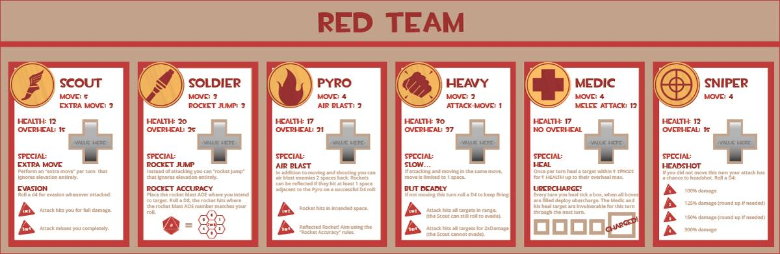

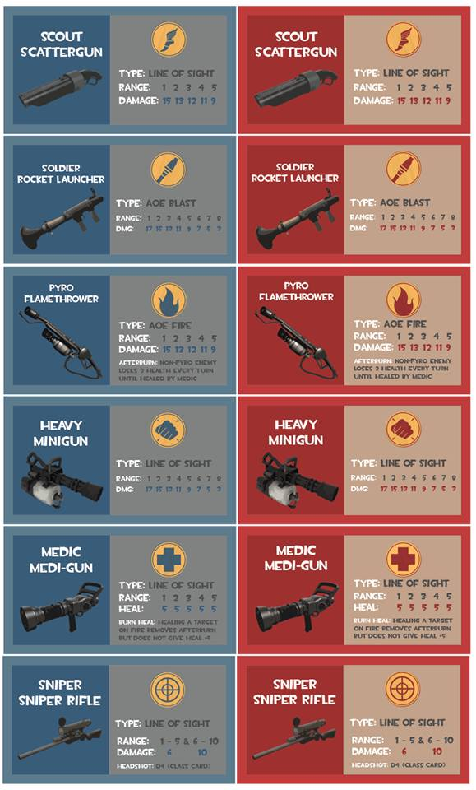

Victory

The player who has managed to eliminate their opponent’s 6 classes or **capture the flag and bring it back to your spawn room before your opponent does** wins!

Team Fortress 2 (version 04: Final)

Design Goals

The final version of my *Team Fortress 2* based board game is influenced by a mini playtests that were not formally recorded amongst Chris Christensen and Garrett Huxtable. I tested out the new weapon load outs for the classes with them and they were very helpful in finding little typos, especially with the Heavy’s Natasha which accidentally had the same stats as the regular Sasha. I can honestly say that once the game really got going Chris and Garrett really got into the game. I even noticed that over a half hour had gone by and when I asked them if they would like to move on to another playtest they wanted to keep playing to see how it would all play out. This is important because my game has managed to keep them wanting to play instead of moving on with something new and different.

The biggest changes aside from the weapons involve a new objective: payload race. I had previously playtested trying to do a capture the flag or a king of the hill, but all those games mostly became death matches. Originally the bomb cart was shared between the two teams, but now it is separate, one cart for each team. This should eliminate a game that seesaws too much back and forth and should make for a quicker game. It is my intention that these carts are so close to each other as to funnel each team’s attention to a central location. The carts moving in opposite directions should force the players to have to make a choice between moving their cart and stopping their opponent. It seems to work as far as splitting up each player’s team instead of them all clumping together. The decision to make the end goal for both teams closer to their opponent’s side of the map should make it harder for one team to win because the other team’s dead classes can spawn in to defend.

I’ve also moved from a grid map to a hex map. The change to a hex map is mostly prompted by how aiming works in this type of a game. I was tired of people being able to shoot farther on a grid map by counting spaces diagonally. The hex map should allow for easier calculation of distance and freer, more natural movement. While the grid worked, playtesting the hex map seemed to show the hex map working equally as well, and the confusion about aiming is definitely less than it was before.