Travis Moore

GAT 211A—Fall 2014

Instructor: Jeremy Holcomb

Project 3

Team Fortress 2  
Game Analysis &  
Intended Intensity Curve

Table of Contents

Team Fortress 2 (version 01: Stripped to the Basics) 2 – 3

Playtesters 2

Playtesting Results 2 – 3

Team Fortress 2 (version 02: Refining Classes/Map) 4 – 5

Playtesters 4

Playtesting Results 4 – 5

Team Fortress 2 (version 03: New Weapons/Objective/Map) 6 – 7

Playtesters 6

Playtesting Results 6 – 7

Team Fortress 2 (version 04: Final) 8 – x

Playtesters 8

Playtesting Results 8 – 9

MDE 9 – 11

Mechanics 9

Dynamics 10 – 11

Experience 11

Intended Intensity Curve 11

Intensity Curve Breakdown 12 – 15

Team Fortress 2 (version 01: Stripped to the Basics)

Playtesters

Classmates from the GAT211 participated as first-time players for the version of my Team Fortress 2 board game that I brought to lab.

**Name: Email:**

* Jason Guelbert j.guelbert@digipen.edu
* CJ Payne [cj.payne@digipen.edu](mailto:cj.payne@digipen.edu)

Playtesting

During the lab I had a team of 4 students, including myself, to playtest my game with. My game is only two player, so CJ and Jason were chosen to playtest my game, while Berne and I watched. The game seemed easy for both of the players to set up, but considering we all have been playing similar games, and the fact that we all know Team Fortress 2, it might be a good idea to playtest outside of school to see if set up is confusing or not. CJ won the starting die roll and decided to go first, leaving Jason to elect to play as the Red team, leaving CJ with the Blu team.

While setting up the game took no time at all, deciding which class to play took both Jason and CJ quite some time. I suppose this is understandable, because each class has unique rules to it and no one wants to misplay with their limited classes. CJ choose to start the game with a good mix of range and close combat with a sniper, pyro, and a soldier. Jason choose to start the game with a scout, heavy, and pyro.

The game started off a little slow with both players inching their classes closer. Without warning, Jason opened up with his pyro, burning CJ’s sniper. While the pyro did take some damage from the sniper, being so close up hurt the sniper’s ability to really damage the pyro and so CJ’s sniper burnt rather quickly.

This was an important moment of the game to gauge how both Jason and CJ felt about their classes. Jason took a lot of glee in rushing in like a mad man with his pyro. Jason would later comment that the pyro felt right and the ability to catch multiple people in the flame AOE stencil was fun. CJ thought the sniper should be able to do a little more damage at close range, but agreed that the sniper should not have an easy time when a pyro is right in its face.

The game continued with CJ spawning a scout to point-blank blast the pyro to death. By this time the slow moving heavy on Jason’s team go in range to tear the scout apart. Soon thereafter a close range heavy war went down with the first heavy to open fire, Jason’s heavy, winning the war. Thanks to a medic, Jason’s heavy was able to stay alive for some time before dying to a soldier rock blast.

The game continued in this kind of a fast pace for some time, with Jason ending the game with 3 classes left to spare. Both CJ and Jason agreed that the Heavy felt a little overpowered and that the scout needed some form of evasion to keep from dying right away. The turn order in its current form also has issues, causing some classes to never be moved when a big fight is going down. Maybe it would be best to have both player’s move all their pieces to be considered one turn. Further playtesting will help to solve this.

Overall, the playtest went better than I expected. I really stripped the game down to a “if you are in range, you do damage” mentality. This allowed me to drop a lot of complexity and keep the game simpler. For the most part the classes feel pretty good, with the idea of one weapon and one special ability seeming to cut down on player’s constantly scanning the rules for confirmation of what their classes can do.

Team Fortress 2 (version 02: Refining Classes/Map)

Playtesters

Classmates from the GAT211 participated as first-time players for the version of my Team Fortress 2 board game that I brought to lab.

**Name: Email:**

* Jason Guelbert j.guelbert@digipen.edu
* Berne Capone [charlesberne.capone@digipen.edu](mailto:charlesberne.capone@digipen.edu)

Playtesting

During the lab I was lucky enough to once again have Jason Guelbert and Berne Capone playtest my game. After setting up the map and briefly scanning the rules the game started with Berne opting to play as Blu and Jason playing as Red. Right away there was an oversight in my game as to what kind of die should be used to determine who goes first. This was a silly mistake, but Berne picked up on it so I should correct this in the next version of the game. Berne won the d4 roll for who goes first and the game officially began.

The first couple of turns did not have a lot of action in them as far as shooting at the enemy goes, but it was interesting to see that Berne and Jason had different ideas for moving their teams. Berne choose to use the first couple of turns grouping up his classes, standing still, and taking advantage of the overheal provided with the medic healing ability. He overhealed 4 of his classes before finally breaking this formation. Jason took to casting a wide net with his classes, only overhealing 2 of his classes that were in range and mostly keeping his Medic close to the Heavy.

As soon as Berne’s sniper got in range he proceeded in a sniper war with Jason’s Sniper. None of them managed to roll headshots and this felt kind of lame. In a future version of the game I’m considering adjusting the headshot roll to give a better chance at more damage instead of the all-or-nothing approach that it is now. This change should make the sniper headshot roll more fun and less of a disappointment. Berne managed to kill the Red sniper on the second shot, but Jason quickly used the Scout’s speed to close the gap with the Sniper and shoot it down.

The game continued with much mindless violence: Blu Scout killing the Red Scout, the Red Pyro flaming the Blu Soldier and Pyro, and it all came down to an epic showdown between Red Heavy and Medic and most of the Blu team. The Red Medic kept the Red Heavy alive long enough for him to destroy 2 other Blu classes, but he could not last forever and was wiped out by the Blu Soldier at a medium range. Overall the game felt like it was working alright, and the fight was pretty fair until the end. Jason was even taunting Berne at several points in the game, a good sign that the players were engaged in the game and not distracted with things that broke the gameplay. Berne won the game with his Soldier and Heavy left after about 10 turns.

Overall Jason felt the game worked well, but the map could use some tweaks. He thinks the game needs more of an objective other than kill the other team, and I’m obliged to agree. At this point the classes mostly feel good, with the exception of the Scout. The little bit of evade he has is not effective, so I’ll be increasing this and maybe giving him another option, like a second smaller move in addition to his move and attack. Berne was happy with the game but mentioned that the medic’s overheal might be too strong. Both Berne and Jason felt the Medic was the most important class, which is an okay feeling to have, but both agreed the Scout was lame. This could be fixed with the above change, or even an objective, like capturing a point on the map.

Team Fortress 2 (version 03: New Weapons/Objective/Map)

Playtesters

Classmates from the GAT211 participated as first-time players for the version of my Team Fortress 2 board game that I brought to lab.

**Name: Email:**

* Jason Guelbert j.guelbert@digipen.edu
* Berne Capone [charlesberne.capone@digipen.edu](mailto:charlesberne.capone@digipen.edu)

Playtesting

Yet again Jason Guelbert and Berne Capone will be playtesting my game, with Berne playing as the Blu team and Jason playing as the Red team. I did not bring written rules to class in order to see how well the class cards and weapon cards speak for themselves. Both Jason and Berne like the look of the cards and even the idea of writing health on the cards using a dry erase marker (provided by the teacher’s assistant, Chris Beagle). Jason did bring up a good point about how players are meant to erase their markings. I will have to include a cloth, paper towels, or some sort of eraser if I want this to work out well in a future version of the game.

The game started out quickly, with both Jason and Berne trying similar strategies in the previous playtesting sessions. This might be an indicator that I need to playtest outside of Jason and Berne. While their insight has always been helpful, I should probably get some new opinions. Right away it is apparent that the every other turn system is not working out well. Both Jason and Berne ask to drop the every other turn system in order to play the game the way it was played in all the playtests before: each player moves all class tokens all at once per turn. I agree, as there is no point in continuing to play this way when it is this unanimous that the turn system is awful.

Shortly thereafter it is revealed that the hidden information part of the class tokens are not very fun either. Because each token has distinct movement, it is obvious what class token is moved at the time, but annoying to have to try and remember when this game is not meant to be focusing on memorizing who is who. The game proceeded using the hidden information feature but it is clear that it will need to be dropped in order to make the game work out better.

Despite these setbacks, the game proceeded well and the changes to the Scout are appreciated by both Jason and Berne. In particular it needs to be made clearer that the extra move is made after the regular move and attacking, but other than that the added mobility seems to suit the Scout well. The Ubercharge of the medic never came into play, which is something I’ll have to check out in another playtest. The Sniper changes were confusing at first because of the need to calculate 125% and 150% when a D4 roll of 2 or 3 happened, so I think I’ll just give straight numbers for the next playtest.

Overall, while the game did not have as much time as the other playtests it worked out well in getting rid of a few glaring problems and pointing out areas where I need to be clearer. The next version of the game will take care of these problems, refine a hex map suitable for my game, and have additional weapon load-outs.

Team Fortress 2 (version 04: Final)

Playtesters

Classmates from the GAT211 participated as first-time players for the version of my Team Fortress 2 board game that I brought to school.

**Name: Email:**

* Garrett Huxtable g.huxtable@digipen.edu
* Chris Christensen chris.christensen@digipen.edu

Playtesting

Outside of the lab I had brought a nearly final version of my game for playtesting amongst my peers at Digipen. Garrett Huxtable and Chris Christensen were available to play my game in return for playtesting for them, as well. In this informal playtest Garrett played as Blu and Chris played as Red. I had not yet finished my rule book, but I wanted to see if my Team Class Cards and the new Weapon Cards could mostly speak for themselves. Any other rule clarifications came directly from me.

Set up did take longer than I had hoped, which is something I’ll have to address in great detail in my finished rulebook. Garrett and Chris also spent a lot of time looking over the weapon cards. I understood that adding new weapons to the game would add more complexity to the game, but I did not think it would take that long to shuffle through the weapon cards. I am hoping that the increase in set up time is offset by the enjoyment of being able to change weapons when you respawn. I feel like the weapon load outs in *Team Fortress 2* are a key part of the game, which let you rock-paper-scissors in a way that still fits the class you want to play as.

Once the game got going combat took place on the third turn of the game. This is much faster than it had occurred in the past, which is something I was looking to do. With less downtime before the combat happens the game would lull less in the beginning and the intensity should climb quickly. Both Garrett and Chris fought over the use of the single bomb cart and it was not until Chris managed to kill off 4 of Garrett’s classes that he really began to make progress on the cart. Fortunately, the cart is not that far away from the spawns so Garrett was able to make somewhat of a defense.

The game continued in this way for some time, and they even wanted to keep playing the game despite me reminding them that the time was up. This is great news, because it means the game was able to immerse Garrett and Chris, despite having played so many similar *Team Fortress 2* games within the last few weeks. Chris and Garrett both agreed that the style of the game was great and that it played really well, but there are a few areas to fix. The both thought that the Pyro is too strong, and needs less range. I am inclined to agree, because the Pyro in all my games was quite a wrecking ball. The also suggested that there be two bomb carts instead of one. This way, the player has to think about either pushing or defending by blocking. This should add extra choice for the player and eliminate a game that seesaws back and forth; which is entirely possible with the way this game is now.

MDE

Mechanics

|  |  |  |
| --- | --- | --- |
| Turn Based | Hex Grid | Multi-Directional Movement |
| Accuracy D8 Rolls  (Rocket Launcher only) | D4 Headshot Rolls (Sniper Rifle only) | D4 Evasion Rolls (Scout only) |
| Air Blast D4 Rolls (Flamethrower only) | Deadly D4 Rolls (Heavy only) | Extra Movement (Scout only) |
| AOE Blasts | AOE Flame | Damage Scaling |
| Ranged Combat | Payload Race | Bomb Cart Pushing |
| Ubercharge (Invulnerability) | Kritz-Krieg (2x Damage Multiplier) | Slow Movement (Weapon Effects) |
| Knockback | Respawning | Weapon Choice |
| Class Types | Movement Speed | Overheal |
| Line of Sight Aiming | Elevation | Invalid Terrain |

Dynamics

The dynamics of my board game start off a little slowly, especially in set up time, but the action quickly ramps up, much like an actual fast-paced and zany game of *Team Fortress 2*. This pacing is made possible by both the layout of the map, as well as the speed and combat ranges of the classes in the game. Damage is high and health is kept to their relative values from the original game, so dying happens often and positioning is key, much like the original game.  
 The dynamics of special abilities provided from the classes themselves, as well as the addition of different weapons all intermingle to provide a player different ways to try and win the game. Most of the weapons have similar damage values which ramp up with how close a class gets to another class. This extra damage for putting oneself closer to harm’s way is an intentional method of making the players choose between a safe distance for little damage or high-risk, high-reward for getting up close. This is a dynamic that can also be found in the original game, as weapons do more damage the closer you are, with the exception of the Sniper.

The addition of an objective, payload race, also adds to the ways the game can be played. Instead of being a simple death match, the bomb carts provide the players a different objective, which they must keep track of in order to win. In order to win the player must move classes further away from their spawn and the other team’s objective point, creating an interesting dynamic of attack or defend.

Experience

My board game focuses primarily on the competition aesthetic. The game is a 1 versus 1 experience where both teams have a symmetrical army fighting upon a symmetrical battlefield with the same objective. The game is definitely a strategy game, now more so than ever considering that the original *Team Fortress 2* game was in real-time, where reflexive skill dominates, and this board game is played in turns where there is time to strategize.

Aside from the competition aesthetic, the board game also includes elements of fantasy which I try to capture with the visual style of the game. Anyone who has played *Team Fortress 2* will recognize the symbols and colors used throughout the game. It is my hope that the visual style of my game will allow players to think that they are playing a genuine *Team Fortress 2* experience in a new and different way.

Intended Intensity Curve

The following graph is the intensity curve I am hoping for when designing this version of my board game version of *Team Fortress 2*:

Each of the points on this intensity curve graph are what I expect a player to experience throughout a normal play session of the board game. Overall I expect the intensity curve to trend upwards at a steady pace before reaching its highest point right near then end of the game.

Intensity Curve Breakdown

Game Setup—Intensity = 1

I expect that before the game really begins, during its initial setup, the game will experience its lowest intensity. This has been observable during all my previous playtests, and especially during the last one. While the game has a lot of pieces to it and takes some time to set up, I expect that players will at the very least be engaged with the visual aesthetics of the game and perhaps even with reading the well-designed rule book.

Game Start—Intensity = 2

When the game actually starts I expect the lead up from setting the game up has at least built some anticipation for playing the game. At this point the players should be pretty familiar with the rules, have been formulating a strategy with their weapon load outs, and are itching to start the game. I expect this point of the game to have a slight rise in overall intensity, but nothing too big. Most of this intensity comes from the players projecting their strategies into the future in an attempt to figure out how to beat their opponent.

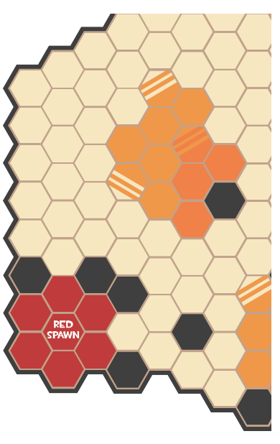Game Start—Moving Out = 3

For the first two to three turns of the game, depending on how the players utilize their maximum move speeds with their class tokens, I do not expect the players to be able get into range for combat yet. At this part of the game the area of the map covered by the players is either directly out in front of their spawn and behind the small terrain piece, or between the small and large terrain pieces. The longer route drags out the beginning of the game at the cost of time to reach the cart, but is relatively safe. This is a route that is intended to give a cautious player time to make a safe strategy to their cart. The short route between the two terrain pieces will get to both the bomb carts sooner, and allows the player to defend the opponent’s bomb cart. The game should experience a slight bump in intensity as players are getting nearer to each other or their objectives.

Game Start—First Clash = 6

The map has been designed to draw players into the center, like a sort of funnel, where the main clashes of the game will occur. I expect the majority of the most intense moments of the game to occur at the center of the map due to the fact that the objectives for both teams are located in this area. By placing the bomb carts here, at an equal distance away for each team it ensures that the engagements should happen at relatively the same time that each player gets there. Also, this area of the map has the highest concentration of invalid terrain, giving short range classes, like the Pyro, some cover in order to get in range to do damage.  
 It is also a deliberate decision to place the ending points of both team’s bomb carts at the furthest away possible from each team’s spawn. The end point for each team’s bomb carts is easier to access for the opposing team, giving the other team a chance at defending the cart at the risk of not spending this time traveling the farther distance to their cart. The small terrain pieces also overlook this main battlefield, acting like battlements for long range classes, like the Sniper.

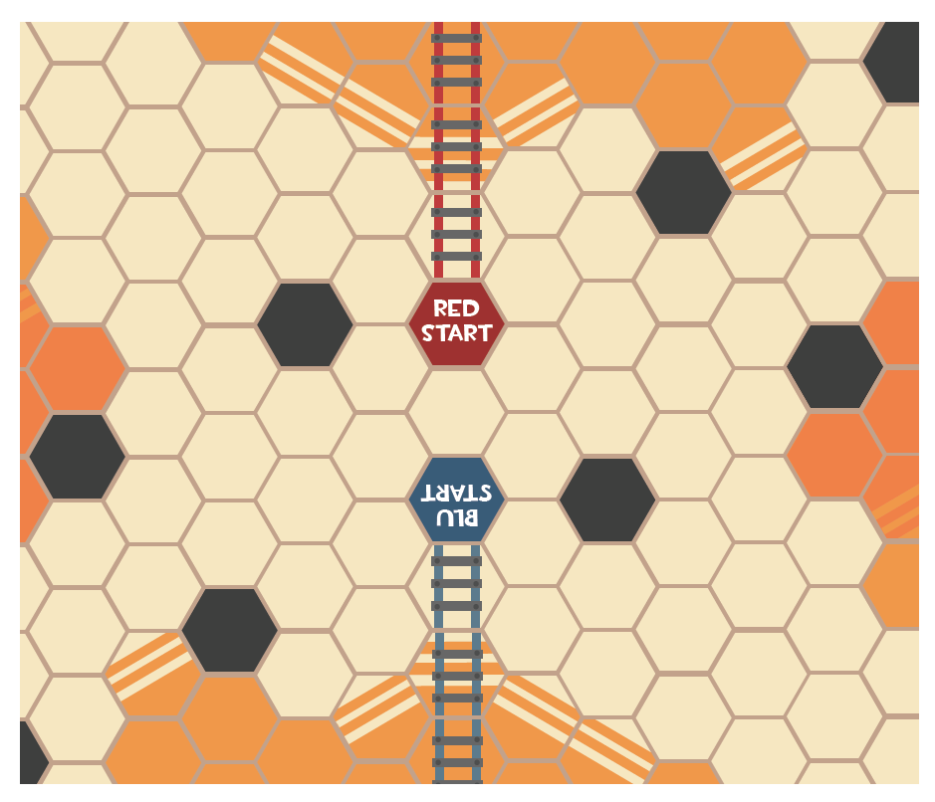

Game Start—Respawning = 4

As classes die I expect the intensity of the game to take small drops as players have to take time moving their class tokens back into the engagement area. This should allow players to reformulate a new strategy for this piece, and gives them an option to defend if they need to. I expect that Respawning will drop the intensity down from an engagement, but still to be higher than initially moving out as the player should have a pretty good idea of how they would like to reengage with their newly returning class token.

Game Start—More Clashes = 7

As more and more pieces are taken out I expect players to use their Ubercharge and Kritz-Krieg to uneven the battlefield and take out more of their opponent’s unprotected classes. At this point the intensity for players should be higher than the initial clashes as only some pieces are probably left and others are racing to get back into the fight.

Game Start—Advantage/Disadvantage = 5

Eventually, one team will get an advantage and have more pieces near their bomb cart in the main battlefield of the map than their opponent. This lull in the action should still feel intense, as the player will have to weigh the option of forgoing attacking in order to proceed with pushing the cart. The dilemma of chasing down an opponent or leaving one’s self open to attack should create an interesting amount of intensity, and should keep the intensity for spiking too far down. The player at a disadvantage will now have to decide if they should spend more resources defending or risk going for pushing their own bomb cart.

Game Start—Bomb Cart Nearly There = 9

As one team gets closer to reaching the end of the bomb cart track the fight will start to take place on an area of higher elevation. This part of the map is farther away for the team trying to win, so I suspect that protecting their classes who are trying to push the cart should feel very intense. Getting classes to this area of the map is easier for the opposing team, but because they are trying to stop the other player from winning, it will be an intense moment for this player as well. This area favors the Scout and Soldier because of their ability to move farther faster and ignore elevation. This area also is not a convenient location to defend for the sniper because the small terrain area does not have easy line of sight due to the placement of invalid terrain blocking their view.

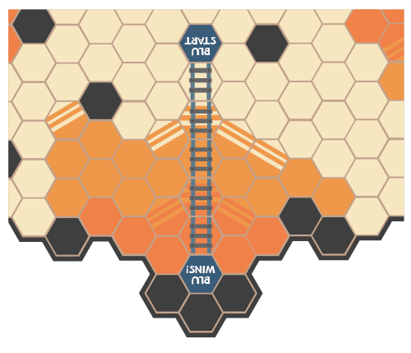

Game Start—End Game = 2

When one team finally wins it should be pretty apparent that they are about to win and not a surprise to both players. The winning player should have a numbers advantage in the farthest area away from their spawn, which shows that they used good tactics in managing their classes, as it is not an easy place to get back to right away if their classes die. I expect the intensity to drop down, like a pressure release at this point in the game. The intensity should not drop to zero, but will most likely be at a place much like at the start of the game.