Subterfuge

Components

* 2 Player Boards (1 blue, 1 green)
* 10 Crew Pieces (5 blue, 5 green)
* 60 Sub Cards (30 blue, 30 green)
* 2D8 Dice (1 blue, 1 green)
* 2D4Dice (1 blue, 1 green)
* 34 flood tokens (17 flooding, 17 flooded)
* 44 Event Cards
* 36 lock tokens

Players

“Subterfuge” is played with 2 players.

Objective

The objective of “Subterfuge” is to outlast your opponent by keeping at least one member of your submarine’s crew alive while eliminating your opponent’s crew.

Setup

Players decide who will play as Blue and who will play as Green. Before the game starts the **Event Cards are shuffled and place face down between both players**. Next each player **sets up their sub with 4 crew pieces** in any area they’d like for them to start in, as well as **placing lock tokens on any doorways** they’d like to start the game with as locked.

**To decide who goes first players roll both their dice, and the highest roll goes first** (in the event of a tie, both players reroll the dice). Players sit across from each other as shown below:

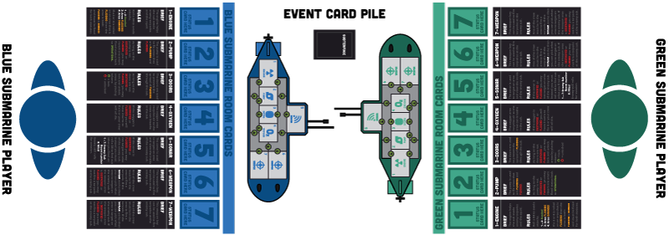

Rules

**Turn Sequence**

The game is played in **alternating turns**, starting with the player who won the dice roll. **The turn sequence is: Draw an Event Card then Perform Crew Actions**.

* **Draw an Event Card:** At the start of a player’s turn they must draw an Event Card and follow the instructions on the card if it can be applied. After the instructions have been followed the card is discarded (if all Event Cards have been used, the pile is reshuffled to be used again).
* **Perform Crew Actions:** Every crew piece can perform 2 actions in one turn. Some of these actions cost only 1 action while others can cost the whole 2 actions:  
  **1 Action –** Move to an adjacent area (if door is not locked)  
   **–** Open and lock a door  
   **–** Attack enemy crew  
   **–** Damage enemy area (area goes to damaged (if already   
    damaged, then it goes to destroyed and kills this crew piece)  
   **–** Repair a Flooding (goes back to operational)  
   **–** Repair a Damaged (goes back to operational)  
  SPECIAL NOTE: A single crew piece can only repair either a flooding or a damaged in one turn, not both.  
  **2 Actions –** Fire a torpedo  
   **–** Use Sonar

Special Actions

Evasion

A player may attempt to evade a torpedo or squid attack if their engines are not flooded or irradiated.

**Evasion: D4 Roll of 1 – 3 : Attack Misses, D4 Roll of 4: Attack Hits**

**No Evasion: D4 Roll of 1 – 3 : Attack Hits, D4 Roll of 4: Attack Misses**

Sonar

A player may use the actions of a crew piece in the Sonar room to specifically target an area of the enemy sub

**Sonar: Player may choose which area is targeted  
No Sonar: Player must roll a D8 to figure out what they are targeting  
 (Roll of 8 means the attack misses altogether)**

Doors

If the Doors area is not destroyed or flooded then the player does not have to use an action from their crew pieces at a door to lock and unlock doors.

**Doors: May unlock and lock doors freely throughout the sub**

**No Doors: Crew piece must use 1 action and be at a door to lock and   
 unlock doors**

Pump

**If the Pump area is not destroyed or flooded then the player can drain an area (and any adjacent area if it is not locked off) completely once per turn**. For example, if both the weapons rooms and the connected hallway are flooded and not locked off from one another, then the whole area is clear of water.

Flooding/Flooded

Flooding is dangerous to the submarine, as well as the crew. Crew can spend 1 action to repair an area that is flooding back to operational (including hallways). Use flooding and flooded tokens to help keep track of hallways that are flooded. **Once an area is flooded it will spread “flooding” statuses to adjacent areas that are not locked on the next turn**.

Firing a Torpedo

As long as a crew piece is in a weapons room and the weapons room is not destroyed or flooded, a torpedo can be fired at the enemy. If the sonar is working and a crew piece is in this room, then the area fired upon can be chosen by the player. If there is no crew piece in the sonar or the sonar is destroyed or flooded, then a torpedo may still be fired, but the player must roll to see what they are targeting. If a torpedo hits, the type of damage is dependent on a D4 roll.

**Damage: D4 Roll of 1 – 2: Flooding (if area is already flooding then it is   
 now flooded). D4 Roll of 3 – 4: Damaged (if area is already   
 damaged then it is now destroyed/irradiated)**

Victory

**The game is over once a player runs out of crew pieces**. The winner is the player who still has crew pieces alive in their sub (despite the damage to their sub).