Travis Moore

GAT 210A—Spring 2014

Instructor: Jeremy Holcomb

Concept & Design

Table of Contents

He Said/She Said (version 01: Everything is Awful) 3 – 6

Written Rules 3 – 4

Design Goals 5

Design Changes 6

He Said/She Said (version 02: Board Game Elements) 7 – 10

Written Rules 7 – 8

Design Goals 9

Design Changes 10

Good Kid/Bad Kid (version 03: Cards Revisited) 11 – 14

Written Rules 11 – 12

Design Goals 13

Design Changes 14

Good Kid/Bad Kid (version 04: Balancing Act) 15 – 18

Written Rules 15 – 16

Design Goals 17

Design Changes 17 – 18

Good Kid/Bad Kid (version 05: Final) 19 – 21

Written Rules 19 – 21

**Written Rules**

He Said/She Said (version 01: Everything is Awful)

Components

60 Lie Cards  
 3 Good Kid Cards  
 2 Bad Kid Cards

Players

1 – 2 players

Objective

The objective of “He Said/She Said” is to win more “good kid cards” than “bad kid” cards by the end of the game.

Setup

Players decide who will play first. The “**Good Kid/Bad Kid**” decks of cards are shuffled and placed facedown between both players. This will be the deck of points that players are playing for. Each round a “**Good Kid/Bad Kid**” card is flipped over and players will compete in a battle of lies to either win a “Good Kid” card or force their opponent to win and take a “Bad Kid” card.

The “**He Said/She Said**” deck of cards is shuffled and split into 2 decks, one for each player, which is placed face down on opposite sides of the “**Good Kid/ Bad Kid**” deck. These are the cards that each player will use to try and out "lay" the other kid with.

The “**Lie**” sections between the two players are where players will place their lies in their respective sports. Winning a “**Lie**” section earns the player a point. When a player runs out of cards during a round, points are counted and the winner wins the “**Good Kid/Bad Kid**” card for that round.

Rules

**Playing the game**

A round starts by flipping over one “**Good Kid/Bad Kid**” card to be fought over by each player. Each round begins by having each player draw 7 cards from their “**He Said/She Said**” deck. The round ends when one player has run out of cards. The player with the last card played on a “**Lie**” section wins a point. The player with the most points at the end of a round wins the “Good Kid” or “Bad Kid” card being fought over.

**Turn Sequence**

The game is played in alternating turns, starting with whoever won the last “Good Kid” or “Bad Kid” card (or whoever elected to go first at the start of the game). A turn sequence is as follows:

* Placing a Lie: At the start of a player’s turn, they must place a lie down in one of the "**Lie**" sections and perform the actions found on the card (if any). After the lie action is over, it is now the other player’s turn.

**New Round**

After a round is over and a “Good Kid” or “Bad Kid” card has been awarded to a player, the next round is played. The player who won a lie section takes those cards to be reshuffled back into their deck. Each player draws 7 new cards, and a new “**Good Kid/Bad Kid**” card is revealed to be fought over.

Victory

The game is over when a player wins by collecting 3 “Good Kid” cards.

Design Goals

The initial idea I had for project-D came from the brainstorming session that we had for project C. Josh wanted to do a time travel card game that would involve placing cards to undo other cards at different points in time. I thought it would be a lot of fun to use that concept but in a more immature way. “He Said/She Said” was planned to be a card game that involved two children telling lies about one another to the principal. The idea was that each player would choose to play as the boy or the girl and they would attempt to tell lies by strategically choosing what cards to play in order to “out-lie” the other.

I have never been a huge fan of pure card games, but I thought I would be capable of making such a game if I really gave it a try. The theme of two children telling lies to outdo one another, seemed like a fun idea that would allow for a funny game that would be enjoyable for players in both playing the game and reading the silly things written on the cards. I had good success with my playtesters in the funny event cards in my last project, “Subterfuge”, so I figured this would be an opportunity to see how much fun I can generate for my players by creating a game with tons of flavor text in the form of immature children lying.

My major inspiration for how the game will play is taken from one of the few card games I know how to play, “Hearts”. I like the idea of cards you want and cards you don’t. So my initial design for “He Said/She Said” will have trick elements in the form of cards you want to win and cards you do not want to win. This should provide an interesting strategy element to the game in the form of rounds you want to win and rounds you want to force your opponent to win.

Design Changes

Playtesting the first version of “He Said/She Said” was a total disaster. I think the complexity of the game as a whole is creating problems. While I had thought the idea of strategically winning and losing lie piles in order to win the round’s “Good Kid” or losing the round’s “Bad Kid” card made sense, it turns out it does not. I think this is a good example of how something seemingly easy to grasp in the mind of the creator does not necessarily translate into easy to explain for someone else. I do not think the rules are so much at fault, because Chris and Garrett both seemed to understand what I had written. However, the act of playing the game proved difficult, especially for Chris. While it would be easy to simply brush it aside as Chris “just not getting it”, I think Chris is a good barometer of whether something is easy to understand or not. For this reason, the lie piles mechanic must go.

The other big problems with this game are the various actions associated with the lie cards. Garrett especially had issues with the types of actions that the cards had on them. My intention was that “sympathy lie” cards would help you, “blame lie” cards would hurt the opponent, and “tall tell lie” cards would be sort of like a wild card, with actions that could either help or hurt. The actions of these cards need to be carefully reconsidered. In fact, I’ll probably just scrap these cards altogether and make a much simpler card battle system.

I’m not going to lie; I am worried that I will not be able to make just a card game. I’ve had much better success with game board elements, so maybe if I add these types of things to the game I’ll find something more cohesive. I’m not going to give up on the card elements just yet, but I think they need to be supplemented by something else.

**Written Rules**

He Said/She Said (version 02: Board Game Elements)

Components

2 Player tokens

1 Principal token  
 2 D6

1 Game board  
 12 Lie Cards

Players

1 – 2 players

Objective

The objective of “He Said/She Said” is to collect as many lies as you think you need to win against your opponent in a lie battle at the principal’s office

Setup

Players sit opposite of one another with the game board placed between them. Each player places their player token in the start location and the principal token is placed in the principal location.

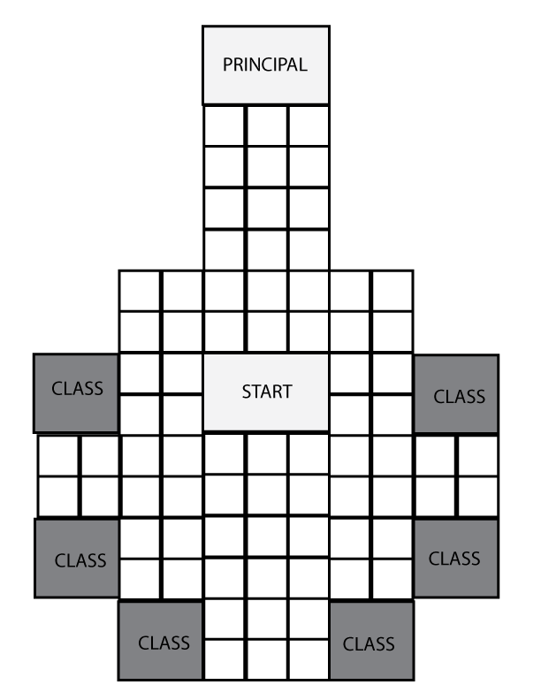

Rules

**Playing the game**

Players elect who will go first. On their turn a player rules a D6 and can move up to the number rolled in any direction.

After a player moves, they then move the principal token the same number of spaces that they rolled. If a principal lands on a player token then this player loses a lie card and must return to the start location.  
If a player enters a class location they receive one random “lie” card from the lie deck. Lie cards are used to help a player defeat their opponent in the ending game “lie battle”. Once a player has been in a class, he or she can no longer receive lie cards from this location.

Once a player feels like they have enough lie cards to win, they can enter the principal office to end the game board part of the game. Once this happens, the player who reached the principal’s office first starts the “lie battle” by placing down a lie card. The players must perform the actions of the lie before the next player can place down their own lie. The winner of the lie battle is the last person to place down a lie card.

Victory

The winner of the lie battle is the last person to place down a lie card.

Design Goals

After the disaster that was the first version of “He Said/She Said” I was beginning to feel discouraged about my ability to create a game that was purely cards. Unfortunately, Josh was not available before the next lab session to help me out with advice from his project-c card game. At this point I was unsure about my ability to make a game that was purely cards. I have not played a lot of board games or card games, and I imagine that if I have, then perhaps I’d recognize patterns that I could use for “He Said/She Said”.

All I really knew at this point is that my playtesters Garrett and Chris did not enjoy the game. This was evident in their expressions and their frustration with the complexity of the game and also the card actions. Although I thought the idea of playing on three different types of lies piles provided an interesting strategy element to the game, I feel it is in the best interest of the game to scrap this complex part of the game. This was a source of confusion in the last game, because you had to win piles in order to win the main card you are after. Keeping it simpler would be better, especially for new players.

Adjusting the card actions took up the majority of my time in version 2 of “He Said/She Said”. The actions just did not work before, so I took a lot of care in making sure that the actions were straight-forward and made sense with the “lie battle” theme. In this version there are fewer cards, because the card battle is meant to be simple and not long and drawn out.

The last big change is the addition of board game elements to the game. I added player tokens, a board, dice, and a third-party principal token. The goal now is to go to classrooms, collect a lie card, and race to the principal’s office to initiate a “lie battle”. It is my hope that the board game part provides some fun and added strategy in the form of collecting cards versus racing to start the battle.

Design Changes

Interestingly enough, my addition of board game elements to “He Said/She Said” have done the exact opposite of what I intended for them to do. I felt the need to add board game elements as a way of creating more fun and interaction between the players, but as it turns out in playtesting the board game elements they did neither of these. The board game elements were a complete flop. The principal token did not accomplish much, and both players kind of ignored it. The see-saw like movement of this piece could probably be to blame, but the principal piece just does not seem that interesting altogether.  
 While both Josh and Howard felt the need to go to every classroom to build a more sizable card deck, these actions felt more like “going through the motions” than anything else. Once again, the board could probably be worked on to make it more interesting, but the interaction between the players is minimal, because they are just going into classroom to collect cards. There is just not enough interaction in this, and it gets in the way of the ultimate showdown that the “lie battle” is.

During the lab for this playtest I approached professor Holcomb about the issues I am having with this game. I asked if it were okay to scrap this game completely, and work on a new game. He said it would be okay, and I might just take him up on it.

**Written Rules**

Good Kid/Bad Kid (version 03: cards revisited)

Components

3 Good Kid Cards and 1 Bad Kid Card

20 Green Cards and 20 Blue Said Cards

1 Blue D6 and 1 Green D6

Players

1 – 2 players

Objective

The objective of “Good Kid/Bad Kid” is to be the first to win 2 Good Kid Cards

Setup

Players decide who will play first. The “**Good Kid/Bad Kid**” decks of cards are shuffled and placed facedown between both players. This will be the deck of points that players are playing for. Each round a “**Good Kid/Bad Kid**” card is flipped over and players will compete in a battle of lies to either win a “Good Kid” card or force their opponent to win and take a “Bad Kid” card (which causes them to lose a “Good Kid” Card). Each player shuffles their deck of cards, which is placed face down on opposite sides of the “**Good Kid/ Bad Kid**” deck. These cards will be drawn from by each player to form their hand. When play begins, players will play their cards on top of the “Good Kid” or “Bad Kid” card being fought over.

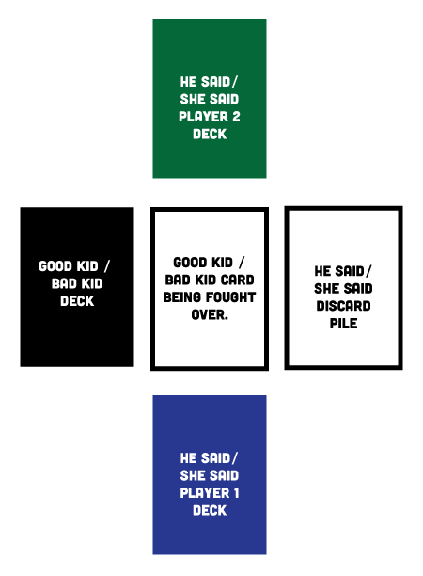

Rules

**Playing the game**

A round starts by flipping over one “**Good Kid/Bad Kid**” card to be fought over by each player. Each round begins by having each player draw 10 cards from their deck. The round ends when one player has run out of cards. The player with the last card played on a “**Good Kid/Bad Kid**” card being fought over wins that card.

**Turn Sequence**

The game is played in alternating turns, starting with whoever won the last “Good Kid” or “Bad Kid” card (or whoever elected to go first at the start of the game). A turn sequence is as follows:

* Placing a Lie: At the start of a player’s turn, they must place their card on top of the ”**Good Kid/Bad Kid**“ card being fought over and perform one of the actions on their card that they played. After the action is played, their turn is over and it is their opponent’s turn.

**New Round**

After a round is over and a “Good Kid” or “Bad Kid” card has been awarded to a player, the next round is played. Players gather their used cards and reshuffle them back into the deck for the next round.

Victory

The game is over when a player wins by collecting 2 “Good Kid” cards.

Design Goals

I was quite conflicted about what to do after version 03 of my project-D game. While I had been given the “okay” to start a new game, I did not know if it was the right thing to do. I had made some progress with the card battle portion on the previous game, but I was not sure if I was interested in pursuing the game any further. In some ways it would easy to just start over from scratch, doing something new that was not a card game. However, while this is just a school project, it just felt like a cop-out to scrap a game because I was having problems with it. After all, if this were my job I could not just give up on a game that my client was expecting me to work on and give them something different.

I decided to cling on to the hope that the card battle from the last game held promise and decided to keep with my little kid theme game. However, I have decided to change the game about lying to little kid insults, because it felt like it fit better. Now the card battle was more of a personal battle of insults between little kids. This would still allow for silly phrases, only now the interaction between the players would be throwing little kid insults at each other instead of trying to out-lie one another.

I prototyped some quickly made cards that would be attack, defense, and basic plain cards, but it did not feel like enough for the game. While looking up little kid insult phrases, it suddenly came to me that I should include little kid games within my card game. It seemed perfect! Little kids are battling each other with insults and challenging each other to games like “Rock Paper Scissors” or “Thumb Wars”. Not only would this help my theme, but it would break up the monotony of being just a card game.

Design Changes

For the most part I’m extremely happy with how this version of my project-D game is turning out. While this version is not a pure card game, it is mostly based on cards and appears to be working out well. I’m going to add to the amount of challenges there are in the game by adding more little kid games. Other than this, the biggest challenge will be in balancing just how many of each card type there are in the game. Considering that my game looks like it is working and I am happy with how the theme fits my game, I’ll start designing actual cards in place of my hand written cards to see how the real components will play in my game.

**Written Rules**

Good Kid/Bad Kid (version 04: Balancing Act)

Components

* **5 Good Kid/ Bad Kid Cards**
  + **3 Good Kid Cards**
  + **2 Bad Kid Cards**
* 64 Kid Cards
  + **20 Blue “Boy” Cards**
  + **20 Pink “Girl” Cards**
* 2 D6

Players

1 – 2 players

Objective

Your opponent is stinky poop head who has tattled on you to the school principal! Clear your good name and make your opponent look bad by winning more **“Good Kid”** cards than **“Bad Kid”** cards!

Setup

* Before playing, the game both players need to decide who will play as the **Blue “Boy”** player and who will play as the **Pink “Girl”** player.
* Each player gets 1D6 and their 32 Kid cards.
* The **“Good Kid/Bad Kid Cards”** are shuffled and placed between both players. Each round one card is revealed. This is the card that both players will fight over.
* You want to win rounds that are for **“Good Kid”** cards and lose rounds that are **“Bad Kid”** cards.
* Each player takes turns placing cards on their play space. The player who runs out of cards first wins the **“Good Kid”** or **“Bad Kid”** card for that round.

Rules

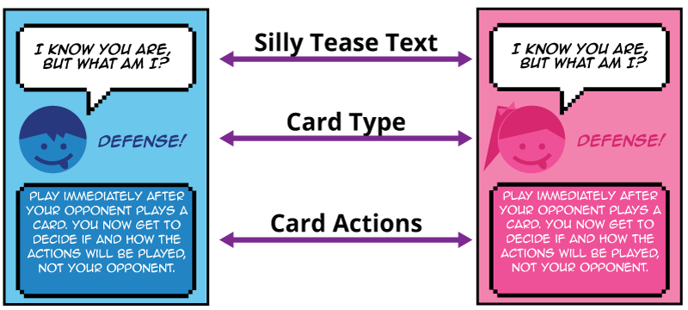

**Playing the game**

* A round starts by flipping over one “**Good Kid/Bad Kid**” card to be fought over by each player.
* Each player draws 10 cards from their deck.
* Players roll to decide who will go first. The player with the highest roll chooses who will go first (ties are re-rolled).
* Players take alternating turns placing down a card in their play space and following the actions, if any, on the card that they played. Players share the discard pile if they are instructed to discard a card.
* The round ends when one player has run out of cards. The player who runs out of cards wins the “**Good Kid/Bad Kid**” card being fought over for that round.

**New Round**

* Players retrieve cards from their place space and reshuffle them into their decks.
* Any cards left in the discard pile are no longer available for either player.
* A new “**Good Kid/Bad Kid**” card is flipped over and fought over.

Victory

The game is over when all of the “**Good Kid/Bad Kid**” cards are won. The player with the better **“Good Kid”** to **“Bad Kid”** card ratio wins!

Design Goals

For this version of the game the biggest concerns I have are whether the components I’ve made work well with my theme, are easy to understand, and the ratio of cards in each player’s deck feels right. I’ve ended up adding a number guessing game and “Hand Slap” game to the challenge style of cards. My hope is that the additional kid games bring more interaction between players and make for an overall fun experience that feels like a game between two immature children more than anything else. Other than this, I have put a lot of work into making the rules clear, by organizing chunks of information into lists and providing a card breakdown. I hope that these changes will make the rules easy for both players to read and flip through as the game is played.

Design Changes

I am so thankful that I playtested this version before turning my project in. For the most part the game feels complete, but there are polishing issues that need to be taken care of. First off, the rules are much easier to read now, but it could use an image of the setup to help players begin playing the game. Also, there is a huge section of my rules that I’ll need to create that I completely overlooked.

I added in a game called “Hand Slap” thinking that players would know what game I was talking about, but as it turns out, this assumption is wrong! While Garrett and Berne did not have a problem with “Rock Paper Scissors” during the last playtest, not everyone is going to know these little kid games. Just to be on the safe side I’ll have to include some concise rules on how to play the little kid challenge games in case my players do not know what these games are.

Unfortunately, the game still has balance issues. The challenge cards are fun, but they come up way too often, which can slow the game down a lot. I have only a few “no action” cards in the deck, and Glen and Jonathan both agree that while the action cards are not as fun as the other cards; they are needed to help these other cards feel special. I think they are right, and I’ll be adding quite a few of these cards to the deck to help make the action cards more important.

**Written Rules**

Good Kid/Bad Kid (Final)

Components

* **5 Good Kid/ Bad Kid Cards**
  + **3 Good Kid Cards**
  + **2 Bad Kid Cards**
* 64 Kid Cards
  + **32 Blue “Boy” Cards**
  + **32 Pink “Girl” Cards**
* 2 D6

Players

1 – 2 players

Objective

Your opponent is stinky poop head who has tattled on you to the school principal! Clear your good name and make your opponent look bad by winning more **“Good Kid”** cards than **“Bad Kid”** cards!

Setup

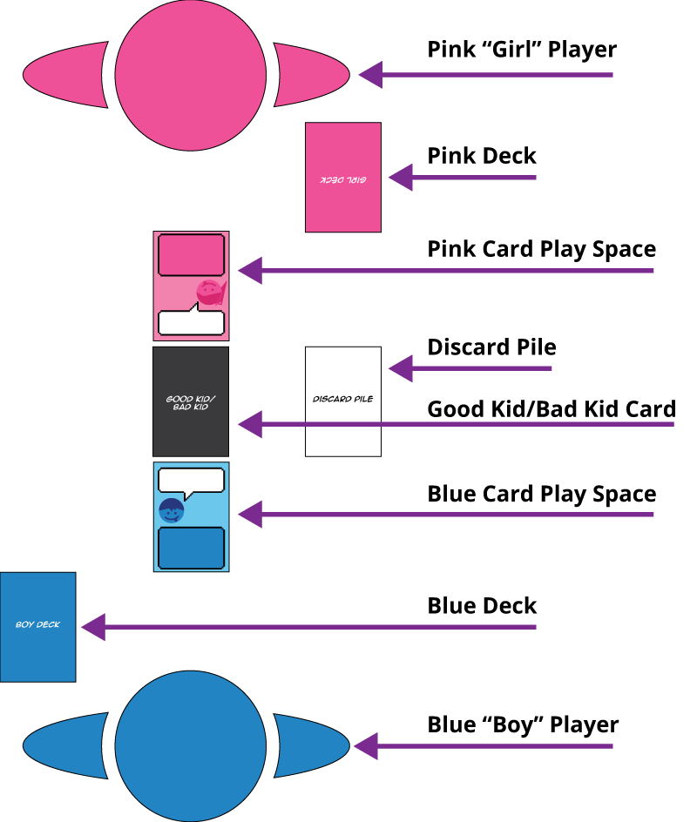

Before playing, the game both players need to decide who will play as the **Blue “Boy”** player and who will play as the **Pink “Girl”** player. Each player gets 1D6 and their 32 Kid cards. The **“Good Kid/Bad Kid Cards”** are shuffled and placed between both players. Each round one card is revealed. This is the card that both players will fight over. You want to win rounds that are for **“Good Kid”** cards and lose rounds that are **“Bad Kid”** cards. Each player takes turns placing cards on their play space. The player who runs out of cards first wins the **“Good Kid”** or **“Bad Kid”** card for that round.

Rules



**Playing the game**

* A round starts by flipping over one “**Good Kid/Bad Kid**” card to be fought over by each player.
* Each player draws 8 cards from their deck.
* Players roll to decide who will go first. The player with the highest roll chooses who will go first (ties are re-rolled).
* Players take alternating turns placing down a card in their play space and following the actions, if any, on the card that they played. Players share the discard pile if they are instructed to discard a card.
* The round ends when one player has run out of cards. The player who runs out of cards wins the “**Good Kid/Bad Kid**” card being fought over for that round.

**New Round**

* Players retrieve cards from their place space and reshuffle them into their decks.
* Any cards left in the discard pile are no longer available for either player.
* A new “**Good Kid/Bad Kid**” card is flipped over and fought over.

Challenge Cards

Challenge cards require players to compete in mini games in order to complete their actions. These games are:

* **Rock Paper Scissors:**
  + Both players play best 2 out of 3 to determine the winner. In this game both players count to 3 and then throw either a rock, paper, or scissors shape with their hands with the following outcome:
    - Rock beats scissors
    - Scissors beat paper
    - Paper beats roc
    - If both players throw the same shape, then they re-throw.
* **Thumb War:**
  + Both players extend either their left or right hand out to one another in a “thumbs up” position and grip each other’s fingers. Both players then try to pin the player’s thumb with their thumb for a 3 second count.
* **Hand Slap Game**
  + The slappee places his hands palm down, hovering above the other slapper’s hands. The slapper hovers their hands below the slappee’s hands, palms up. The two players' hands should be barely touching each other, and all the hands should be around mid-torso height. The slapper is on offense, and attempts to bring his hands over to slap the backsides of his opponent's hands. The slapper wins if they are able to slap their opponent’s hands, and the slappee wins if they are able to avoid the slap.

Victory

The game is over when all of the “**Good Kid/Bad Kid**” cards are won. The player with the better **“Good Kid”** to **“Bad Kid”** card ratio wins!