Travis Moore

GAT 210A—Spring 2014

Instructor: Jeremy Holcomb

Good Kid/Bad Kid Rules

Good Kid/Bad Kid (final)

Components

* **5 Good Kid/ Bad Kid Cards**
  + **3 Good Kid Cards**
  + **2 Bad Kid Cards**
* 64 Kid Cards
  + **32 Blue “Boy” Cards**
  + **32 Pink “Girl” Cards**
* 2 D6

Players

1 – 2 players

Objective

Your opponent is stinky poop head who has tattled on you to the school principal! Clear your good name and make your opponent look bad by winning more **“Good Kid”** cards than **“Bad Kid”** cards!

Setup

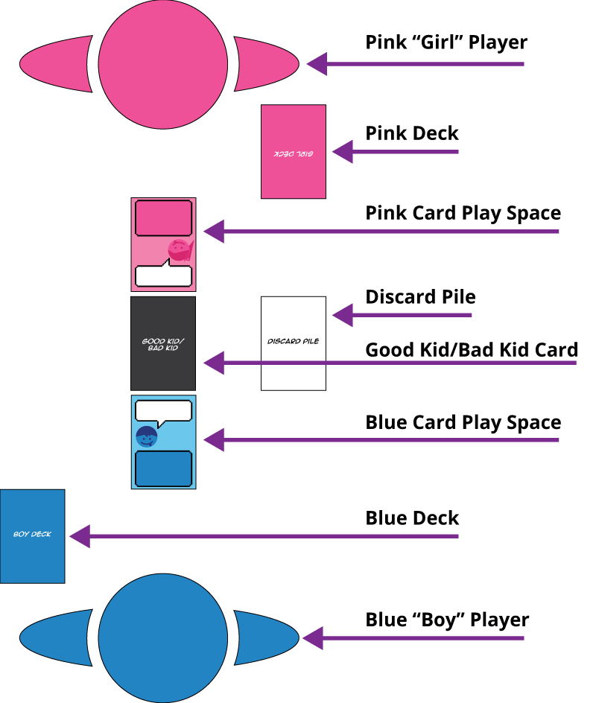

Before playing, the game both players need to decide who will play as the **Blue “Boy”** player and who will play as the **Pink “Girl”** player. Each player gets 1D6 and their 32 Kid cards. The **“Good Kid/Bad Kid Cards”** are shuffled and placed between both players. Each round one card is revealed. This is the card that both players will fight over. You want to win rounds that are for **“Good Kid”** cards and lose rounds that are **“Bad Kid”** cards. Each player takes turns placing cards on their play space. The player who runs out of cards first wins the **“Good Kid”** or **“Bad Kid”** card for that round.

Rules

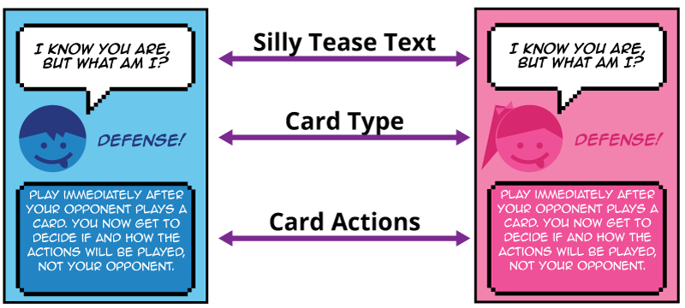

**Playing the game**

* A round starts by flipping over one “**Good Kid/Bad Kid**” card to be fought over by each player.
* Each player draws 8 cards from their deck.
* Players roll to decide who will go first. The player with the highest roll chooses who will go first (ties are re-rolled).
* Players take alternating turns placing down a card in their play space and following the actions, if any, on the card that they played. Players share the discard pile if they are instructed to discard a card.
* The round ends when one player has run out of cards. The player who runs out of cards wins the “**Good Kid/Bad Kid**” card being fought over for that round.

**New Round**

* Players retrieve cards from their place space and reshuffle them into their decks.
* Any cards left in the discard pile are no longer available for either player.
* A new “**Good Kid/Bad Kid**” card is flipped over and fought over.

Challenge Cards

Challenge cards require players to compete in mini games in order to complete their actions. These games are:

* **Rock Paper Scissors:**
  + Both players play best 2 out of 3 to determine the winner. In this game both players count to 3 and then throw either a rock, paper, or scissors shape with their hands with the following outcome:
    - Rock beats scissors
    - Scissors beat paper
    - Paper beats roc
    - If both players throw the same shape, then they re-throw.
* **Thumb War:**
  + Both players extend either their left or right hand out to one another in a “thumbs up” position and grip each other’s fingers. Both players then try to pin the player’s thumb with their thumb for a 3 second count.
* **Hand Slap Game**
  + The slappee places his hands palm down, hovering above the other player's (slapper) hands. The other player hovers their hands below the first, palms up. The two players' hands should be barely touching each other, and all the hands should be around mid-torso height. The slapper is on offense, and attempts to bring his hands over to slap the backsides of his opponent's hands. The slapper wins if they are able to slap their opponent’s hands, and the slappee wins if they are able to avoid the slap.

Victory

The game is over when all of the “**Good Kid/Bad Kid**” cards are won. The player with the better **“Good Kid”** to **“Bad Kid”** card ratio wins!