Travis Moore

PHY 115—Spring 2014

Assignment 8

1. A cat of mass 4 kg is sliding down a toboggan of (vertical) height h= 10 m. The initial speed of the cat is zero. The speed of the cat at the bottom of the toboggan is 10 m/s.

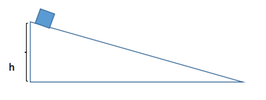

a. What is the gravitational potential energy of the cat at the top of the toboggan?

Gravitational Potential Energy of an object at vertical position y is: Ugrav = mgy   
Ugrav = 4kg \* 9.8m/s2 \* 10m

Ugrav = 3920 J

b. What is the work done by the friction force on the cat during the entire time the cat is in contact with the toboggan? Is it positive or negative? Note: you will not need to determine the friction force.

Because the friction force is opposite of the cat’s displacement, the friction force work is a negative amount of Joules.

c. What is the work done by the normal force on the cat? Please explain your answer.

Normal Force is: Fn = Fgcosϴ, with Fg = mg, so Fn = (mg)cosϴ  
Fn = (mg)cos(90), Fn = (mg)cos(0), Fn = 0

There is no work done by the normal force on the cat because the force acting on the cat is perpendicular (cos(90) = 0).

2. An airplane pilot, whose mass is 90 kg, wants to show off to his friend, who is watching him from the ground.

a. The pilot executes a vertical loop maneuver. In this maneuver, the airplane moves in a vertical circle of radius 2.7 km, at a constant speed of 225 m/s. What is the normal force on the pilot when the airplane is at the bottom of the loop?

Normal Force is: Fn = Fgcosϴ, with Fg = mg, so Fn = (mg)cosϴ  
Fn = (90kg \* 9.8m/s2)cos(180)

Fn = -882J

b. Unfortunately, the maneuver fails and the pilot falls (at an initial speed of zero) from the airplane. In addition to that, his parachute does not work immediately and the pilot falls 400 m, until he reaches a terminal velocity of 50m/s. At this time, the parachute magically opens and the speed of the pilot is subsequently reduced. Calculate the work done on the pilot by the drag force during the time the parachute is not working. Neglect the mass of the parachute.

Gravitational Potential Energy of an object for a change in vertical position y is:   
Ugrav = Ugravf - Ugravi   
Ugrav = (90kg \* 9.8m/s2 \* 50m/s) - (90kg \* 9.8m/s2 \* 0m/s)

Ugrav =50J

3. A 2.0 kg wooden box (see figure below) slides on a flat, frictionless surface, in the positive x direction. When the box is moving at 3.0 m/s, it hits a rubber wall (modeled as a spring) with a spring constant of 1.0 x 103 N/m. The cart compresses the rubber to its maximum displacement with respect to its equilibrium position (xmax). Treating the box as a particle and neglecting any non-conservative forces.

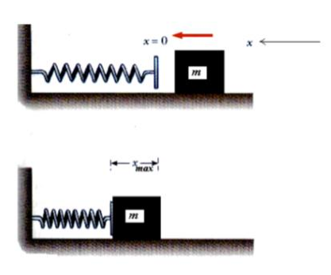

a. Determine the total energy of the cart at any time.

Total Energy is: E = K + Uel, with Uel = ½kx2Uel = ½kx2initial Uel = ½(1.0 \* 103N)(0)2  
initial K = ½(2.0kg)(0)2

final Uel = ½(1.0 \* 103N)(xmax)2  
final K = ½(2.0kg)(3.0m/s)2

b. Determine xmax.

final Uel = ½(1.0 \* 103N)(xmax)2 = 0  
final K = ½(2.0kg)(3.0m/s)2

0 = ½(2.0kg)(3.0m/s)2 + ½(1.0 \* 103N)(xmax)2

c. Extra-credit – Determine the speed of the box when the block is located at xmax/2.