Travis Moore

PHY 115—Spring 2014

Assignment 9

1. Digipen Zee is trying to alleviate her end-of-semester stress by throwing an elastic ball at a wall. The ball strikes the wall at an angle of 30 degrees with the positive horizontal axis, and rebounds with the same speed at 30 degrees with the negative horizontal axis (see figure). The mass of the ball is 100 grams. The speed of the ball is 25 m/s.

a. Is the kinetic energy of the ball conserved? Explain.

Because there is no unbalanced force acting on the ball, the total momentum of the system (ball and wall) is conserved, so the kinetic energy of the ball is conserved.

b. Determine the change in linear momentum of the ball. Please state your answer by specifying the horizontal and vertical components of the change in linear momentum.

Change in Linear Momentum: *F*Δ*t = m*Δ*v* *= mvf - mvi*  
FΔt *=* 0.1kg \* 25m/s

FΔt *=* 2.5kg \* m/s

c. Extra-credit (only this part is extra-credit) If the ball is in contact with the wall for approximately 3.0 x 10-3s, what is the average force (direction and magnitude) of the wall on the ball?

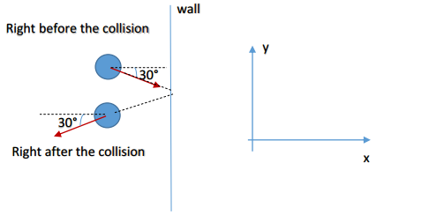

2. Digipen Zee has graduated. To celebrate the event, she pops a cider bottle, holding the bottle horizontally. The cork is ejected horizontally in the positive x-direction, as the bottle recoils horizontally in the negative x-direction. The mass of the bottle (including the cider) is 2.0 kg. The mass of the cork is 5.0 grams. The bottle recoils at a speed of 1.0 m/s. What is the velocity (direction and magnitude) at which the cork is ejected from the bottle?

Momentum of Cork + Momentum of Bottle = 0kg \* m/s  
(0.005kg \* v) + (2.0kg \* (-1 m/s)) = 0  
v = ((2 kg \* m/s) / 0.005kg)

400 m/s

3. The cork (mass = 5.0 grams), traveling horizontally at 150 m/s, hits a 0.50-kg rubber Kirby figurine that is hanging from the ceiling (see figure). The cork makes a completely inelastic collision with the figurine, becoming embedded in it. After the impact, the system Kirby-cork swings up to a maximum height h. Determine h. Hint: this is a ballistic pendulum.

½ (mc + mk)V2 = ½ kxmax2  
½

Fn = -882J

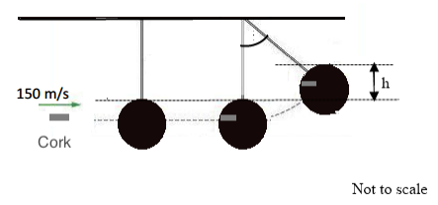

4. Digipen Zee is vacationing in NYC. She is now ice-skating at the crowded Rockefeller Center ice rink. Zee’s mass is 50 kg. Neglect friction and any other nonconservative forces (meaning that all collisions are elastic) to answer parts a through c.

a. While traveling at 4.0 m/s in the positive x-direction, Zee approaches a 30-kg kid who is at rest. Zee and the kid collide. After the collision, the kid moves in the positive x-direction. What is the velocity of the kid immediately after the collision?

mw0vw0 + mb0vb0 = mw1vw1 + mb1vb150kg \* 4m/s + 30kg \* 0m/s = 50kg \* 0m/s + 30kg \* v

6.7 m/s

b. What is the velocity (direction and magnitude) of Zee immediately after the collision?

mw0vw0 + mb0vb0 = mw1vw1 + mb1vb1

Fn = -882J

c. Although she is a little dizzy, Zee is still ice-skating after the collision with the kid. But, unfortunately, as she is moving in the positive x-direction at 3.0 m/s, she approaches another ice skater, who happens to be her cousin Zoe. Zoe’s mass is 60 kg. Zee and Zoe collide. Zoe was at rest before the collision. What are Zee’s and Zoe’s velocities immediately after the collision?

mw0vw0 + mb0vb0 = mw1vw1 + mb1vb150kg \* 3.0m/s + 60kg \* 0m/s = 50kg \* 3.0m/s + 60kg \* v

d. If Zee and Zoe stuck together after the collision, what would be their final velocity (immediately after the collision)? Would that be an elastic or inelastic collision?

It would be an inelastic collision  
v = m1v1 + m2v2 / m1 + m2  
v = 50kg \* 3.0m/s + 60kg \* 0m/s = 150 kg \* m/s / 110kg

v = 1.4 m/s