Travis Moore

ART260—Fall 2015

Instructor: Richard Rowan

Business Requirements & Personas

Table of Contents

Business Requirements & Personas 3 – 9

Business Requirements 3 – 6

Genre 3

Competitive Space 4

Devices & OS versions 4 – 5

Proposed Business Model 5 – 6

References 6

Personas 6 – 9

Sarah Ward 7

Tina Gabriel 8

Auston Lindsay 9

Business Requirements

In order to make a product that will adhere to the business requirements given for a successful game title there are a few considerations that should be considered before making a new game. In particular, consideration towards a new game’s genre, competitive space, and which devices and operating systems the game will run on all affect the business model that I am proposing.

Genre

Of the top grossing games that make up the google play sore, only one of these games is a paid app, *Minecraft*, while the other top grossing games use a micro transaction system (AndroidFact, "Top 20 Google Play Store Top Grossing Games Has Only One Paid Game”). This allows players to download and start playing the game without the barrier of paying to play a game they do not know if they will like first. I would recommend our game follows this model for our genre.

As far as genre goes for our game, I would argue that we choose between either a strategy, trivia, or adventure game; as these games have the highest percentage of devices making in-app purchases (Apsalar , "New Mobile App Data"). This will help ensure that our game reaches an audience that is predisposed to making in-app purchases based on the data I’ve collected.

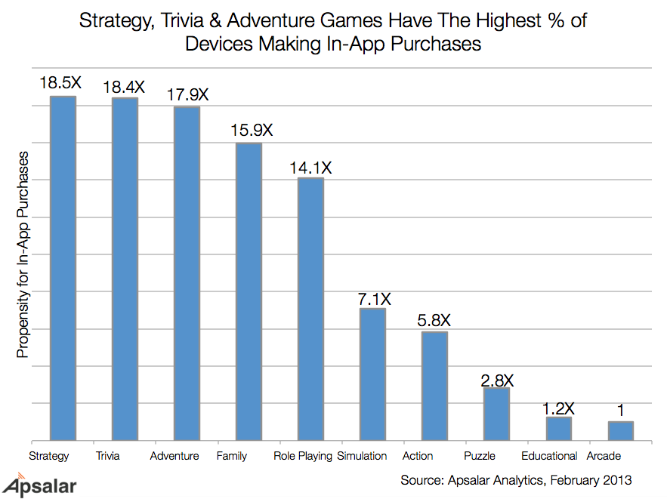

Competitive Space

Considering our game will not be an innovator in genre, our game will face competition from other games that already exist and are well established. Based on making a game that is the strategy genre, our competitive space for a strategy game goes up against games like *Clash of Clans* and *Game of War – Fire Age*. Trivia games that occupy the mobile game space include titles like *Trivia Crack* and *Quiz Up*. As far as Adventure titles go, the biggest competitor would be *Minecraft*.

These games have shown continued success in the market and our new game will have to stand out in some way in order to get attention, so I would also recommend a well-thought out marketing strategy to help our game stand out and get attention.

Devices & OS Versions

The first requirement that the new game must adhere to is that the game must run on mobile devices that represent 75 percent market share or greater. The restriction of the new game having to run on mobile devices has its limitations, but thankfully smartphones make up 75 percent of the mobile phone market, up from 65 percent from a year ago (SFGate, "Smartphones Make up 75 Percent of Mobile Market"). Due to this it is safe for us to target smartphones over simpler track phones that would severely limit the capabilities of our game.

Of the smartphones available on the market, 82.8 percent of smartphones use the Android operation system (IDC, "IDC: Smartphone OS Market Share”). Of the devices using Android, the current version of operating system being used ranges between the two major release versions of Android, 4.0 through 5.1, with the majority of devices running 4.4 at 3.2 percent (Developers.android.com, “Dashboards”). This research leads me to believe that our game should be made using the previous 4.0 version of Android’s OS as the baseline for making our game.

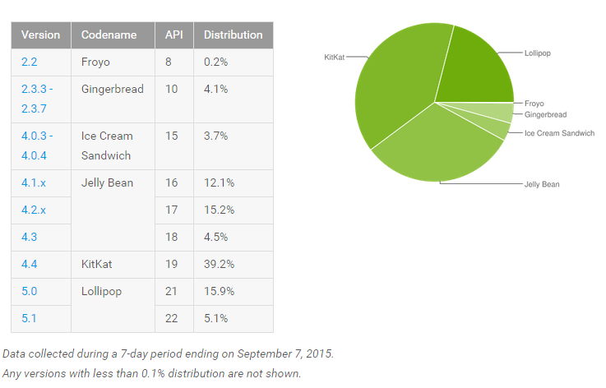

Of the devices that are running android, the largest market share holder continues to be Samsung, with 39.3 percent, followed by HTC at 26.2 percent (PassMark , "Android Devices & Smartphones Marketshare in the Last 30 Days"). The rest of the manufacturers that make up the market are at 11% or below, but should still be considered when testing for the game has started.

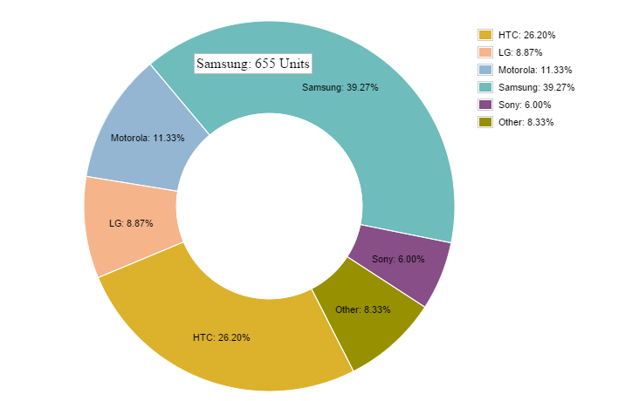

Proposed Business Model

Based on the research I’ve done it would be a good idea for us considering using the micro transaction model in the new game we decide to make. Whatever genre we choose, no matter strategy, trivia, or adventure, we need to make use of in-app purchases rather than force the user to make a purchase up front for the game. For the sake of statistics, I’d recommend making a strategy game because this genre proves to me the most successful at driving in-app purchases.

As far as devices go, our game will be safe to make if we target the smartphone audience in both Android and IOS operating systems if we are able to, so as not to leave out potential markets. However, if we need to reign in our focus, it is safer to develop solely for the Android market and we’ll be fine developing for Android version 4.0 as the lowest version of an OS to target. It will be important that our game is engaging and has some sort of marketing behind it in order to stand out against a sea of already established games no matter what approach we take.

References

The following sources were used as references throughout this paper:

1. "Smartphones Make up 75 Percent of Mobile Market." SFGate. Web. 22 Sept. 2015.
2. "IDC: Smartphone OS Market Share." Www.idc.com. Web. 22 Sept. 2015.
3. "Dashboards." Developers.android.com. Web. 22 Sept. 2015.
4. "Android Devices & Smartphones Marketshare in the Last 30 Days." PassMark. Web. 22 Sept. 2015.
5. "Top 20 Google Play Store Top Grossing Games Has Only One Paid Game." AndroidFact. Web. 22 Sept. 2015.
6. "New Mobile App Data." Apsalar. Web. 22 Sept. 2015.

Personas

The following three personas are in the 24 – 35 age range, 60 percent female, and are examples of player types that our game should try to appeal to if we were to make a strategy game for the mobile market:

Persona 01: Sarah Ward—The Social Gamer



**Age:** 27

**Sex:** Female

**Relationship Status:** Single

**Occupation:** Barista

**Game Experience:** Sarah is connected to her phone at almost all hours of the day. Sarah uses games as a way to stay socially connected with her friends and so she spends a lot of time online and playing games with and against her friends. She plays games about 12 hours a week.

**Backstory:** Sarah would not really consider herself a gamer, but she grew up in a household with 3 younger brothers who all play games. Sarah is a bright, motivated student getting her degree in psychology at the local university. Always busy with work or school, Sarah uses social media to stay in touch with friends and family.

**Favorite Games**

* Candy Crush
* Trivia Crack
* Hanging With Friends

**Motivations**

* Playing with friends
* Ease of use
* Customization

**Frustrations**

* Complexity
* Slow paced games
* No progression

**Quote:** “I don’t really go out of the way to play any particular games, just the ones my friends are playing. It’s fun to quickly play a fun game with a friend that doesn’t take a lot of time.”

**Ideal Experience:**

* Easy to pick up and start playing
* Ability to connect to social media in order to start playing with friends
* Shot game play length
* A feeling of progression
* The ability to return to the game at your own pace

Persona 02: Tina Gabriel—The Challenge Gamer



**Age:** 25

**Sex:** Female

**Relationship Status:** Single

**Occupation:** College Student

**Game Experience:** Tina enjoys a challenge that is   
difficult, but fair. Tina grew up playing sports and likes to compete against others. Tina is comfortable playing on   
mobile devices and consoles and plays about 18 hours a   
week when she’s bored.

**Backstory:** Tina has always been involved in activities with her friends and likes to challenge herself to be the best. Whether it is on the field or online, Tina likes to compete. Tina doesn’t have as much time as she’d like to play games with being a student at school, but she keeps in touch with friends through games.

**Favorite Games**

* Starcraft
* Team Fortress 2
* Rocket League

**Motivations**

* Being the best
* Achievements
* Feeling smart

**Frustrations**

* Pay to win games
* Unfair games
* Massively multiplayer games

**Quote:** “Who doesn’t like to challenge themselves, push themselves to be the best? I like to prove to myself that I can win if I put my mind to it.”

**Ideal Experience:**

* Lots of strategy
* Competitive environment
* Fair and balanced system
* Accomplishments to show up how well she plays the game
* Social elements to play with and against friends

Persona 03: Auston Lindsay—The Mastery Gamer



**Age:** 24

**Sex:** Male

**Relationship Status:** Single

**Occupation:** College

**Game Experience:** While Auston would prefer to play more games than he currently has time for, the few games that Auston does play provide him with the ability to master the game, whether through challenge or multiplayer modes. Auston plays 10 hours of games a week.

**Backstory:** Auston loves video games, but understands that school is the most important thing for him to focus on. Because of this, Auston is selective about what games he has time to play. Auston likes to analyze and study games to not only become the best designer he can be, but to master the intricacies of the game and be the best.

**Favorite Games**

* Dark Souls
* Team Fortress 2
* DoTA2

**Motivations**

* Mastering complex mechanics
* Achievements
* Progression Systems

**Frustrations**

* Games that are too easy
* Completely single player experiences
* Long narratives

**Quote:** “If it were up to me I’d play every game to 100 percent completion. I love understanding a game to the fullest and only wish I had more time to play the games I love.

**Ideal Experience:**

* Competitive
* Simple to complex mechanics with a variety of interactions
* Match making systems
* Challenging puzzles