ART-260

Lab 01

Travis Moore

Professor Rowan

09/03/2015

Lab 1—UX Analysis

Choose a commercial, well-known console or PC game that you are familiar with and you believe has a reasonably good user experience. Write a 300 – 500 word assessment of the following areas of the user experience:

SPLICE

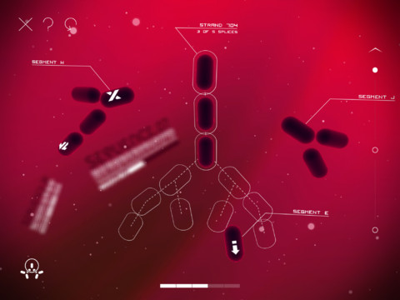

Primary Game Screen (what you seem most of the time you’re playing):

Splice is puzzle game involving splicing genes in a specific sequence in order to beat levels and progress through the game. The UI is very minimal in a great way in order to make a difficult puzzle game easily understandable so as to not further complicate the game. Splice is primarily played with the mouse and the controls have been designed to be easily clickable and also uses the mouse will in a very intuitive way to tweak the timeline of moves you’ve made forwards and backwards. The primary UI elements are displayed in white, creating a color connection for the user that anything in white is an element of the UI and is probably clickable or contains player information. Secondary UI information that is layout related or not meant to be clicked is done in a darker gray.

The user interface elements are split up into in-game and HUD elements that all share the color scheme of white. Immediately usable in-game information is a bright white, while secondary information is a semi-transparent white. Upon clicking or hovering over an UI element, the UI white color becomes fully opaque and it is clear that this is the primary thing you are now interacting with. Using the mouse and selecting genes automatically provides the player with a white outline of the possible configurations of the move and the way the gene will rearrange based on the move you make.

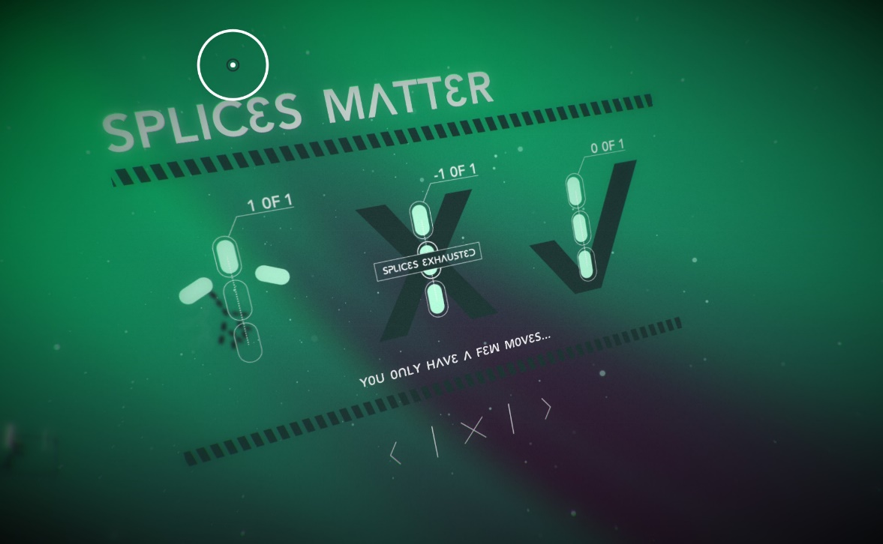

Menu Navigation (what you use to enter other game screens or move between modes):

Splice’s menu system is unique in that the menu system feels very fluid and not separate from the game. Navigating between menus appears to occupy the same game space as the game, with only the elements on the screen shuffling in and out of place instead of reloading or making it seem like a hard transition to a new space is taking place. The information that the game gives you let you know what a particular button will do is provided by consistent use of symbols. Left and right chevrons always progress the player to a new level or screen. An “X” will always close out a menu or exit. Overall the minimalistic style makes it very clear how the game works and how to interact with it.