Travis Moore

GAT251—Fall 2015

Instructor: Bill Morrison

Level Planning Workflow

Table of Contents

Level Planning Workflow 3 – x

Purpose 3 – 4

External Purpose 3

Internal Purpose 3 – 4

The Idea 4 – 8

Episode Concepts 4 – 5

Concept Selection 5 – 8

Environment 9

Setting & Story 9

Focal Points 9 – 10

Guidance & Identity 9 – 10

Objectives 10

Obstacles 10

Layouts 11

Map Sections with Notes 11

Visual Development 12

Aural Development 12

Quantify & Enumerate 12

Models 12

Textures 12

Animation 12

Sounds 12

Internal Purpose 12

Production Plan 13

Level Planning Workflow

Purpose

Identify the key requirements of your level, whether they are external to the project or your internal goals for the episode.

External Purpose

**What is the game type or genre?**

The game I will be making will be focused on providing the discovery aspect of the engagement theory. The genre that this might closest resemble is a 3D platformer.

**Are there any game or genre conventions that need to be delivered on within this experience?**

The game must deliver on the discovery aspect of the engagement theory and be easy for the player to navigate, whether I choose to do a third-person or first-person view for the player.

**Is this experience single-player or multiplayer?**

This experience will be single-player focused.

**Where does this episode fit in the overall arc of the experience?**

This episode is just a small 3D space that focuses on discovery. It would probably work well as a hub world or a beginning type of level where the player is exploring the environment and how the controls work.

**Are there any game mechanics that need to be taught or used within this episode?**

As a 3D platformer the game needs to have basic 3D movement and jumping. Perhaps if I have time I’ll implement a “use” mechanic to open doors or read signs. I’m going to try to keep this game as basic as possible to instead focus on the space. Maybe I’ll have a dark level with a flashlight to help really focus the player on the “unknown” of the space.

**How much should each mechanic be used in this episode?**

Considering I am really going to emphasize the discovery aspect of the engagement theory I will be making extensive use of the ability to move and jump in 3D space. The “use” mechanic may not even be implemented.

Internal Purpose

**What do you want the players to feel or experience?**

I want the players to feel interested in the environment and feel like the 3D space is worth exploring. I’m not quite sure if I’m going to go for shock and awe, but I want the 3D space to be compelling in some way to make people actually check everything out.

**What technical/design/art skill do you want to learn/practice while creating this episode?**

The biggest skill I’m looking to exercise in creating this level is my ability to design a compelling 3D space. I have never created a 3D space before, so this project will provide me with a lot of opportunity to learn and practice.

**Why do you want to create this particular episode?**

I want to create this level purely for the learning opportunity and practice. I hope to be able to design better 3D spaces after completing this project.

**How will you make this environment stand out (visual, technical, and/or design)?**

Considering I am a designer, I hope to make this level stand out from a design aspect foremost. Secondly I’d like the environment to stand out visually, but I may resort to using Unity3D store assets as opposed to making my own to save on time. This project will excel if I give more thought to level design and less to creating individual environmental models.

The Idea

Brainstorm ideas that you could build that might fulfill one or more of the requirements you identified while building your purpose.

Episode Concepts

Generate up to 10 ideas each with their own *Primary Goal*, *Environment Setting*, anda brief *description of mood*.

1. **Trek across the desert**
   1. Desert dunes
   2. Barren, unwelcoming, arid
2. **Jungle exploration to find a temple**
   1. Jungle, jungle temple
   2. Entangled, thriving, dense
3. **Descend into the mysterious pit**
   1. Pit, caves, maze
   2. Dark, mysterious, vast
4. **Search an abandoned space ship**
   1. Space, large space ship
   2. Artificial, lonely, confusing
5. **Scale the tallest mountain**
   1. mountains
   2. Rocky, steep, towering
6. **Explore a fantasy/alien world**
   1. Strange new world
   2. Odd, fascinating, dangerous
7. **Make your way through the forest**
   1. Forest and river
   2. Serene, natural, misty
8. **Escape from hell**
   1. Hell
   2. Perilous, fiery, maze-like
9. **Go to the office**
   1. City streets, office building
   2. Monotonous, familiar, soul-draining
10. **Escape the mad scientist’s lab**
    1. laboratory
    2. Weird science, experiments, dangerous

Concept Selection

For each concept write down your thoughts on how each concept might work.

1. **Trek across the desert**
   1. *What specifically excites you about this concept?*
      1. I like the idea of rolling sand dunes creating a large sense of open space and small sprinkles of rocky terrain or other mysteries providing peaks of interest for the player to explore.
   2. *What worries you about this concept?*
      1. Not having a real clear objective, other than exploring. Creating the actual art assets I would need for it.
   3. *Rate this concept on a scale of 1 to 10 on how well it delivers on purpose.*
      1. 7
2. **Jungle exploration**
   1. *What specifically excites you about this concept?*
      1. The opportunity to create a dense and heavily populated landscape of trees, rocks, and plants seems like a fun way to deliver interesting things for the player to look at in this environment
   2. *What worries you about this concept?*
      1. Creating all the art assets needed to create this environment worries me the most.
   3. *Rate this concept on a scale of 1 to 10 on how well it delivers on purpose.*
      1. 6
3. **Descend into a mysterious pit**
   1. *What specifically excites you about this concept?*
      1. The opportunity to use enclosed spaces to create mood and funnel the player along a path seems fun. Opening the space up to large caverns with a giant maze seems interesting, too.
   2. *What worries you about this concept?*
      1. Creating all the art assets needed to create this environment worries me the most.
   3. *Rate this concept on a scale of 1 to 10 on how well it delivers on purpose.*
      1. 8
4. **Search an abandoned space ship**
   1. *What specifically excites you about this concept?*
      1. It could be fun to play with a dark interior space that is mysterious as to what happened before the player got there. Lighting could be fun on a ship that is barely functioning.
   2. *What worries you about this concept?*
      1. Not really delivering on an ending and creating all the art assets needed to create this environment worries me the most.
   3. *Rate this concept on a scale of 1 to 10 on how well it delivers on purpose.*
      1. 6
5. **Scale the tallest mountain**
   1. *What specifically excites you about this concept?*
      1. The purpose would be clear in that the player would probably naturally try to reach the top.
   2. *What worries you about this concept?*
      1. It seems like it’s been done a lot before.
   3. *Rate this concept on a scale of 1 to 10 on how well it delivers on purpose.*
      1. 5
6. **Explore a fantasy/alien world**
   1. *What specifically excites you about this concept?*
      1. There are lots of possibilities for weird environments and props.
   2. *What worries you about this concept?*
      1. Creating all the weird and new art assets for a brand new environment worries me the most.
   3. *Rate this concept on a scale of 1 to 10 on how well it delivers on purpose.*
      1. 7
7. **Make your way through the forest**
   1. *What specifically excites you about this concept?*
      1. Art assets would be easy to come by, I’d imagine.
   2. *What worries you about this concept?*
      1. Not really having an end goal and being bland is my biggest concern.
   3. *Rate this concept on a scale of 1 to 10 on how well it delivers on purpose.*
      1. 5
8. **Escape from hell**
   1. *What specifically excites you about this concept?*
      1. Everything! This could be a lot of fun to create an ascent like trying to escape the gaping maw of the abyss!
   2. *What worries you about this concept?*
      1. Practically everything!
   3. *Rate this concept on a scale of 1 to 10 on how well it delivers on purpose.*
      1. 9
9. **Go to the office**
   1. *What specifically excites you about this concept?*
      1. It could be fun to do a sort of “Shawn of the Dead” where it’s the same old path to work but something is obviously wrong today.
   2. *What worries you about this concept?*
      1. It would require a subtle touch to only slightly hint at things being askew.
   3. *Rate this concept on a scale of 1 to 10 on how well it delivers on purpose.*
      1. 6
10. **Escape the mad scientist’s lab**
    1. *What specifically excites you about this concept?*
       1. It would be fun to show the world at a scale appropriate for a lab rat.
    2. *What worries you about this concept?*
       1. Creating all the art assets needed to create this environment worries me the most.
    3. *Rate this concept on a scale of 1 to 10 on how well it delivers on purpose.*
       1. 8

Environment

With the core concept selected, now it is time to become more specific about the nature of your environment.

**IDEA SELECTED: DESCEND INTO THE PIT**

Setting & Story

**Is this an interior or exterior space (or both)?**

The start of the game is an exterior space, but it quickly becomes an exploration through an interior space.

**Is this a natural or man-made environment?**

It is mostly a natural environment with a few man-made structures within the pit.

**Is this experience single-player or multiplayer?**

This is a single-player experience.

**What is the climate and weather of this location right now?**

The climate is dark, dry, and during the peak of summer.

**What is the time period of this setting (month and year)?**

The month of August, set in a time long ago.

**What time of day is it right now (affects lighting/audio)?**

The time of day is currently dusk with night quickly falling.

**What are the characteristics of the terrain in this environment?**

The characteristics of the terrain are rocky, other-worldly, ancient, old, undisturbed for many years.

Focal Points

Utilize key visual landmarks for the level to provide the player *Guidance* and *Identity*.

Guidance & Identity

These focal point help orient the player as to where they are in a level and guide them to the next point of interest and help shape the visual character of your environment with an identity that makes it feel unique:

* The entrance to the pit
* Tunnels and large openings to caverns
* A labyrinth

Objectives

Identify the obstacles that the player will encounter in this episode.

**What does the player need to do within the environment in order to progress?**

The player will need to successfully plan out a path through a mostly enclosed environment and overcome steep ledges and navigating a labyrinth in order to escape the pit alive.

Obstacles

Identify the objectives that the player will encounter in this episode.

**What opposition does the player need to overcome? Enemies? Puzzles? Item Collection? Exploration? Do these obstacles have a backstory as to why it is there?**

The player will have to watch for pits, small ledges, and navigate a labyrinth in order to escape the pit alive.

Layouts

Plot out the map boundaries, landscape areas, focal points, buildings, player paths, side-paths, shortcuts, secret areas, objectives, obstacles, and story points in an overhead map. Use this to help develop a visual sense of the nature of the environment

Map Sections with notes

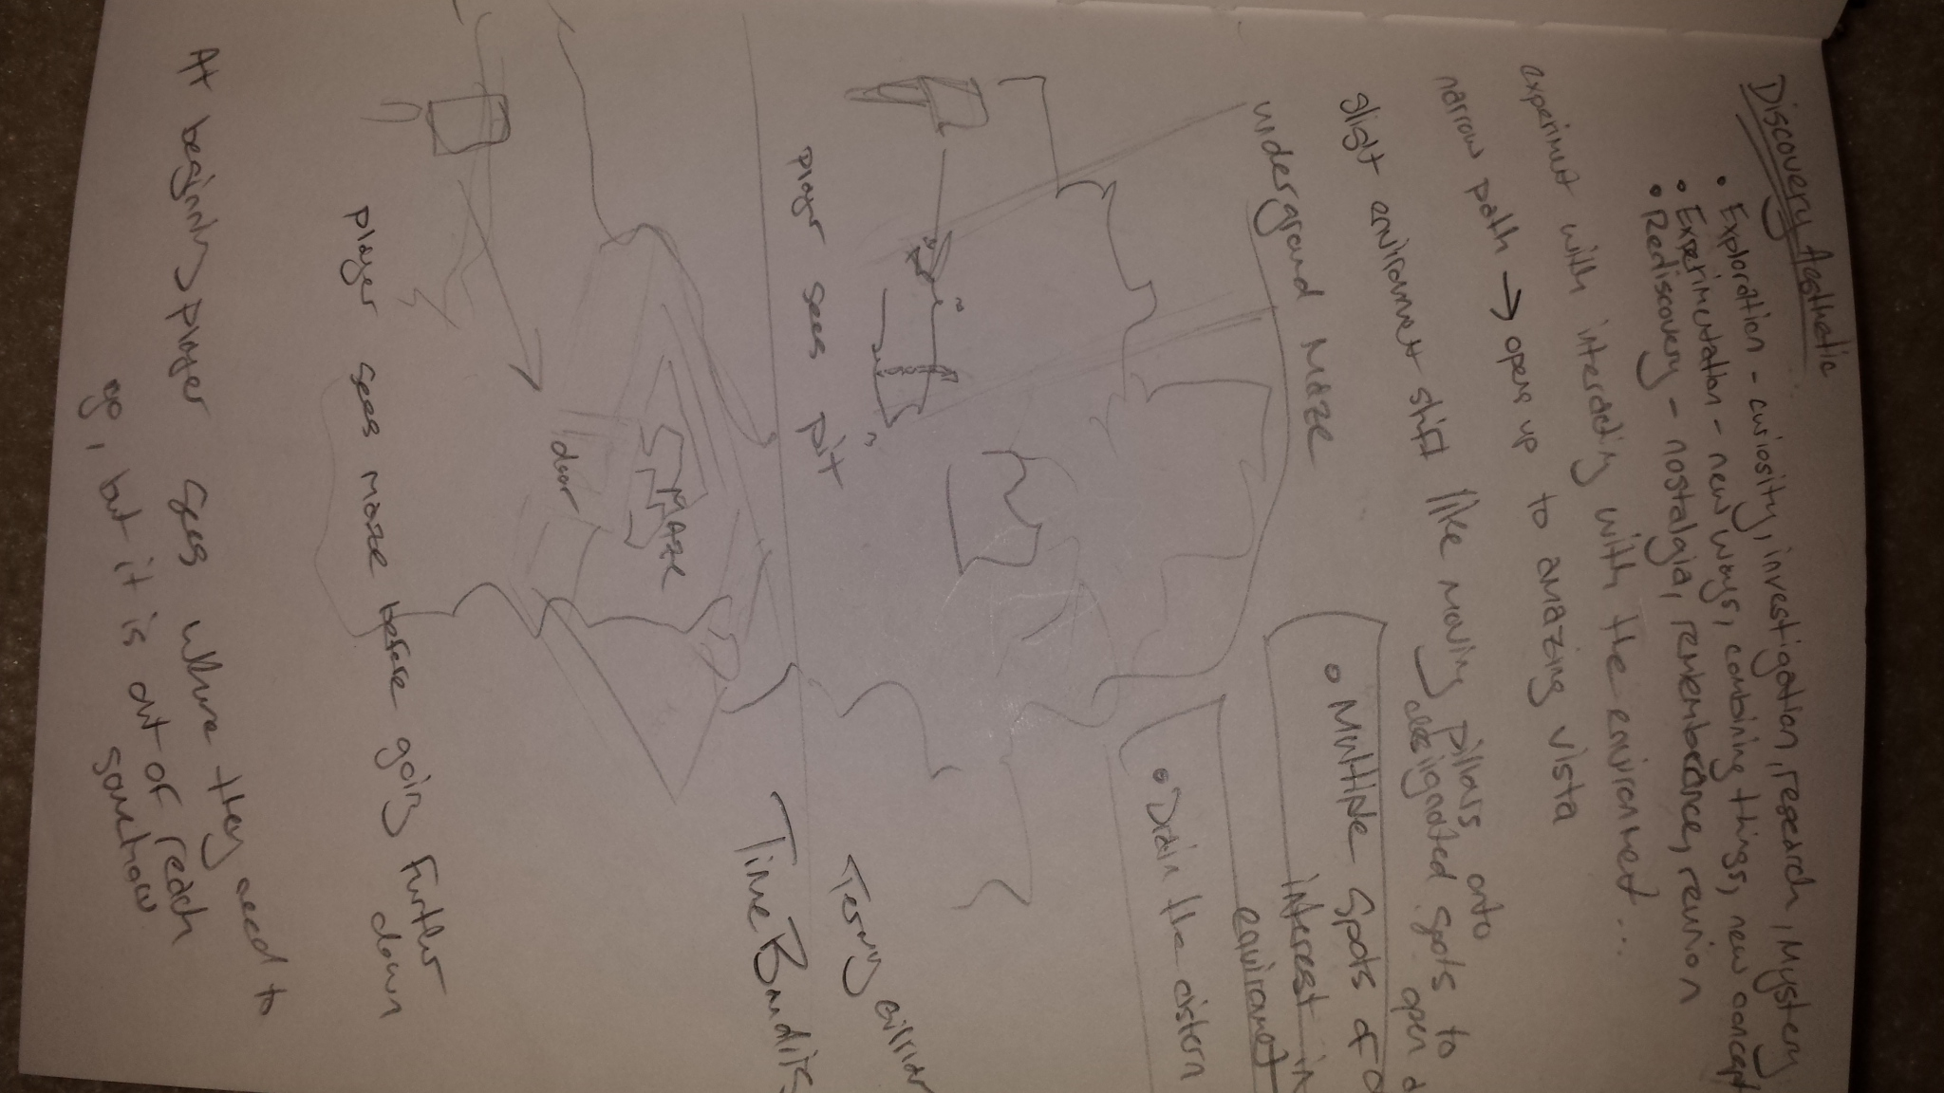

Visual Development

**What artistic style will be used for the environment as constrained by available art skill and technology limitations?**

I’ll be trying to achieve a low-poly environment that is highly stylized through the use of a cool color palette and lighting that makes everything seem eerie and other-worldly.

Aural Development

**What genre or mood of the background music will you use?**

I’ll keep background music to a minimum to play up the enclosed spaces muffling outside noises.

**What are the key sounds biomes in your level and what sounds characterize them?**

Soft noises with heavy reverb will help make my pit feel like a cave or a small, enclosed space.

**What sounds will guide the player through the level, if any?**

I’m not sure yet.

Quantify & Enumerate

Now that you know what your level will look like, sound like, and play like, it is time to make a list of everything you need to do.

Models

* Rocks
* Tunnels
* Ropes
* Moss
* Stalagmites
* Stalactites
* Mushrooms
* Various Plants
* Lava
* Water
* Temple Walls
* Ancient Doors

Textures

* Rocks
* Plants
* Lava
* Ancient Writing

Animations

* Doors
* Falling Rocks
* Dust

Sounds

* Ambient Noise
* Rocks
* Water Dripping
* Lava rumbling
* Wind
* Stones shifting

Production Plan

Now that you have a list of everything you need to make, it is time to put together your production plan.

**Estimate the size and effort of completing the items you’ve listed.**

I’m going to be honest, I have no idea how much time this will all take. That being said, I know it will definitely take a lot of time, especially if I need to make all the assets. I’m highly relying on the asset store right now, but I’ll have to do a lot of research to figure out how much I’ll really need.

**Determine when you can work on your project?**

I can work on my project on Wednesday, Saturday, and Sunday.

**Project how long it will take you to complete and how much work you will need to do each day to finish on time?**

Another question that I really don’t know. I think this project will be a good standard to use in future projects to be able to more accurately predict how much time this will take.